Forecasting Flu Activity in Hong Kong Considering the Impact of School Absenteeism Data
  - Yan Chen
Table of Contents
Introduction 2
Problem Definition 2
Target and Feature Variables 2
Stationarity and Seasonality of Disease-related Variables 2
School Absence Data 4
Methods 6
Baseline Models 6
Random Forest 6
GRU or LSTM 7
TFT 8
Results 9
Baseline Models 10
Random Forest 10
GRU and LSTM 17
Temporal Fusion Transformer (TFT) 19
More comparison under different forecast horizons 21
Conclusion 21
References 22

Introduction
Due to the crucial impact of population density and interaction patterns on the transmission of certain infectious diseases, we propose the hypothesis that the changes in school absenteeism could serve as the indicator of disease prevalence. For instance, (Sasaki et al., 2009) has found that tracking disease-specific school absenteeism data can effectively forecast the outbreaks of influenza in Japan, while non-disease-specific school absenteeism data has shown limited correlation with influenza activity in the US (Egger et al., 2012). In this study, we analyze the non-disease-specific school absenteeism data in Hong Kong spanning from 2008 to 2020 to evaluate its predictive potential for influenza cases, including both type A and B strains.

Problem Definition

Target and Feature Variables
The dataset includes a target variable representing the occurrence of flu across all subtypes. There are four categories of variables:
1. Disease-related variables, such as Adenovirus, RSV, Influenza B, Influenza H1, Influenza H3, Paraflu12, and Paraflu34, are not available for time t+1. It's important to note that cumulative flu cases (aggregated from Influenza B, Influenza H1, and Influenza H3) are used as the target variable.
2. Weather-related variables are known at time t+1 and include absolute humidity, relative humidity, solar radiation, pressure, maximum temperature, minimum temperature, mean temperature, temperature range, total rainfall, and wind speed.
3. Seasonal variables, such as year, month, and week of reported cases, are known at time t+1. These values are transformed using a sinusoidal function.
4. The student school absence-related variable is also known at time t+1.

Stationarity and Seasonality of Disease-related Variables
Firstly, Figure 1 presents a visualization of all observations relevant to diseases. Based on Augmented Dickey-Fuller (ADF) tests performed for each variable, it is found that, except for Adenovirus, the time series for other diseases are stationary.
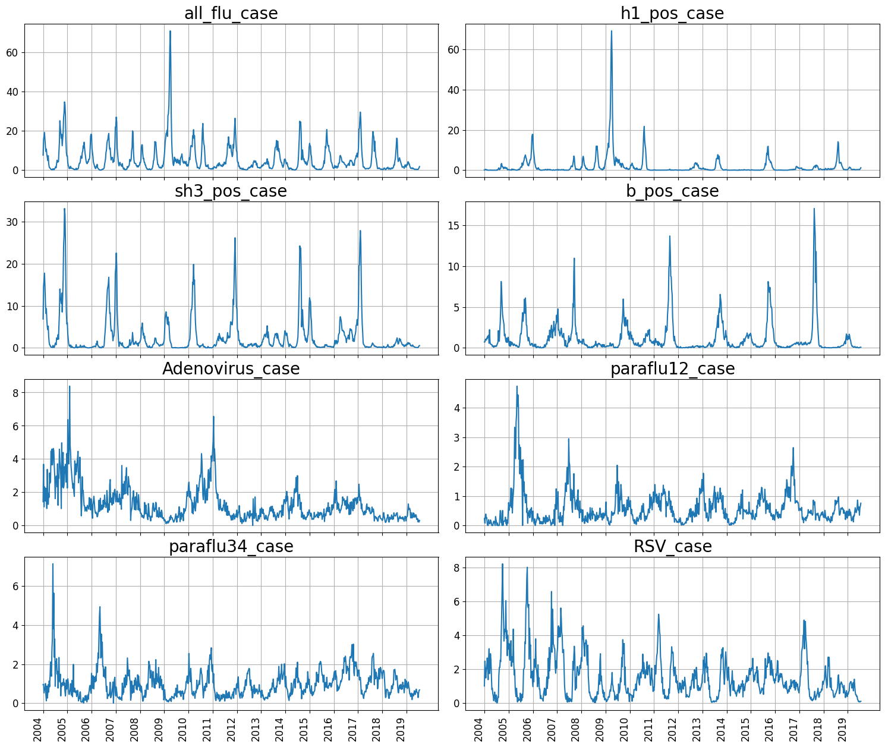
Figure 1. Line chart of reported cases for each disease from 2004 to 2020.
Since cyclical patterns are observed in Figure 1, spectral analyses are conducted to capture dominant frequencies for each disease variable as in Figure 2. Currently, two sinusoidal functions (sin and cos) are used to encode the seasonality factors. In the future, Harmonic regression may be used to capture more complicated seasonality dynamics.
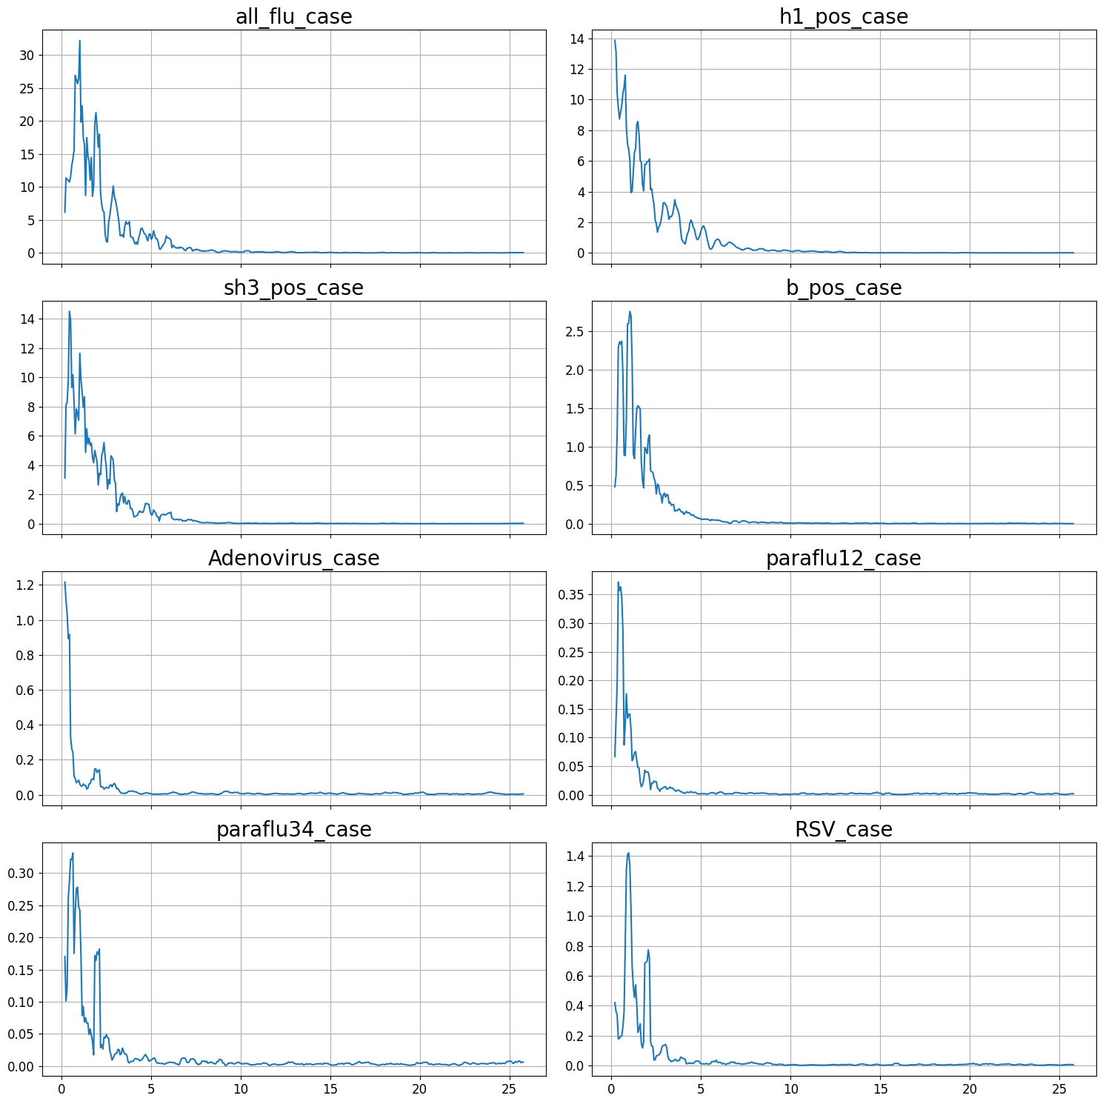
Figure 2. Spectral analysis for each disease variable.

School Absence Data
Figure 3a is the distribution illustrated as a histogram for school absence data. Important metrics for its distribution are in Table 1. Because the school absence data has 40% missing, an appropriate approach needs to be employed to filling these missing data. We can observe the pattern of the missing data as in Figure 4a. Since there is a clustered missing data from year 2004 to 2008, this part of observations is removed when the school absence data is used as a feature. The missing pattern after removing this part of observations is shown in Figure 4b. Figure 4a shows the histogram of school absence data before filling missing data, while Figure 4b shows the histogram after the missing data has been filled by 95% percentile.
Table 1. Descriptive statistical metrics for the 2004-2020 School absenteeism data.
Metrics | Mean | Median | Min | 25% | 75% | 95% | Max | Missing%
 | 4.13 | 4.10 | 1.20 | 2.60 | 5.20 | 7.085 | 11.00 | 40.17

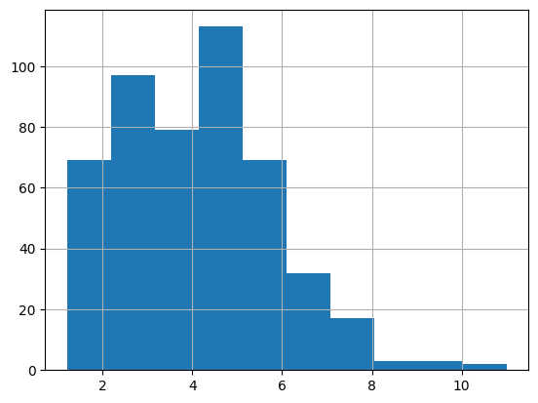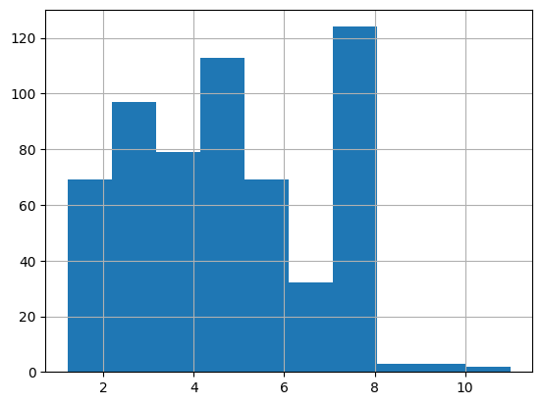
Figure 3. School Absenteeism data distribution (a) before and (b)after filling in the missing data.
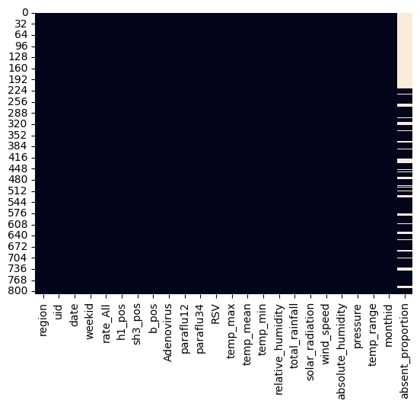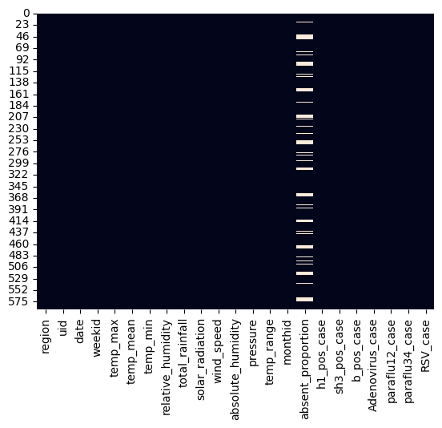
Figure 4.(a) Pattern of absence missing data from 2004,(b) Pattern of absence missing data from 2008.

Methods

Baseline Models
Because of the unique seasonality observed in disease cases, it is reasonable to use historical values as a baseline model for predictions, even for forecasting periods up to eight weeks (Figure 5a), especially for shorter-term predictions (Figure 5b). More specifically, the baseline model predicts the values of the target variable at times t+1 to t+h using the values of the target variable at time t. Baseline models serve as benchmark to evaluate the performance of subsequent, more complicated models.

Random Forest
The Random Forest model is chosen due to its resilience to outliers and its ability to provide insight into feature importance. However, as it's not inherently designed for time series modeling, historical information is integrated into the feature space by including lagged variables for each feature. In the constructed Random Forest model, for every original predictor, its lagged observations up to 8 weeks prior are included as input variables. This expands the total predictor dimension to 144 if school absence data is not considered, and to 152 if school absence data is included.
The important hyper-parameters that have been tuned for the Random Forest models are:
- n_estimators =[20,40,80]: number of decision trees used in the Random Forest
- max_features=[10,20,40]: number of subset features used when considering the best split
- max_depth=[4,8,16]: The maximum depth of the tree
- min_samples_split=[8,16]: The minimum number of samples required to split an internal node
- min_samples_leaf=[4,8]: The minimum number of samples required to be at a leaf node
- criterion={“squared_error”, “absolute_error”, “friedman_mse”}: the function to measure the quality of a split.
- bootstrap ={True, False}: Whether bootstrap samples are used when building trees. If False, the whole dataset is used to build each tree.
- train_start_fix = {0,1}: 0 means that the start of training data is t-N when making predictions for observations starting at t. 1 means that the start of training data is always from t=0.

GRU or LSTM
Because GRU lacks a dedicated memory unit and only features two gates (reset and update), while LSTM includes three gates (input, output, and forget), LSTM typically excels in capturing long-term information whereas GRU is more adept at identifying short-term changes. Consequently, a framework comprising two layers of LSTM/GRU is developed with the goal of enhancing the accuracy of time series forecasting (Refer to Figure 5).
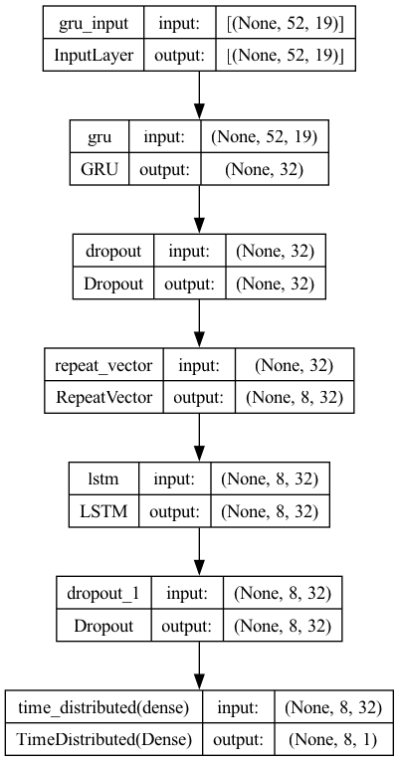
Figure 5. The LSTM neural network structure.

Due to the adaptable nature of the Keras deep learning module, there's room to investigate custom sample weights and loss functions to discover optimal combinations. The key hyperparameters of this framework include:
- first layer and second layer modules: either LSTM or GRU
- customized sample weights: three approaches are used to mitigate the low occurrence of extreme value observations: (1) divide the data samples into bins,(2) take power operation , and (3) take exponential operation
- learning rate ranges from 1e-3 to 1e-2
- number of neurons in each layer is either 16 or 32
- dropout rate is either 0.2 or 0.3
After hyper-parameter tuning, it is found that the optimal configuration consists of a GRU layer as the first layer followed by an LSTM layer, binning the data samples, utilizing a learning rate of 1e-2, and employing a dropout rate of 0.3.

TFT
Temporal Fusion Transformer (TFT), proposed by (Lim et al., 2019), aims to improve the interpretability of multi-horizon and multivariate time series forecasting. It's an attention-based model that evaluates the influence of each covariate at every lag.
Its predictors are divided into three groups:
- Static variables: These are variables that remain constant over time, such as the region where the disease case is reported.
- Time-varying known variables: These are variables that change over time but are already known at the time of forecasting, such as temperature or wind speed.
- Time-varying unknown variables: These are variables that change over time and are unknown at the time of forecasting, such as newly added cases of other diseases for the forecasting horizon.
The three categories of predictors mentioned above are put into a variable selection module. Then, the static variables are directed into static covariate encoders, the time-varying unknown variables are channeled into LSTM encoders, and the time-varying known variables are sent into LSTM decoders. Following another GRU operation, all these transformed predictors are combined within a multi-head attention framework. Subsequently, after another GRU operation, the final dense layer produces the ultimate output.
In the implementation of TFT, seasonal and weather-related variables are treated as time-varying known variables, and all the disease-related variables are treated as time-varying unknown variables.
The hyper-parameters of the TFT framework include:
- gradient_clip_val: is set to a value between 0.1 to 10 to avoid exploding gradients
- hidden_size: hidden size of network which is its main hyperparameter and can range from 8 to 512
- dropout: is set to between 0.2 to 0.3
- hidden_continuous_size: default for hidden size for processing continuous variables (similar to categorical embedding size)
- attention_head_size: number of attention heads (4 is a good default)
- learning_rate: is set to between 1e-4 to 1e-2

Results
Metrics used to evaluate the forecasting performance of the models include:
- MAE: Mean Absolute Error
- RMSE: Root Mean Squared Error
- SMAPE: Symmetric Mean Absolute Percentage Error
- NNSE: The Nash–Sutcliffe efficiency is calculated as one minus the ratio of the error variance of the modeled time-series divided by the variance of the observed time-series
- IS: Interval scores, which evaluate the prediction intervals and equal the width of the prediction interval plus penalties for being outside the interval
Table 2 summarizes the performance of various methods as a ratio relative to the metric of the baseline model, considering both scenarios with and without school absenteeism data. Table 3 reports the MAE between ground truth and predictions over the years from 2013 to 2018 across methods considering school absenteeism. The prediction horizons are all 8 weeks across methods.
Table 2. Compare the performances of various methods as a ratio relative to the baseline
metric, considering both scenarios with and without school absence data.
Methods\Metrics | MAE | RMSE | SMAPE | 1 - NNSE
Baseline | 1.00 | 1.00 | 1.00 | 1.00
Random Forest (no absence, lookback 8w) | 0.7939 | 0.7889 | 0.8755 | 0.7558
Random Forest (with absence, lookback 8w) | 0.7883 | 0.8014 | 0.9064 | 0.7715
LSTM (no absence, lookback 8w) | 0.8091 | 0.8485 | 0.8835 | 0.8122
LSTM (with absence, lookback 8w) | 0.8216 | 0.7975 | 0.9375 | 0.7595
TFT (no absence, lookback 8w) | 1.0322 | 0.9975 | 1.1865 | 0.9925
TFT (with absence, lookback 8w) | 0.8772 | 0.8853 | 1.0612 | 0.8621

Table 3. MAE between ground truth and predictions over the years from 2013 to 2018 across methods considering school absenteeism. The prediction horizons are all 8 weeks across methods.
Year/Methods | Baseline | Random Forest | LSTM | TFT
2013 | 2.5066 | 2.3700 | 2.2910/2.6130 | 2.8098
2014 | 4.5384 | 3.1700 | 3.1400/3.1700 | 3.8825
2015 | 2.8598 | 1.7820 | 2.1400/1.9750 | 2.3777
2016 | 4.3118 | 2.7730 | 5.5800/4.7900 | 4.7860
2017 | 2.5931 | 1.7710 | 2.5310/1.6490 | 2.2438
2018 | 2.1496 | 1.6920 | 1.6650/1.8820 | 1.2876

Baseline Models
Figure 6 visually compares the prediction of influenza cases with their ground truth using baseline models under different forest horizons (two weeks and eight weeks). It can be concluded that, in the baseline models, a longer forecast horizon lead to a broader lag between the prediction and ground truth.
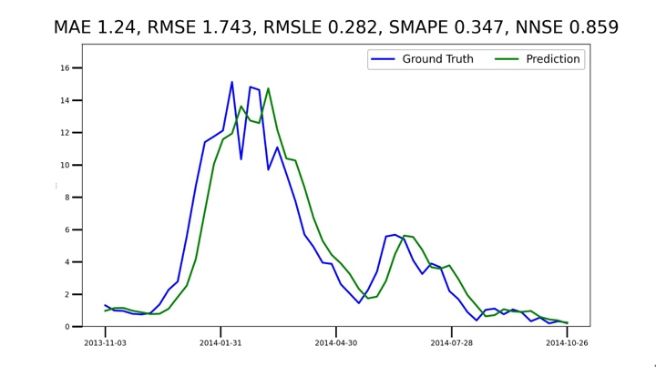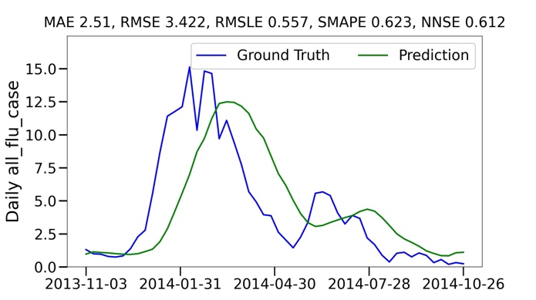
(a) forecast horizon h= two weeks (b) forecast horizon h= eight weeks
Figure 6.Visualizations and statistical metrics to compare predictions of flu cases with their ground truth using baseline models under different forecast horizons.

Random Forest
Random Forest is chosen because of its resilience to overfitting and its capability of obtaining non-linear relationship between input features and targets. We start from using a lookback horizon of 8 weeks and incorporating the school absenteeism data into the feature space. Figure 7 shows that Random Forest outperforms the baseline model by 27% in terms of MAE.
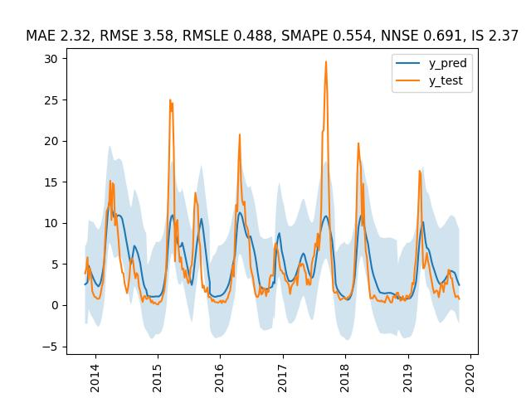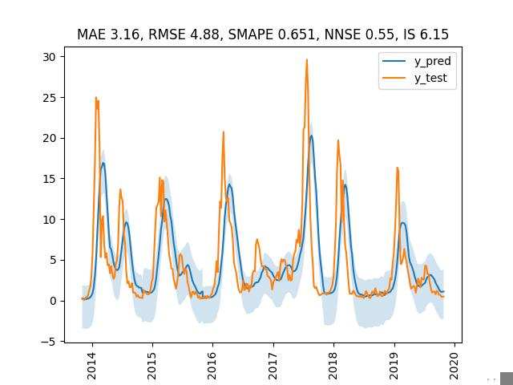
(a) (b)
Figure 7. Visualizations and statistical metrics to compare predictions of flu cases with their ground truth using Random Forest with a prediction horizon of 8 week. Orange line: ground truth, blue line: predictions, light blue shade: quantile predictions based on training residuals. (a) Random Forest, (b) Baseline Model.
Figure 8 is a visualization comparison between the baseline model and random forest model for the prediction of year 2013-2014 influenza disease cases. It shows that there is a smaller number of lags between the predicted values using random forest and the ground truth.
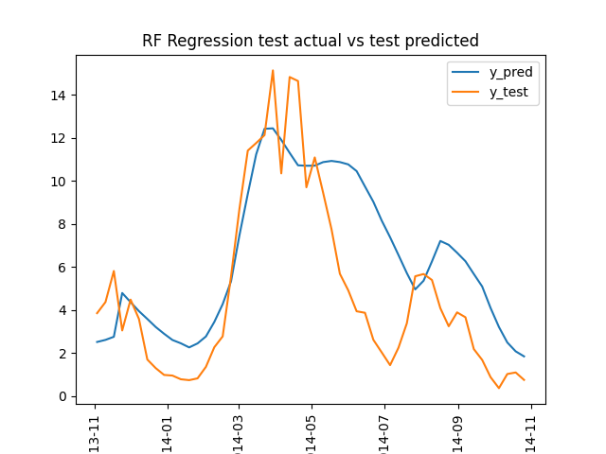
Figure 8. Visualizations and statistical metrics to compare predictions of flu cases with their ground truth using baseline model and Random Forest. The prediction horizons are all 8 weeks for both methods.

We can also conclude from Table 3 that random forest has superior prediction accuracy comparing with other methods including the baseline model both across all years between 2013 and 2018 and in any particular year even when the forecast horizon is 8 weeks.
We have also calculated the impurity-based feature importance (Figure 9) using the same model configuration with lookback period of 8 weeks. Several observations can be drawn from Figure 9:
- The importance of school absenteeism data ranks 11th out of 25 variables on average
- The importance of lagged target variable is significantly greater than that of the absenteeism data
- The importance peaked at a lag of 8 weeks for both the lagged target variable and absenteeism data
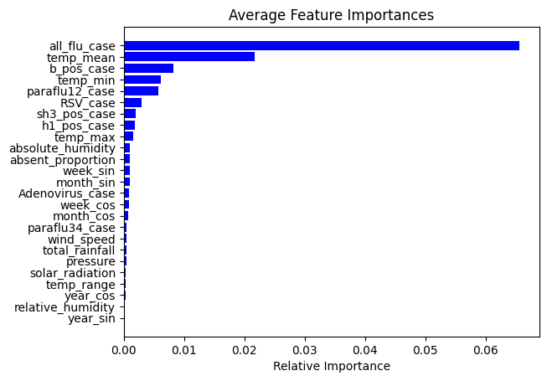
(a)
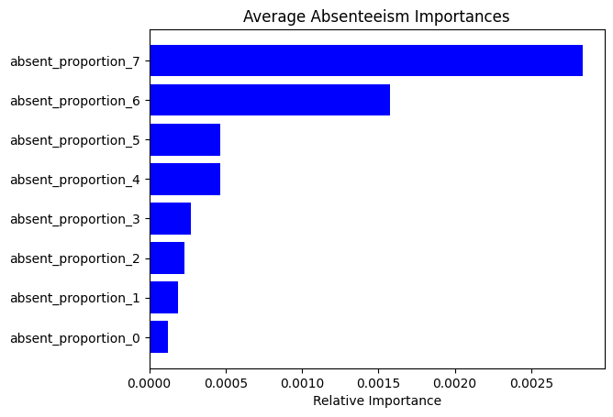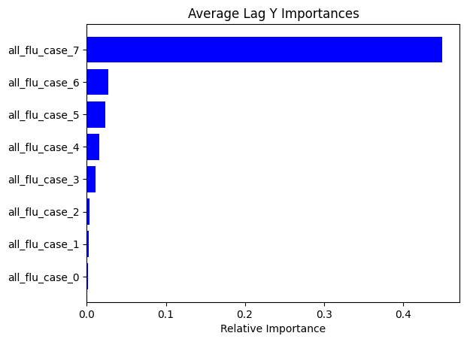
(b) (c)
Figure 9. Impurity-based feature importance of (a) all features, (b)school absenteeism data, and(c) lagged target variables (all influenza cases) when lookback horizon is 8 weeks.
Because of the above observations, we would like to conduct two further experiments: (1)predict the influenza activity without the absenteeism data and monitor its performance, and (2)expand the look-back horizon to 12 and 16 weeks to see whether the feature importance for both will still peak at 8th week.
Firstly, by expanding the look-back horizon to 12 and 16 weeks, Table 4 shows that the prediction performance with absenteeism data is marginally better than the prediction without absenteeism data across all lookback horizons vary from 8 weeks to 16 weeks.
Table 4. Compare accuracies with and without absenteeism data across various model configurations, including lookback horizon and pre-screening of features.
MAE | Lookback 8w | Lookback 12w | Lookback 16w | Lookback 16 w Prescreen
With absenteeism | 2.32 | 2.41 | 2.56 | 2.74
Without absenteeism | 2.34 | 2.43 | 2.58 | 2.77

Secondly, we compare the feature importance ranking of the school absenteeism data when the look-back windows are expanded to 12 and 16 weeks. Figure 10 shows that when the lookback horizon is 12 weeks, the feature importance ranking of the school absenteeism data decreases from 11th to 14th, and it further decreases to 16th when the lookback horizon is 16 weeks.
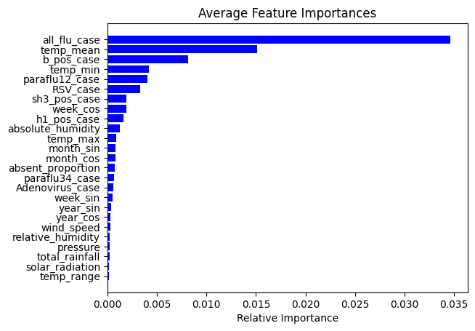
(a)
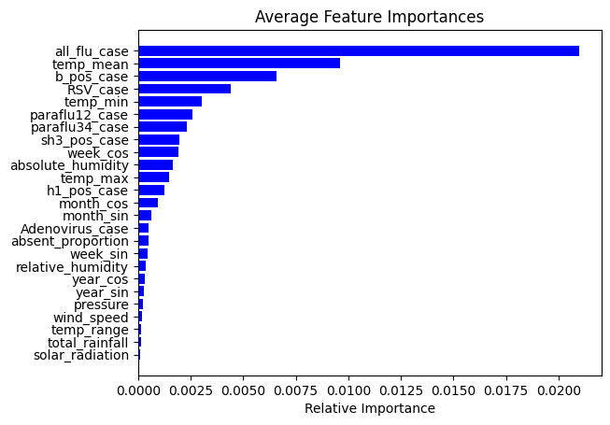
(b)
Figure 10.Impurity-based feature importance of all features when lookback horizon is (a)12 weeks, (b) 16 weeks.
Under the random forest model, if there is no pre-screening of features, from Figure 9,Figure 11, it seems like the longer the lagged school absenteeism data, the greater the feature importance according to impurity decrease.
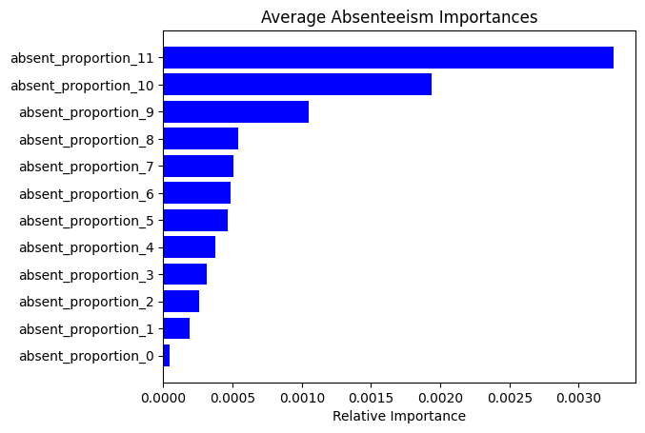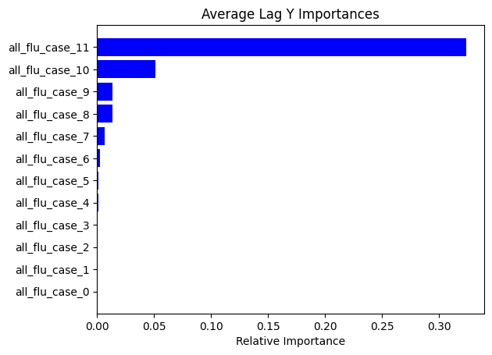
(a) (b)

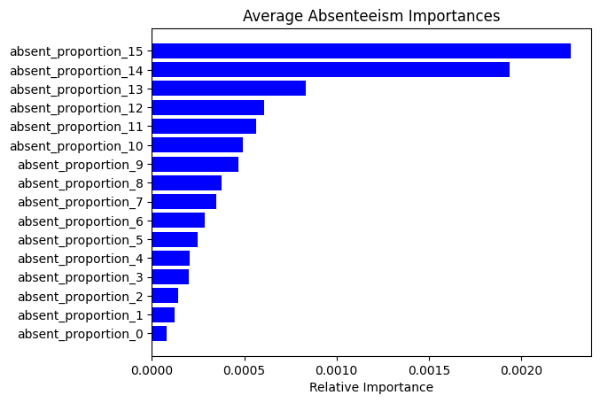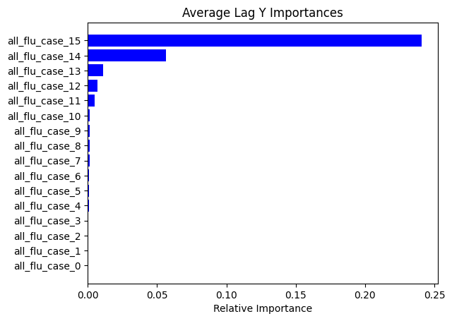
(c) (d)
Figure 11. The impurity-based feature importance of each lagged absenteeism variable and target variable. (a) feature importance for absenteeism variables with look-back horizon of 12 weeks, (b) feature importance for lagged target variables with look-back horizon of 12 weeks, (c) feature importance for absenteeism variables with look-back horizon of 16 weeks, (d) feature importance for lagged target variables with look-back horizon of 16 weeks
However, this is not the case when a pre-screening is applied before training the model. Besides the limitation of impurity-based feature importance calculation, including a bias toward high cardinality features and ignoring the data shift between the training and test data, another two potential contributing factors are overfitting and multi-collinearity when no pre-screening of the features is conducted. If pre-screening is applied, in general, the school absenteeism lagged at least 10 weeks have better feature importance than the remaining ones (See Figure 12).
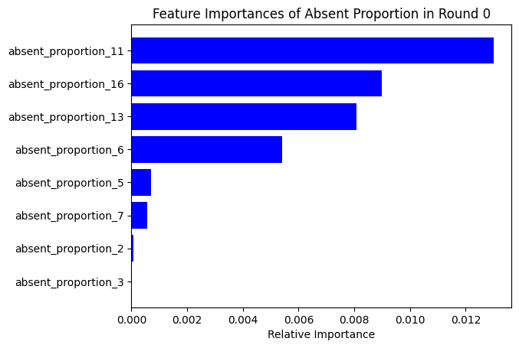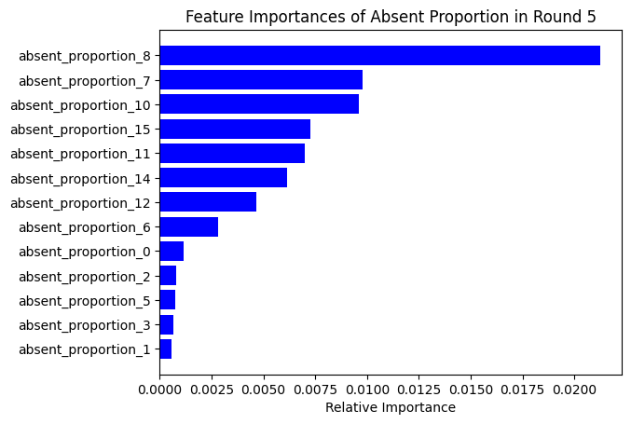
(a) (b)
Figure 12. The impurity-based feature importance of lagged absenteeism variables after pre-screening by Pearson Correlation with a lookback horizon of 16 weeks. (a) feature importance for absenteeism variables in years 2009-2013, (b) feature importance for absenteeism variables in years 2009-2018.

Although random forest is the framework that has achieved the best overall prediction performance according to Table 2. However, Figure 7 reveals that the point predictions for extreme levels of disease cases are all smaller than 15. There are two potential contributing factors:
- The importance of the lagged observations of the target variable (all_flu_case) is disproportionally larger than all other factors. Since random forest build trees by arbitrarily excluding variables at nodes, the trees with most nodes excluding this dominating feature will have seriously biased prediction for these disease cases with extreme levels. After averaging over all trees, the predictions for these extreme observations will converge to an average level.
- Random forest regression has difficulty extrapolating at levels outside the training data
To mitigate the disparity between the predicted values and ground truth for the extreme cases, the following treatments have been explored:
- Log Transformation
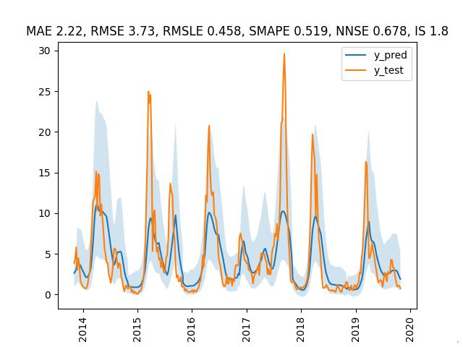
(a)No transformation (b)Log transformation
Figure 13. Visualizations and statistical metrics to compare predictions of flu cases with their ground truth using Random Forest with a prediction horizon of 8 week. Orange line: ground truth, blue line: predictions, light blue shade: quantile predictions based on training residuals. (a) No transformation, (b) Log transformation.
Figure 13 reveals that Log transformation is able to improve the overall prediction performance from 2.32 to 2.22 in terms of MAE. However, it fails to significantly improve the prediction for extreme level data points.
- Log-diff Transformation
Figure 14 reveals that Log-diff transformation is able to relax the predictions at the extreme level datapoints to a broader range. However, since it introduces a larger variance to the target variables, the overall prediction performance significantly deteriorated.
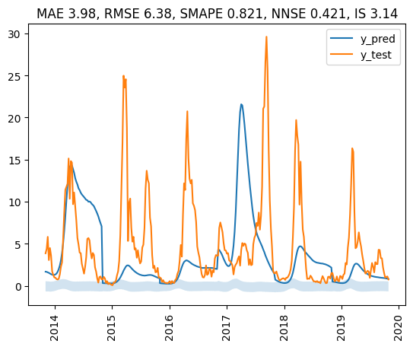
(a)No transformation (b)Log-diff transformation
Figure 14. Visualizations and statistical metrics to compare predictions of flu cases with their ground truth using Random Forest with a prediction horizon of 8 week. Orange line: ground truth, blue line: predictions, light blue shade: quantile predictions based on training residuals. (a) No transformation, (b) Log-diff transformation.

GRU and LSTM
When using a look-back horizon of 8 weeks, LSTM was able to outperform the baseline model by around 20% (see Table 2) and is the 2nd best framework in terms of the overall MAE. Compared with Random Forest, LSTM is better at capturing the extreme levels of the target variable, which is more obvious when the loo-back horizon is shorter, say 2 weeks. Under this scenario, LSTM achieves the best MAE of 1.56, surpassing that of the random forest at an MAE of 1.62 (see Figure 15).
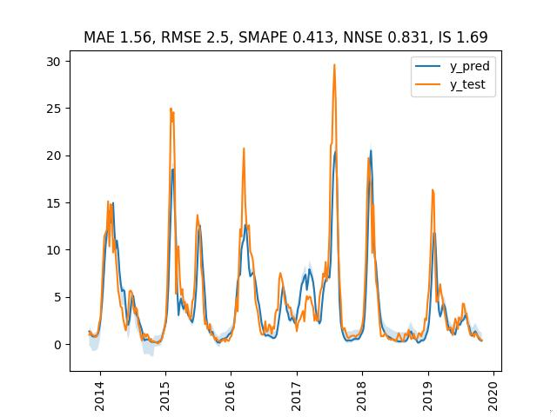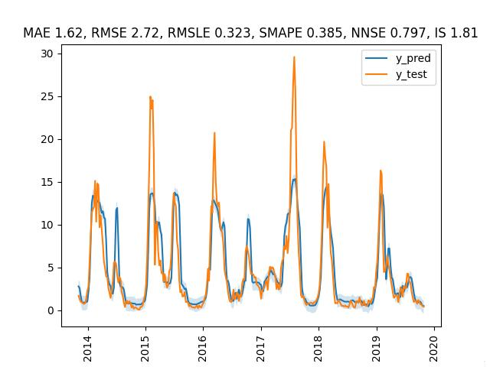
Figure 15. Visualizations and statistical metrics to compare predictions of flu cases with their ground truth using LSTM Random Forest with a prediction horizon of 2 week. Orange line: ground truth, blue line: predictions, light blue shade: quantile predictions based on training residuals. (a) LSTM, (b) Random Forest.
Firstly, we are evaluating the impact of the school absenteeism data on prediction accuracy under the LSTM framework using various look-back horizons. Table 5 shows that the prediction accuracy when including the school absenteeism data in the feature space is in general better than the opposite scenario. Only when the lookback horizons are either 8 weeks or 16 weeks, there is almost no difference in the prediction accuracy between the two scenarios.

Table 5. Compare accuracies with and without absenteeism data across various model configurations, including lookback horizon and extra dense layer before the final layer.
MAE | Lookback 8 | Lookback 16 | Lookback 52 | Lookback 8 with extra dense layer | Lookback 16 with extra dense layer | Lookback 52 with extra dense layer
With absenteeism | 2.94 | 3.37 | 2.71 | 2.85 | 2.92 | 2.75
Without absenteeism | 2.93 | 3.36 | 2.83 | 2.87 | 3.07 | 2.86

Secondly, the permutation-based feature importance is calculated as the added MAE when randomly shuffle the data along the dimension of a specific feature. Figure 16 shows that the importance of absent_proportion ranks 7th among all features when the lookback horizon is 8 weeks, and it deceases to 14th when the lookback horizon becomes 52 weeks.

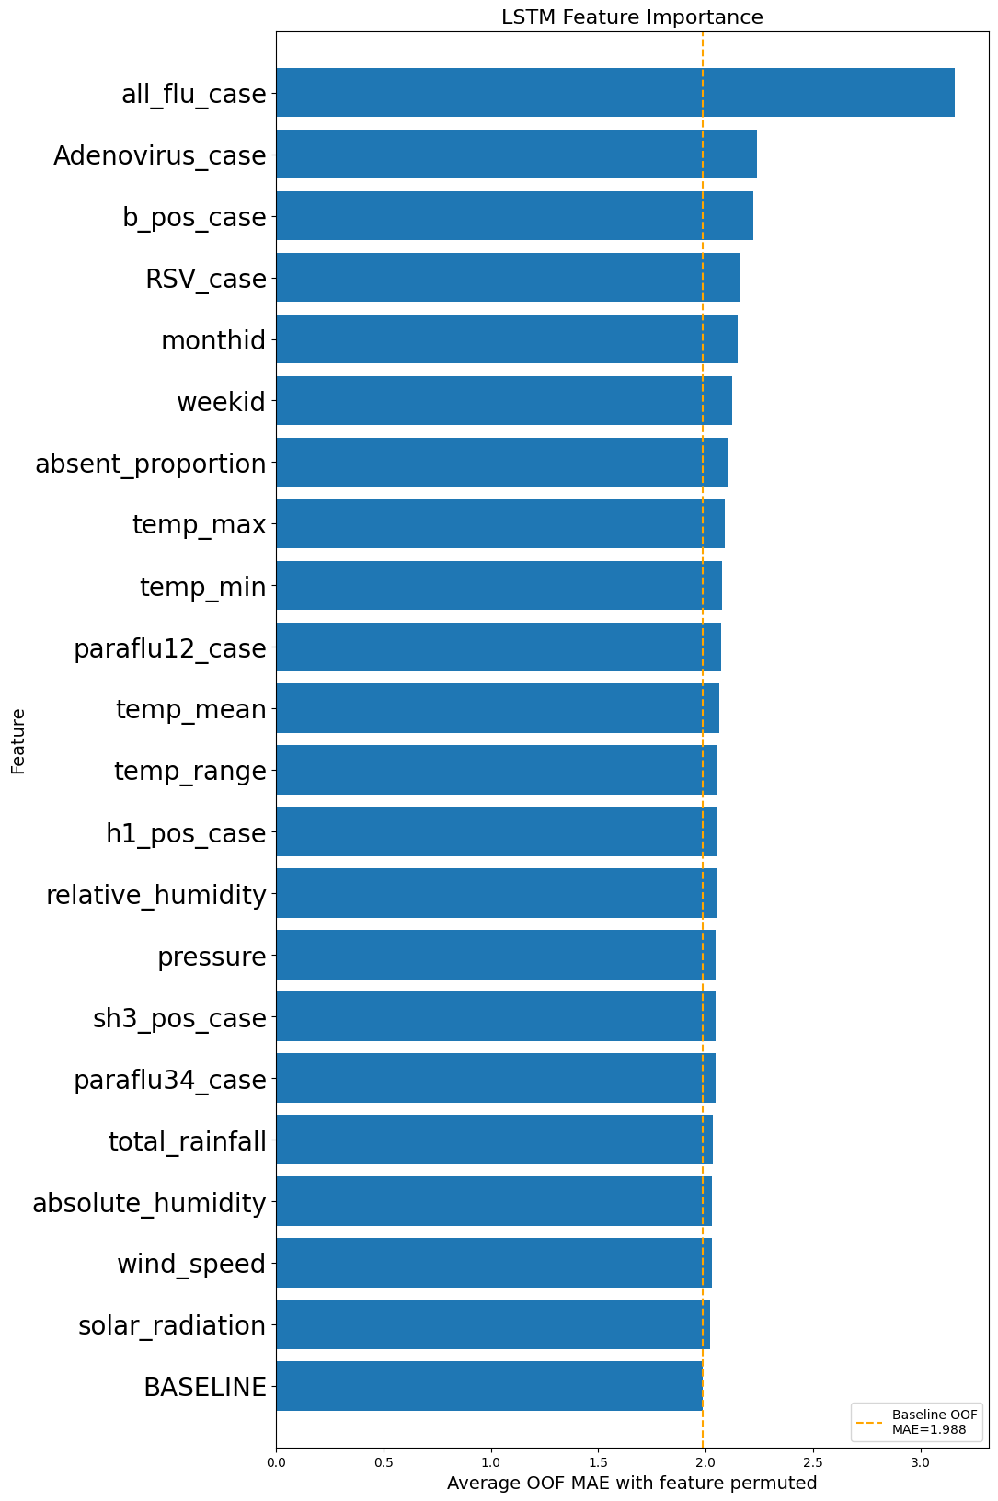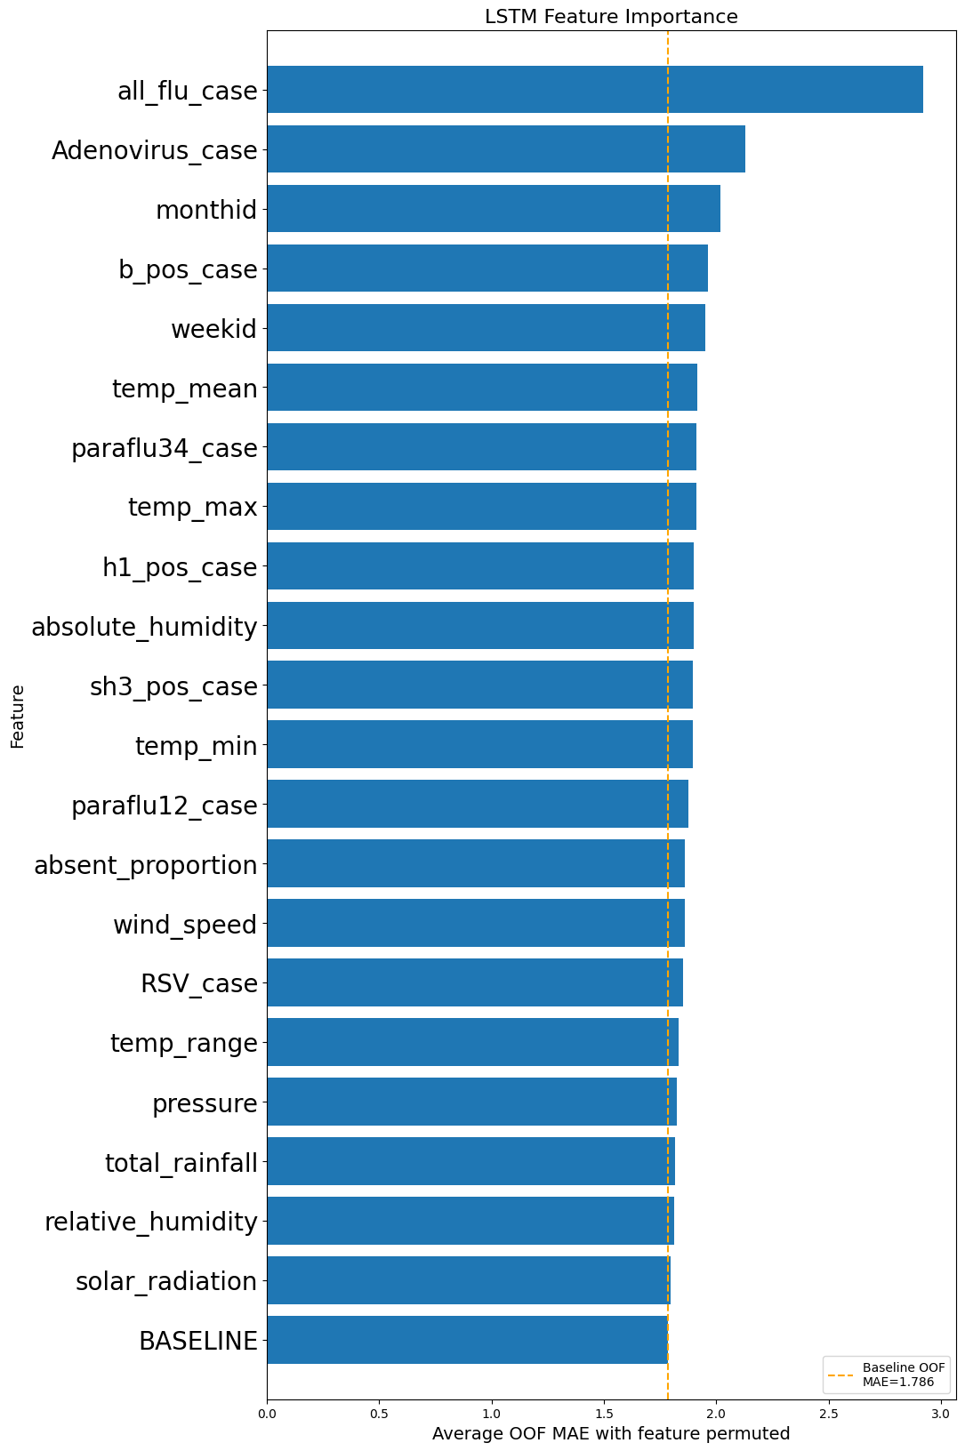
(a) Lookback 8w with extra dense layer (b) Lookback 52w with extra dense layer
Figure 16. Feature importance of school absenteeism data through permutation importance. (a) with a look-back horizon of 8 weeks, (b) with a look-back horizon of 52 weeks.

Temporal Fusion Transformer (TFT)
Figure 17 shows that although random forest has better overall prediction accuracy than TFT in terms of MAE, TFT achieves better uncertainty measured interval score (TFT has an interval score of 1.18 while random forest’s interval score is 2.37). Table 2 also shows that the prediction accuracy when including the school absenteeism data in the feature space is better than the opposite scenario by 16%. The feature significance of school absenteeism data ranked 2nd to last both as an encoder variable and a decoder variable (see Figure 18).

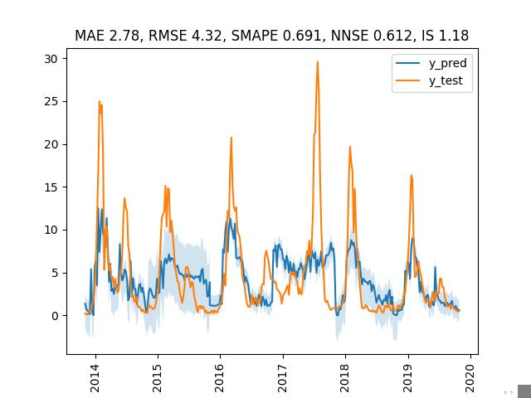
Figure 17. Visualizations and statistical metrics to compare predictions of flu cases with their ground truth using TFT and Random Forest with a prediction horizon of 8 week. Orange line: ground truth, blue line: predictions, light blue shade: quantile predictions based on training residuals. (a) TFT, (b) Random Forest.

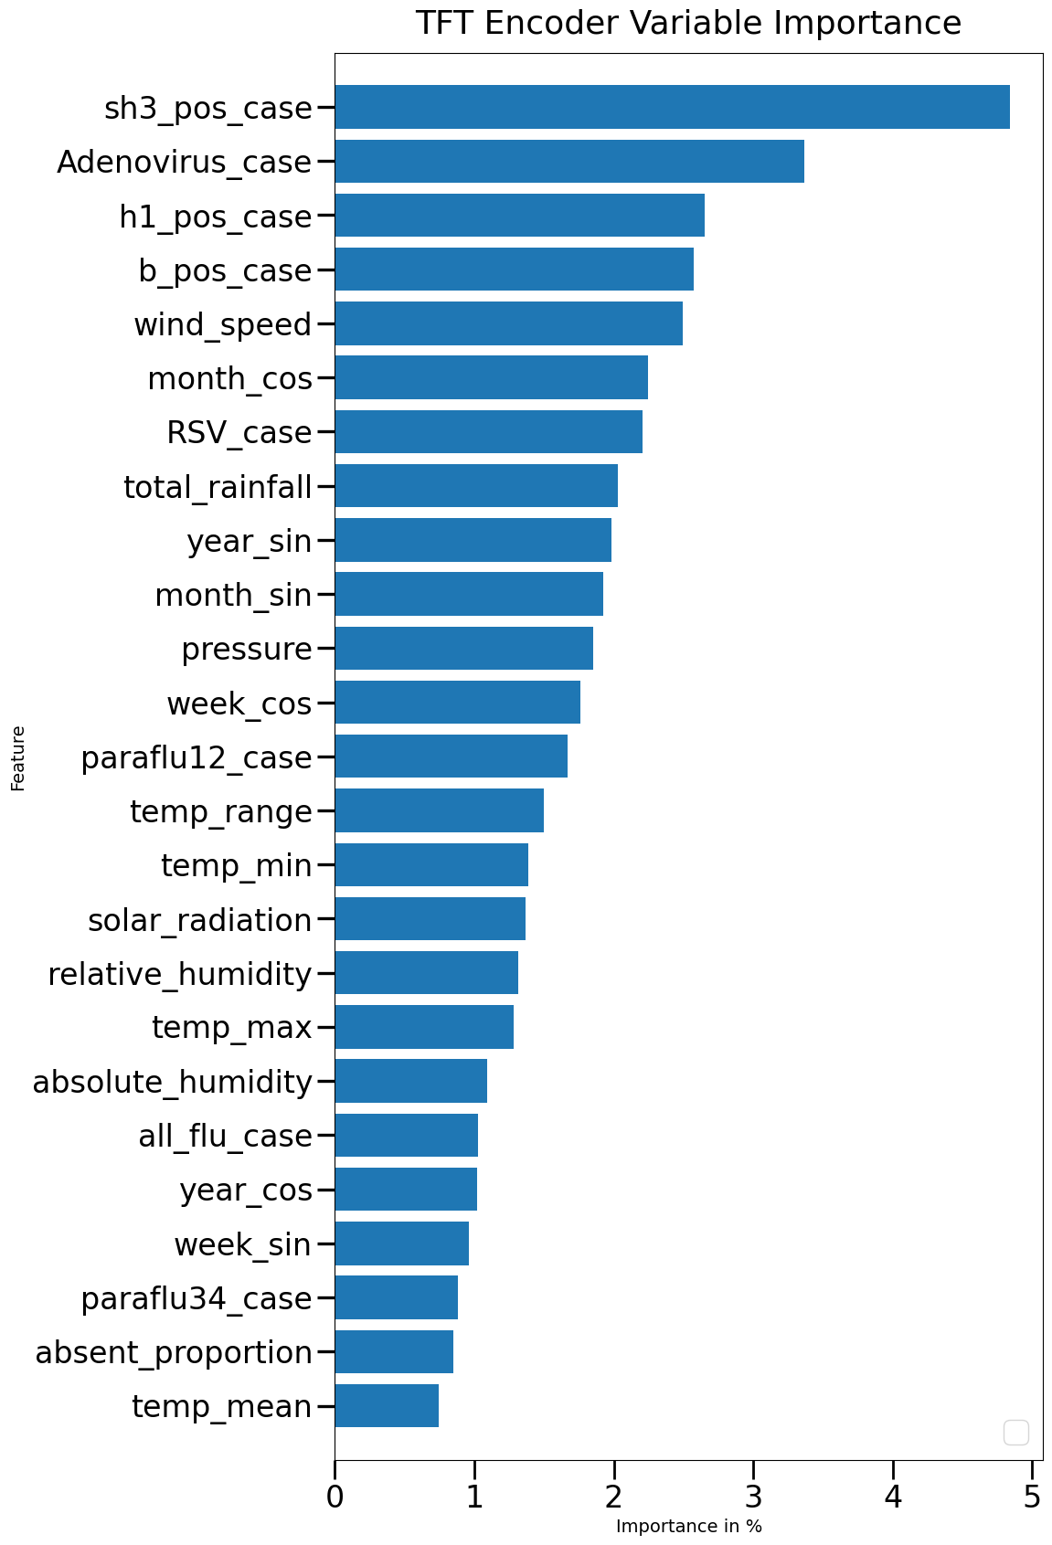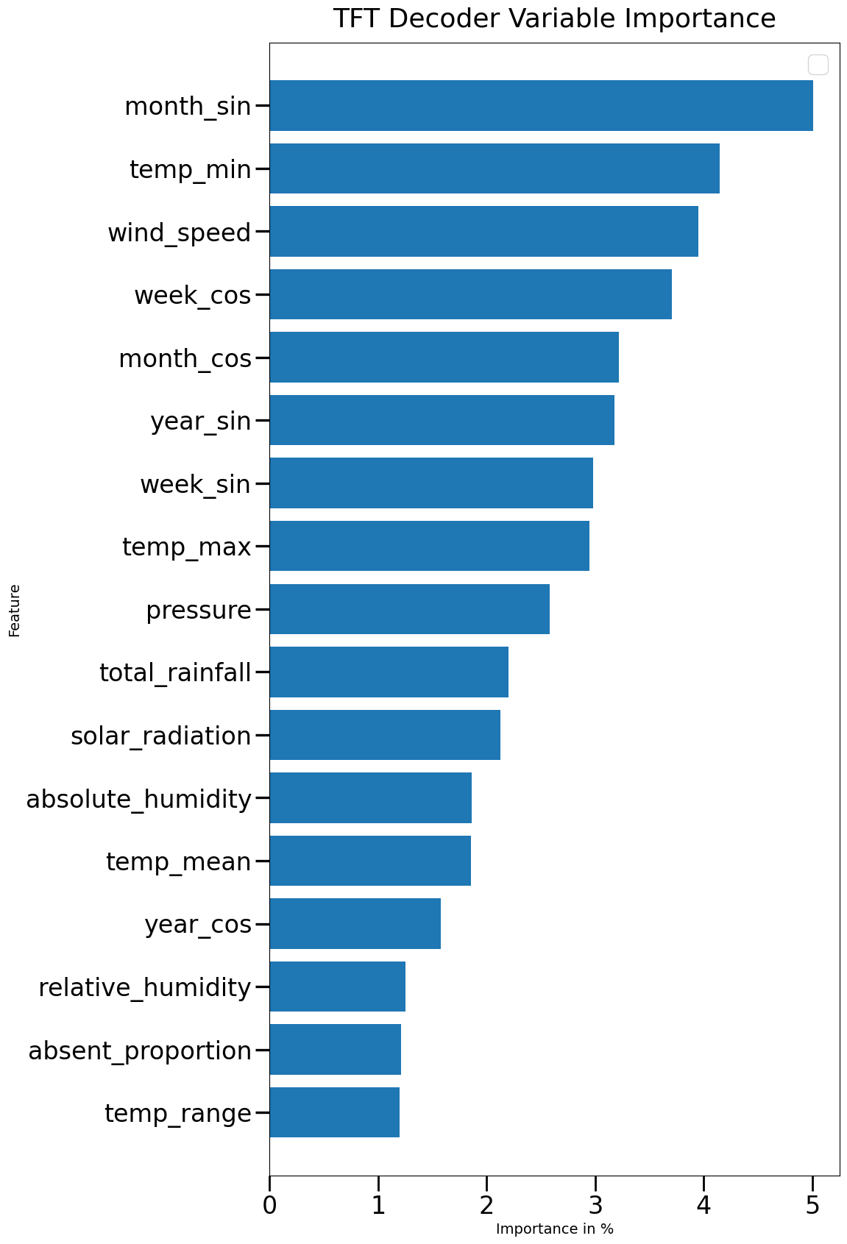
(a)Feature importance of encoder variables (b)Feature importance of decoder variables
Figure 18. Feature importance of both encoder and decoder variables when the look-back horizon is 8 weeks.

More comparison under different forecast horizons
Figure 19 illustrate the predictions of influenza cases under different forecast horizons when the lookback horizon is 8 weeks. We can see the LSTM framework is better at capturing the extreme data points patterns.
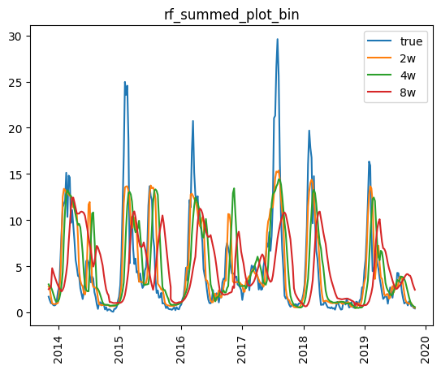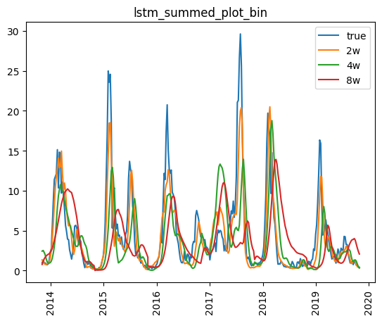
(a) (b)
Figure 19. Influenza prevalence predictions from 2014 to 2019 under forecast horizons of 2 weeks, 4 weeks and 8 weeks. (a)using Random Forest framework, (b) using LSTM framework.

Conclusion
Including school absenteeism data can enhance accuracy in predicting influenza prevalence. Random Forest generally excels in forecasting disease cases with limited data availability. LSTM performs better than Random Forest with a two-week lookback horizon, especially in scenarios involving extreme data points. TFT shows promise with improved data availability but necessitates additional hyperparameter tuning. School absenteeism data holds higher feature importance with shorter lookback periods. In Random Forest models, school absenteeism data at longer lags exhibits greater feature importance. Determining the optimal lags for school absenteeism data in LSTM and TFT frameworks requires further exploration.

References
Egger, J. R., Hoen, A. G., Brownstein, J. S., Buckeridge, D. L., & Konty, K. J. (2012). Usefulness of School Absenteeism Data for Predicting Influenza Outbreaks, United States. Emerg. Infect. Dis., 18(8), 1375–1377. https://doi.org/10.3201/eid1808.111538
Lim, B., Arik, S. O., Loeff, N., & Pfister, T. (2019). Temporal Fusion Transformers for Interpretable Multi-horizon Time Series Forecasting. ArXiv. https://doi.org/10.48550/arXiv.1912.09363
Sasaki, A., Hoen, A. G., Ozonoff, A., Suzuki, H., Tanabe, N., Seki, N., Saito, R., & Brownstein, J. S. (2009). Evidence-based Tool for Triggering School Closures during Influenza Outbreaks, Japan. Emerg. Infect. Dis., 15(11), 1841. https://doi.org/10.3201/eid1511.090798

