Task and output correlations
Sample Correlation (when task correlation is 0.9)
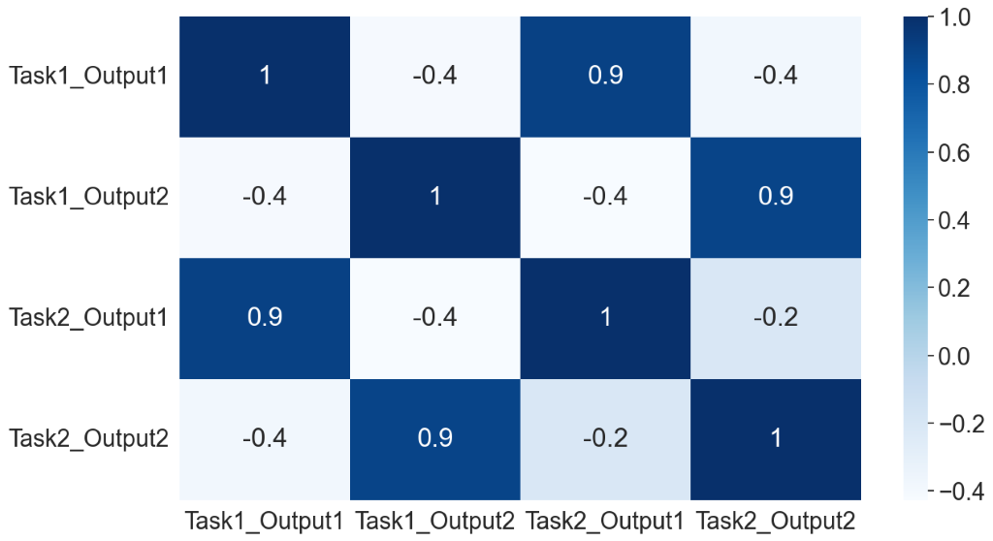

Optimized Correlation (when task correlation is 0.9)
