Lab Week 3: Exploratory Data Analysis – One, Two or More Batches
Objectives
Following completion of this topic, students should be able to:
a) identify different types of data;
b) allocate using a simple random sampling techniques;
c) describe data with appropriate choice of statistics for the centre (location) and spread;
d) identify and work appropriately with outliers and different distributions (shapes) of data sets;
e) produce and interpret graphs and summary statistics for univariate data (one variable);
f) produce and interpret graphs and summary statistics for comparing two and more batches of univariate data;
g) write in a meaningful way about a single quantitative variable; and
h) write about comparisons of batches of data in a meaningful way.
Data
From WebVista, Data,
- 131_HealthData.sav; Lab3Data.sav; Snowfall.sav; Chips.sav; Planes.sav
Lab Test Reminder
The lab test next week will be based on lab work similar to Labs in week 2 and 3.
Task 1: Tutor Led - Exploratory Data Analysis – Data Checking
In the context of checking data, write a meaningful paragraph about what the boxplot, stem-and-leaf plot, and summary statistics reveal about the variable cholesterol, before drug treatment? Use the internet to find out the two ways Cholesterol is measured.

Example 1: Cholesterol Data Before Drug Use (Data from file 131_HealthData)
Produced from Analyse, Descriptive Statistics, Explore, with options selected in plots
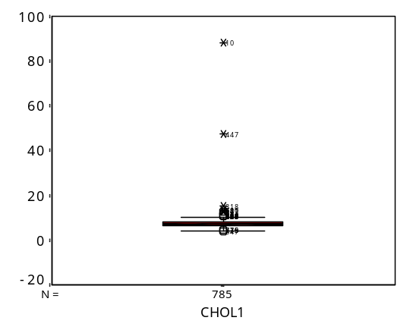 | Descriptives
   |  |  | Statistic | Std. Error
  CHOL1 | Mean |  | 7.5469 | .12361
   | 95% Confidence Interval for Mean | Lower Bound | 7.3043
   |  | Upper Bound | 7.7896
   | 5% Trimmed Mean |  | 7.3388
   | Median |  | 7.2000
   | Variance |  | 11.995
   | Std. Deviation |  | 3.46337
   | Minimum |  | 4.10
   | Maximum |  | 88.1
   | Range |  | 84.0
   | Interquartile Range |  | 1.5000
   | Skewness |  | 18.078 | .087
   | Kurtosis |  | 395.782 | .174
CHOL1 Stem-and-Leaf Plot
Frequency Stem & Leaf

4.00 Extremes (=<4.3)
.00 4 .
10.00 4 . 78&
17.00 5 . 2234&
39.00 5 . 666778899&
83.00 6 . 00001111122233334444
147.00 6 . 555555566666667777777888888888999999
158.00 7 . 000000000111111112222222233333333444444
99.00 7 . 555555566666777777888999
99.00 8 . 000001111222233333444444
57.00 8 . 55566667778899
18.00 9 . 0123&
20.00 9 . 5678&
13.00 10 . 002&
21.00 Extremes (>=10.4)

Stem width: 1.00
Each leaf: 4 case(s)
& denotes fractional leaves.
Meaningful paragraph:
This study is taken to examine cholesterol level before and after drug treatment. Cholesterol is a waxy substance that's found in the fats (lipids) in blood. While your body needs cholesterol to continue building healthy cells, but having high cholesterol can increase risk of heart disease. There are 785 samples taken for this study. We can see there are two extreme values of high cholesterol which is greater or equal to 10.4mg and four data which is less than or equal to 4.3mg. The center of the data modal stem is 7.0 to 7.5mg or mean of 7.55mg approximately. The median which is 50% of the data is found to be 7.2mg. The distribution of data reasonably normal or bell shaped in distribution with the spread measured by standard deviation of 3.5mg approximately and the Interquartile range which contain 50% of data found to be 1.5mg. No other patterns are evident in these data.
Example 2: Error Checking the variable State
Australia has six states each with postcodes, New South Wales (2000-2999), Victoria (3000-3999), Queensland (4000-4999), South Australia (5000-5999), Western Australia (6000-6999), Tasmania (7000-7499), and Territories ACT (2000-2999), Northern Territory(0800-0899). After each state and territory are the postcodes for each state. The following side-by-side boxplot for cholesterol by state was produced using 131_HealthData.sav. It is evident that there are problems with the “state” variable. To investigate further a frequency distribution has been produced on the variable state. (Note SPSS V12 might not produce this until some of the errors are fixed).
Graphs, Boxplots, Simple, Summaries for groups of cases, Define, Variable Chol1, Axes State
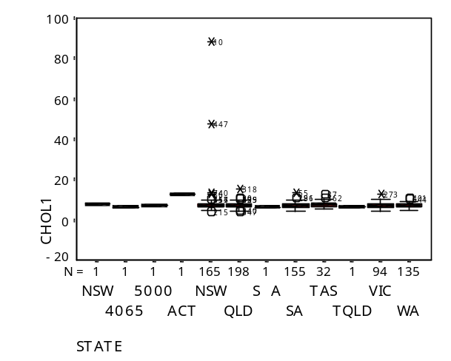
Analyse, descriptiove Statistics, Frequencies for the variable State provides the following frequencies and a warning

STATE
 |  | Frequency | Percent | Valid Percent | Cumulative Percent
Valid | NSW | 1 | .1 | .1 | .1
 | 4065 | 1 | .1 | .1 | .3
 | 5000 | 1 | .1 | .1 | .4
 | ACT | 1 | .1 | .1 | .5
 | NSW | 165 | 21.0 | 21.0 | 21.5
 | QLD | 198 | 25.2 | 25.2 | 46.8
 | S A | 1 | .1 | .1 | 46.9
 | SA | 155 | 19.7 | 19.7 | 66.6
 | TAS | 32 | 4.1 | 4.1 | 70.7
 | TQLD | 1 | .1 | .1 | 70.8
 | VIC | 94 | 12.0 | 12.0 | 82.8
 | WA | 135 | 17.2 | 17.2 | 100.0
 | Total | 785 | 100.0 | 100.0

Warnings
One or more values of variable STATE contained a non-printing character. Each such character was replaced by a space. The data file itself was not modified.

Ensure that you can produce this output.
Task 2: Locating Errors in Data
The boxplot, Task 2, revealed two extremely high values for cholesterol before drug treatment. When there are outliers in plots it is useful to check to see if there is an error. Errors may be due to:
- Mistake when Measuring. The data point is as recorded on the recording sheet. To know if this is possible do a web search to identify the known limits for cholesterol measurements. Cholesterol values in healthy adults range from , ……… to …………mmol/L.
- There appears to be an upper and lower limit to the values that cholesterol can take on eg nothing lower than 0.
- Recording mistake. The data point was measured correctly but the data entry is incorrect.
- Recording mistake. The data point was not recorded correctly but logic or additional information can be used to determine the correct entry eg the postcode can also reveal the state data were collected from.
Strategies for locating the outliers.
- Sort the data by the variable cholesterol and find the record number for the highest and/or lowest values (potential outliers, potential errors). Check the original records in E-Learning in the file called 131_HealthRecords.pdf. Note, not all outliers are errors, they cannot be discarded without good reason. Tip: if one value is wrong in a record check the variables for the entire record or until there are no more errors in the line of data.
- Select Data, Sort Cases by State, locate records, compare to original data records, and change where appropriate.
- There are also other approaches
- Locate any errors for the variables cholesterol and state.
- If errors are found, take appropriate action to fix the values
- Record the nature of any changes to the data.
Changes to the Assignment Data 131_HealthData_sav
Record Number(s) | Variable (s) | Change From | Change To
442 | state | 4065 | QLD
980 | state | 5000 | SA
1130 | state | TQLD | QLD
4306 | state | S A | SA
13 | chol1 | 88.1 | 8.1
2809 | chol1 | 47.4 | 7.4
2860 | chol1 | 5.7 | 7.5
13 | hdl1 | 10.9 | 0.9
Note. While this approach to checking data locates some errors it does not locate errors which produce feasible values for a variable.
Check the record and data entry for record 2860. Find the error and fix it. Record any change and the reason for making it in the above table.

Save the corrected data in a new file
Task 3: Exploratory Data Analysis – After Data Checking
Produce a boxplot, histogram, stem-and-leaf plot and summary statistics. Write a meaningful paragraph about the variable cholesterol, considering: the shape of the distribution, outliers, centre, spread, and any other things of interest.
Example 1 Cholesterol Data Before Drug Use
(Data, -Learning file 131_HealthData.sav) Output using corrected data
Box Plot  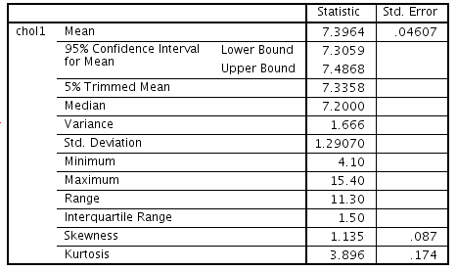  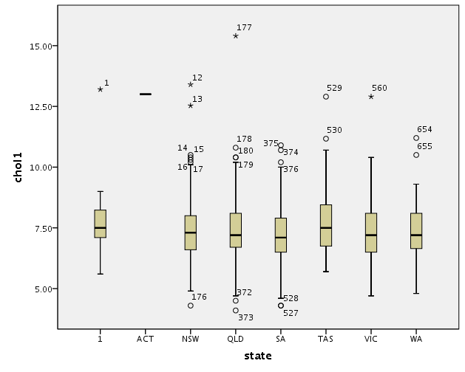 | Stem-and-Leaf
Descriptive Statistics (Try Analyse, Descriptives Explore and Descriptives options)
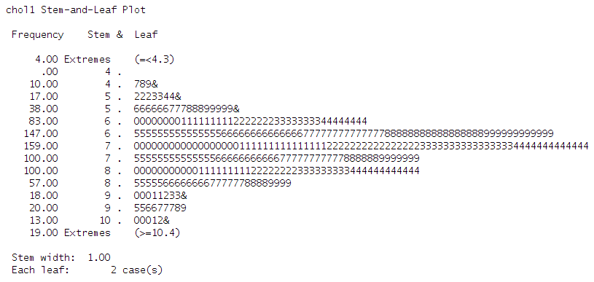
Meaningful Paragraph
This study is taken to examine cholesterol level before and after drug treatment. Cholesterol is a waxy substance that's found in the fats (lipids) in blood. While your body needs cholesterol to continue building healthy cells, but having high cholesterol can increase risk of heart disease. There are 785 samples taken for this study. We can see there are two extreme values of high cholesterol which is greater or equal to 10.4mg and four data which is less than or equal to 4.3mg. The center of the data modal stem is 7.0 to 7.5mg or mean of 7.4mg approximately. The median which is 50% of the data is found to be 7.2mg. The distribution of data reasonably normal or bell shaped in distribution with the spread measured by standard deviation of 1.29mg approximately and the Interquartile range which contain 50% of data found to be 1.5mg. No other patterns are evident in these data.
Task 4: Describing and Summarising Univariate Data
Based on the stem-&-leaf plot and boxplot provide a meaningful paragraph describing the variable plotted in terms of: (1) Shape, (2) Outliers, (3) Centre, (4) Spread and (5) Any other things of interest

Example Snowfall Data
Produced from Analyse, Descriptive, Explore, with options selected in plots and statistics
Data in file snowfall  Snowfall is measured in inches  SNOWFALL  Stem-and-Leaf Plot  Frequency Stem & Leaf  5.00 0 . 02224  5.00 0 . 77889  2.00 1 . 12  2.00 1 . 78  1.00 2 . 1  1.00 Extremes (>=34)  Stem width: 10.00  Each leaf: 1 case(s) | 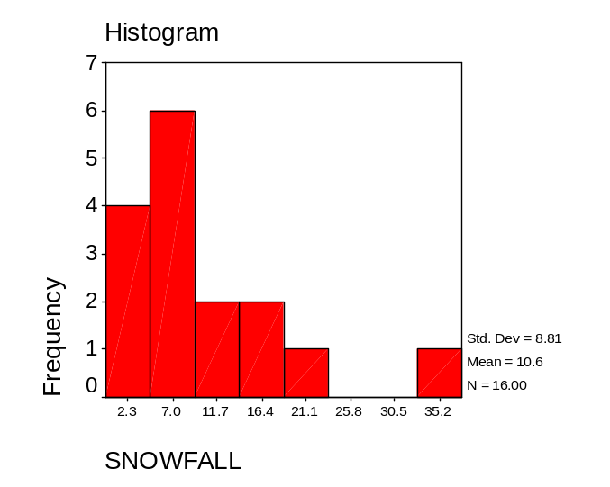
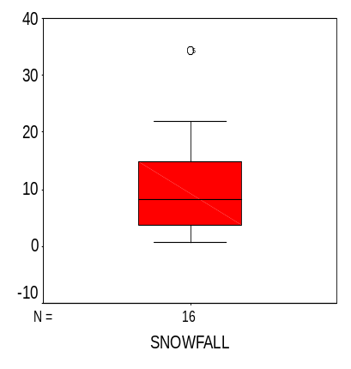 | Meaningful paragraph  There are 16 samples taken for this snowfall study. We can see that there is one extreme value, which is greater than 34inches. The center of data model stem is 0 to 10inches or mean 10.6inches approximately. The median which is 50% of the data can be found to be 7inches approximately. The distribution of the data is slightly positive with the spread measurement by standard deviation 8.81inches approximately. There is no other patterns in this study.
Compare graphs identifying what each of the stem-and-leaf, boxplot and histogram best highlights.
Bloxplot = highlighted mininum, 25%of data, median, 75%of data, maximum and outliers.
Stem and Leaf = highlighted the the frequency of data
Histogram = highlighted standard deviation, mean and total samples, another way to show the data from stem and leaf.
Task 5: Producing and Commenting on Univariate Analyses
Using Lab3Data produce the stem-&-leaf plot, boxplot, histogram for finger length.
Provide a meaningful paragraph for the variables plotted providing comments on (1)context (2) Shape, (3) Outliers (4) Centre, (4) Spread and (6) Any other things of interest
Confirm your thinking in task 6..
Stem-and-Leaf  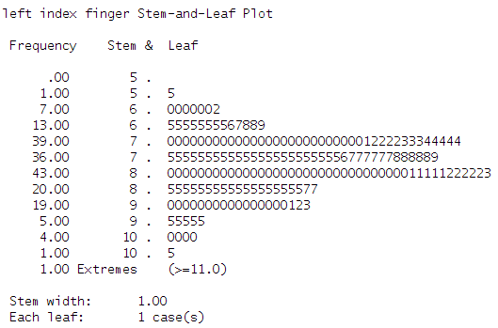 | Boxplot  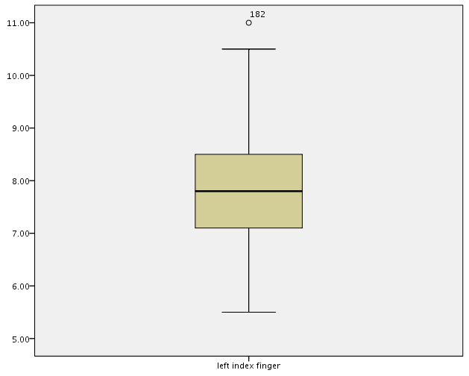
Histogram  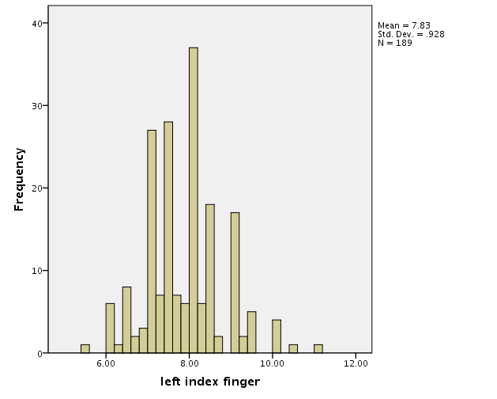 | Meaningful Paragraph  This study is to find out the length of human index finger, there is 189samples taken in this study. We can see that there is one extreme value, which is greater than 11cm. The centre of the data modal is 8.0 to 8.5cm or mean 7.03cm approximately. The median which is 50% of the data can be found to be 7.7cm approximately. The distribution of the data is slightly negative skewed with the spread spread measurement of standard deviation 9.28cm approximately. There is no other patterns in this study.
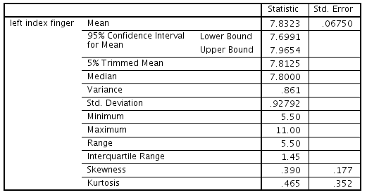
Descriptives Output

Task 6: Comparing Two Batches of Data
Using Lab3Data produce a back-to-back stem-&-leaf plot and side-by-side boxplots, comparing male and female finger length. The back-to-back stem-and-leaf plots needs to be drawn by hand or put in a table in your word processor, but you may take advantage of SPSS separate stem-and-leaf plots for males and females. Write a meaningful paragraph comparing finger length for males and females discussing: (1) Context (2) Shape (3) Outliers, (4) Centre, (5) Spread, (6) Minimum and maximum finger length, and (7) Any other things of interest
Stem-and-leaf plot Comparisons
FEMALE |  |  | MALE
Frequencies | Leaf | Stem | Leaf | Frequencies
1 | 5 | 5
6 | 000000 | 6 | 2 | 1
6 | 855555 | 6 | 5556789 | 7
12 | 421000000000 | 7 | 000000000000000002223334444 | 27
6 | 775555 | 7 | 555555555555555555567777888889 | 30
5 | 3000 | 8 | 00000000000000000000000000001111122222 | 38
 |  | 8 | 55555555555555555577 | 20
 |  | 9 | 0000000000000000123 | 19
 |  | 9 | 55555 | 5
 |  | 10 | 0000 | 4
2.00 Extremes (>=10.5)
Side-by-side boxplots  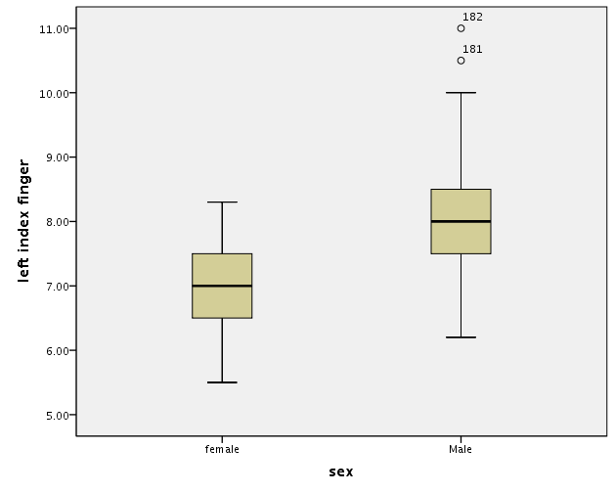 | Meaningful paragraph drawing comparisons  This study of the length of human index finger is conduct with 36females and 153males as samples. There is two extreme value for males, which is greater or equal to 10.5cm. For both males and females, the distribution of data reasonably normal or bell shaped in distribution. The centre of data modal which is 8.0 to 8.5cm for males and 7.0 to 7.5cm for females. The minimum for females is 5.5cm and for males is 6.0cm, the maximum for females is 8.0cm, but for males is 10.0cm. There is no other patterns in this study.
What advantage does one type of plot have over the other?
Boxplot look simple with required info, but Stem and Leaf show each sample result.
Task 7: Comparing more than two groups of data
a) Write a short report comparing the three distances flown by three paper planes as illustrated in the next figure.
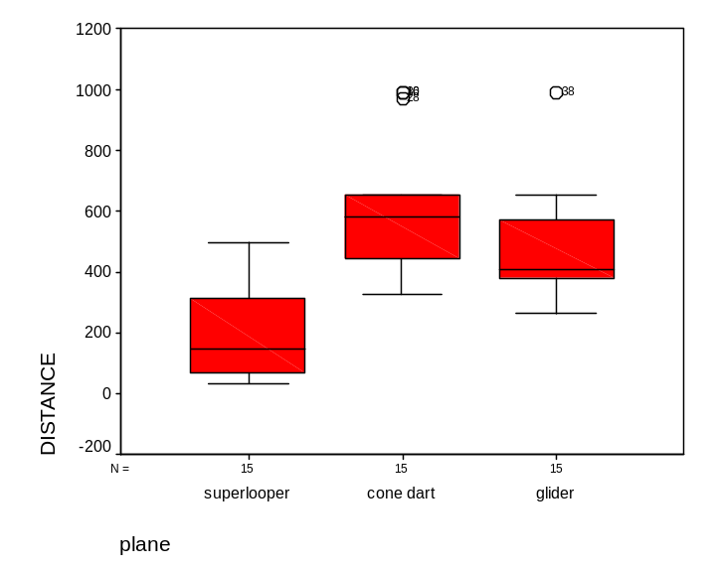
The boxplots show distances flown for three types of paper planes from file planes.sav. Confirm that you can produce this output.
Report:
This study three different named paper plane flying distance, each type of the paper plane is given 15times to fly. For Cone Dart, there is 3extreme high distance value and for Glider and there is 1 extreme high distance value, both is greater than or equal to 950cm. We can see that Superlooper flying distance is the shortest, Cone Dart and Glider is about the same. Both Superlooper and Glider is posite skewed, but Cone Dart is negative skewed. The median which is 50% of the data can be found to be approximately 170cm, 550cm and 400cm respectively. There is no other patterns in this study.
b) Why would a back to back stem-and-leaf plot NOT be suitable for comparing the plane distances flown by the three planes? What comparison is not very good when made with the side-by-side (one axis) boxplots. ANS: back to back stem is only suitable to compare two set of data, in this case, there is three set of data. Boxplot is not suitable to compare data if the y-axis range of data is differ too much, which make the comparison graph unreadable.

