Lab Week 5: Relationships between Quantitative Variables

Objectives
Following completion of this topic, students should be able to:
a) produce scatterplots for bivariate quantitative data (two quantitative variables);
b) use SPSS to produce correlations and line of best fit for two quantitative variables;
c) use the least squares regression equation to make predictions;
d) interpret and know the limitations of line of best fit (regression equation);
e) transform variables to make non-linear relationships linear
f) Write meaningful paragraphs describing the nature of relationships

Data
- Brain.sav, Cereals.sav, Chips.sav, Gestation1.sav,
- Lab3data, Ozone.sav, Snail.sav, Time.sav

Task 1: Interpreting Scatterplots
For each of the following scatterplots, indicate in terms of the variables plotted
1. Does the scatterplot show evidence of a relationship?
2. Why there is/is not evidence of non-linearity
3. The direction and approximate strength of the relationship
4. Any bivariate outliers
5. Any influential points
6. Any other patterns of interest
7. Confirm that you can produce the output
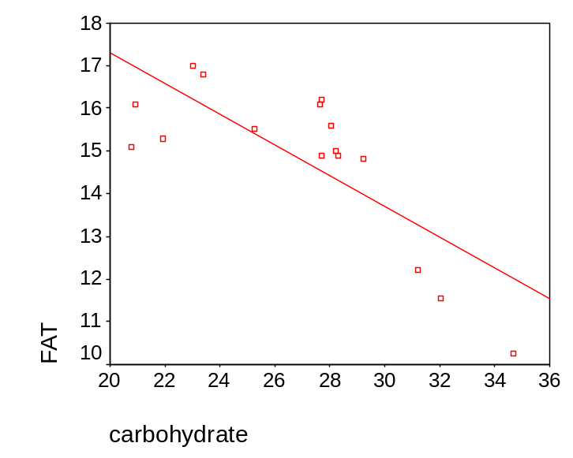 | 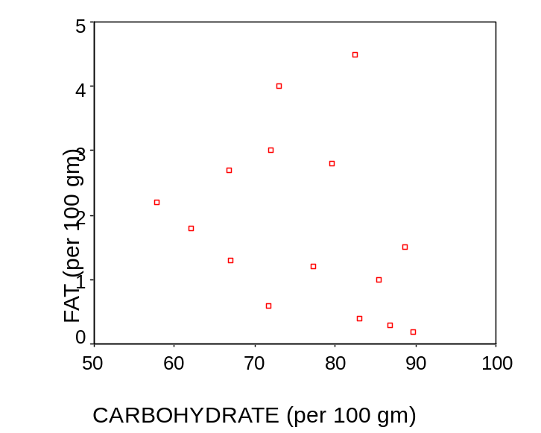
Plot of relationship between carbohydrate per 100 gm and fat per 100 grams of chips. Data in file chips.sav | Plot of relationship between carbohydrate per 100 gm and fat per 100 grams of cereal. Data in file cereals.sav.
1. Possible evidence of nonlinearity in the centre  2. Negative linear relationship, and approximate strength is 0.7.  3. As carbohydrate increases, fat decreases.  4. The point(35,10)could be outlier  5. No other patterns observed. | 1.Possible evidence of non-linearity.  2. Negative linear relationship, and approximate strength is 0.3.  3. As Carbohydrate increased. Fat decreases  4. The point(82,4.7) could be outlier  5.No other patterns observed.

Task 2: Reading Correlation Output
Using the following correlation outputs:
1. What is the value of the correlation co-efficient?
2. What does the correlation suggest about the nature of the relationship?
3. What proportion of the variation in the one variable can be explained in terms of the other?
4. How many (x,y) pairs of values were used?
5. Given the plot of the two variables (Task 2) how reasonable is this correlation as an estimate of the relationship between the variables? Justify your answer.
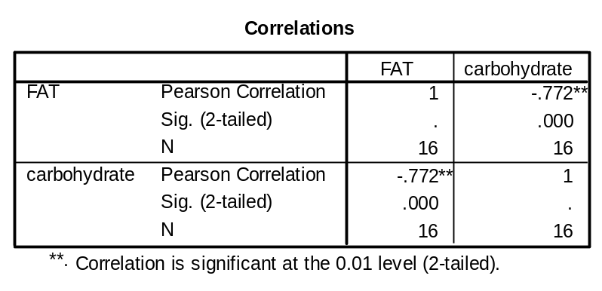Table: Correlation between carbohydrate and fat for chips. Data Chips.sav  1. r = 0.772  2.There’s fair negative correlation between Carbohydrate and Fat.  3. r²= (-0.772)² = 0.5959; 59.59% of variation in Fat can be explained by variation in Carbohydrate.  4. 16(x,y)pairs were used.  5.Given the scatter plot, it is reasonable to estimate the correlation coefficient value by looking into the direction and linearity of the straight line. | 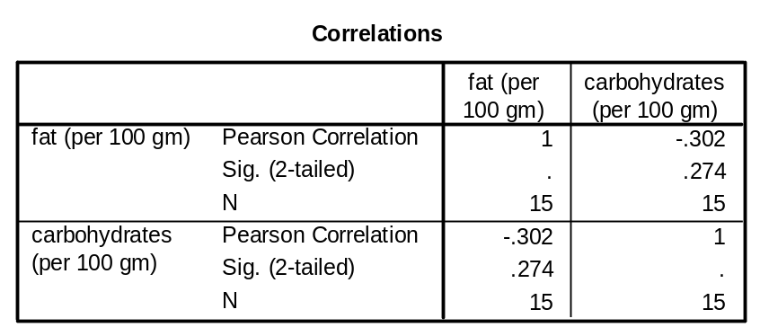  Table: Correlations between fat and carbohydrates. Data cereals.sav  1. r = 0.302  2. There is low negative correlation between Carbohydrate and Fat.  3. r²=(-0.302)²=0.0912; 9.12% of variation in Fat can be explained by variation in Carbohydrate.  4.15pairs were used.  5. Given the scatter plot, it is not reasonable to estimate the correlation coefficient value by looking into the direction and linearity of the straight line.

Task 3: Producing scatterplots and correlations
Using data Lab3Data.sav produce the scatterplots AND correlations for each pair of variables in Task 5 pre-assessment 1. Use the output to check your pre-assessment answers.
Scatterplot Height Measure 1 and Height Measure 2
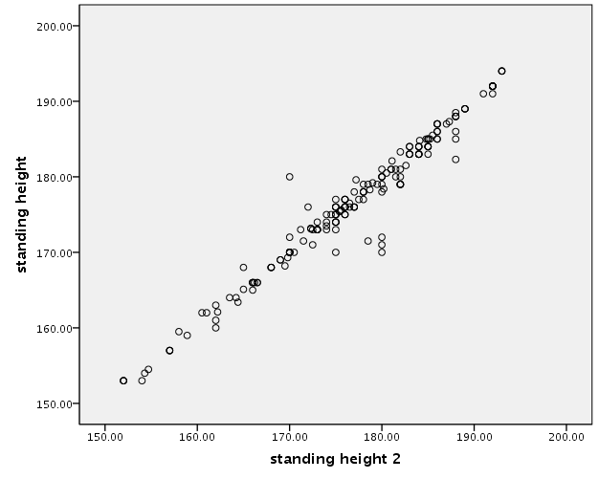
Scatterplot Left hand span with right hand span
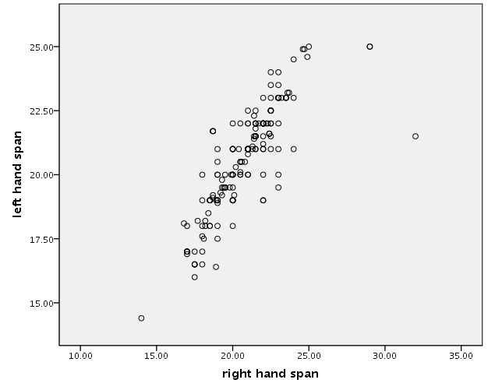
Scatterplot left Index finger length with left hand span
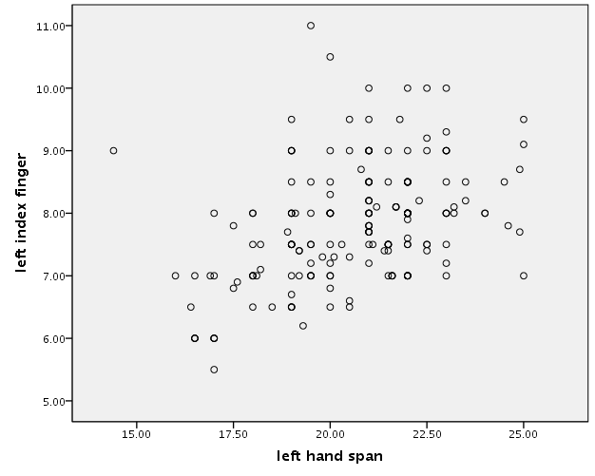

Task 4: Reading and Interpreting Regression Output
Example 1: Regression Output- Carbohydrate and Fat for Chips.sav
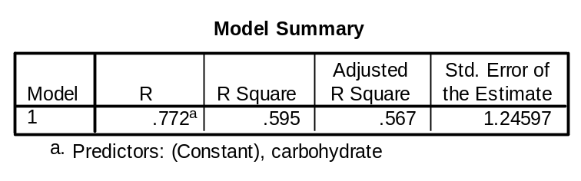
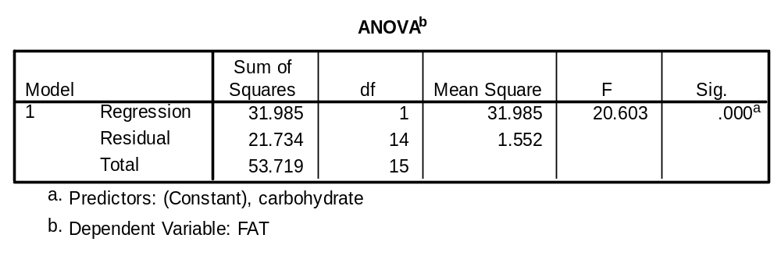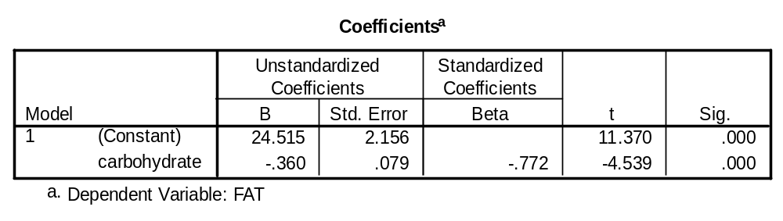
Circle and label the information you use to answer the following questions
1. The value of the correlation between the two variables.  Correlation coefficient, r = -0.772 | 2. The proportion of variation of the response(Y) that can be described in terms of the predictor(X).  Coefficient of determination explain the proportion of variation. r² = 0.595; 59.5% of variation in FAT can be explained by the variation in Carbohydrate.
3. The name of the response variable that is being predicted.  The response variable is FAT, also called as dependent variable | 4. The equation for the least squares regression line.  Y=24.515 - 0.360x
5. The value of the predicted variable when the explanatory variable is 10?  Y= 24.515 - 0.360(10)= 20.915  *not appropriate to predict | 6. The value of the predicted variable when the explanatory variable is 20?  Y= 24.515 - 0.360(20) = 17.315
7. Identify the corresponding scatterplot in Task 2. Use it to determine whether or not it is appropriate to predict the value of the response variable given each of the values of the explanatory variable in parts (5) and (6). | It not appropriate to predict FAT value when the Carbohydrate value given as 10, because it is outside the range of the data upon which the model was developed.
Example 2: Regression Output – Carbohydrate and Fat for Cereals.sav
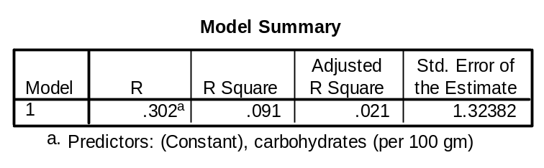
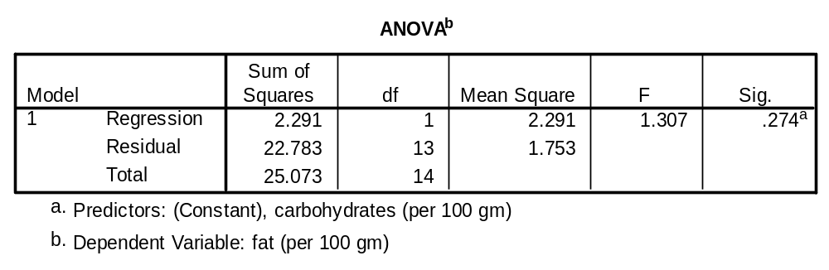
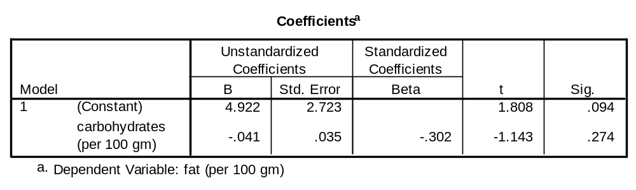

Circle and label the information you used from the output.to answer the following questions.
1. The value of the correlation between the two variables.  Correlation coefficient, r = -0.302 | 2. The proportion of variation of the response that can be described in terms of the predictor.  Coefficient of determination explain the proportion of variation. r²=(-0.302)²=0.0912; 9.12% of variation in Fat can be explained by variation in Carbohydrate.
3. The name of the response variable that is being predicted.  The response variable is FAT, also called as dependent variable | 4. The equation for the least squares regression line predicting fat.  Y=4.922-0.41x
5. The value of the predicted variable when the explanatory variable is 10?  Y=4.922-0.41(10)=0.822  *not appropriate to predict | 6. The value of the predicted variable when the explanatory variable is 20?  Y=4.922-0.41(20)=-3.278  *not appropriate to predict
7. Identify the corresponding scatterplot in Task 2. Use it to determine whether or not it is appropriate to predict the value of the response variable given each of the values of the explanatory variable in parts (5) and (6). | It not appropriate to predict FAT value when the Carbohydrate value given as 10 and 20, because it is outside the range of the data upon which the model was developed.

Task 5: Interpreting Regression Output
Using Lab3Data.sav produce the scatterplot and regression output using index finger length to predict left hand span, check and fix errors and produce final scatterplot.
Output
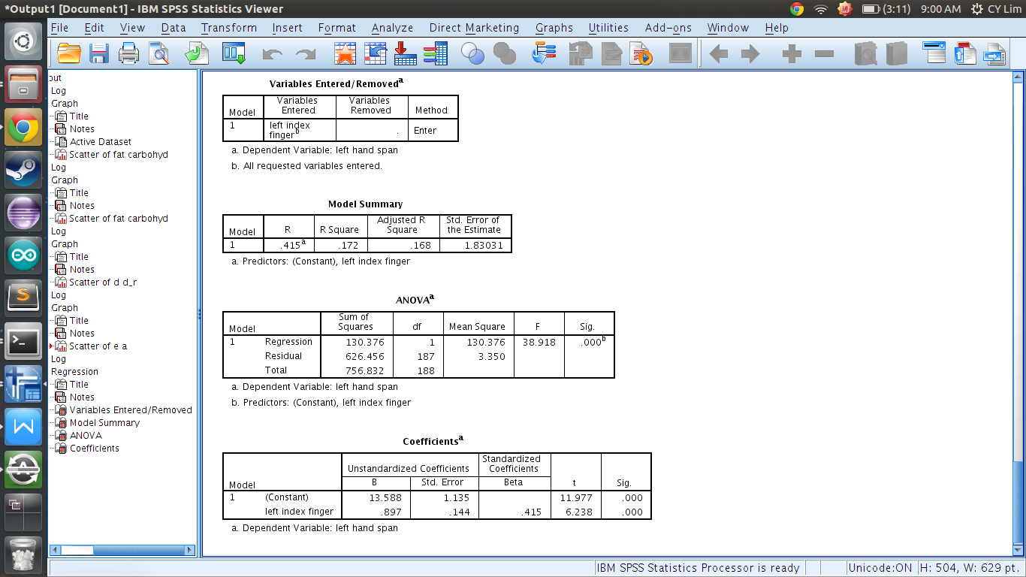
Use the output to identify:
1. the value of the correlation between the two variables  Correlation coefficient, r = 0.415 | 2. the proportion of variation of the response that can be described in terms of the predictor variable  Coefficient of determination explain the proportion of variation. r²=(-0.415)²=0.1722; 17.22% of variation in Fat can be explained by variation in Carbohydrate.
3. the least squares regression equation  Y=13.588-0.897(x) | 4. the value of the predicted hand span when the index finger length is 7cm?  Y=13.588-0.897(7)=7.309
5. the value of the predicted variable when the explanatory variable is 12cm?  Y=13.588-0.897(12)=2.824  *not appropriate to predict | 6. Is it appropriate to make the predictions in (4) and (5)  It not appropriate to predict hand span value when the index finger value given as 12cm, because it is outside the range of the data upon which the model was developed.

Task 6: Non linear relationships
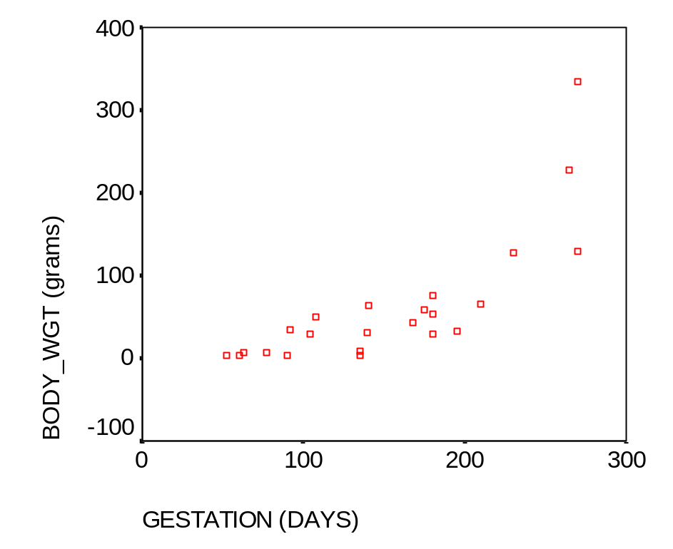  Data Source: Whitman p.50 | The scatterplot reveals a non linear relationship between gestation time and neonatal body weight.  There is a correlation, moderately high, of .779 between the two variables but it is likely to be an underestimate of the correlation as it is non linear.  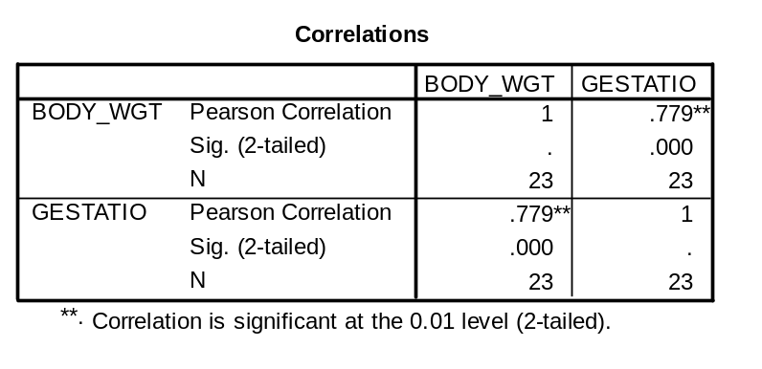ITo linearise the relationship, one or the other variables needs to be transformed. Looking at the scatterplot, identify and try various transformations to see if the relationship between the variables (or transformed variables) makes the relationship more linear. Then calculate the correlation between the transformed variable and the non transformed variable.
Produce a Scatterplot of the transformed Bodyweight by Gestation and Pearsons r. Comment on what you find.  Data set gestation.sav  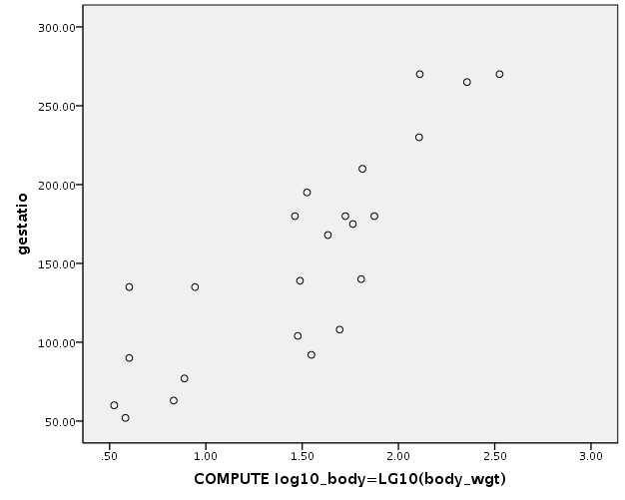  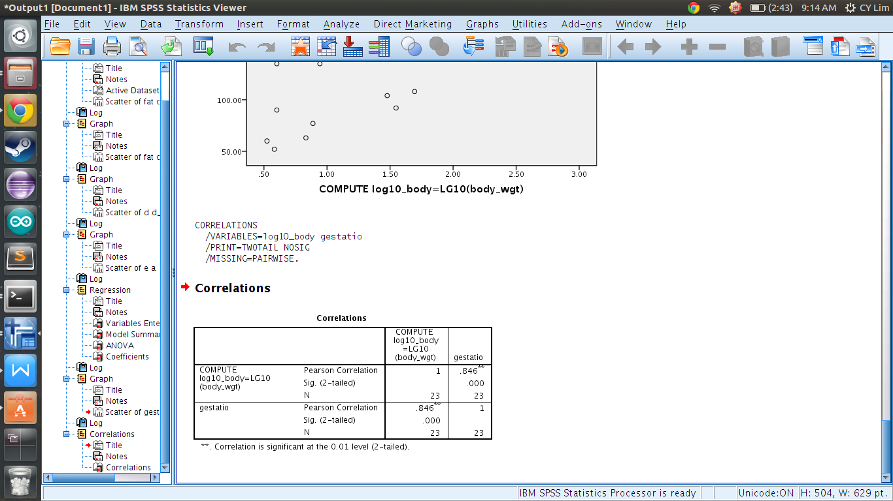  * comment in terms of linearity, person r, | Scatterplot of Bodyweight by transformed gestation and Pearson’s r. Comment on what you find.  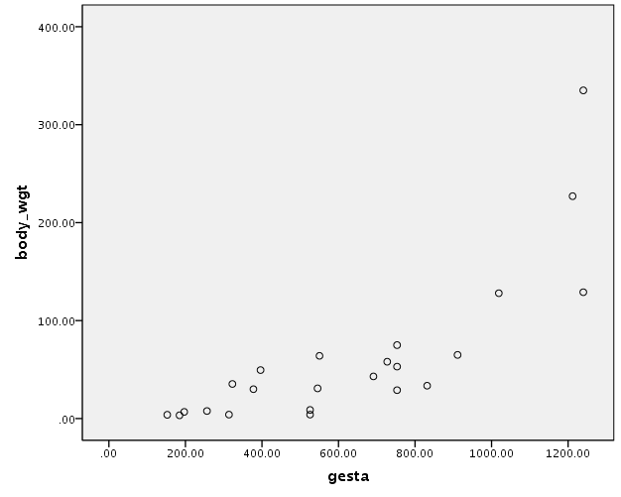  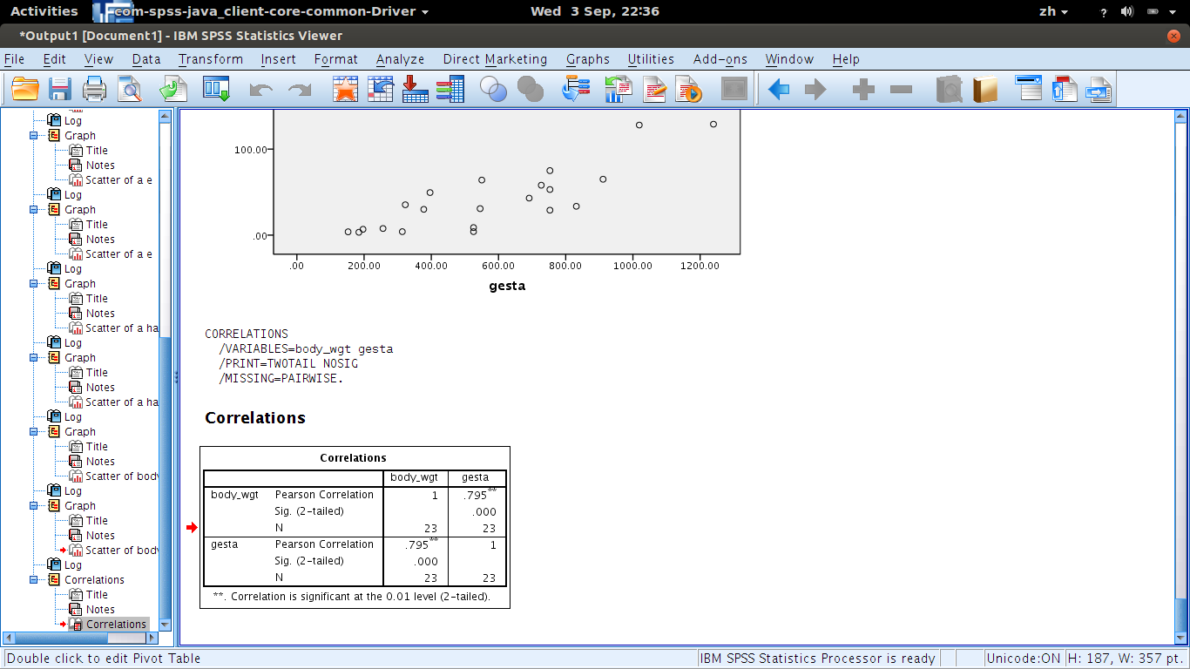
If you were to predict bodyweight which transformation would you prefer and why?
Transformation of Body Weight, it makes the scatter plot easier to view and more linear.

