Lab Week 7: Poisson Distribution Chi-Square & Independence
Time expected to complete lab 2- 4 hours Time Taken
Objectives
Following completion of this topic, students should be able to:
a) Calculate theoretical values of centre spread and probability for Poisson distributed random variables
b) Simulate and calibrate the Poisson model; and
c) Test Goodness of Fit for Poisson.
d) Use Pearson’s Chi-square test for association in contingency tables
Data
- Flaws.sav

Task 1: Poisson model, calibration, P(X=x) and GOF
A manufacturer wishes to establish his baseline production before implementing changes to his processes. Employees, cutting leather for shoes, are rotated every half hour so that fatigue does not set in, thereby increasing the risk of flaws. The data on flaws over 40 half hour periods has been collected and is in flaws.sav. The manufacturer considers the data to be Poisson distributed.
a) Using flaws produce appropriate descriptive statistics and graphical output to provide a report on flaws per half hour period.
Output:
*put picture
Report:
*write report

b) Use the output to estimate the rate of flaws per half hour correct to one decimal place.
E(X) =⋋t = 1.8250 = 1.8
c) Using the estimate of lambda, specify the formula then calculate the probabilities:
P(X=x)=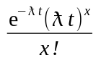
P(X=0)=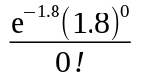= 0.1620
P(X=1)=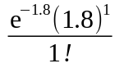=0.2949
P(X=2)=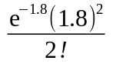=0.2683
P(X=3 or more)=1-[P(X=0)+P(X=1)+P(X=2)] = 1 – (0.1620+0.2949+0.2583)
= 0.2748
d) Use these probabilities to calculate the expected number of half hour periods which will have 0,…3 or more flaws.
Show working for when X=0
X (flaws) | 0 | 1 | 2 | 3 or more | Total
P(X=x) | 0.162 | 0.2949 | 0.2683 | 0.2748 | 1
Expected number of time periods | 6.48 | 11.796 | 10.732 | 10.992 | 40
Observed number of time periods | 8 | 9 | 12 | 11 | 40

e) Produce a bar chart and use it to comment on the fit of the model to the data given your estimated λ.
*bar chart
*Comment
f) Test the goodness of fit of the model to the data with the estimated parameter λ, using α=.05 specifying:
i. If and how cells needed to be further combined

ii. Null and alternative hypotheses

iii. Degrees of freedom
df = n-p-1 = 4-1-1 = 2
iv. Decision Rule

v. Specify formulae and calculate Chi-square

vi. State your conclusions

g) Given the estimate of λ, evaluate E(X)?

h) Given the estimate of λ, what should be the variance of the number of flaws per half hour?

i) Given the estimate of λ, what should be the standard deviation of the number of flaws per half hour?

Task 2: Reading contingency table output
Resources:
- Utts & Heckard Chapter 15 More about categorical variables
- SPSS Note 11 CRV –Normal
- Table 2 Standard Normal Tables

Tutor lead discussion
Students in STAT131 were asked to conduct a simple experiment. As they approached a person they were to make eye contact and either smile or not smile. They recorded the response. The following data were entered into SPSS and the data was weighted by the variable count. The data as entered were as follows:

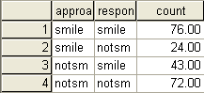

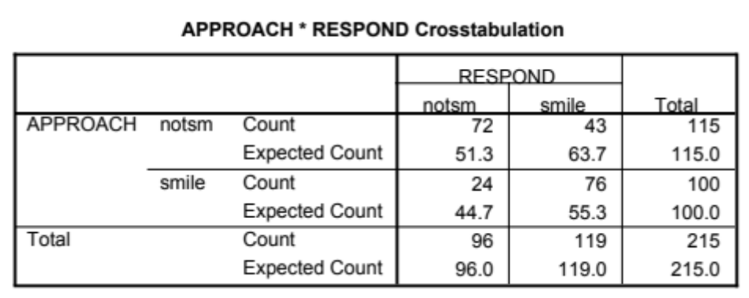
a) Demonstrate two methods of showing whether or not approach is independent of response?

b) If approach were independent of response what would the expected values for each cell?

c) The expected values are those we expect if the variables are independent when we have a population. Use the output below and indicate whether of not when we infer from the sample to the population if there is evidence of an association between approach and response.
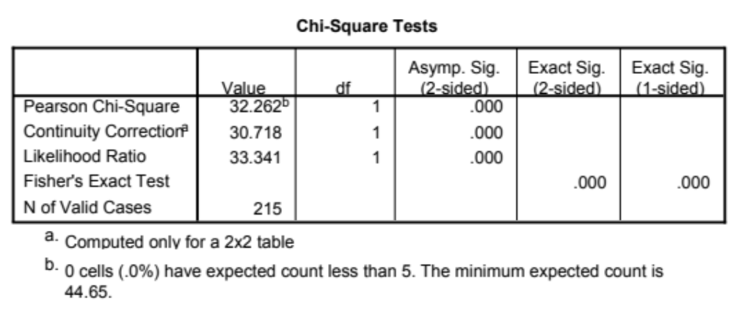
- Are the assumptions regarding cell size met for the Chi-square analysis?

Label the relevant parts of your output.

