**CS 530 Project(200 pts) Visualization of FA**

There are some tool available online to simulate FA online. For example, <https://favisualizer.vercel.app/>. To create a FA, users on such sides must enter regular expressions to create a FA. That is, given regular expression is basically converted into FA.

In this project, you will implement a construction of finite automata (FA) when its transition diagram is given. That is, your input is not a regular expression, instead it is the transition table of FA. Hence, you should be converting the table into a FA. Once the construction of the FA is done, then the user should be able give an input string, say **w**, of defined alphabet. Then, your FA should visualize simulation of **w** on the FA. That is, FA should read one character at a time from the string **w** and clearly display move from state to state in the FA. At the end, it should display whether string **w** is accepted or not.

**Example**: The following transition diagram is give on alphabet {0,1} with states {**a, b, c, d**} with start state **a** and final states F={**a, d**}.

|  |  |  |
| --- | --- | --- |
| $$δ$$ | 0 | 1 |
| a | {a, b} | {b, c} |
| b | c | d |
| c | a | b |
| d | {c, a} | {a, d} |

Once the above input is read from an input file, your code will construct the following FA.

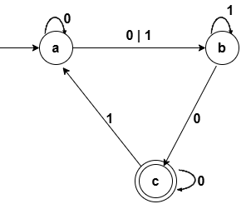

Once the FA is created, then user should enter a string w of 0’s and 1’s. For example, w=0001. FA can simulate w by reading one character at a time and show state move.

1. a—0—a—0—a—0—a—1—b
2. Not accepted but need to check if there is any other option for reading w
3. a—0—a—0—a—0—b—1--b
4. Not accepted
5. a—0—a—0—b—0—c—1—a
6. Not accepted
7. a—0—b—0—c—c—c—1—a

Not accepted because all possible transitions do not end in the final state. The input string w is rejected. One can see that w=00110 is accepted.

1. Draft-1(100 pts) **Due on March 28, 2025**, by 9:00 AM. In the first draft, reading input from a file and construction of FA should be completed.
2. Final project Due (100 pts) **Due on April 22, 2025**, by 9:00 AM