Sales Analytics Suite
Churn Prediction
Simple User Guide
Menu path: Predictive Analytics > Churn Prediction

1. Introduction
Churn Prediction helps you spot customers who might be about to stop buying from you — before they actually disappear. "Churn" simply means a customer walking away.
It works by comparing how much and how often a customer is buying right now against how much they usually bought in the past. If someone who used to order regularly suddenly goes quiet, this tool notices it early, so your team can reach out and try to win them back before it's too late.
Every customer ends up in one of three simple groups: Safe, At Risk, or New/Waiting (not enough history yet to judge). No technical knowledge is needed to read the results — just look at the status and the risk score next to each name.

2. Tools Used
Everything runs inside the Churn Prediction screen — no extra setup is required to get started. Behind the scenes, the system uses:
- Your customer records and their sale order history already stored in the system.
- A scoring method that compares each customer's recent activity to their own past average.
- A smart classifier that learns the pattern of "at risk" customers from your own historical data and applies it automatically.
- An explanation layer that highlights which factors (recent order gap, drop in spend, etc.) mattered most for each customer's score.
- A results table on screen showing each customer's status, with an option to download it as an Excel report.

3. Steps to Use
- Go to the Predictive Analytics menu and click on Churn Prediction.
- Choose how far back you want to look — by Month, Quarter, Half Year, or Year.
- Choose how many of those periods to compare (for example, the last 6 months).
- Click to run the analysis. A list of customers will appear.
- Each customer will show their last purchase date, total orders, total amount spent, and their status: Safe, At Risk, or Waiting.
- Look at the probability shown next to each customer — a higher "at risk" probability means stronger evidence they are slowing down.
- Focus your attention and follow-up calls on the customers marked At Risk first.
- Download the list as an Excel file if you want to share it with your sales or account management team.

4. Flowchart — How Churn Prediction Works
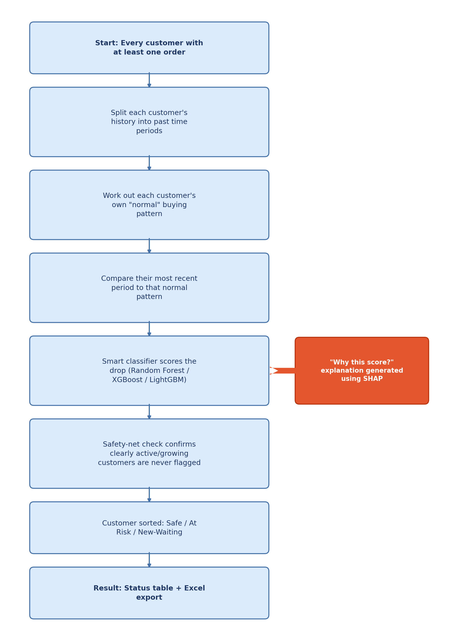

5. Method Used (In Simple Terms)
Here is what happens, step by step, once you run the analysis:
Step 1: Collecting each customer's history
The system looks at every customer who has placed at least one order, and splits their history into a series of past time periods — for example, the last several months, one after another.
Step 2: Working out what "normal" looks like
For each customer, it works out their usual buying pattern — how often they order and how much they usually spend — based on their own past periods. Nobody is compared to anyone else; every customer is judged against their own history.
Step 3: Comparing recent activity to normal
It then looks at the customer's most recent period and compares it to their own normal pattern. If their recent buying has dropped well below what's normal for them, that's a warning sign.
Step 4: Letting a smart classifier learn the pattern
Rather than relying on one fixed rule, the system trains a classifier on your own historical data — it automatically picks whichever pattern-learning method (out of a few well-known options) performs best on your business's data, then uses it to turn each customer's numbers into an "at risk" probability.
Step 5: Classifying the customer
Based on this comparison, each customer is placed into one of three groups:
Status | What it means
Safe | Still buying close to (or above) their usual pace — no action needed right now.
At Risk | Buying noticeably less than usual — a good candidate for a check-in call or a retention offer.
New / Waiting | Too new to judge yet — there isn't enough purchase history to compare against.
Step 6: Explaining the "why"
For every customer flagged, the system also works out which factors weighed most heavily on their score — for example, a longer-than-usual gap since their last order, or a drop in average spend — so your team knows what to mention on the follow-up call, not just that a call is needed.
Step 7: Double-checking with a smart safety net
Even after this comparison, the system double-checks itself: if a customer is clearly still active or growing, it will never be mistakenly marked At Risk, no matter what else the numbers suggest. This keeps the results trustworthy and avoids false alarms.

6. Packages Used
These are the main software building blocks working quietly behind the scenes for Churn Prediction:
Package | What it does (in plain terms)
scikit-learn | Prepares and standardizes each customer's numbers on a fair, comparable scale, splits the data into training and testing samples, and provides the Random Forest classifier — a well-known pattern-learning method used to score churn risk.
XGBoost / LightGBM | Two additional, more advanced pattern-learning methods the system can automatically choose between (alongside Random Forest) if they perform better on your specific business data.
SHAP | Powers the "why is this customer at risk" explanations — it works out which individual factors (recency, spend drop, order frequency) pushed a customer's score up or down.
Pandas & NumPy | The number-crunching toolkit. Organizes customer and order data into the past time periods used for comparison.
XlsxWriter | Builds the Excel file the moment you click Download, so results can be shared with your sales or account teams.

7. Good to Know
- A customer needs at least a little purchase history before they can be properly judged — brand-new customers are marked Waiting rather than guessed at.
- Looking back over a longer period (more months or quarters) usually gives a more reliable picture of what's "normal" for each customer.
- The system remembers recent results for a few hours, so reopening the dashboard shortly after running it will load instantly instead of recalculating from scratch.
- An administrator can fine-tune exactly which factors matter most (for example, order count vs. total amount spent) under the Algorithm Configuration settings, if your business wants a customized definition of "at risk".

8. Important — Please Read Before You Rely on This
⚠ A risk score is a probability-based estimate, not a certainty
- Churn Prediction learns from patterns in your own past data. It can be wrong in both directions: a loyal customer having a quiet month (a holiday, a temporary supply issue, being on vacation) may be flagged At Risk even though they plan to return, and a customer truly drifting away may occasionally still show as Safe.
- The fewer past periods a customer has, the less reliable their score will be — that's why very new customers are marked Waiting rather than scored outright.
- The model reflects patterns learned from your historical data; if your business, pricing, or typical customer behavior changes significantly over time, the model's judgement of "normal" may need to be recalibrated by an administrator.
- Treat every At Risk flag as a prompt for a personal check-in, not as proof the customer is leaving. Combine the score with your own knowledge of the relationship before deciding how (or whether) to act.

