Sales Analytics Suite
Demand Forecasting
Simple User Guide
Menu path: Predictive Analytics > Demand Forecasting

1. Introduction
Demand Forecasting helps you predict how many units of a specific product you're likely to sell in the near future. While Sales Forecasting looks at your overall revenue across the whole business, Demand Forecasting zooms in on one product at a time — so it always answers the question "how many of THIS item should I expect to sell?"
This is especially useful for planning stock: ordering enough of a popular product ahead of time, avoiding over-ordering something that isn't in demand, and freeing up cash and warehouse space that would otherwise sit in slow-moving inventory.
Just like Sales Forecasting, no technical knowledge is needed — you pick a product and a few simple options, and the system does the calculation for you.

2. Tools Used
Everything happens inside the Demand Forecasting screen — no extra setup is needed. Behind the scenes, the system uses:
- Your past sale order lines for the selected product — how many units were sold and when.
- A forecasting engine that studies that specific product's own ordering pattern over time (not your whole business at once).
- The product's historical average selling price, used to turn a quantity forecast into an estimated sales value.
- A chart and table on screen showing past and predicted quantities, with an option to download as Excel.

3. Steps to Use
- Go to the Predictive Analytics menu and click on Demand Forecasting.
- Select the product you want to forecast from the product list.
- Set the historical date range to look back on (for example, the last 3 months) — the period the system will learn from.
- Choose how far ahead to forecast, and whether to view it by Day, Month, or Year.
- Click to run the forecast. A chart will appear showing past order quantities followed by the predicted future quantities.
- Check the table below the chart for exact numbers — quantity, average price, and expected value for each period.
- Switch to a different product at any time to compare demand across your catalog.
- Download the results as an Excel file if you want to use them for stock planning or share them with your purchasing team.

4. Flowchart — How Demand Forecasting Works
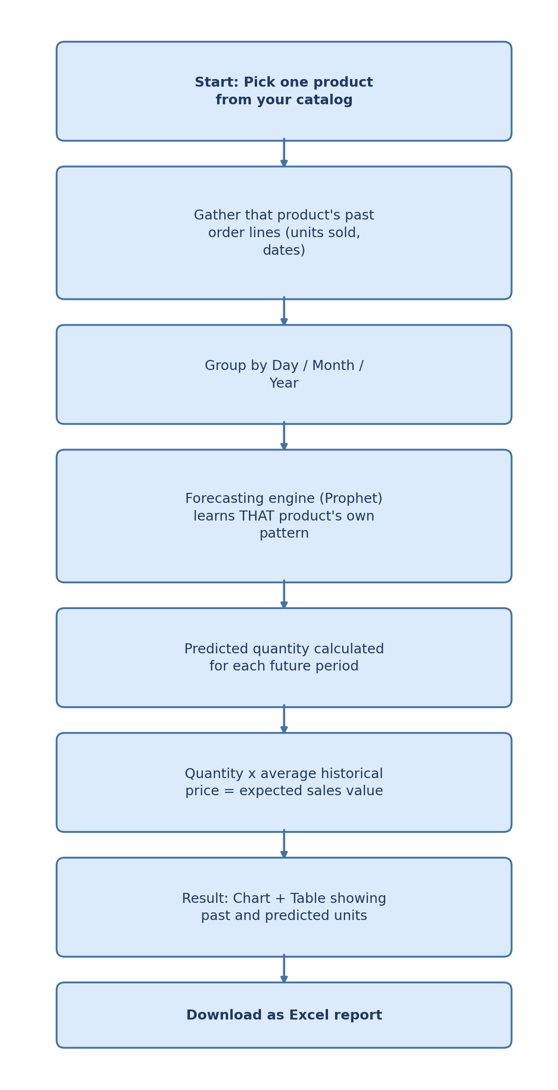

5. Method Used (In Simple Terms)
Here is what happens, step by step, once you run a forecast for a product:
Step 1: Gathering the product's history
The system looks at every past order for the selected product within your chosen date range, and works out how many units were sold in each period — day, month, or year, depending on what you picked. Still-open, not-yet-finished periods are excluded so they don't skew the numbers.
Step 2: Learning the buying pattern
Using the same well-established forecasting technique behind Sales Forecasting (Prophet), the system studies how demand for that one product has moved over time — whether it tends to rise, fall, or repeat a seasonal pattern — using the product's own order history only, not the rest of your catalog.
Step 3: Predicting future quantity
Based on that pattern, it calculates an expected quantity for each future period you asked for. A forecast is only produced once there is enough history to learn from — if a product has too little order history, the system will let you know rather than guessing blindly.
Step 4: Turning quantity into expected value
Since knowing "how many units" isn't always enough on its own, the system also multiplies the predicted quantity by the product's average historical selling price, giving you an estimated sales value for each future period too.
Step 5: Showing you the full picture
Finally, the actual past numbers and the predicted future numbers are shown together on one chart and one table, so you can see clearly where history ends and the forecast begins — for that single product.

6. Packages Used
These are the main software building blocks working quietly behind the scenes for Demand Forecasting:
Package | What it does (in plain terms)
Prophet | The forecasting engine. Learns the selected product's own rise-and-fall pattern over time and projects it forward into future quantities.
Pandas & NumPy | The number-crunching toolkit. Organizes each product's order lines by date and calculates quantities, averages, and totals.
XlsxWriter | Builds the Excel file the moment you click Download, so you can share or archive the product-level forecast.

7. Good to Know
- A product needs a reasonable amount of order history before a forecast can be produced — very new or rarely-ordered products may not have enough data yet.
- If a product doesn't sell often, try grouping by Month instead of Day to get a clearer, more reliable pattern.
- The estimated sales value assumes the product's price stays close to its historical average — if you're planning a price change, treat that value as a starting estimate rather than a guarantee.
- Use Demand Forecasting alongside Sales Forecasting: Sales Forecasting gives you the big picture for the whole business, while Demand Forecasting helps you plan stock for individual products.

8. Important — Please Read Before You Rely on This
⚠ A forecast is an educated estimate, not a guarantee
- Demand Forecasting assumes that a product's future buying behavior will broadly resemble its past behavior. It has no way of knowing about a promotion you haven't run before, a competitor launching a similar product, a sudden supply issue, or a viral trend that has never happened to this product before.
- Products with a short, sparse, or very irregular order history (new arrivals, rarely-ordered items, one-off bulk purchases) will naturally produce a less reliable forecast — treat those numbers with extra caution.
- The expected sales value is only an estimate based on the historical average price; if you change pricing, run a discount, or the market shifts, the real value achieved can differ noticeably.
- Always use this forecast as one input into your stock-ordering decision, alongside your own knowledge of upcoming promotions, seasonality, and supplier lead times — not as the sole basis for large purchase orders.

