Sales Analytics Suite
Sales Forecasting
Simple User Guide
Menu path: Predictive Analytics > Sales Forecasting

1. Introduction
Sales Forecasting helps you see, in advance, how much your business is likely to sell in the coming days, weeks, or months. Instead of guessing, it looks at all the sales you've already made and uses that history to work out what is likely to come next.
Think of it like a weather forecast, but for your sales — instead of predicting rain or sunshine, it predicts whether your sales are likely to go up, go down, or stay steady, and by roughly how much.
This is useful for everyday planning: deciding how much stock to keep ready, setting realistic sales targets for your team, budgeting for the months ahead, and knowing what to expect before it actually happens — rather than being surprised by it.
You don't need any data-science background to use it. You choose a date range and a few simple options, click a button, and the system does all the heavy calculation for you behind the scenes.

2. Tools Used
Everything happens inside the Sales Forecasting screen — you don't need to install or configure anything separately. Behind the scenes, the system draws on:
- Your own sales order history — every confirmed sale already recorded in the system.
- A forecasting engine that studies patterns such as busy seasons, holidays, weekdays vs. weekends, and repeat trends.
- An optional AI assistant that can also factor in current news and events, if you switch on "AI Mode".
- A chart and table on screen to show you the results, with a one-click option to download them as an Excel file.

3. Steps to Use
- Go to the Predictive Analytics menu and click on Sales Forecasting.
- Choose the date range you want to look back on (for example, the last 12 months) — this is the history the system will learn from.
- Choose how the sales should be grouped: by Day, Week, Month, or Year.
- Pick a mode: Algorithm Mode (uses only your own sales data) or AI Mode (also considers current news and events).
- If you chose AI Mode, you can type a few keywords about anything specific you want it to pay attention to (for example, a product name, a promotion, or an upcoming event).
- Click to run the forecast. A chart will appear showing your past sales followed by the predicted future sales.
- Hover over any point on the chart to see a simple explanation of why that number was predicted.
- If needed, click Recompute to update the forecast with new keywords or settings, or download the full report as an Excel file for offline use or sharing.

4. Flowchart — How Sales Forecasting Works
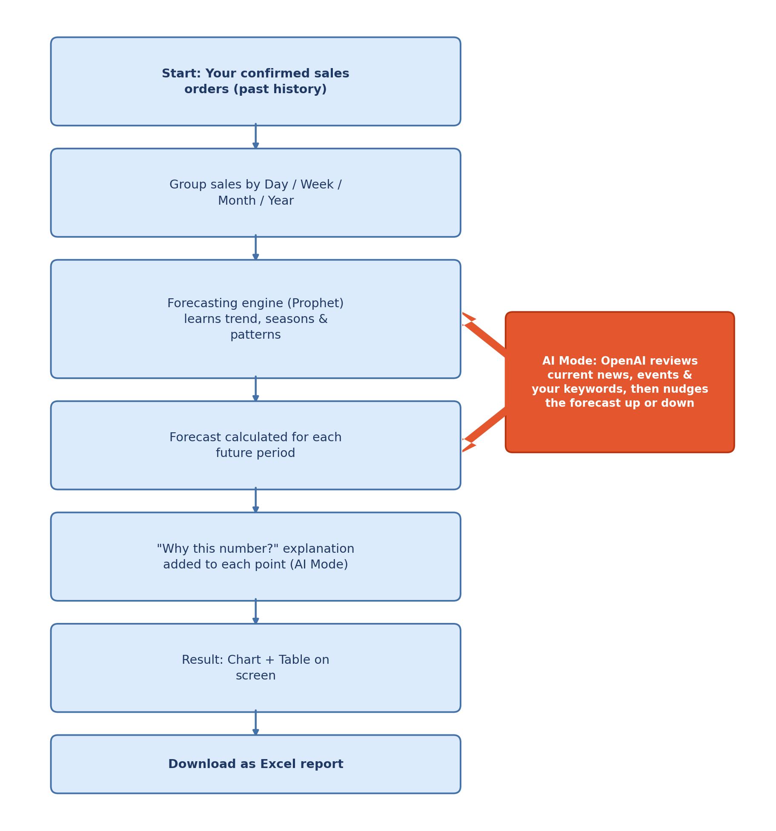

5. Method Used (In Simple Terms)
Here is what happens, step by step, once you click to run a forecast:
Step 1: Gathering the history
The system collects every confirmed sale you've made in the date range you picked, and organizes it by day, week, month, or year — whichever you chose. Incomplete or still-open periods (like the current, not-yet-finished month) are set aside so they don't distort the pattern.
Step 2: Learning the pattern
The main forecasting engine — a well-established technique called Prophet — looks for patterns in that history: do sales usually rise in certain months? Are weekends busier? Does a big sale tend to follow a smaller one? It separates your sales into an overall trend (the general direction) and repeating seasonal patterns (weekly cycles, yearly cycles, holidays), so the forecast reflects real rhythms rather than a simple straight line.
Step 3: Making the prediction
Using everything it has learned, the system calculates a realistic prediction for each future period. It doesn't just draw a straight line upward or downward — it tries to reflect the natural ups and downs your business normally sees.
Step 4: Adding real-world awareness (AI Mode only)
If you turned on AI Mode, an AI assistant reviews current news and events (and any keywords you gave it) and slightly adjusts the numbers up or down if something in the news is likely to affect sales — for example, a positive trend in your industry, or a slow season due to a holiday.
Step 5: Explaining the "why"
When AI Mode is used, each predicted point also comes with a short, plain-English explanation you can see by hovering over the chart — for example, current stock levels, recent momentum, a similar spike or dip in an earlier cycle, or a relevant news event. This helps you understand why a number is what it is, not just what the number is. (In Algorithm Mode, the chart shows the numbers without this extra commentary.)
Step 6: Showing you the result
Finally, everything is displayed as an easy-to-read chart and table, with your past sales and the predicted future sales shown side by side, so you can see clearly where history ends and the forecast begins.

6. Packages Used
These are the main software building blocks working quietly in the background. You will never see these names on screen, but it helps to know what each one is responsible for:
Package | What it does (in plain terms)
Prophet | The main forecasting engine. Studies your sales history and splits it into an overall trend plus repeating seasonal patterns (weekly, monthly, yearly, holidays) to predict what comes next.
Pandas & NumPy | The number-crunching toolkit. Organizes, cleans, and calculates all the sales data behind every chart and table.
OpenAI (AI Mode) | Reads current news and the keywords you provide, then nudges the algorithm-only forecast to reflect real-world events.
XlsxWriter | Builds the Excel file that is generated the moment you click Download.

7. Good to Know
- The more sales history you include, the better and more reliable the forecast will usually be.
- AI Mode needs an internet-connected AI service to be set up first — if it isn't, you can still use Algorithm Mode, which always works.
- Your last forecast is automatically saved, so you can come back and see it again without running it a second time.
- You can always export your data to Excel to share with your team or review offline.

8. Important — Please Read Before You Rely on This
⚠ A forecast is an educated estimate, not a guarantee
- Sales Forecasting learns from patterns in your past data. It cannot foresee sudden, one-off events it has never seen before — a new competitor, a supply shortage, an economic shift, a natural disaster, or a viral social-media moment can all move real sales away from the prediction.
- Very short, very new, or unusually spiky sales histories give the engine less to learn from, so the forecast will naturally be less reliable in those cases.
- AI Mode's news-reading is only as good as the news it finds at the time you run it — it can miss an important development, or occasionally misjudge how relevant a piece of news really is to your business.
- Treat every forecast as a helpful planning guide, not a promise of future sales. For big decisions — large stock orders, budget targets, hiring plans — always cross-check the numbers with your own business knowledge and your team's experience before acting on them.

9. Server Requirements (For Administrators)
Sales Forecasting loads and processes a large amount of sales-order history in the server's memory each time a forecast is run. On a server left at Odoo's default resource limits, running a forecast over a very wide date range can fail with the message “The requested date range contains too much data to be processed at once (Memory Limit Exceeded)”, or the request can time out.
To avoid this, the server administrator should raise the memory and time limits in the Odoo configuration file (odoo.conf) and restart the Odoo service.

Recommended odoo.conf settings
limit_memory_soft = 8589934592 ; ~8 GiB
limit_memory_hard = 10737418240 ; ~10 GiB
limit_time_cpu = 1200 ; 20 minutes
limit_time_real = 2400 ; 40 minutes

How much to allow (based on database size)
Set the memory limit to at least 20% of the database size, with a minimum of 4 GiB. A simple formula:
limit_memory_hard = max( 4 GiB , 20% x database size )
Database size | Recommended limit_memory_hard | Recommended limit_memory_soft
Up to 5 GB | 4 GiB (minimum) | 3 GiB
10 GB | 4 GiB | 3 GiB
25 GB | 5 GiB | 4 GiB
50 GB | 10 GiB | 8 GiB
100 GB or more | 20 GiB (or 0 = unlimited) | 16 GiB

Good to know
These limits control virtual memory, not physical RAM. The server does NOT need 10 GB of actual RAM — the real memory used per forecast is much smaller.
A live server with 8 GB of RAM or more is recommended for comfortable use.
No significant extra disk space is required for this feature.
If you still see the “too much data” message, run the forecast over a smaller date range (for example one year or one quarter at a time) and try again.

