◉
OPHAN
Brand Kit
Self-improving dev agent
January 2026

Overview
Ophan is a self-improving AI development agent based on the Two-Loop paradigm. The name comes from the biblical Ophanim — "wheels within wheels" from Ezekiel's vision — representing nested loops that move without turning (adapt autonomously) and are covered in eyes (always observing and learning).
This brand kit defines the visual identity and voice for Ophan across all touchpoints: CLI, documentation, marketing, and community.

Color Palette

Brand Colors
Gold is the primary brand color. Use it for the logo, accents, emphasis, and key interactive moments.
Ophan Gold | #D4A84B | Logo, accents, emphasis, highlights
Pale Gold | #E8D5A3 | Hover states, large decorative text
Deep Gold | #8B6914 | Links on light backgrounds (AA compliant)

Dark Mode (Primary)
Dark mode is the primary context for Ophan. The CLI, marketing, and hero sections use this palette.
Void | #000000 | Primary background
Obsidian | #0A0A0A | Cards, slight lift
Charcoal | #171717 | Elevated surfaces
Graphite | #404040 | Borders, dividers
Ash | #737373 | Secondary text, timestamps
Silver | #D4D4D4 | Primary text
White | #FFFFFF | High emphasis text

Light Mode (Documentation)
Light mode is used for documentation and README content where readability is paramount.
White | #FFFFFF | Primary background
Bone | #FAFAFA | Code blocks, subtle sections
Fog | #F5F5F5 | Cards, elevated surfaces
Ash | #737373 | Tertiary text, captions
Graphite | #525252 | Secondary text
Ink | #171717 | Primary text
Void | #000000 | Headings, logo

Semantic Colors
Used for status indicators in CLI output and UI. These are functional, not decorative.
Success | #22C55E | Pass, converged
Warning | #F59E0B | Approaching limits
Error | #EF4444 | Fail, escalation
Info | #3B82F6 | Neutral status, links (when gold conflicts)

Typography

Font Family
IBM Plex is the sole typeface for Ophan. It provides an industrial, precise feel that matches the "wheels within wheels" mechanical vibe.
Use | Font | Fallback Stack
Headlines & Body | IBM Plex Sans | 'IBM Plex Sans', -apple-system, BlinkMacSystemFont, sans-serif
Code & CLI | IBM Plex Mono | 'IBM Plex Mono', 'Consolas', 'Monaco', monospace

Type Scale
Element | Weight | Size | Line Height | Color (dark)
Display | 600 | 40px | 1.1 | Gold
H1 | 600 | 32px | 1.2 | Gold or White
H2 | 600 | 24px | 1.3 | White
H3 | 500 | 18px | 1.4 | White
Body | 400 | 16px | 1.6 | Silver
Secondary | 400 | 14px | 1.5 | Ash
Caption | 400 | 12px | 1.4 | Ash
Code inline | 400 (Mono) | 14px | 1.5 | Gold on Charcoal
Code block | 400 (Mono) | 14px | 1.6 | Silver on Charcoal

Weights to Load
- 400 (Regular) — body text, secondary
- 500 (Medium) — H3, subtle emphasis
- 600 (SemiBold) — H1, H2, display, strong emphasis

Voice & Tone
Ophan's voice reflects its nature: an ancient throne-bearer, covered in eyes, moving with deliberate purpose. It does not rush. It does not grovel. It witnesses.

Principles
Principle | Meaning | Example
Weighted | Statements land, no rushing | Opening pull request. (not "Creating PR...")
Unhurried | Space between thoughts, measured rhythm | Line breaks between phases
Confident | Declarative, present tense, no hedging | Convergence reached. (not "I think it worked")
Witnessing | Observes and reports, not performing | Tests passed (not "I ran the tests for you")
Precise | Specific, but not cluttered | 24 specs, 1.2s (not "quickly")
Calm | Even in failure, no alarm | Build failed. Examining. (not "Oops!")

Rhythm
- Let messages breathe — use line breaks between phases
- Em-dashes for related details, not parentheses
- No trailing ellipses — each line is complete
- Full words, not abbreviations (pull request, not PR)

Do / Don't
Do | Don't
Opening pull request. | Creating PR...
Convergence reached after 3 iterations. | Done! Converged in 3 tries ✓
Build failed. Examining. | Oops, build failed. Let me retry...
Tests passed — 24 specs, 1.2s | Tests passed (24 specs in 1.2s)
Escalating to human. Issue opened. | I'm stuck, creating an issue for you
Clarification needed. | I'm not sure what you mean?
Guidelines updated. | I've updated the guidelines for you!

Terminology
Use | Avoid
Convergence reached | Done, succeeded, completed
Iteration | Attempt, try, retry
Examining | Looking at, checking
Correcting | Fixing, trying again
Escalating | Giving up, stuck, failed
Clarification needed | I don't understand
Issue identified | Found the problem
Task received | Got it, okay

Formatting
- Sentence case
- Periods on all statements
- No exclamation points
- No emoji
- No ellipses
- No contractions
- Em-dash with spaces for related details

Sample Messages

Full Task Flow
Task received.
Reading guidelines.
Reading criteria.
Generating authentication module.
Running validations.
✓ Lint passed
✓ Types passed
✗ Tests failed — 2 specs
src/auth.test.ts:18
Expected token, received undefined
Examining.
Issue identified — token not returned from login handler.
Correcting. Iteration 2 of 5.
✓ Lint passed
✓ Types passed
✓ Tests passed — 14 specs, 0.8s
✓ Build completed
Convergence reached after 2 iterations.
Opening pull request.
Task complete. 2 iterations. 48s. $0.09.

Visual Language

Icon Style
Attribute | Value
Stroke weight | 2px
Corner radius | 0 (square) or 2px max
Style | Outline, not filled
Grid | 24x24 base
Color | Single color (Gold, White, or Ash depending on context)
Recommended base icon sets: Lucide or Phosphor. Customize key icons (loop, eye, wheel) for brand-specific moments.

Diagram Conventions
- Outer loop boundary — Gold
- Inner loop boundary — White or Silver
- Human/oversight — Gold, dashed
- Arrows/flow — Gold
- Labels — Silver (Plex Sans 500)
- Background — Void or Charcoal
- Rounded rectangles for containers (4px radius)
- 2px strokes, consistent with icons

Code Block Styling
Dark mode (primary):
Element | Color
Background | Charcoal #171717
Text | Silver #D4D4D4
Comments | Ash #737373
Strings | Pale Gold #E8D5A3
Keywords | White #FFFFFF
Functions | Gold #D4A84B
Light mode (documentation):
Element | Color
Background | Bone #FAFAFA
Text | Ink #171717
Comments | Ash #737373
Strings | Deep Gold #8B6914
Keywords | Ink #171717 (bold)
Functions | Deep Gold #8B6914

CLI Screenshot Treatment
- Actual terminal window chrome (macOS or minimal)
- Void #000000 background
- Drop shadow: 0 24px 48px rgba(0,0,0,0.4)
- Border radius on window: 8px
- Padding inside terminal: 16px
- Gold prompt character (◉) or Ophan logo as prompt

Applications

GitHub Social Card
1280×640 PNG — Used when the repository is shared on social platforms.
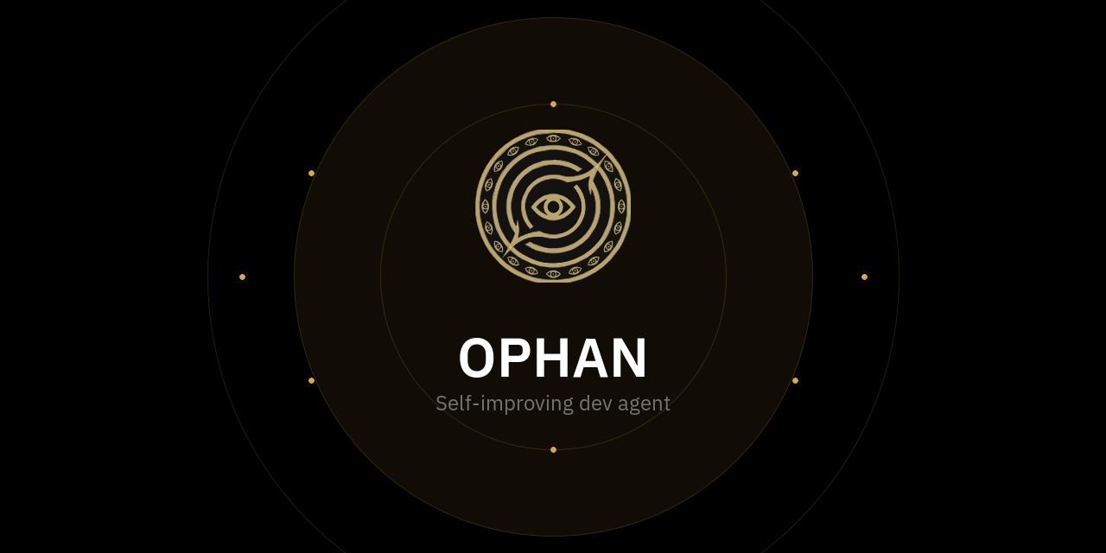

README Header
800×200 PNG — Used at the top of README.md files.


README Header (Compact)
800×120 PNG — Compact variant for smaller contexts.


Priority Assets
Asset | Purpose | Size/Format
GitHub social card | Shows when repo is shared | 1280×640 PNG
README header | Top of README.md | ~800px wide SVG or PNG
Favicon | Browser tab, bookmarks | 32×32, 16×16 ICO + 180×180 PNG
npm badge | Package listing | Standard badge size (~100×20)
Open Graph image | Docs site, link previews | 1200×630 PNG
CLI prompt icon | Terminal branding | Text character (◉)

Secondary Assets
Asset | Purpose
Documentation site header | Persistent nav/branding
Architecture diagram | Two-loop illustration for docs
Slide template | Presentations, talks
Social avatar | If Ophan gets an account

Context Usage
Context | Mode | Why
CLI output | Dark | Native terminal feel
Website hero | Dark | Brand impact
Docs content | Light | Readability, convention
README body | Light | GitHub default
README badges/header | Dark | Stand out
Code blocks | Light (Bone bg) | Familiar
Marketing/slides | Dark | Premium feel

Quick Reference

Color Hex Codes
Name | Hex
Ophan Gold | #D4A84B
Pale Gold | #E8D5A3
Deep Gold | #8B6914
Void | #000000
Obsidian | #0A0A0A
Charcoal | #171717
Graphite | #404040
Ash | #737373
Silver | #D4D4D4
White | #FFFFFF
Bone | #FAFAFA
Fog | #F5F5F5
Ink | #171717
Success | #22C55E
Warning | #F59E0B
Error | #EF4444
Info | #3B82F6

Font Stack
Sans: 'IBM Plex Sans', -apple-system, BlinkMacSystemFont, sans-serif
Mono: 'IBM Plex Mono', 'Consolas', 'Monaco', monospace

Voice Checklist
- No ellipses, no exclamation points, no emoji
- No contractions
- Full words (pull request, not PR)
- Em-dashes for related details
- Line breaks between phases
- Declarative, not hedging
- Calm, even in failure

