**::::::::Desktop:UW CMYK Colour.eps**

|  |  |
| --- | --- |
| By: | Cynthia Deng & William Gao |
| Student Number: | 20782862 & 20780743 |
|  |  |
| Submission date: |  |
|  |  |
| Submitted to: | Prof Irene Huang |
|  |  |

**Department of Electrical and Computer**

**Engineering**

**ECE 358: Computer Networks**

**Project 1: M/M/1 and M/M/1/K Queue**

**Simulation**

Contents

Question 1 3

I. M/M/1 Queue 3

Question 2 3

Question 3 8

Question 4 9

M/M/1/K Queue 9

Question 5 9

Question 6 9

# Question 1

|  |  |  |
| --- | --- | --- |
| **Run** | **Mean** | **Variance** |
| 1 | 0.013858672478097408 | 0.00017418973917540548 |
| 2 | 0.012303461910498893 | 0.00016470504001987526 |
| 3 | 0.013300150856802513 | 0.00017009661987798348 |
| 4 | 0.014624846865467396 | 0.00022944861550141895 |
| 5 | 0.013492076623601867 | 0.0001816752818396449 |
| **avg** | 0.013515842 | 0.000184023 |

The average mean is 0.013515842 while the average variance is 0.000184023.

This agrees with the expected values since the mean of the function is given by 1/𝜆, which in our case, with 𝜆 = 75, 1/ 𝜆 = 0.0133.

The variance also agrees with expected value since the expected value is 1/ 𝜆­2, which in our case is equal to 1.778*10­-4.

# I. M/M/1 Queue

## Question 2

In our code, we have 5 defined functions that will be performing all the calculations. In the main function, we will be defining the variables needed and printing the final E(N) and P_idle graphs.

Our 5 defined functions are **generateExponentialVar**(lamb), **populateArrays**(lamb, lambL, C, T), **createDES**(p_a, p_d, o), **queueProcessing**(DES, T), and **oneSimulation**(lamb, avg_l, C, T).

**generateExponentialVar**(lamb) shown in Fig. 1 generates a random exponential value with the inverse method. The input of this function is the 𝜆 found in the equation. This function is used to generate the various random exponential values that are needed throughout the code. This includes inter-arrival time, inter-observation time, and packet length

Figure 1. generateExponentialVar function

**populateArrays**(lamb, lambL, C, T) generates the multiples arrays that contain packet arrival times, packet departure times, as well observation times. Since this is an infinite queue, all these values are pre-generated and thus, this function is able to return packet departure times as well as the other two (which is not the case for finite queue).

In order to generate inter-arrival times, inter-observation times, as well as packet length, we specify the necessary lambda and run this through the previous function, **generateExponentialVar**. The arrival time that is appended to the arrival time array will then be a cumulative value of all the previously generated inter-arrival times. This logic also holds for observation times, with the difference being that the rate will be 5 times faster for observation times. A sample of the code used to generate arrival times is shown in Fig. 2 below.

Figure 2. Sample code used to generate arrival times

Departure time is calculated differently, and since it uses information from both arrival times and packet length, it is calculated after the above while loops. Since there is one packet departure for every packet arrival, a for loop will iterate that many times. In the for loop a service time will be calculated each iteration based on the correlated random packet length. For the first arrival time, the departure will be directly correlated with arrival time plus the service time. For every packet after that, a check needs to be performed. If the current packet arrival time is greater than the previous departure time, then there is no queue, and the departure will be a simple sum of packet arrival time and packet service time. If the current packet arrives before the previous packet departs, that means there is a queue, and the packet needs to wait. This means the departure time will actually be the sum of the previous departure time and the current packet service time. The value that is calculated is then appended onto an array that will contain all the final departure times. The code that does this can be found in Fig. 3.

Figure 3. Sample code used to generate the departure times

**createDES**(p_a, p_d, o) is the function used to create a combined list of Arrivals, Departures, and Observations, sorted by the time of the event. The inputs this function take are the 3 arrays that contain packet arrival times, packet departure times, and observation times. The output of this function is an array of dictionaries, where each dictionary represents one time point.

The logic of the **createDES** function is as follows. The code iterates through each of the 2 input arrays, and adds a dictionary to the array with two keys. The two keys are “type” and “time”, where type corresponds with what type of event it was, and time is the numerical value found in the original array. The sample code for **createDES** can be found in Fig. 4.

Figure 4. Sample code of createDES

The final function **queueProcessing**(eventTypes, DES, T) performs the calculations needed to find the E[N] and the PIDLE. The function requires the two arrays containing event types as well as event times, and the simulation time. It outputs the final E[N] and PIDLE.

**queueProcessing** will be iterating through eventTypes and DES simultaneously and if the DES value is greater than the simulation time, the process will stop. While iterating, depending on the event type value, NA, ND, and NO­ will be incrementing. When the event is an observation, an idle counter will also increment so that we can later calculate for PIDLE. During an observation, the number of packets in the queue will also be added to a total packet count which will be used to calculate E[N]. Finally, the function will actually calculate and return E[N] and PIDLE. Fig. 5 shows sample code of this function.

Figure 5. Sample code of function queueProcessing

In terms of computing the performance metrics, E[N] was calculated as shown in Eq. 1 below, and PIDLE was calculated as shown by Eq. 2 below.

$$E\left[N\right]=\frac{\sum_{i}{N_{Ai}-N_{Di}}}{N_{ofinal}}$$

Equation 1. Formula used for calculating E[N] performance metric

$$P_{IDLE}=\frac{counter_{IDLE}}{N_{ofinal}}$$

Equation 2. Formula used for calculating PIDLE­ performance metric

In the **oneSimulation** function, it will be taking lamb, avg_l, C and T as the inputs. This is where **populateArrays**, **createDES**, and **queueProcessing** are called. The final output is a printed value of E[N] and PIDLE.

Lastly, in the main function, the variables are initialized, and rho is then used to calculate the lambdas needed for the multiple iterations. The final outputs are 2 separate figures, one of E[N] vs rho and the other is of PIDLE vs rho. Fig. 6 below shows the for loop that runs through each iteration of rho

Figure 6. For loop that iterates through values of rho

The stability check was performed on T = 1000 and 2T = 2000, where lambda = 75. The variance in results between T and 2T are minimal enough that the time for simulation should be stable now.

|  |  |  |
| --- | --- | --- |
| **T** | **E[N]** | **PIDLE** |
| 1000 | 0.17313206296780262 | 0.852122932048538 |
| 2000 | 0.17571581703668546 | 0.8506730200039464 |

## Question 3

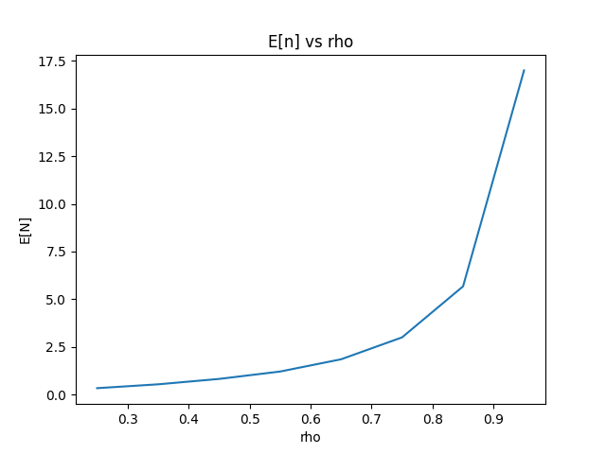

The E[N] vs rho graph is an exponential curve while the PIDLE vs rho is a linearly decreasing line.

The reason for the E[N] vs rho curve increasing is because as rho increases, there will be an increasing number of packets arriving per second. Since service time does not change, this means there will be a greater NA – ND the greater the value of rho. It is exponential as

The reason for the PIDLE vs rho line decreasing is because as rho increases, we can see that lambda also increases. As lambda increases, the number of packets arriving every second increases and leaves less time for the queue to be idle, thus resulting in decreasing PIDLE. The reason it is linear is because rho is the utilization of the queue, and this is directly correlated with idle time as 100% - rho (utilization) = PIDLE(idle time). Since rho is linear, PIDLE should also be linear.

The T in this simulation was 1000, since 2T holds stability, as shown in the table below.

|  |  |  |  |  |
| --- | --- | --- | --- | --- |
|  | **E[N]** | | **PIDLE** | |
| **Rho** | **T** | **2T** | **T** | **2T** |
|  | 0.3311 | 0.3325 | 0.7516 | 0.7507 |
|  | 0.5349 | 0.5384 | 0.6507 | 0.6498 |
|  | 0.8192 | 0.8168 | 0.5495 | 0.5499 |
|  | 1.2261 | 1.2221 | 0.4491 | 0.4506 |
|  | 1.8582 | 1.8513 | 0.3493 | 0.3505 |
|  | 2.9937 | 3.0302 | 0.2489 | 0.2492 |
|  | 5.7082 | 5.7180 | 0.1507 | 0.1490 |
|  | 20.0646 | 18.7293 | 0.0502 | 0.0493 |

## Question 4

For rho = 1.2, the E[N] is equal to 49483.3405 while the P_IDLE is equal to 2.9995220761492e-06. While initially these numbers seem to be extreme, it follows the trend set by the graphs of an exponential growth of E[N] and a linearly decreasing trend of PIDLE. The queue at this point is essentially never idle, and as a result, the queue will accumulate more and more packages over time resulting in an E[N] that is exponentially growing towards infinity.

# M/M/1/K Queue

## Question 5

## Question 6