All,

In preparation for Wednesday's meeting I've created assignment "drop boxes". Login to <https://box.net> -- you should see a "your name Research" folder. Upload your findings here in the appropriate sub folders.

Here's the formal assignment as initially described by Dr. Nair.

|  |
| --- |
| **Assignment #1. Simple Spiker Model**  1.  The approach to design passive properties is straightforward - test it out to make sure it works in all biologically plausible cases. Provide your comments on the interface. Then report on the method you used to match the F-I curve.  2. Survey the other software available to model single cells, and suggest how we might improve ours to provide more value to the users. (Other software in previous email below, encourage you to look around others as well) |

Do try to get as far as you can but don't stress too much about getting it done by tomorrow if it's a problem. The idea is that these assignments will help you build a knowledge-base of information you can go back to when you need it.

This week’s meeting will discuss any findings, go over the formal process for building your cell (calculating passive properties by hand and setting cell variables). We may discuss other cell models if time allows.

If you have any questions please let me know.

Tyler

**Context**

I've updated the list of cells available so when you run

bmtool util cell --prefab vhseg

You should see and adaptation cell and bursting cell.

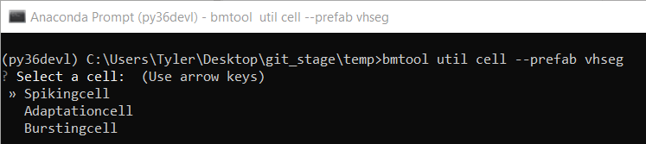

Other errors should be resolved now based on prior conversations.

Before running these cells upgrade to the latest version of BMTool by running:

pip install --upgrade bmtool

Should be on version 0.1.5.

As Dr. Nair mentioned

* Try giving each of these different cell types a run
* Manipulate the activation segregation variable
  + Eg: 'xseg_chan' where 'x' is the gate and 'chan' is the channel type.
* Try different combinations of activation variable manipulation
* Fit the passive properties of your cell to a fictional cell's v_rest, r_in, and tau
* Edit the conductance and reversal for each channel to fit an idealized FI curve (of your choosing)
* Screenshot your results and mention anything you learned from the process, this will be essential for tuning Hipp cells later

If you run into any issues or have any questions please let me know.

(User guide: <https://tylerbanks.net/assets/BMTool-User-Guide.pdf>)

Tyler

PS: I'll try to add a few more cell types this weekend (HTO/LTO) - you can get the latest set of prefab cells by running

bmtool util cell --prefab --prefab-refresh vhseg

anytime. This will also resolve issues if you've run --prefab previously.