**Test Case LIBRARY COMPONENT DOCUMENT**

**TEST PLAN**

Date: December 21, 2016

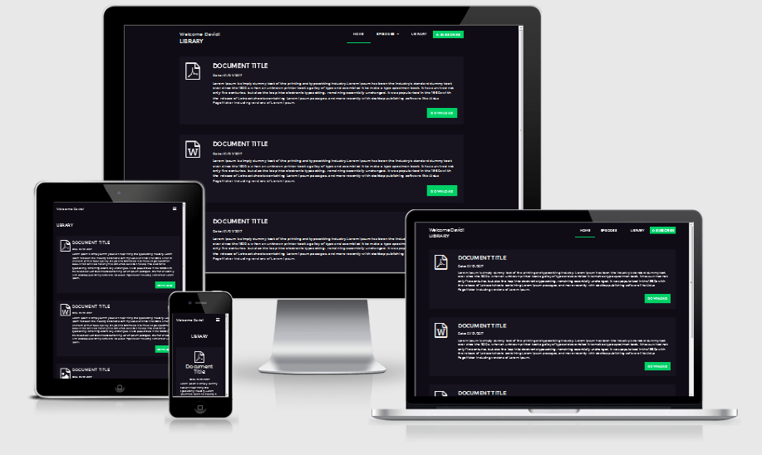

**Prepared by**: Scott Wren

# Revision History

|  |  |  |  |
| --- | --- | --- | --- |
| Date | Version | Description | Author |
| 12/21/2016 | 1.0 | Initial version for comments. | Scott Wren |

# Introduction

The Test Plan has been created to the front end library component page. It includes the objectives, scope, schedule, risks and approach.

## Objectives

The library component is currently a responsive web page that is used to display a list of documents from a data store. The web page uses HTML5, CSS, JS, and Bootsrap to create a responsive page. The test team is responsible for testing the component and ensuring it meets the responsive needs for the majority of devices.

## Team Members

|  |  |
| --- | --- |
| **Resource Name** | **Role** |
| Scott Wren | Developer / Tester |
| Melani Sunderman | Tester |
|  |  |

# Scope

The initial phase will include all ‘must have’ requirements. These and any other requirements that get included must all be tested.

**Phase 1**

At the end of Phase 1, a tester must be able to:

1. View a list of documents clearly in the default view port.
2. Resize the view and be able to view the document library.
3. The component library must view reasonably on iPhone & Nexus Devices.

# Assumptions / Risks

## Assumptions

This section lists assumptions that are made specific to this project.

1. Delivery of the product is in un-minified source code.

## Risks

The following risks have been identified and the appropriate action identified to mitigate their impact on the project. The impact (or severity) of the risk is based on how the project would be affected if the risk was triggered. The trigger is what milestone or event would cause the risk to become an issue to be dealt with.

|  |  |  |  |  |
| --- | --- | --- | --- | --- |
| # | Risk | Impact | Trigger | Mitigation Plan |
| 1 | Scope Creep – as testers become more familiar with the tool, they will want more functionality | High | Delays in implementation date | At the end of the testing phase the testers can put forward suggestions. |
| 2 | Changes to the functionality may negate the tests already written. | High – to schedule and quality | Start test cases all over again. | No changes at this stage are allowed. |

# Test Approach

The project is using an agile approach, with daily iterations. At the end of each day the requirements identified for that iteration will be delivered and will be tested. This is only temporary because the component is small.

## Test Automation

Automated unit tests are part of the development process within Dreamweaver 2017. Other responsive testing should be done outside of the development stage.

# Test Environment

The testing environment currently consists of Google Chrome, Firefox, Opera, Edge, IE8, IE9, Safari, and Android web browsers.

# Milestones / Deliverables

## Test Schedule

The initial test schedule

|  |  |  |  |  |
| --- | --- | --- | --- | --- |
| **Task Name** | **Start** | **Finish** | **Effort** | **Comments** |
| Test Planning | 12/21 | 12/21 |  |  |
| Review Requirements documents | 12/21 | 12/21 | .50 |  |
| Create initial test estimates | 12/21 | 12/21 | .30 |  |
| Staff and train new test resources |  |  | N/A |  |
| First deploy to QA test environment |  |  | .10 |  |
| Functional testing – Iteration 1 |  |  | 2 |  |
| Iteration 2 deploy to QA test environment |  |  |  |  |
| Functional testing – Iteration 2 |  |  |  |  |
| System testing |  |  |  |  |
| Regression testing |  |  |  |  |
| User Acceptance Testing |  |  |  |  |
| Resolution of final defects and final build testing |  |  |  |  |
| Deploy to Staging environment |  |  |  |  |
| Performance testing |  |  |  |  |
| Release to Production |  |  |  |  |

# Testing Review

## Library.html

The general result is that the library components functions well across multiple devices and there appears to be no issues. **Please note that this was only soft testing of the devices and hard testing is yet to be established.**

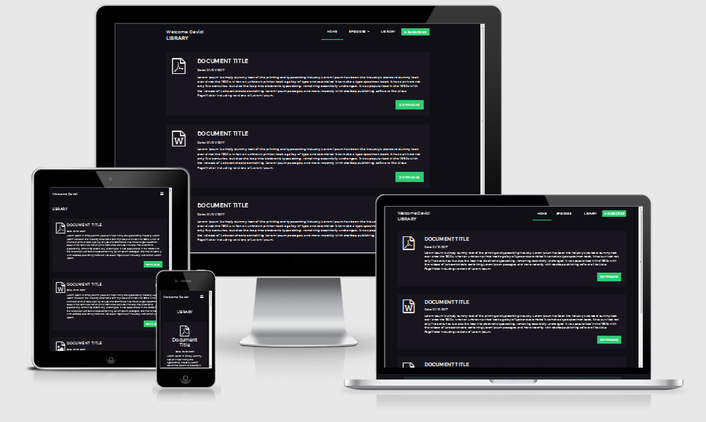

Device views – Android / iPhone

|  |  |
| --- | --- |
| \\vmware-host\Shared Folders\Desktop\Nexus4Portrait.png | \\vmware-host\Shared Folders\Desktop\iPhone5Portrait.png |
| Nexus 4 Width 348px Android Browser | iPhone 5 Width 320px Safari Browser |
|  |  |
| \\vmware-host\Shared Folders\Desktop\iPhone6Portrait.png |  |
| iPhone 6 Width 375px  Safari Browser | iPhone 6 Plus 375px Safari Browser |
|  |  |
| \\vmware-host\Shared Folders\Desktop\iPadPortrait.png |  |
| iPad 768px Safari Browser |  |

## Library-list.html

The list view version of library components functions well across multiple devices and there appears to be no issues. **Please note that this was only soft testing of the devices and hard testing is yet to be established.**

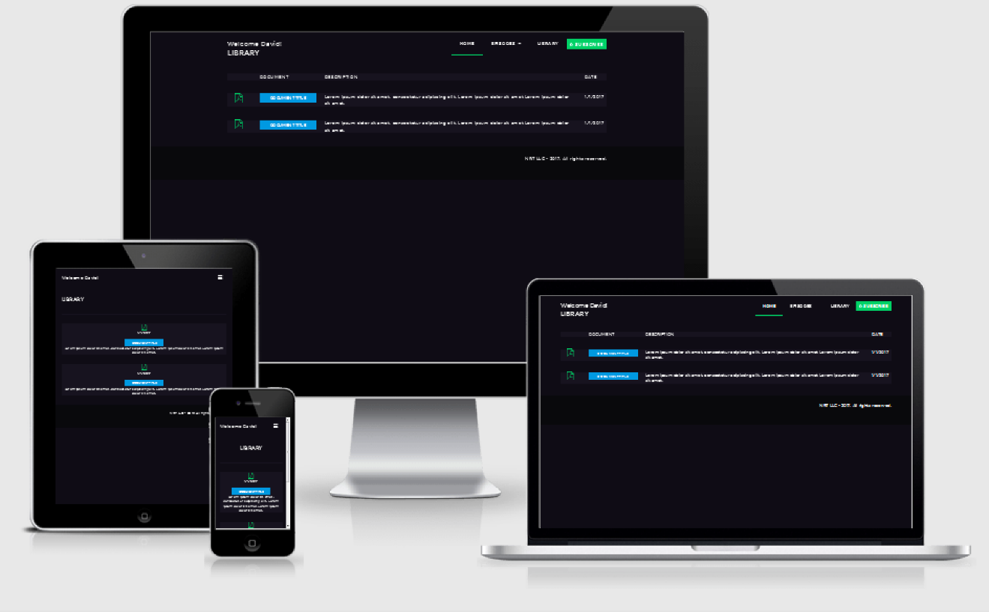

|  |  |
| --- | --- |
| \\vmware-host\Shared Folders\Desktop\Nexus4Portrait-List.png | \\vmware-host\Shared Folders\Desktop\iPhone5Portrait-list.png |
| Nexus 4 width 348px Android browser | iPhone 5 Width 320px Safari browser |
|  |  |
| \\vmware-host\Shared Folders\Desktop\iPhone6Portrait-list.png | \\vmware-host\Shared Folders\Desktop\iPhone6PlumpPortrait-list.png |
| iPhone 6 width 375px Safari browser | iPhone 6 width 414px Android browser |
|  |  |
| \\vmware-host\Shared Folders\Desktop\iPadPortrait-list.png |  |
| iPad 768px Safari Browser |  |