Library Component

**Load/Performance Test Plan**

Version 1.0

Author: Scott Wren  
scott.wren@nrtsoutheast.com

**Document Revision**

|  |  |  |  |
| --- | --- | --- | --- |
| Date | Version | Name | Comment |
| 12/22/2016 | 1.0 | Scott Wren | Initial document |
|  |  |  |  |
|  |  |  |  |

# 

# Reference Documents

Reference information used for the development of this plan including:

* Test Case Library Component Document – Ref RLFECD1216-1.0 (Test requirements)
* Responsive Library Front End Component Document – Ref RLFECD1216-1.0 (Specification)

# Scope

**What does this document entail?**  
This document describes the testing procedure for testing the library component pages and will outline the results.

**What is being tested?**  
The library component pages. library.html, library-list.html

**What is the overall objective of this plan?**

* To document test objectives, test requirements, test designs, test procedures, outline results, and other project management information
* Receive feedback
* To define development and testing deliverables

# Approach

The library component pages will be tested using an external online service to gauge the response time and loading time of the component page.

# Load Test Types and Schedules

Specify the test types (with definition for each) to run:

* Acceptance test
* Baseline test
* Browser regression test - Code regression is not needed but browser regression is required.
* Benchmark test

Be specific:

* Page object load time
* 8 cycles of the test will be ran
* Schedule date 12/22/2016

# Performance/Capability Goals

Identify goals:

* **Percentage of requested static pages that must meet the acceptable response time?**   
  100%
* **Percentage of requested scripts that must meet the acceptable response time?**   
  75% (Theme based scripts)
* The page should load in under 2.0 secs as specified by Google 2016 SEO algorithm update

Other questions to consider:

* **What is response time?**   
  500 ms
* **What is acceptable response time?**   
  2.0 secs
* **Which metrics should we collect?**   
  Page object load time, page size, requests, google speed rating, waterfall
* **How do we determine which components are problematic?**  
  Based on size, non-minified code, non-optimized images, and server response time which may be out of our scope.

# Load Testing Process, Status Reporting, Final Report

**Describe the testing and reporting procedures.**

* The library.html and library-list.html will be cycled 8 times. These tests will be tested from 2 separate locations using at least 2 different testing tools. The pages will be executed on the same staging hardware, OS (CentOS) and web server (Apache) running PHP 5.4.13.
* Test will baseline load as follows:
* Load Test Team will test library.html and library-lists with 10 Simultaneous Clients/Users, and report back on the following metrics:
* Response time each transaction hitting the Web site.
* Failed web transactions
* There will be Status Reports sent to Team Lead detailing:
* Performance tests run
* Performance metrics collected
* Performance Errors and status
* Bugs
* Status Summary
* The Final Report will include summary bug counts, overall performance assessment, and test project summary items.

Additional Information to be provided by Development Team:

1. Build Schedule
2. Acceptance test criteria
3. Deployment Plans

# Bug Reporting and Regression Instructions

Describe the bug reporting process and the fix/change regression test procedures.

1. Note what the bug is
2. How it occurred
3. The impact on the rest of the page
4. Fixes can include using shiv, shim, and polyfills

# Tools Used

State the tool solutions for the project:

* Load testing tools  
  Pingdom, Google speed test
* Monitoring tools  
  N/A

Tool Options:

* Desktop
* Mobile

# Training Needs

Training programs to be provided to the team to enable successful planning and execution. N/A

# Load Descriptions

Server-based

* **Number of users and/or sessions**  
  10+
* **Average session time**  
  20 secs
* **Number of page views**  
  1
* **Average page views per session**  
  4
* **Peak period**  
  11:00-13:00
* **Number of hits**  
  Unknown
* **Average page size**598K
* **Most requested pages**  
  N/A – Single page testing
* **Average time spend on page**20 secs
* **New users vs. returning users**N/A
* **Frequency of visits (e.g., 75% of users made one visit)**  
  N/A
* **Demographics**  
  N/A
* **Client information**  
  Chrome Version 55.0.2883.87 m (64-bit), Firefox ESR 45.6.0, IE 11.0.9600.18537, Unable to test EDGE, JS Enabled

User-based

* **Number of users**2
* **Session length**  
  30 minutes
* **User activities and frequency of activities per session**  
  Page load, resize, turn off JS in browser

Other questions to consider:

* **What is the definition of “workload”?**  
  A user requesting a page and downloading page.
* **How do we size the workload?**  
  MB
* **What is the expected workload?**  
  1MB
* **What’s the mix ratio of static pages vs. code?**  
  UNKNOWN
* **What is the definition of “increased load”?**  
  Additional page requests and downloads
* **What is future growth? Can it be quantified?**  
  Future growth is additional functionality added to the page
* **What is the definition of scalability?**The page will scale in both workload.

# System Under Test Environment

Specifying mixes of system hardware, software, memory, network protocol, bandwidth, etc.

* **Network access variables**  
  Unknown
* **Demographic variables**  
  San Jose, NYC
* Client baseline configurations
* **Computer variables**  
  VMWARE running Windows 7
* **Browser variables**  
  JS enabled/disabled
* Server baseline configurations
* Computer variables  
  N/A
* System architecture variables and diagrams  
  Unknown

Other questions to consider asking:

* **What is the definition of “system”?**  
  The system is defined as the web page running on the server and being distributed from a single server location.
* **How many other users are using the same resources on the system under test (SUT)?**20-50
* **Are you testing the SUT in its complete, real-world environment (with load balances, replicated database, etc.)?**  
  No
* **Is the SUT inside or outside the firewall?**  
  Inside
* **Is the load coming from the inside or outside of the firewall?**  
  Both

# Exclusions

Set clear expectations

* Content accuracy or appropriateness testing is out of the scope of this plan.
* SEO
* Accessibility
* Internationalization
* Compatibility Testing

# Test Deliverables

* This test plan
* Performance testing goals
* Workload definitions
* User scenario designs
* Test procedures
* Metrics to collect
* Test run results
* Performance related error reports (e.g., failed transactions)
* Functional bug reports (e.g., data integrity problems)
* Periodic status reports
* Final report

# Budget/Resource

**Monetary requirements for equipment and people to complete the plan.**  
Scott Wen – Melani Sunderman

# Team Members and Responsibilities

Project team members, their responsibilities and contact information.  
Scott Wren – Developer  
Scott Wren – Tester  
mel

# List of Appendices

Specific test case, test design and test script information to be added as we go. Here are a few examples:

* N/A

# Results – library.html

|  |  |  |  |  |
| --- | --- | --- | --- | --- |
| Date/Time | Location | Load time ms | Page size KB | Requests |
| 12/21/2016 | San Jose | 431 | 598.5 | 20 |
| 12/21/2016 | San Jose | 252 | SAA | SAA |
| 12/22/2016 | NYC | 827 | SAA | SAA |
| 12/22/2016 | NYC | 799 | SAA | SAA |
| 12/22/2016 | San Jose, Cali | 264 | SAA | SAA |
| 12/22/2016 | San Jose, Cali | 268 | SAA | SAA |
| 12/22/2016 | Vancouver, Canada | 800 | SAA | SAA |
| 12/22/2016 | Vancouver, Canada | 900 | SAA | SA |

## Content size by domain

|  |  |  |
| --- | --- | --- |
| **Content type** | **%** | **Size KB** |
| Script | 45.9 | 274.86 |
| CSS | 37.0 | 221.23 |
| Other | 15.4 | 10.04 |
| HTML | 1.7 | 10.04 |
| Total | 100 | 598.49 |

## Content size by domain

|  |  |  |
| --- | --- | --- |
| **Domain** | **%** | **Size KB** |
| Domain server | 45.9 | 497.24 |
| maxcdn.bootstrapcdn.com | 12.2 | 72.72 |
| fonts.gstatic.com | 4.5 | 26.83 |
| fonts.googleapis.com | 0.3 | 1.7 |
| Total | 100 | 598.49 |

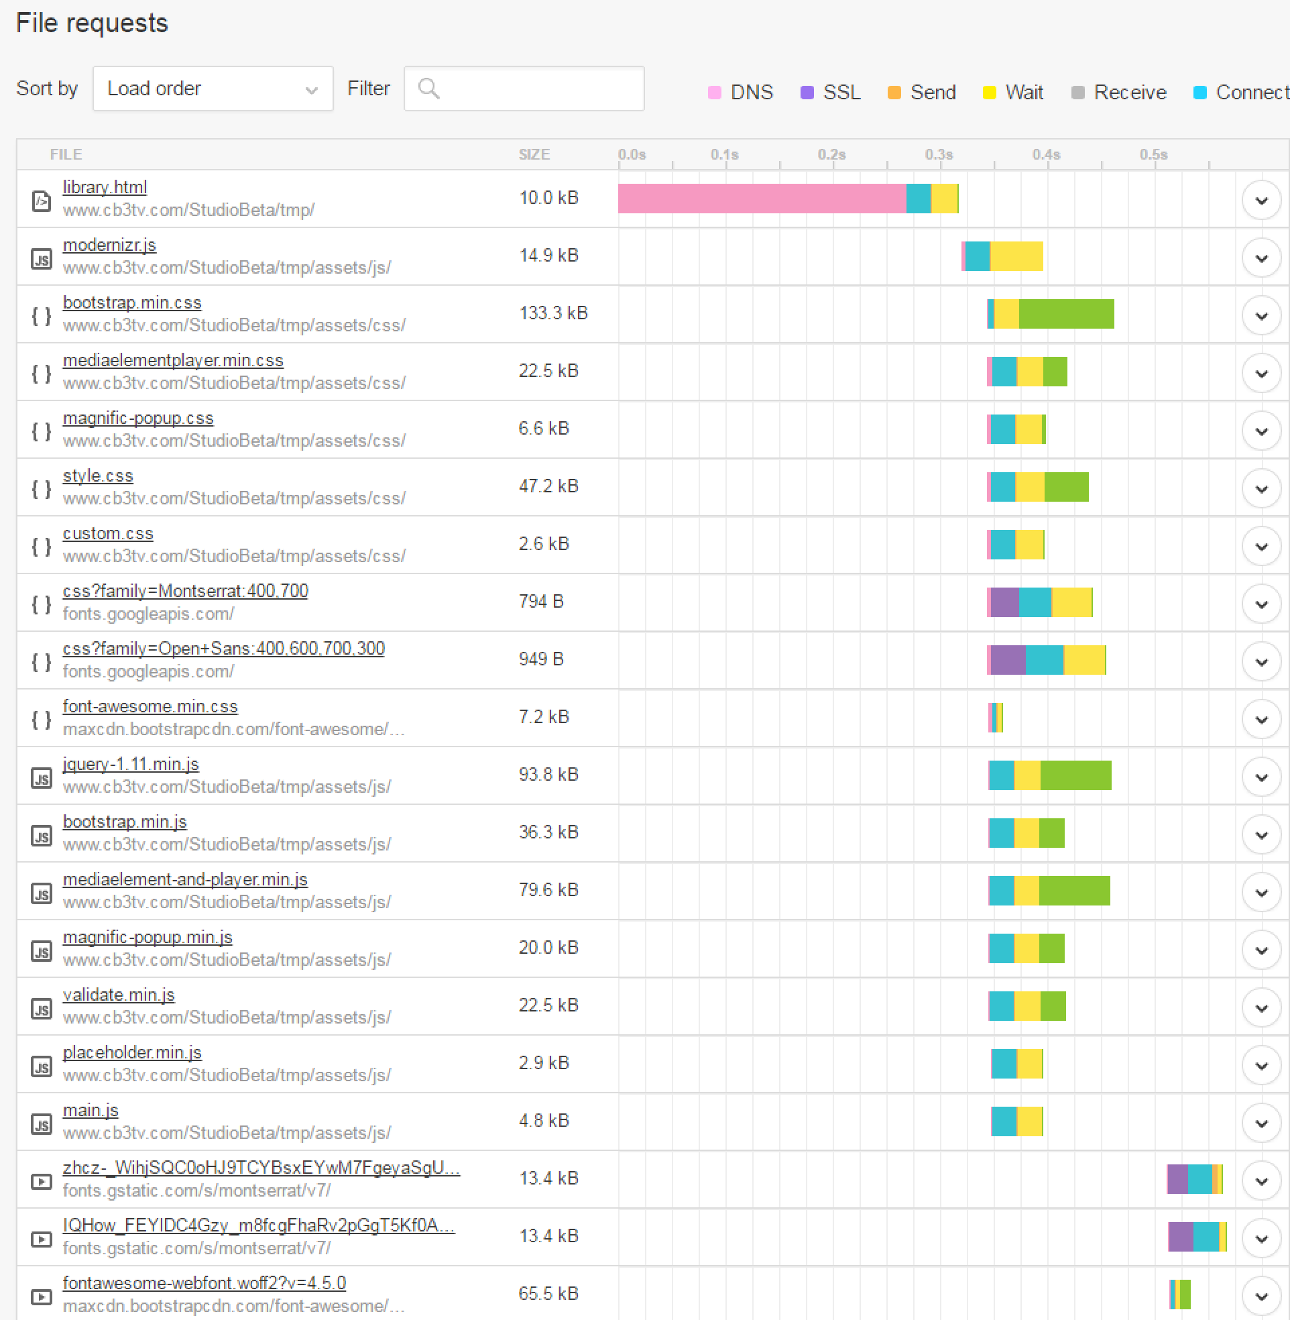

# Results – library-lists.html

|  |  |  |  |  |
| --- | --- | --- | --- | --- |
| Date/Time | Location | Load time ms | Page size KB | Requests |
| 12/21/2016 | San Jose | 431 | 598.5 | 20 |
| 12/21/2016 | San Jose | 252 | SAA | SAA |
| 12/22/2016 | NYC | 827 | SAA | SAA |
| 12/22/2016 | NYC | 799 | SAA | SAA |
| 12/22/2016 | San Jose, Cali | 264 | SAA | SAA |
| 12/22/2016 | San Jose, Cali | 268 | SAA | SAA |
| 12/22/2016 | Vancouver, Canada | 800 | SAA | SAA |
| 12/22/2016 | Vancouver, Canada | 900 | SAA | SA |

## Content size by domain

|  |  |  |
| --- | --- | --- |
| **Content type** | **%** | **Size KB** |
| Script | 45.9 | 274.86 |
| CSS | 37.0 | 221.23 |
| Other | 15.4 | 10.04 |
| HTML | 1.7 | 10.04 |
| Total | 100 | 598.49 |

## Content size by domain

|  |  |  |
| --- | --- | --- |
| **Domain** | **%** | **Size KB** |
| Domain server | 45.9 | 497.24 |
| maxcdn.bootstrapcdn.com | 12.2 | 72.72 |
| fonts.gstatic.com | 4.5 | 26.83 |
| fonts.googleapis.com | 0.3 | 1.7 |
| Total | 100 | 598.49 |

