Responsive Library Front End Component Document

Scott Wren

Version 1.0

December 2016

# Revision History

|  |  |  |  |
| --- | --- | --- | --- |
| Date | Version | Description | Author |
| 12/21/2016 | 1.0 | Initial version for RFC. | Scott Wren |

# Introduction

This document provides a high level overview of the library front end component that will be used in the recruiting web site as specified by David Knife ([David.Knife@nrteast.com](mailto:David.Knife@nrteast.com)).

**1.1 Purpose**

This document will address the following

* The components implementation
* The technologies used
* A use case example
* How it fits into the overall website design

To depict the component accurately, the diagram below provides and overview on how the component fits within the system design.

This document does not discuss the server architecture or implementation that the component will reside on.

* 1. **Scope**

The library component scope will consist of a single HTML front end web page that is responsible for display a list of documents. It will be responsive across multiple devices. This is only a front end requirement.

* 1. **Requirements**

**David Knife - email specification:** *The 2 files I’ve been working on are index.html and episode.html. Additional css I’ve added to assets/css/custom.css. I’ve been doing basic responsive testing but if you see anything that obviously needs changed then please go ahead. There’s a bunch of other html files in the directory which came with the theme as well that contain certain theme specific designs in case they’re of use. There is no backend PHP or DB work done yet as I’m focusing solely on getting the designs finalized first.*

*I’d like you to work on the Library component. This will basically be a separate page that will contain various documents to download, likely in pdf/docx/xlsx formats so you can use those font-awesome icons. It doesn’t need to be anything real fancy but should display well across devices of course. I won’t be adding any kind of search as the document library won’t be extensive.*

*Please document any changes you make so I’ll be able to review. I’ll be available during my vacation by email if you need anything, I just won’t be responding as often.*

* 1. **Document organization**

|  |  |
| --- | --- |
| Introduction | Provides information related to this document and its purpose. |
| Design Overview | Describes the approach, architectural goals, restraints, and design patterns. NOTE: This is only based on examining the template files as I have not seen the overall goal and direction of this project. |
| Topology Diagram | Describes the various system interactions with the library component. |
| Application Architecture | A detailed description of the layers used to build upon the component. Describes the presentation layer, business layer, and resource layer. The data layer is not represented because the components front end only being implemented. |
| Object Model | Describes the conceptual representation of the domain problem represented by a class diagram. |

* 1. **Abbreviations, definitions, and acronyms**

**HTML** – Hypertext Markup Language

**HTTP** – Hypertext Transfer Protocol

**CSS** – Cascading Style Sheets

**PHP** – Hypertext Preprocessor Scripting Language

**JS** - Javascript

**Bootstrap** – A front end framework for working with HTML, CSS, and JS for developing responsive design.

**UML** – Unified Modeling Language

**User** – Anyone interacting with the component

**1.6 Audience**

The intended audience for this document are the project development teams, testing team, and development managers.

# Design overview

**2.1 Approach**

Requirements Phase - The initial version of this document has been created to describe the architecture requirements.

System Design Phase - During this phase a prototype mockup is created in preparation for the constructions phase.

Construction Phase – During this phase the document should not change drastically and is only updated to reflect changes.

Transition Phase – During this phase no further additions or medication are made to this document.

**2.2 Architectural Representation and Constraints**

The architectural goals of the component are to provide a front end that will allow a user to access a list of documents in PDF, Word, Excel format etc. The architecture constraints are:

* To work within the template theme and design principles.
* Bootstrap version 3.3.6 will be used
* jQuery 1.11.1 will be used
* HTML5 is to be used

**Use case view**  
Audience: The end user  
Area: Describes a set of scenarios and use cases that represent the component interacting with actors.

**Logical view**

Audience: Designer/Business Analyst

Area: The functional requirements based on the design’s object model.

**Data view:**

Audience: Web designers/Programmers/Data Analysts/Business Analysts

Area: Describes the topology and the mapping from the local, to staging to production.

**Deployment view:**

Audience: Web designers/eMarketing

Area: Describes the topology and the mapping from the local, to staging to production.

**2.3 Guideline Principles**

The guideline principles provide a target architecture which the component must satisfy. Some of which are set out below.

**2.3.1 Scalable**

The component must be bi directional scalable. The component should scale both vertically and horizontally.

**2.3.2 Standards**

The component must abide to industry standards as outline in the testing documentation for this component. (see appendix)

**2.3.3 Client Side**

User will be able to access the library component using a web browser that supports HTML5 and JS.

**2.3.4 Security**

The user is only allowed read/write access as per the browser settings. No other rights are allowed other than to read the web page within the context and restraints of the web browser.

**2.3.5 Persistence**

No browser local storage, cookies or tracking are implemented.

**2.4 Design Principles**

Presentation services are delivered to the web browser using HTML, JS, and CSS.

A common look and feel across devices is required.

The design patterns used in the component are the component itself and custom style sheets. The design patterns used are

* Responsive UI
* Mostly fluid
* Column drop
* Column content reflow

# Use Case View

**3.1 Use case processes**

Use cases that represent the interaction with the library component are

* Begin new desktop process
* Begin new mobile process
* Download document process
* View document process

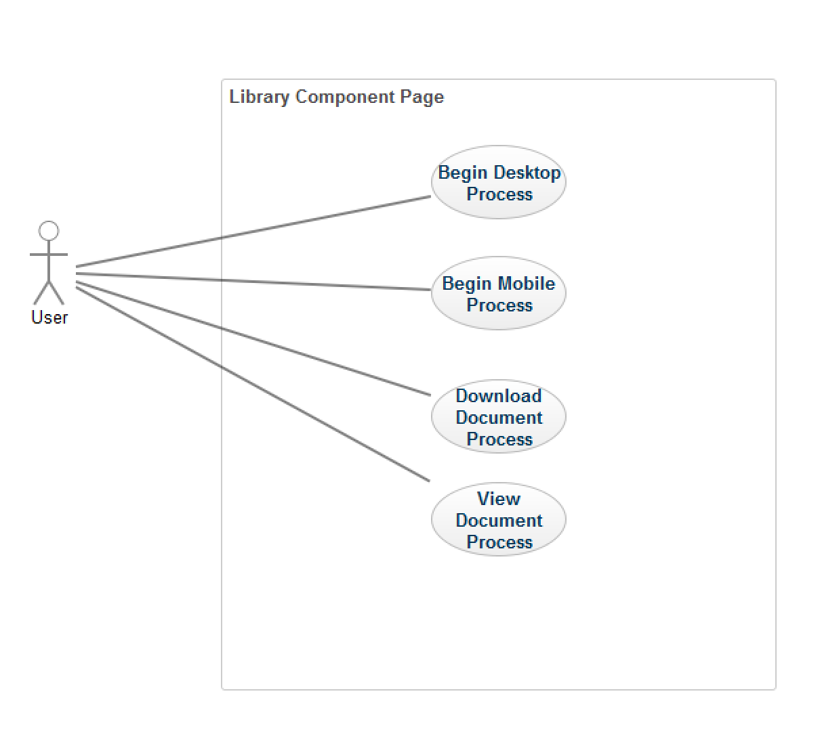

**3.2 Actors**

1. Reader
2. System: Unspecified Web server

**3.3 Realizations**

The diagram below describes how functionality is identified and a use case scenario.

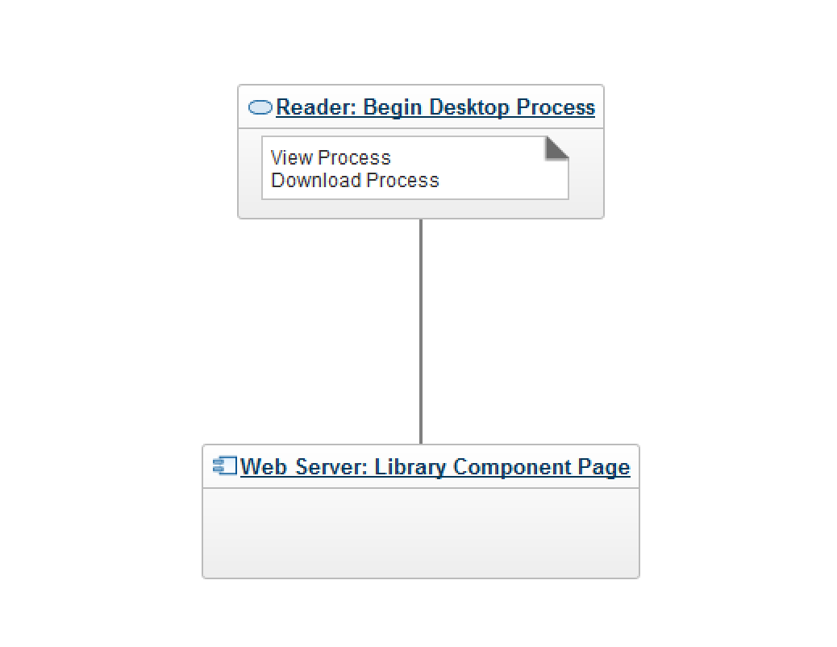

**3.4 Deployment View**

FTP Client ----> Hosting server

# Topology

The diagram below illustrates the system architecture and how the library component fits within it. **NOTE:   
* No firewall is present in this diagram as hosting requirements are unknown.  
* No data store is specified as this is an unknown requirement.**



NOTE: Unspecified web server. Unspecified data store

# Logical View

**5.1 Overview**

The separation of concerns is highlighted in these layers. Based on the information provided in the specification the layer representation is as follows

* Presentation Layer (UI/Web Browser)
* Business Layer (PHP/Web server)
* Service/Data Layer (CRUD) – Not specified in the specification.
* Data Store (Database server or Files system) – Not specified

**5.2 Process View**

User-> Session-> Web Page-> Library Component-> CRUD-> Data store

# Data View

The data view UI is displayed only via the web browser which gives access the business layer which in turn will contact the layers further up the chain.

# Deployment

Current deployment specification dictates that deployment should be via FTP.

**7.1 FTP Settings**

Username [scott.wren@nrteast-marketing.com](mailto:scott.wren@nrteast-marketing.com)

(Removed for security reasons)

Server 192.169.214.35

Use FTP without TLS

CWD: The / directory

# Issues

# Appendix A: Tools

|  |  |  |  |
| --- | --- | --- | --- |
| Software | Version | Source | Description |
| Dreamweaver | CC 2017 | Adobe | Text editor for HTML/CSS/JS |
| Filezilla | 3.22.1 | https://filezilla-project.org | For deploying files |
| W3C Markup Validation Service | 1.3+hg | https://validator.w3.org | Validating HTML |
|  |  |  |  |
|  |  |  |  |

# Appendix B: Working Files

|  |  |  |  |
| --- | --- | --- | --- |
| Files | Version Control History | Source | Description |
| library.html | 0.02 | 192.169.214.35 | Library component page |
| Library-lists.html | 0.01 | 192.169.214.35 | Alternate library component page |
| Assets/css/custom.css | 0.01 | 192.169.214.35 | Custom stylesheet |
|  |  |  |  |
|  |  |  |  |