IMAGE PROCESSING
AND
SIMILAR IMAGES DETECTION

“UB Image Processing”

Abstract:

Image Processing is a form of signal processing for which the input is an image, such as photographs or frames of video and the output of image processing can be either an image or a set of characteristics or parameters related to the image. The Project entitled “UB Image Processing” deals with the design of the tool for Processing Images to edit them by changing various characteristic and properties. In Addition to the Processing, it also provides a tool which detects the similarity between ranges of Images. The Project takes image files as an input in two formats, JPEG (.jpeg) and Bitmap (.bmp) and amplifies/diminish the various characteristic like Brightness, Contrast, Sharpness, blurriness, Mean Removal etc. The use of the project can be variable in fields like image processing, image enhancement, duplicate image verification and Image Sequence Detector.

Keywords: JPEG, Bmp, Red-Green-Blue (RGB), Hue-Saturation-Value (HSV), GDI+, bitmap Image, Levenshtein Algorithm, Edit-Distance, weight Factor,

Introduction:

UB Image Processing Tool is a Photo Editor tool like MS Paint and Adobe Photoshop but with an added functionality of similar Image detector. The tool is built using the GDI + functionality provided for writing effective graphics applications on the .NET Framework 3.5. The Similar Image Detection tool is based on the Levenshtein Mean Distance Algorithm which calculates the mean distance of the comparing images to find the similarity between those Images. The Photo Editor tool can only Process JPEG and Bitmap Images but Similar Image Detector is made capable of detecting similarity among other formats as well like PNG and GIF Images.
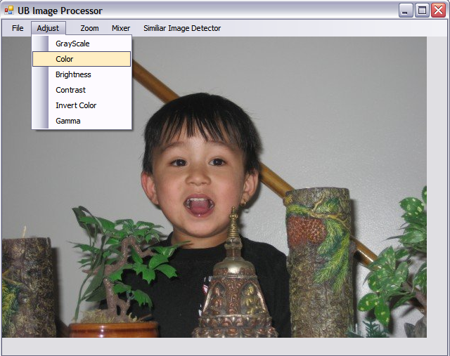
Tools used:

- Microsoft visual Studio 2008
- .Net Platform 3.5
- GDI + functionality from .Net
- Programming Language : C#

- Features:

This Project is divided into 5 main group functionalities. They are listed as follows:
- File Menu
- Open
- Save
- Reload
- Exit
- Image Adjustment Features
- Grayscale
- Color
- Brightness
- Contrast
- Invert Color
- Gamma

- Image Zoom Feature
- 25%
- 50%
- 100 %
- 2000%

- Image Mixer
- Smooth
- Sharpen
- Blur
- Mean Removal

- Similar Image Detector
- Find Similar Images

Detail Functionality
This Project has a File menu which handles opening the image file from Windows browser Dialogue, saves the edited image as a new file, and reloads the same image again for Processing and menu to exit the program. Apart from this basic functionality it has these image enhancement features as discussed below.

When the image are loaded into the system, no matter what the format of image it is always converted internally to bitmap for processing.

- Image Adjustment Features:

  - Grayscale :
This Function is used to convert color images to grayscale images. It takes a bitmap image as input and converts the image to grayscale by converting the weight of Red Blue Green (RGB) into factor of 30 % Red, 59% Green, and 11 % Blue. The resultant average weight value is then provided to all RGB components to obtain the Grayscale Image.
  - Color :
This function is used to add color component to the image. It takes the user Input for RGB component within the range of -255 to 255 and adds the provided components to the pixel’s RGB value.
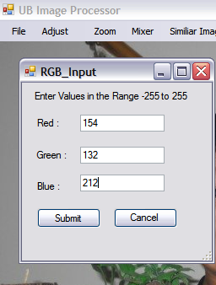
  - Brightness:
This function is used to increase or decrease the brightness of the image. It takes the user Input for Brightness component within the range of -255 to 255 and adds the same component to the pixel’s RGB values.
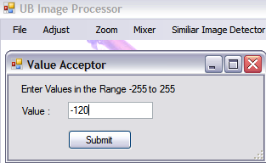
  - Contrast:
This function changes the contrast values of the image. It takes the User Input for Contrast in Range of -100 to 100, and internally divides the number by 100 and adds 100 % to it to get the percentile value. The Value is then processed to get the contrast component for each Red, Blue and Green Component of Pixel.
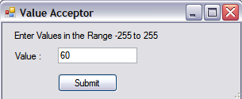
Input: contrast 60
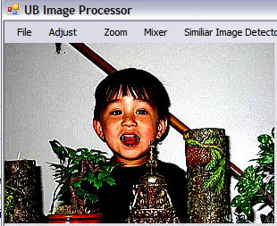
Resultant Picture after Change of Contrast
  - Invert Color:
This Function is used to change the color to opposite value, sometime it is also called the negative image generator. It inverts the pixel values stored by each RGB component of each Pixel. To invert the Pixel, each RGB weight is subtracted by 255 which is the maximum weight for each component.
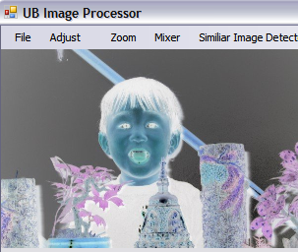
Picture: Resultant Image of Inversion of Color
  - Gamma:
This Function is used to change RGB values of image through gamma input. It is also same as changing Color component but instead of the RGB weight values only the Gamma Values of RGB are provided ranging only between 0.2 and 5. The Gamma value for new bitmap image is calculated based on the formula
GammaVal[i] = MinimumOf(255,(255 * i/255(Power(1.0/red))+ 0.5))
Where i is the value ranging from 0 to 255. Each Gamma Value is calculated for indivisual Red, Blue and Green Components.
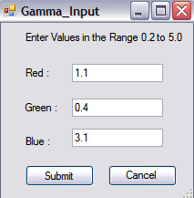

- Image Zoom Feature

  - 25 % :
This Feature shrinks the image size to 25 percentage of actual image size.
  - 50 % :
This Feature shrinks the image size to 50 percentage of actual image size.
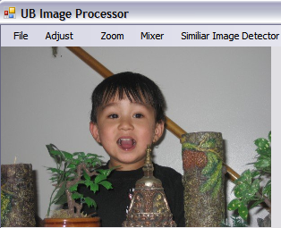
Pic: Image Zoomed to 50%
  - 100 % :
This Feature gets the original size of the image.
  - 200 % :
This Feature blows up the image size to 200 percentage of actual image size.

- Image Mixing Feature

  - Smooth
This Feature is used to remove the sharp contrasting pixels from the image to give same shade to all the image. It adjusts the image with pixel values converted to a average range value eliminating the peak and dwarf pixels resulting in a smooth range pixel values. This function uses the pixel weight of 1.In this particular program we have taken the pixel smooth weight factor to be in addition of 8 to the actual weight of 1.

  - Sharpness
This Feature is used to get the contrasting feature of the image to expose the distinctiveness of an indivisual pixels. It adjusts the image with amplification of peak and dwarf pixel to a higher range so that the lower pixel difference is amplified to the higher value. This Function takes the pixel weight of 11. For sharpning the image pixel values to generate the sharp images, the weight factor is substracted by 8. The boundry for influencing the related pixel is limited to 2 on both side which results in 2*2*2 i.e., 8 pixel getting influenced.

  - Blurness
This Function is used when user needs to takeaway the clearity of the picture, it is useful when some scars on the face are to be removed . It blurs the images to nullify the sharp contrast difference between the surrounding pixels. It uses the weight 4 with weight factor of 12
  - Mean Removal
This Function is used when the overall commonness of the image is to be removed for analysis or only to see the differential pixels of the images. It removes the common or mean pixel value from the entire RGB component so that only the pixels above the mean values are visible. The resultant RGB component is always original value minus mean value hence the name Mean Removal function.
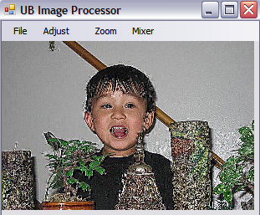
Picture: Resultant Picture after Mean Removal

- Similar Image Detector
This tool is used to find similar images in a selected folder with many images. This tool also provides with how much percentage the images are matching with each other. The more the percentage the more likelihood the image is same or at least from same shot.
This has 2 practical implementations:
- Finding Duplicate images
- Finding images generated from the same shot (E.g. Consecutive images generated from video shot)

This detector calculates the edit distance between each relative pixel between two images to find the total “Edit Distance”. It uses “Levenshtein Distance Algorithm” to find the edit distance. This distance is found from two bitmap images with 256 * 256 pixel matrix which is then mapped to similar image and the pixel distance between corresponding matrix entries is calculated. The lesser the edit distance the more chances that the image are similar.

When user clicks on this function the new window pops up asking user to select the Folder containing images. Once the Image folder is selected and the process button is pressed, the process of comparison starts with the progress bar notifying the overall progress of the process.

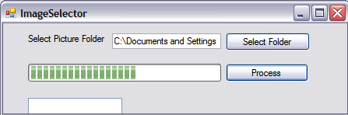

Picture: Dialogue to Select the image folder and Process it

Once the Images are searched, the list on the left will list out all the images which are listed as similar to other images. When the user selects the image from that list, the second list on bottom right hand side pops up with all the images which are similar to the selected image on left along with the percentage of matchup between those images. Both the selected images from both lists will be displayed as a preview image on top. As the images are changed, the preview window keeps showing the respective pictures.

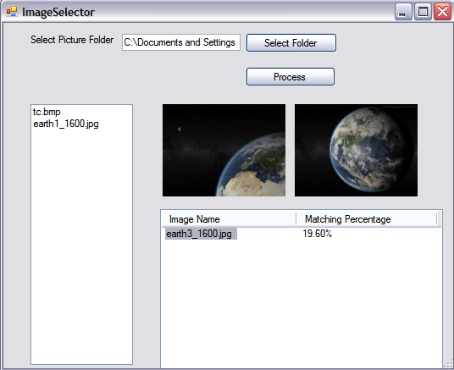

Picture: Shows the 2 images selected on left and right side with matching percentage of 19.60 %

This process makes use of threading as the calculation to be done is in large scale. The program calculates the total number of images and creates 10 threads. It then divides the processing of images equally to all 10 threads, so all the threads get equal number of images to process and the process is speeded up roughly 10 times faster.

Limitation:

Known issues which were not implemented/rectified due to time constraints:

The Image once modified cannot be reverted back to original state (Undo Feature)

The custom zoom is not available so it is limited to only 4 options.

Image Selection for Cropping is not provided.

User input for Blur, Sharpen, Smooth and Mean Removal is not provided instead the static value is used.

Similar Image Detector tends to be showing error if the folder contains other non image files.

User comparison of user selected image is not provided

Conclusion:

In this way an image editing tool was developed with enhanced facility to change the characteristic properties of Images along with an additional tool to compare image similarity to find the matching images.

References:

Graphics Programming with GDI+ by Mahesh Chand

C# Image Processing, Paper, by Asif Mahmood

Introduction to GDI+ in .NET, www.Codeproject.com/ KB/GDI-plus/GDI_.aspx

http://en.wikipedia.org/wiki/Levenshtein_distance

Fast, memory efficient Levenshtein algorithm , Source : http://www.codeproject.com/KB/recipes/Levenshtein.aspx

