## ­­EduViz – Lean Approach

This project lends itself well to *Lean.* The focus on producing code in quick cycles provides an enormous advantage—the opportunity to test, elicit feedback, and debug code quickly without waiting for other tasks to be completed. EduViz is a deeply involved project with strong collaboration between statisticians and developers—this works well with Lean’s emphasis on shared understanding throughout a project.

The idea of *work, learn, adjust* goes hand-in-hand with this visualization initiative. Most of the early stages of data visualization are for exploratory purposes (e.g., to understand the dataset). This gives rise to an opportunity for developers and team members to learn and understand the dataset together, and make appropriate adjustments in visualizations and organization of information as they arise.

## Lean Principles of Interest

In adapting this project to *Lean,* some of the Lean Principles stand out more than other. This section focuses on the most relevant and striking principles as they apply to the project.

### Cross-Functional Teams

The critical players that drive creation of deliverables are the statisticians and the developers. The initial, Waterfall-esque idea of a “hand-off” of datasets or code will not suffice. Rather, statisticians and programmers need to work together; it is critical that the programmers understand the dataset, and that the statisticians understand the way their data will be manipulated and transformed.

### Shared Understanding

On the whole, this project demands unparalleled skills in data analysis, programming, and visualization. It is impossible for any one team member to be an expert in every realm. Having all data, project files, and code available for all team members is integral. Using services like *GitHub*, and *iPython Notebook,* members of the team can more readily discuss and target technical facets of the project. For instance, a statistician might say “I have a question about lines 240-255 in the *vis.js* file.”

A programmer can then pull up the code and discuss it with relative ease, rather than trying to give a long-winded explanation full of computer jargon that might not be comprehensible or user to the statistician.

### Small Batch Size

Given the gargantuan dataset (17 years, tens of thousands of rows and 1700 variables), small batch size is essential to making measurable progress. Rather than releasing a tremendous dataset to a hapless programmer, it is sensible to divide the data into a more manageable unit for inspection. For instance, the statisticians may choose to begin with one year of data, and one set of related variables (perhaps completion rates, repayment rates, etc.)

This allows our data viz programmers to generate a smaller visualization in less time. The advantage of this is that:

1. It helps statisticians to understanding a critical component of their dataset
2. It gives a simple visualization that can be more easily understood by members of the team, stakeholders, and the customers
3. It gives initiative and direction to which data elements should be explored next

This principle is perhaps the most relevant for the project. The following section will explain the MVP (minimum viable product).

## Minimum Viable Product

The completed product will be intricate, aesthetic, and informative. It will contain several dashboard visualizations, narrative explanation, and tools for users to explore further. However, this can’t be accomplished without incremental understanding of the dataset as well meaningful discussion on findings.

The idea of trying to release the entire project in one go is not feasible. In this case, an *MVP* might look like this:

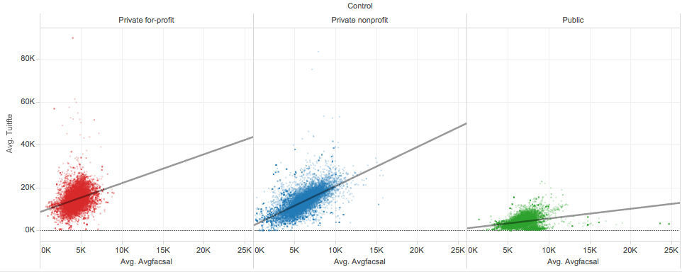

Pictured is a visualization that only uses part of the dataset. The data that relates to internal school expenses and revenue is used; this is only a small subsection of the actual dataset. The chart plots average tuition expenditures per full-time student on the y-axis, and average monthly faculty salary on the x-axis. Each pane is a different type of school; red is private for-profit universities, blue is private non-profit, and green is public. Each dot is a university in 2013.

This is a concise visualization that leads to interesting discussions and exploration about the data. Some questions might be “why do public universities spend so much less on their students?” or “is it worth it for faculty members to work at a for-profit institution?”

A small visualization such as this one is successful in:

1. Bringing some understanding to the dataset as a whole
2. Inciting meaningful discussions about higher-education institutions
3. Having a tangible and interactive product that stakeholders and the customer can use
4. Giving the customer an idea of what they can expect in later deliveries