Test Suite

Test Plan

v.2.0



Team Members:

Cavaughn Browne

Christian Norfleet

Damien Moeller

Aimee Phillips

**Table of Contents**

**1. Introduction** **2**

1.1. Product Overview 2

1.2. Test Types 2

1.2.1. Unit Testing 2

1.2.2 Integration Testing 2

1.2.3 System Testing 3

**2. Scope and Objectives** **3**

2.1. Unit Testing 3

2.2. Integration Testing 3

2.3. System Testing 3

**3. Resources** **4**

3.1. Human 4

3.2. Hardware and Software 4

**4. Test Schedule** **5**

**5. Test Scenarios** **6**

**6. Revision History** **9**

**7. References** **9**

# **1. Introduction**

The purpose of this document is to describe the testing for the Test Suite application. This document describes the scope of testing, activities to be completed, schedule and resources used for the testing the system before it is delivered.

## 1.1. Product Overview

The Test Suite creates appropriate test data for early undergraduate computer science student’s programs. The test suite is to be run concurrently with the program being tested [the test suite does not run the program]. The Test Suite allows for a variety of test settings that can be saved for later use. After running the test suite can then save a report which can be reviewed by the student’s professor to help validate the program. During testing, if the student hand-writes expected results, they may compare them to the results, which is given by the program, and analyzed within the Test Suite.

## 1.2. Test Types

The following are the types of testing our team will carry while developing the Test Suite system:

### 1.2.1. Unit Testing

Unit testing is a level of software testing where each component is isolated and tested to discover errors before integrating the component into the system.

### 1.2.2 Integration Testing

Integration testing is a level of software testing where the interaction between the previously tested individual components of the system will be examined. Therefore, the individual components are combined and tested as a group.

### 1.2.3 System Testing

System testing is a level of software testing where after a complete integration test, the software is then tested in its intended environment with actual user input and user interactions.

# **2. Scope and Objectives**

## 2.1. Unit Testing

At regularly scheduled intervals and at the end of each module’s creation, the module will be subjected to review and testing by the coder and the rest of the team. The purpose of these tests is to ensure each module is correct and free from as much errors as possible. The issues to consider are correctly reading inputs from a source file, generating appropriate test cases for those inputs, suggesting proper test drivers, GUI functions such as comparing test results, saving/loading configurations and saving the test report) are working as expected and time.

## 2.2. Integration Testing

Integration tests will be done to ensure that the modules interface well with one another and there is no break in the flow of functionality. The modules will be integrated one after another as their unit testing is completed and tested. So, when all the modules are integrated, the final tests will prove that the system works as a complete integrated unit.

## 2.3. System Testing

This tests ensures that the system meets the requirements as specified in the system requirements document. The complete and integrated software will be tested in the actual environment where it will be used by the users of the software. Therefore, this assesses the software's quality ensuring any deficiencies are fixed before delivery. All possible inputs and activities are tested to make sure the software will perform as expected and the error count is miniscule when it is delivered.

# **3. Resources**

Paradigm’s Test Suite application will be tested using the following resources.

## 3.1. Human

The Paradigm development team is Cavaughn Browne, Damien Moeller, Christian Norfleet, and Aimee Phillips. The Test Suite is created with consulting with software engineering expert and customer Catherine Stringfellow.

## 3.2. Hardware and Software

The system will be tested using several computers. Each machine will have at least the following specifications:

* A 32 bit architecture.
* 1.6 GHz processor.
* At least 2 GBs of RAM.

The system will be tested on computers with at least the following software:

* 32 or 64 bit Windows Operating System.
* Visual Studio 2012 or later.

# **4. Test Schedule**

Figure 1 shows the testing process that Paradigm will carry out during development of the system. Testing during each iteration will be scheduled as followed:

Unit testing: As needed during module creation and for each module immediately after it is created.

Integration testing: After the completion of multiple modules. The activity should be performed until it can be said with certainty that modules act in an expected manner with each other.

System testing: After implementation of each module is complete and at least one week before delivery, system testing will be done to further assure the system is as correct as possible and satisfies the requirements.

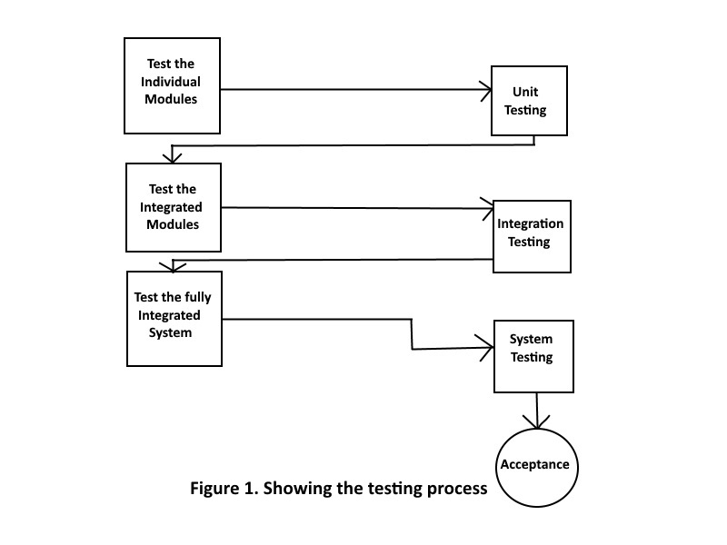

# **5. Test Scenarios**

|  |  |  |  |  |  |  |
| --- | --- | --- | --- | --- | --- | --- |
| # | Description | Input | Expected  Output (EO) | Actual Output (AO) | Passing Criteria | Test Result |
| 1 | Test for opening the source file by clicking | Click on the open file button or file->openfile then click double click test.cpp. | test.cpp | TBD | EO=AO | TBD |
| 2 | Test for opening file using pathname | Click on the open file button or file->openfile then typing the file path. | C:\Users\Damien\Documents\test.cpp | TBD | EO=AO | TBD |

**Table 1 Opening the file**

|  |  |  |  |  |  |  |
| --- | --- | --- | --- | --- | --- | --- |
| # | Description | Input | Expected  Output (EO) | Actual Output (AO) | Passing Criteria | Test Result |
| 1 | Test case generation for empty file | Empty.cpp (empty file) | Empty list for test inputs and variables | TBD | EO=AO | TBD |
| 2 | Random test case generation at test level 1 | Randtest.cpp (program with multiple cin and file input statements) | Variables: testInt, testChar, testDoub  Test Inputs: (random integer value)  (random char value)  (random double value) | TBD | EO=AO | TBD |
| 3 | Random test case generation at test level 2 | Randtest.cpp (program with multiple cin and file input statements) | Variables: testInt, testChar, testDoub  Test Inputs: (random char value)  (random char value)  (random char value) | TBD | EO=AO | TBD |
| 4 | Random test case generation at test level 3 | Randtest.cpp (program with multiple cin and file input statements) | Variables: testInt, testChar, testDoub  Test Inputs: (random string value)  (random string value)  (random string value) | TBD | EO=AO | TBD |
| 5 | Boundary test case generation at test level 1 | Boundtest.cpp (program with statements  int testval;  cin >> testval; and  if (testval >= 1)) | Variables: testval, testval  Test Inputs: 1, 0 | TBD | EO=AO | TBD |
| 6 | Boundary test case generation at test level 2 | Boundtest.cpp (program with statements  int testval;  cin >> testval; and  if (testval >= 1)) | Variables: testval, testval, testval, testval  Test Inputs: 1, 0, 2147483648,  -2147483649 | TBD | EO=AO | TBD |
| 7 | Boundary test case generation at test level 3 | Boundtest.cpp (program with statements  int testval;  cin >> testval; and  if (testval >= 1)) | Variables: testval, testval, testval, testval, testval, testval  Test Inputs: 1, 0, 2147483648,  -2147483649,  0.9, 1.1 | TBD | EO=AO | TBD |
| 5 | Loop test case generation at test level 1 | Looptest.cpp (program with statements  int testval;  cin >> testval; and  while (testval >= 1)) cin >> testval; | Variables: testval, testval, testval, testval, testval, testval  Test Inputs: 0, 1, 0, 1, 1, 0 | TBD | EO=AO | TBD |
| 6 | Loop test case generation at test level 2 | Looptest.cpp (program with statements  int testval;  cin >> testval; and  while (testval >= 1)) cin >> testval; | Variables: testval, testval, testval, testval, testval, testval, testval, testval  Test Inputs: 0, a, 1, a, 0, 1, 1, 0 | TBD | EO=AO | TBD |
| 7 | Loop test case generation at test level 3 | Looptest.cpp (program with statements  int testval;  cin >> testval; and  while (testval >= 1)) cin >> testval; | Variables: testval, testval, testval, testval, testval, testval, testval, testval, testval, testval  Test Inputs: 0, a, 1, a, 0, 1, 1, 0, 1 0, 1 1 0 | TBD | EO=AO | TBD |

**Table 2 Test case generation**

|  |  |  |  |  |  |  |
| --- | --- | --- | --- | --- | --- | --- |
| # | Description | Input | Expected  Output (EO) | Actual Output (AO) | Passing Criteria | Test Result |
| 1 | Test for results comparison | “Test1” into HW result field, “Test1” into Program result field | √ | √ | EO=AO | Passed |
| 2 | Test for results comparison | “Test1” into HW result field, “1tseT” into Program result field | X | X | EO=AO | Passed |

**Table 3 Result comparison**

|  |  |  |  |  |  |  |
| --- | --- | --- | --- | --- | --- | --- |
| # | Description | Input | Expected  Output (EO) | Actual Output (AO) | Passing Criteria | Test Result |
| 1 | Test for generating test driver | Click generate test driver after a source file is opened. | Files are produced which can run the input classes. | TBD | EO=AO | TBD |

**Table 4 Test driver generation**

# **6. Revision History**

|  |  |  |
| --- | --- | --- |
| Date | Revision History | Comment |
| 01/11/2017 | v.1.0 | Document Draft |
| 4/19/2017 | v.2.0 | Revised draft document - complete test plan |

# **7. References**

"Integration Testing." *Software Testing Fundamentals*. N.p., n.d. Web. 10 Apr. 2017. <http://softwaretestingfundamentals.com/integration-testing/>.

Kung, David Chenho. *Object-oriented Software Engineering: An Agile Unified Methodology*. New York, NY: McGraw-Hill, 2014. Print.