
Test Suite

Requirement Document

Christian Norfleet
Aimee Phillips
Cavaughn Browne
Damien Moeller
Table of Contents

1. Introduction
1.1. Main Objective
1.2. Specific Goals
1.3. Overview of Document

2. Users
2.1. Expected users
2.2. Use Cases
2.3. Scenarios

3. System
3.1. Development and Target Environments
3.2. Functional Requirements
3.2.1. Issues
3.2.2. Major Functions
3.2.3. Major Classes
3.2.4. Minor Functions
3.3. User Interface Specifications
3.4. Non-Functional Requirements
3.4.1. Management and Technical Information
3.4.2. System Evolution/ Maintenance

4. Other Deliverables required

5. Risks

6. Glossary of terms used in this document

7. References
1. Introduction

The purpose of this document is to lay out detailed outline of our software and goals. Students from CMPS 1044 to CMPS 3013 often have problems with testing their programs. Students currently submit programs without proper testing due to lack of knowledge of testing methods and tool-sets. Although the program might seem functional, the students may overlook possible faults and develop bad habits. This program will aid said students by parsing code and generating applicable test cases and test drivers.

1.1. Main Objective

The main objective is to create a test suite for students to use to test their programs. This testing program will also provide a user friendly GUI to produce a test report that the users can use to improve their programs. The development will transpire over a period of three months. This program will be open source to enable future teams to expand the feature set of functions to be implemented.

1.2. Specific Goals

The client requires testing program to be compatible with the C++ language. This program will be designed for the windows environment. The interface will feature open dialogue box for file submission, and will allow user to select various languages, various test methods, and levels of test.

1.3. Overview of Document

The rest of the items in this document will address hardware requirements, software requirements, future users, all functions and constraints, and GUI (Graphical User Interface) requirements.

2. Users

This section describes who are the users of the system and how they will interact with it. Expected users, use cases, and scenarios are described in detail below.

2.1. Expected Users

The users of this system will be Computer Science Undergraduates from the introductory Computer Science course CMPS 1044 to the CMPS 3013 Advance Structures and Algorithms.

2.2. Use Cases

The following are the use cases (see Figure 1):
  - Generate Test Cases
  - Suggest Test Scripts
  - Produce Testing Report Document
  - Save Testing Report Document

Use Case Diagram:
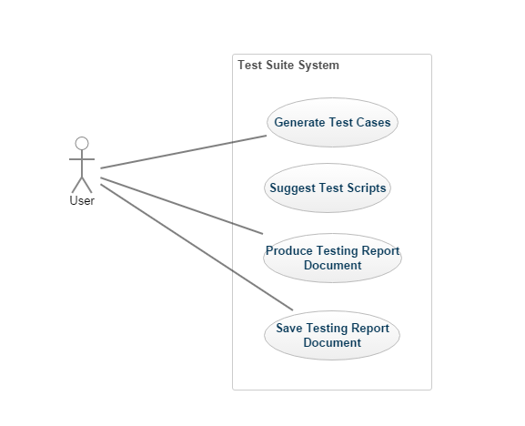
Figure 1. Use case diagram

2.3. Scenarios

Subject | Action of Subject | Object Acted Upon
File dialogue | opens | file
Language checkbox | chooses | Language flag
Level checkbox | chooses | Level flag
Test checkbox | chooses | Method flag
Test generator | creates | test report
Results table | compares | results
File dialogue | saves | test report

3. System

This section analyzes and list requirement specifications that the system must meet set by the customer and the users. The system's development and target environment, functional and non-functional requirements.

3.1. Development and Target Environment

The development environment consist of Windows and Visual Studio. The target environment consist of a similar system. It is recommended that the user system consist of:
- Software: Windows OS, Microsoft Visual Studio
- Hardware: Personal desktop or notebook computer, CD Drive or USB port

3.2. Functional Requirements

The Functional requirements for the system include:
- Must be able to give sets of test cases for input source file code.
- Must be able to read source code files.
- Must be able to produce test variables and test drivers.
- Must be able to compare expected results and program results
- Must be able to produce a template for a testing report document based on current session tests.
- Must be able to save testing report document.

3.2.1. Issues
The following are a number of issues that will be addressed during development:
- Parse a specified file for input.
- Generate a test report for current session.
- Create a user friendly GUI that is easy to work with.
- Generate the different types of test cases.

3.2.2. Major Functions
The major functions of the system consist of:
- Read Source code.
- Generate test cases or drivers.
- Create testing report.
- Save testing report.
- Compare results

3.2.3. Major Classes
The major classes of the system consist of:
- Test Generator.
- Test Interface.

3.2.4. Minor Functions
The minor functions of the system consist of:
- Check data type.
- Read class functions.

3.3. User Interface Specifications
In accordance to the customer’s needs, the preliminary user interface should consist of at
least the following:
- Main window with title text and window management buttons
- Main menu (file, about, etc)
- Check Boxes for the options given to the user
- Grid for displaying generated test cases, input, expected output, and the source file program output.
- Buttons (save, check expected results with the actual results, etc)

3.4. Non-Functional Requirements
The nonfunctional requirements consist of:
- Must be extendable to reading more languages over time.
- Must be scalable to allow for other types of testing methods.
- Must be able to run on Windows Operating Systems.
- Source code must be in C++ (.cpp and .h).

3.4.1. Management and Technical Information
No financial cost during project development. The software must be developed during a three month period within the spring 2017 semester, and finished by May 2017. The system must run on Windows 7 or above, and the program code will be written in C#. The system will make at most one pass per test session over the source file.

3.4.2 System Evolution/ Maintenance
The system will be developed with expansion in mind. The system will be passed on, so that in the future it will be able to analyze additional languages and use various other testing methods.

4. Other Deliverables required
Paradigm will deliver the given by the deadline:
- User manual
- Final report
- Test plan & report
- Design diagrams
  - UML class diagram
  - UML sequence diagram
  - State Transition diagram
  - Navigation diagram

5. Risks

Risk | Probability | Impact | Mitigation
Lack of communication between team and customer | high | high | Ensure frequent customer meetings.
General conceptualization | medium | high | Communication between team members.

6. Glossary of terms used in this document
CMPS – Computer Science
GUI - Graphical User Interface
UML - Unified Modeling Language

7. References

Stringfellow, Dr. Catherine
Kung, David Chenho. Object-oriented software engineering: an agile unified methodology. New York, NY: McGraw-Hill, 2014. Print.

