Client Requirements

Project Goal

* Create a scheduling web application for field services and improve automated scheduling process
* Our primary user would be the Dispatcher scheduling work for field technicians and resources

Requirements

* Booking interface that allowed Dispatchers create, update, view, delete Work Orders
* Dispatchers can schedule and dispatch Technicians and resources to fulfill Work Orders
* Utilize a Gantt chart where Dispatchers can drag work orders into technician and Resources schedules

Sched

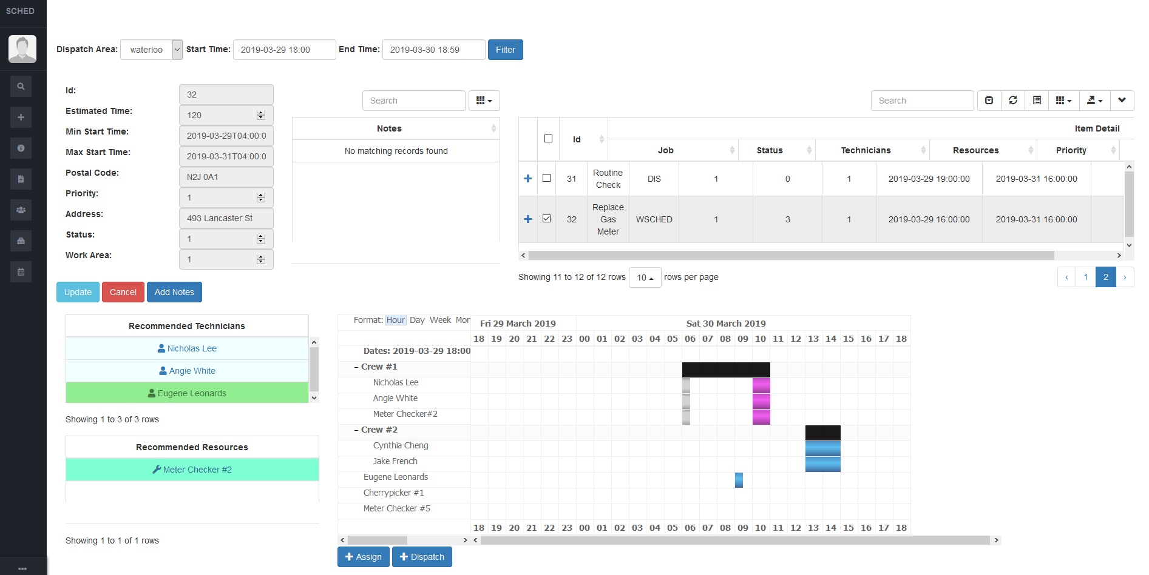

Technologies

ASP.NET

Microsoft Server Database

jsGantt Improved

Innovations

Recommendations of Technicians/Resources

* Based on distance, availability, gamfication, cost

Single dashboard view, allowing Dispatchers to toggle different information they may want to view while completing scheduling

An interactive visual experience for Dispatchers via being able to drag, drop and move Work Orders on a Gantt chart to complete scheduling

Obstacles/Lessons Learned

jsGantt Improved Limitations

* An open source javascript library that creates a Gantt chart however required many changes to meet client requirements

jsGantt Improved Limitations Solution

* We updated and enhanced code to be used as a scheduler allowing multiple Work Orders to be assigned to Technicians/Resources, displayed in combined rows which displayed significant Work Order information on hover over time slots and drag functionality, allowing updating of work order time with a simple drag and drop

How to solve the gap between List and Chart

* We can display work order information and we can display the gantt chart but how do we link them?
* We used Droppable to be able to grab data from the Work Order List and move it into the Gantt chart for scheduling. We updated the draggable Work orders to highlight Technicians and Resources that match selected Work Order requirements as well as matched the look and size of the time slots providing Dispatchers a relative visual to what it would look like in the Gantt Chart