Table of Contents
Team Members 4
Member Roles 4
Expectations 6
Consequences 6
Agreement 6
Business Purpose: 7
Project Roles/Responsibilities: 8
Event Table: 8
Features List: 11
System Objectives: 12
Project Critical Success Factors: 12
Preliminary Technical Architecture: 13
Header Comments 20
Identifier Formatting 20
Object Naming 20
Variables/Constants 21
Curly Braces 21
Spacing 21
Methods 21
Exception Handling 22
Attendance 23
Agenda 23
Deliverables 23
Action Items (Copy incomplete action items from previous Meeting Agenda / Minutes) 24
What 24
Minutes / Notes 24
Attendance 25
Present 25
Agenda 25
Deliverables 25
Action Items (Copy incomplete action items from previous Meeting Agenda / Minutes) 26
What 26
Minutes / Notes 26
Attendance 27
Present 27
Agenda 27
Deliverables 27
Action Items (Copy incomplete action items from previous Meeting Agenda / Minutes) 28
What 28
Minutes / Notes 28
Attendance 29
Present 29
Agenda 29
Deliverables 29
Action Items (Copy incomplete action items from previous Meeting Agenda / Minutes) 30
What 30
Minutes / Notes 30
Attendance 31
Present 31
Agenda 31
Deliverables 31
Action Items (Copy incomplete action items from previous Meeting Agenda / Minutes) 32
What 32
Minutes / Notes 32
Attendance 33
Present 33
Agenda 33
Deliverables 33
Action Items (Copy incomplete action items from previous Meeting Agenda / Minutes) 34
What 34
Minutes / Notes 34
Team Member Activities 35
Team Activty 35
Issues/Obstacles/Dependencies/Problems 35
Team Member Activities 36
Category 36
Team Activty 36
Issues/Obstacles/Dependencies/Problems 36
Team Member Activities 37
Category 37
Team Activty 37
Issues/Obstacles/Dependencies/Problems 38
Team Member Activities 39
Category 39
Team Activty 40
Issues/Obstacles/Dependencies/Problems 41
Team Meetings and Activities 42
Issues/Obstacles/Dependencies/Problems 42

Team Charter

Team Members
Cynthia Cheng ccheng5421@conestogac.on.ca
Nicholas Lee nlee6989@conestogac.on.ca
Thomas Craig tcraig1398@conestogac.on.ca
Chris Banks cbanks4667@conestogac.on.ca

Member Roles

Project Management
Team leadership | Cynthia Cheng
Project planning | Thomas, Chris
Project record-keeping | Cynthia, Nicholas
Analysis, Design and Documentation
Interacting with clients | Cynthia, Nicholas, Thomas, Chris
Diagramming and documenting client requirements | Cynthia, Nicholas, Thomas, Chris
Diagramming and documenting overall design | Cynthia, Nicholas, Thomas, Chris
Technical documentation | Cynthia, Nicholas, Thomas, Chris
Client documentation | Cynthia, Nicholas, Thomas, Chris
Web Development
Creating web graphics | Cynthia, Nicholas, Thomas, Chris
Web site design | Cynthia, Nicholas, Thomas, Chris
Web page design | Cynthia, Nicholas, Thomas, Chris
Web programming | Cynthia, Nicholas, Thomas, Chris
Interactive testing | Cynthia, Nicholas, Thomas, Chris
Business Layer Development
Class design | Cynthia, Nicholas, Thomas, Chris
Business programming | Cynthia, Nicholas, Thomas, Chris
Technical / lower-level programming | Cynthia, Nicholas, Thomas, Chris
Unit and integration testing | Cynthia, Nicholas, Thomas, Chris
Database Development
Database design | Cynthia, Nicholas, Thomas, Chris
SQL/LINQ Devlopment | Cynthia, Nicholas, Thomas, Chris
Other
Report development | N/A
Installer development | N/A

Expectations

Equal sharing of work.

Attending all meetings on Mondays and Wednesdays. If unable to attend, notify by team chat latest 8am day of meeting.

Creating deliverables on time (Wednesdays). If unable to meet expected timeframe, notify teammates via team chat to arrange back-up meeting for Thursday to discuss issues.

Any ideas, issues, etc. must be informed to group ASAP via team chat

Consequences

If a member misses a scheduled meeting (Monday and Wednesday) without giving advanced notice they must buy a pack of 20 timbits for the following meeting.

If a member is unable to complete their share of work and did not make alternative arrangements as per above, the member will 10% per missed deliverable.

Agreement

Each team member must sign the charter. The Team Charter can be revised at any time during the project with the consent of all team members.
Cynthia Cheng __________________ Date:
Nicholas Lee __________________ Date:
Thomas Craig __________________ Date:
Chris Banks __________________ Date:

Project Charter

Business Purpose:
Create a scheduling web application for field services and improve automated scheduling process. Dispatchers will be able to schedule Technicians and Resources to fulfil Work Orders. Dispatchers will be recommended Technicians and Resources based on the Job requirements in the Work Order, availability, Resource requirements, and geographic proximity of preceding job site within a regional work area.

Project Roles/Responsibilities:
Circumference Team:
Product Owner and Project Management: Daniel Heidt and Ted Byers
Mentors: Daniel Heidt, Ted Byers, Diane MacMartin, Ian MacIntyre

Conestoga College SCHED Team:
*First name is lead, followed by support
Project Management: Cynthia Cheng, Nicholas Lee, Thomas Craig, Chris Banks
Work Orders: Nicholas Lee, Cynthia Cheng, Thomas Craig, Chris Banks
Booking Interface (Without Gantt Chart): Cynthia Cheng, Chris Banks, Thomas Craig, Nicholas Lee
Booking Interface (Gantt Chart): Thomas Craig, Chris Banks, Nicholas Lee, Cynthia Cheng
Automatic Scheduler: Cynthia Cheng, Christ Banks, Thomas Craig, Nicholas Lee
Map Interface: Chris Banks, Cynthia Cheng, Nicholas Lee, Thomas Craig

Event Table:

Event | Trigger | Source | Use  Case # | Use Case | Response | Destination
Dispatcher can view Dashboard | Dispatcher logs into Scheduler | Dispatcher | UC01 | View Scheduler Dashboard | Scheduler Dashboard is displayed.  Contains the following:  Work Order List  Gantt Chart  Filtering Options | Dispatcher
Dispatcher wants to add a new Work Order | Add Work Order | Dispatcher | UC02 | Add a Work Order | Work Order is added to be scheduled | Database
Dispatcher views a Work Order | Select Work Order | Dispatcher | UC03 | View a Work Order | Work Order details can be viewed | Dispatcher
Dispatcher wants to update an existing Work Order | Update Work Order | Dispatcher | UC04 | Update a Work Order | Work Order details are updated | Database
Dispatcher wants to cancel a Work Order | Cancel Work Order | Dispatcher | UC05 | Cancel a Work Order | Work Order is cancelled | Database
Dispatcher wants to filter the Work Orders | Filter Work Order Panel | Dispatcher | UC06 | Filter Work Order List | Work Orders can be filtered to display relevant Work Orders | Dispatcher
Dispatcher wants to search for a Work Order | Search | Dispatcher | UC07 | Search for a Work Order | Work Order can find a specific Work Order | Dispatcher
Dispatcher wants to assign a Resource to a Work Order in Gantt Chart | Drag and drop Resource onto Gantt Chart | Dispatcher | UC08 | Schedule Resource for Work Order | Resource has been scheduled into assigned status for a Work Order | Dispatcher
Dispatch wants to assign a Technician to a Work Order in Gantt Chart | Drag and drop Technician onto Gantt Chart | Dispatcher | UC09 | Schedule Technician for Work Order | Technician has been scheduled into assigned for a Work Order | Dispatcher
Dispatcher wants to remove a Resource from a Work Order in Gantt Chart | Link beside Resource’s name | Dispatcher | UC10 | Cancel Work Order assignment of Resource | Resource is no longer assigned to Work Order | Dispatcher
Dispatcher wants to remove a Technician from a Work Order in Gantt Chart | Link beside Technician’s name | Dispatcher | UC11 | Cancel Work Order assignment of Technician | Technician is no longer assigned to Work Order | Dispatcher
Dispatcher wants to change Work Order’s scheduled time in Gantt Chart | Drags Work Order to different time slot | Dispatcher | UC12 | Work Order time slot is updated | Work order is updated with new timeslot | Dispatcher
Dispatcher wants to view a single day in the Gantt Chart | Date option in Gantt Chart | Dispatcher | UC13 | View a single date in Gantt Chart | Gantt chart is zoomed in to display selected date | Dispatcher
Dispatcher wants to view multiple days in the Gantt Chart | Date option in Gantt Chart | Dispatcher | UC14 | View multiple dates in Gantt Chart | Gantt chart is zoomed out to display multiple days | Dispatcher
Dispatcher wants to complete dispatching schedule | Complete Dispatch Link | Dispatcher | UC15 | Dispatch Schedule | Assigned Work Orders in Gantt Chart are Dispatched to Technicians and Resources | Dispatcher
Dispatcher wants to see information of assigned Work Orders in Gantt Chart | Hover over an assigned timeslot in Gantt Chart | Dispatcher | UC16 | View Assigned Work Order Information | Condensed Work Order information is displayed | Dispatcher
Dispatcher uses automatic scheduler | Automatic Scheduler turned on | Dispatcher | UC17 | Use Automatic Scheduling | Gantt Chart schedule is filled with automatic scheduler based on customized business rules | Dispatcher
Dispatcher wants to view Technician and Resource locations in comparison to Work Order location on a map | Map link | Dispatcher | UC18 | View Location Mapping | A map identifying Technicians and Resources locations of preceding Work Order location to Work Order location being scheduled | Dispatcher
Dispatcher wants to know the estimated time of arrival of a Technician or Resource for a Work Order | Hover over Technician/ Resource | Dispatcher | UC19 | View Technician or Resource ETA | Display estimated time of arrival of a Technician or Resource from preceding Work Order location to Work Order location being scheduled | Dispatcher

Features List:

Booking interface (Not including Gantt Chart)
- Dispatchers are able to add, view, update, and delete Work Orders and their details
- Dispatchers are able to add notes to Work Orders
- Dispatchers are able to filter and search Work Orders
- Dispatchers are able to select, assign, and dispatch Work Orders
- Dispatchers are able to drag and drop Work Orders, Technicians, and Resources to be scheduled in a Gantt Chart
Booking Interface (Gantt Chart)
- Dispatchers can view a scheduled Work Order’s key customer information in Gantt Chart
- Dispatchers can view a single or multiple days schedule in the Gantt Chart
- Dispatchers can drag and drop Technicians and Resources in the Gantt Chart to schedule Work Orders
- Dispatchers are able to change Status of Work Order
Automatic Scheduler
- Dispatcher can enable Automatic Scheduler to recommend scheduling for a day / week according to customizable business rules
- Dispatcher can edit an automatically generated schedule before dispatching
- Dispatcher and Automatic Scheduler can’t override bookings made via portal
- Dispatcher is able to complete Dispatch functionality
- Dispatcher is able to Retract WO functionality
Map Interface
- Dispatcher can view location of Technicians and Resources
- Dispatcher can view a hot call Work Order Location and status of nearby Technicians at time of hot call
- Dispatcher can view the ETA for a Technician from the preceding Work Order to Work Order being scheduled

System Objectives:

- System should be available at all times except for scheduled maintenance periods.

- All transactions must provide less than 2 seconds response time

- System must be able to retain above response time when systems are upgraded/scales to for a larger database

- Web application must be easy to navigate and provide relevant content to users

Project Critical Success Factors:

- Deliverables completed as per project plan schedule

- Timely iteration feedback

- Ability to discuss with Client about any project questions, business requirements, and updates for the duration of the project

Preliminary Technical Architecture:

- .Net

- C#

- SQL Server

- ASP.Net

Project Plan

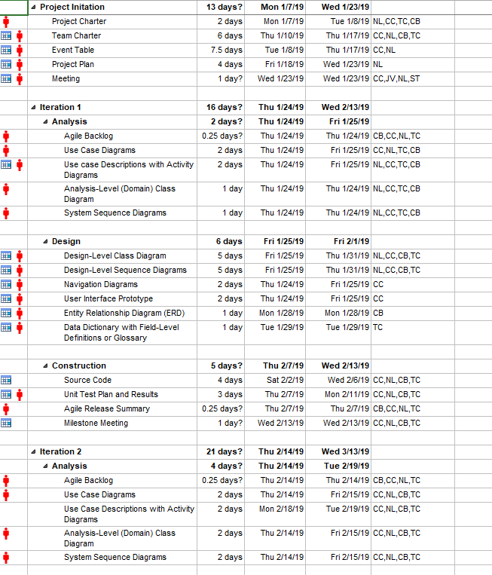

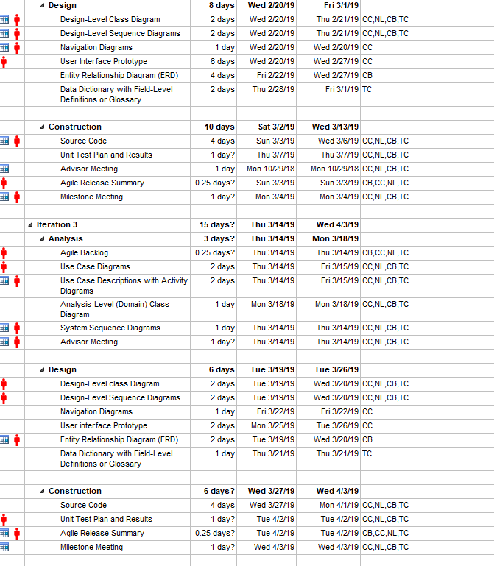
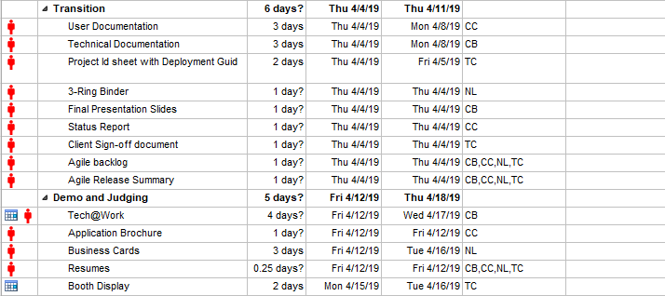

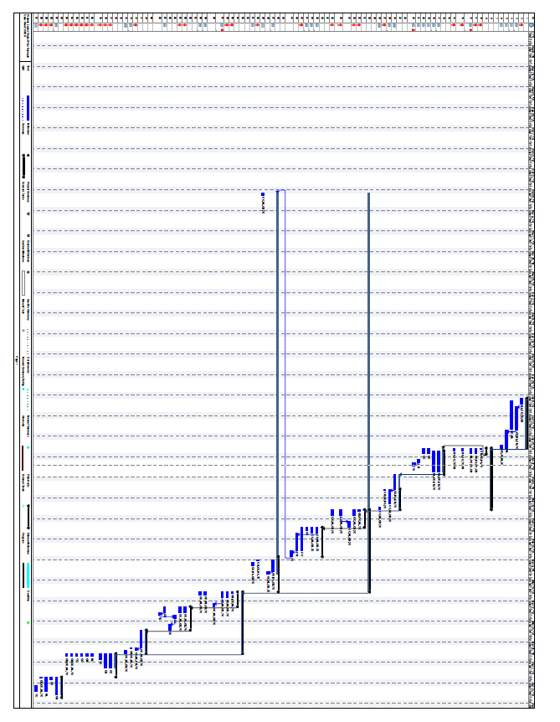

Project Coding Standards

Header Comments
The header comments should include:
- Class Description

Identifier Formatting
Element | Format | Example
Class | PascalCase | BankAccount
Interface | PascalCase | IEnumerable
Static Object | ALL UPPERCASE | DEPOSIT
Method Parameter | camelCase | userName
Variable | camelCase | firstName
Constant | ALL UPPERCASE | TAX_RATE
Namespace | PascalCase | Property.Basement
Property | PascalCase | GetUserName
Method | PascalCase | AddUser
Enumeration | PascalCase | MyConstant
Event | PascalCase | LaunchProgram
Database Table | snake_case | order
Database Column | snake_case | order_id
Database Key Words | ALL UPPERCASE | ON

Object Naming
The object names will be prefixed with the abbreviated name of the type of object. The objects themselves will be named with entire words with no abbreviations
Examples:
- TextBox – txtFirstName
- Label – lblFirstName
- Button – btnGenerate

Variables/Constants
- All variables will be created on separate lines
- All variables will be initialized after they are created
- All variables should be accessed using properties outside of the class, not directly
- All constants will be declared globally (class scope)
Examples:
- string firstName = ””;
- int number = 0;

Curly Braces
- All of the code between curly braces should be indented 1 tab space (including nested brackets)
- Closing curly braces should appear on a separate line
Example:
If (x = 0) {
//code here
}

Spacing
- A blank line should appear before and after a control construct (if, for, while, etc)
- A blank space should appear after each comma in a comma-separated list
- A line of code should be split into several lines if it extends further than the code window
- A space should appear before and after operators such as > < =.

Methods
- All method parameters should be of a certain type, not generic like object
- Any methods that has multiple return paths should have a return statement associated with each
- A single method should fulfill a single task and should not be broad in its purpose
- Any major operations (i.e. DB Access) should not be handled within an event handler, and should be called in a separate method
- Documentation comments should appear above each method indicating its purpose, parameters and return value
- Implementation comments will be provided for explaining complex logic

Exception Handling
- A try-catch block should be looking for specific exceptions where known
- A try-catch block should always have a catch for general exceptions
- The catch block should not be left empty
- A try-catch block should not enclose the entire method code, only the part that will throw an exception

Meeting Agenda / Minutes

Location: Doon Collaboration Room 3 Date: 2019.01.10 Time: 09:15
YYYY MM DD HH MM

Attendance
Present | Regrets | Status  Report?
Nick Lee
Cynthia Cheng
Daniel Heidt
Ted Byers
 | Team Status Report?

Agenda
1st Meeting – General Introductions | Complete
Review Initial Project Plan | Complete

Deliverables
Start looking into available Gantt libraries
Review SCHED requirements document
Circumference to provide examples of rough expected wireframes

Action Items (Copy incomplete action items from previous Meeting Agenda / Minutes)
What | Who | When | Complete?
Look into available Gantt libraries | Cynthia Cheng, Nicholas Lee | In progress, required before Iteration 2
Review SCHED requirements document | Cynthia Cheng, Nicholas Lee | 2019.01.14
Examples of expected front end/wireframes | Daniel Heidt, Ted Byers | 2019.01.14

Minutes / Notes
General introduction to project and team members
Review Project Plan
Review expectations

Location: Doon Work Room 3 Date: 2019.01.14 Time: 12:30
YYYY MM DD HH MM

Attendance
Present | Regrets | Status  Report?
Nick Lee
Cynthia Cheng
Daniel Heidt
Ted Byers
 | Team Status Report?

Agenda
2nd Meeting, Review any questions about SCHED requirements
Discuss Wireframe and Navigation of app interface
Discuss existing Database architecture

Deliverables
Start looking into available Gantt libraries | List created, in review
Review SCHED requirements document | Completed
Circumference to provide examples of rough expected wireframes | Completed
Review Database
Begin Wireframing

Action Items (Copy incomplete action items from previous Meeting Agenda / Minutes)
What | Who | When | Complete?
Look into available Gantt libraries | Cynthia Cheng, Nicholas Lee | In progress, required before Iteration 2
Review SCHED requirements document | Cynthia Cheng, Nicholas Lee | 2019.01.14 | Complete
Examples of expected front end/wireframes | Daniel Heidt, Ted Byers | 2019.01.14 | Complete
Review current database files/structure | Cynthia Cheng, Nicholas Lee | 2019.01.18
Create Initial Wireframes | Cynthia Cheng, Nicholas Lee | 2019.01.18

Minutes / Notes
Reviewed SCHED requirements document
We were shared the incorrect team’s documents, this has been fixed
Discuss any questions from SCHED requirements

Location: Doon Collaboration Room 3 Date: 2019.01.16 Time: 18:00
YYYY MM DD HH MM

Attendance
Present | Regrets | Status  Report?
Nick Lee
Cynthia Cheng
Barbara Pridham
 | Team Status Report?

Agenda
1st Facilitator meeting - Introduction | Complete
Discuss possibility of combining group with Thomas Craig and Chris Banks | Complete
Review current documentation | Complete

Deliverables
Complete Inception Phase Documents to be reviewed 2019.01.23

Action Items (Copy incomplete action items from previous Meeting Agenda / Minutes)
What | Who | When | Complete?
Inception Phase Documentation Review | Cynthia Cheng, Nicholas Lee | 2019.01.23
Submit Inception Phase | Cynthia Cheng, Nicholas Lee | 2019.01.30

Minutes / Notes
General team introduction
As we were having difficulty finding a 3rd member, pitched the idea of adding Thomas Craig
And Chris Banks into our team as they had yet to get a capstone project
Reviewed location of documentation templates and what is required to complete inception phase
Agreed to have inception phase documents ready for next facilitator meeting for review before
Submitting for client sign off
Reviewed current documentation and client requirements

Location: Remote meeting view Join.me Date: 2019.01.18 Time: 08:45
YYYY MM DD HH MM

Attendance
Present | Regrets | Status  Report?
Nick Lee
Cynthia Cheng
Daniel Heidt
Ted Byers
 | Team Status Report?

Agenda
Review initial wireframes | Complete
Discuss any database questions | Complete
Discuss required fields to be displayed and general interface interactions | Complete
Discuss any missed areas/flow that should be added to wireframe

Deliverables
Start looking into available Gantt libraries | List created, in review
Review Database | Complete
Begin Wireframing | Complete

Action Items (Copy incomplete action items from previous Meeting Agenda / Minutes)
What | Who | When | Complete?
Look into available Gantt libraries | Cynthia Cheng, Nicholas Lee | In progress, required before Iteration 2
Review current database files/structure | Cynthia Cheng, Nicholas Lee | 2019.01.18 | Complete
Create Initial Wireframes | Cynthia Cheng, Nicholas Lee | 2019.01.18 | Complete
Think of color coding for different statuses, logic for suggested/recommended | Cynthia Cheng, Nicholas Lee | 2019.01.21
Review qualification logic requirements | Daniel Heidt, Ted Byers | 2019.01.21
Define skills table requirements | Ted Byers | 2019.01.21

Minutes / Notes
Cynthia had issues with being able to display wireframe with join.me
This was resolved by sending a .png of the wireframes for Daniel to screenshare instead
Discussed how to split up the areas of the application and how they would interact (filterable, rearrangable, hovers, etc).
Confirmed Technicians and Resources share the same table
Hover logic by distance to job site differed to Iteration 3 as gamification may affect Gantt filters
Started discussing color coding of statuses to be more visible
Reviewed new skill/license/certifications and cost tables to be implemented

Location: Doon Collaboration Room 3 Date: 2019.01.21 Time: 12:30
YYYY MM DD HH MM

Attendance
Present | Regrets | Status  Report?
Nick Lee
Cynthia Cheng
Daniel Heidt
Ted Byers
 | Team Status Report?

Agenda
Discuss any missed areas/flow that should be added to wireframe | Complete
Discussed possibility of having new members join the team | Complete
Reviewed Ted’s initial skills requirements | Complete
Discussed how we should have Inception Documents for Circumference to review | Complete
Discussed more logic requirements | Complete

Deliverables
Inception Documents for Client Sign Off
Update Wireframes

Action Items (Copy incomplete action items from previous Meeting Agenda / Minutes)
What | Who | When | Complete?
Look into available Gantt libraries | Cynthia Cheng, Nicholas Lee | In progress, required before Iteration 2
Think of color coding for different statuses, logic for suggested/recommended | Cynthia Cheng, Nicholas Lee | 2019.01.21 | Complete
Review qualification logic requirements | Daniel Heidt, Ted Byers | 2019.01.21 | Complete
Define skills table requirements | Ted Byers | 2019.01.21 | Complete
Complete Inception Documentation | Cynthia Cheng, Nicholas Lee | 2019.01.28
Provide existing example of filters available | Ted Byers | 2019.01.28
Update Wireframe | Cynthia Cheng | 2019.01.28

Minutes / Notes
Reviewed new skills requirements and logic
Discussed logic requirements for technicians proximity, eligibility, rank score
Discussed how sorting will be set by default
Discussed what filters are available and what fields should be visible in WO pane vs Job details pane
Circumference requested updated wireframes, Cynthia to provide
Ted to provide an example of filterable fields to be added to search requirements

Location: Doon Collaboration Room 3 Date: 2019.01.23 Time: 17:00
YYYY MM DD HH MM

Attendance
Present | Regrets | Status  Report?
Nick Lee
Cynthia Cheng
Thomas Craig
Chris Banks
Barbara Pridham
 | Team Status Report?

Agenda
2nd Facilitator Meeting, Introduction of new team members Thomas Craig and Chris Banks | Complete
Discuss possibility of combining group with Thomas Craig and Chris Banks | Complete
Review Inception Documents | Complete
Review any questions with new members | Complete

Deliverables
Complete Inception Phase Documents to be reviewed with Barbara 2019.01.23 | Complete

Action Items (Copy incomplete action items from previous Meeting Agenda / Minutes)
What | Who | When | Complete?
Inception Phase Documentation Review | Cynthia Cheng, Nicholas Lee | 2019.01.23 | Complete
Submit Inception Phase | Cynthia Cheng, Nicholas Lee | 2019.01.30

Minutes / Notes
General team introduction of new members
Review of inception phase documents with Barabara, to be updated and sent to Circumference for client sign off

Team Member Status Report

Team Member Name: Chris Bank Date: 2019.01.30
YYYY MM DD

Team Member Activities
Category | Activity | Hours  (.25 increments)

Team Activty
Location | Activity | Hours  (.25 increments)
Doon Collaboration Room 3 | Facilitator Meeting | 1
2A206 | Coding Standards | 1.25

Issues/Obstacles/Dependencies/Problems

Categories:

PM Project Management | WEBPR WEB PRogramming
IWC Interacting With Clients | ITEST Interactive TESTing
DCR Diagramming and Documenting Client Requirements | ENTPR ENTity class design and PRogramming
DOD Diagramming and Documenting Overall Design | ITEST Interactive TESTing
TDOC Technical DOCumentation | TPR Technical / lower-level PRogramming
CDOC Client DOCumentation | UTEST Unit and integration TESTing
GUID GUI Design | DBD DataBase Design
WINPR WINdows PRogramming | SQL SQL development
WSD Web Site Design | RPT Report Development
WPD Web Page Design | INST Installer development

Team Member Name: Thomas Craig Date: 2019.01.30
YYYY MM DD

Team Member Activities
Category | Activity | Hours  (.25 increments)

Team Activty
Location | Activity | Hours  (.25 increments)
Doon Collaboration Room 3 | Facilitator Meeting | 1
2A206 | Coding Standards | 1.25

Issues/Obstacles/Dependencies/Problems

Categories:

PM Project Management | WEBPR WEB PRogramming
IWC Interacting With Clients | ITEST Interactive TESTing
DCR Diagramming and Documenting Client Requirements | ENTPR ENTity class design and PRogramming
DOD Diagramming and Documenting Overall Design | ITEST Interactive TESTing
TDOC Technical DOCumentation | TPR Technical / lower-level PRogramming
CDOC Client DOCumentation | UTEST Unit and integration TESTing
GUID GUI Design | DBD DataBase Design
WINPR WINdows PRogramming | SQL SQL development
WSD Web Site Design | RPT Report Development
WPD Web Page Design | INST Installer development

Team Member Name: ____Nicholas Lee___ Date: __2018._01._23_
YYYY MM DD

Team Member Activities
Category | Activity | Hours  (.25 increments)
PM | Use cases | 0.25
PM | Project Plan | 0.50

Team Activty
Location | Activity | Hours  (.25 increments)
Collab | Meeting with client | 1.25
collab | Meeting with client | 1.25
collab | Facilitator Meeting | 1.0
remote | Meeting with client | 1.25
Collab | Meeting with client | 1.25
Collab | Facilitator Meeting | 1.0

Issues/Obstacles/Dependencies/Problems
Confusion about capstone team with initial list of groups posted on eConestoga
Difficulties finding a 3rd member, resolved by combining with another 2 person capstone group
Issues using join.me screenshare, bypassed by creating an image of content and having another member display it

Categories:

PM Project Management | WEBPR WEB PRogramming
IWC Interacting With Clients | ITEST Interactive TESTing
DCR Diagramming and Documenting Client Requirements | ENTPR ENTity class design and PRogramming
DOD Diagramming and Documenting Overall Design | ITEST Interactive TESTing
TDOC Technical DOCumentation | TPR Technical / lower-level PRogramming
CDOC Client DOCumentation | UTEST Unit and integration TESTing
GUID GUI Design | DBD DataBase Design
WINPR WINdows PRogramming | SQL SQL development
WSD Web Site Design | RPT Report Development
WPD Web Page Design | INST Installer development

Team Member Name:Cynthia Cheng Date: 2019.01.30
YYYY MM DD

Team Member Activities
Category | Activity | Hours  (.25 increments)
PM, IWC | Reviewed and signed NDA for Circumference | .25
PM | Set up locker for at school documentation and binder | .25
PM | Reviewed Project Plan and SCHED Requirements | 3
PM | Reviewed new SCHED Requirements for Skills/Certifications/Licenses | 1
GUID | Initial Wireframes | 3
GUID | Updated Wireframes – Incomplete | 4
CDOC | Wrote Project Charter and Events Table | 3

Team Activty
Location | Activity | Hours  (.25 increments)
Doon Collaboration Room 3 | Client Meeting | 1.25
Doon Work Room 3 | Client Meeting | 1.25
Doon Collaboration Room 3 | Facilitator Meeting | 1
Remote Meeting via Join.Me | Client Meeting | 1.25
Doon Collaboration Room 3 | Client Meeting | 1.25
Doon Collaboration Room 3 | Facilitator Meeting | 1

Issues/Obstacles/Dependencies/Problems
Using Lunacy for Wireframes, issue with saving when using existing sketch resources taking more time to create and update wireframes
Issue with using Join.me screenshare. Tried to install application but would auto disappear/uninstall
Ill over weekend of Jan 25 to Jan 28 preventing work on updating wireframes

Categories:

PM Project Management | WEBPR WEB PRogramming
IWC Interacting With Clients | ITEST Interactive TESTing
DCR Diagramming and Documenting Client Requirements | ENTPR ENTity class design and PRogramming
DOD Diagramming and Documenting Overall Design | ITEST Interactive TESTing
TDOC Technical DOCumentation | TPR Technical / lower-level PRogramming
CDOC Client DOCumentation | UTEST Unit and integration TESTing
GUID GUI Design | DBD DataBase Design
WINPR WINdows PRogramming | SQL SQL development
WSD Web Site Design | RPT Report Development
WPD Web Page Design | INST Installer development

Team Status Report

Date: 2019.01.29
YYYY MM DD

Team Meetings and Activities
Location | Team Meeting / Team Activity | Present  (list of initials) | Date  YYYY.MM.DD | Duration  (nearest .25 hr)
Doon Collaboration Room 3 | Client Meeting | NL, CC | 2019.01.10 | 1.25
Doon Work Room 3 | Client Meeting | NL, CC | 2019.01.14 | 1.25
Doon Collaboration Room 3 | Facilitator Meeting | NL, CC | 2019.01.16 | 1
Remote Meeting via Join.Me | Client Meeting | Nl, CC | 2019.01.18 | 1.25
Doon Collaboration Room 3 | Client Meeting | NL, CC | 2019.01.21 | 1.25
Doon Collaboration Room 3 | Facilitator Meeting | NL, CC,CB,TC | 2019.01.23 | 1
2A206 | Coding Standards | CB,TC | 2019.01.23 | 1.25

Issues/Obstacles/Dependencies/Problems
Confusion about capstone team with initial list of groups posted on eConestoga
Difficulties finding a 3rd member, resolved by combining with another 2 person capstone group
Issues using join.me screenshare, bypassed by creating an image of content and having another member display it

Client Sign-Off: Inception Phase

I, Daniel Heidt , acknowledge that I have received all the stated deliverables and that they are at an acceptable quality to me.

Deliverables:
- Team Charter
- Project Charter with Event Table
- Project Plan
I also acknowledge receipt of the Client Expectations letter from the college.

_________ x Signed Date: _______30 January 2019_________________.

