EECE 6082C VLSI Design for Test/Power
Project 2 is due on 3/28 (11:59pm), 2021
Each team can have up to 2 members

The purpose of this project is to use Synopsys boundary scan compiler (BSD) to synthesize boundary scan design used for board-level testing using the GCD (greatest common divisor) circuit below. The VHDL code is given under the same directory.

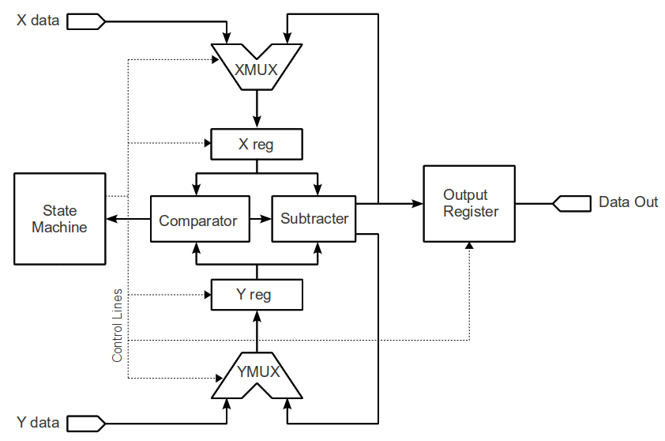

Figure 1. The GCD machine

The following function gives the basic idea how this is done with A>=B.
GCD (A, B):
(a) If the remainder of A/B is 0, then B is the GCD.
(b) If it is not 0, then find the remainder of A/B and assign B to A and the remainder to B.
(c) Return to step (a) and repeat the process.
For example, the greatest common divisor between 12 and 8 is 4. You can get this by 12%8, and the remainder is 4. Then, you divide 8 by 4 and the remainder is 0. So, you have GCD(12,8)=4.

VHDL code of the machine will be given and you have to synthesize it using a 90-nm technology cell library that contains scan cells. Please make sure that the registers will be synthesized as flip-flops, not latches because we will use MUX-FF as scan cells. You have to fix the VHDL code if necessary. The circuit will be synthesized as shown in Fig. 1.

Follow the steps you did in Project 1 to add a scan chain for the GCD machine.

Phase 1: Standard boundary scan design

By using the GCD with an internal scan chain as a core logic, boundary scan design is performed in this phase. Mainly, all input/output pins must be added with boundary scan cells and linked as a scan chain, and a TAP controller with standard instructions (EXTEST, SAMPLE, PRELOAD, and BYPASS) must be synthesized. Luckily, Synopsys BSD Compiler makes all necessary connections between the TAP controller and the test structures such as BYPASS register and boundary scan chain (connecting all pads of the pins). Check your design compliance with IEEE1149.1.

A Top file must be designed to combine your GCD machine, normal pads, and boundary scan pads. A Pin file and a GTECH lib file are also required. All these three files will be posted in Canvas. To help you fully understand the relationship between the Top file and the Pin file, a file called Top-Pin-Relationship.pdf will also be posted in Canvas for your reference.

Follow the instructions provided by Synopsys Tutorial: Using BSD Compiler (file name: 05-lab6-synopsis_bsd_compiler.pdf) to finish this phase.

Phase 2: Boundary scan design for the internal scan chain

First, you must implement the scan chain for the GCD machine, and then the scan chain you designed must be connected into the boundary scan structure (e.g., TAP controller). Here, you implement another instruction: SCANCH (with code 1101) to the boundary scan architecture. SCANCH is used to integrate your scan chain test with boundary scan test structure, such that test data can be shifted in/out your scan chain designed in this phase through boundary scan interface. The single scan chain including boundary scan chain and internal scan chain will simplify the testing of internal logic and external connections.

The major commands for you to finish this task are:

- set_dft_signal -view spec -type tdi -hookup_pin core/test_si: used to connect tdi and test_si.
- set_scan_path STT_REG -class bsd -view spec -hookup
You can use this above command to specify the scan sequence
- set_bsd_instruction SCANCH -register STT_REG -code 1101
You can use the above command to link the scan path and the BSD instruction (1101 in this example).

Go through the paper: COMBINING INTERNAL SCAN CHAINS AND BOUNDARY SCAN REGISTER: A CASE STUDY for details (file name: 10-paper-how to connect BSR+Scan.pdf). File 11-sample work is used for your reference.

After you combine both boundary scan chain and internal scan chain of the GCD machine, use the flush test pattern discussed in the class to verify whether the entire chain is connected well. Mainly, you must write a Verilog testbench that instantiates a copy of the Top module that contains the GCD core and the boundary scan cells.

First, use TMS and TDI signals to scan in the SCANCH instruction to configurate the single scan chain. Then, apply the flush test pattern (again by TMS and TDI signals) to the single scan chain and verify the scan output response (at TDO) using the required number of test clocks.

Though it is not a requirement of this project, you are encouraged to follow the case study paper announced to generate test patterns for the GCD machine under the test environment of the single scan chain.

