**Mar 2, 2019**

**Python-APIs**

**The Weather**

Whether financial, political, or social -- data's true power lies in its ability to answer questions definitively. Using Python requests, APIs, and JSON traversals we can answer a fundamental question:

"What's the weather like as we approach the equator?"

After obtaining a list of more than 500 cities around the globe, with a range of latitude between (-90, 90) and longitudes between (-180, 180), and based on the Latitude vs. Temperature Plot (see plot 1), we can demonstrate that effectively there’s a correlation between latitude and temperature, being the cities closer to the latitude 0 (Ecuador) the warmer cities. It’s interesting to highlight that cities in the southern hemisphere of the globe are warmer than the ones in the northern.

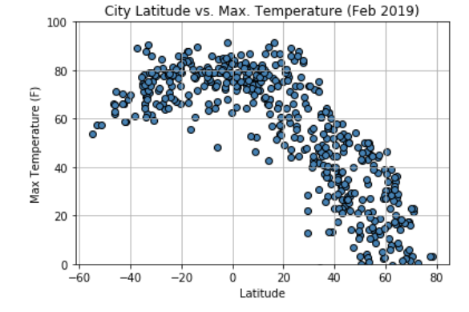

*Plot 1: City Latitude vs. Max temperature*

Going further, we can observe in plot 2 of City Latitude vs. Humidity that this variable is somehow related to the Latitude but definitively there’s other factor(s) influencing the humidity as well, as there’s a wide range of cities between latitudes (-30,70) with 100% of humidity and with low percentage going even up to almost 0%. It would be interesting to compare this factor with the geographic zone of each city (using a Google Map API for example) to demonstrate this hypothesis.

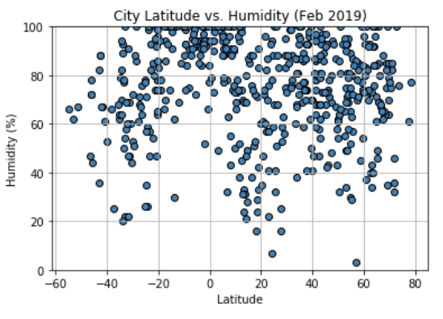

*Plot 2: City Latitude vs. Humidity*

We can compare Humidity and Cloudiness with the latitude, as observed in plot 3 below, and we can deduce the same, that there’s a relation between latitude and cloudiness but combined probably with other factor(s), maybe location and season for example.

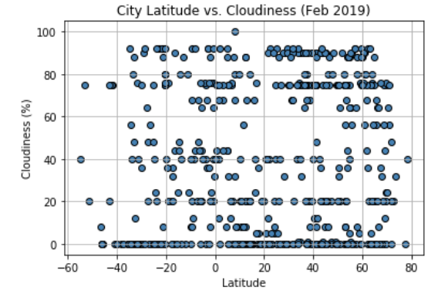

*Plot 3: City Latitude vs. Cloudiness*

Looking at the graph below, about City Latitude and Wind Speed, there’s an evident tendency to have less speed in general but not directly related to latitude. This factor could be interesting to combine with a temperature of winds and season of the year, as we can always infer a difference when this last to variables change.

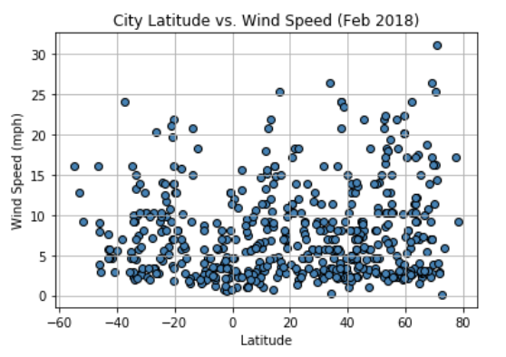

*Plot 4: City Latitude vs. Wind Speed*