DA_Anova.R

USUARIO 1

2024-05-08

#Cynthia Amely Plata Suarez   
#2071394  
#08/05/2024  
  
  
# Ingresar datos ----------------------------------------------------------  
  
#Ingresar datos del diseño aleatorio  
# 5 tratamientos germinativos  
# 4 repeticiones cada tratamiento  
  
  
germ <- c(3, 3, 4, 2, 7, 8, 7, 6, 8, 9, 8, 7, 6, 7, 7, 6, 3, 2, 1, 3)  
trat <- gl(5, 4, 20, labels = c("Ctrl", "EM", "Ra4h", "AG", "AC"))  
  
Experimento <- data.frame(trat, germ)  
  
boxplot(Experimento$germ ~ Experimento$trat, col = "blue", xlab = "Tratamiento", ylab = "Germinacion (%)")

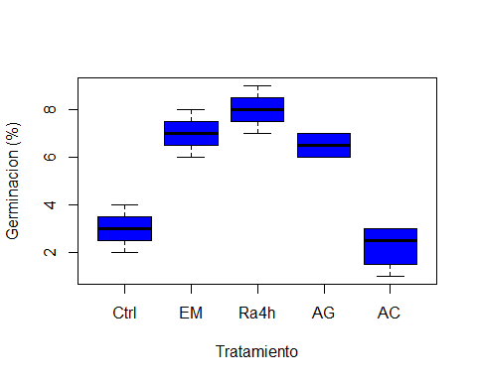

# Revisar normalidad  
shapiro.test(Experimento$germ)

##   
## Shapiro-Wilk normality test  
##   
## data: Experimento$germ  
## W = 0.90183, p-value = 0.04462

#Revisa la igualdad de la varianza  
bartlett.test(Experimento$germ, Experimento$trat)

##   
## Bartlett test of homogeneity of variances  
##   
## data: Experimento$germ and Experimento$trat  
## Bartlett's K-squared = 0.65675, df = 4, p-value = 0.9566

med.trat <- tapply(Experimento$germ, Experimento$trat, mean)  
med.trat

## Ctrl EM Ra4h AG AC   
## 3.00 7.00 8.00 6.50 2.25

#Media general  
MG <- mean(Experimento$germ)  
  
  
var.trat <- tapply(Experimento$germ, Experimento$trat, var)  
var.trat

## Ctrl EM Ra4h AG AC   
## 0.6666667 0.6666667 0.6666667 0.3333333 0.9166667

Experimento$SC <- (Experimento$germ - MG)^2  
  
#Suma de cuadrados del experimento SCTotal  
SCtot <- sum(Experimento$SC)  
SCtot

## [1] 114.55

#Suma del cuadrado del tratamiento SCTrat  
SCtrat <- sum((med.trat-MG)^2 * 4)  
SCtrat

## [1] 104.8

#Suma de cuadrado error  
SCtot - SCtrat

## [1] 9.75

SCtrat/4

## [1] 26.2

9.7/15

## [1] 0.6466667

26.2/0.64

## [1] 40.9375

#ANOVA usando funcion aov  
Exp.aov <- aov(Experimento$germ ~ Experimento$trat)  
summary(Exp.aov)

## Df Sum Sq Mean Sq F value Pr(>F)   
## Experimento$trat 4 104.80 26.20 40.31 7.42e-08 ***  
## Residuals 15 9.75 0.65   
## ---  
## Signif. codes: 0 '***' 0.001 '**' 0.01 '*' 0.05 '.' 0.1 ' ' 1

#Existen diferencias entre los trat de germ  
#Por lo tanto, aplicaremos prueba de Tukey   
  
TukeyHSD(Exp.aov)

## Tukey multiple comparisons of means  
## 95% family-wise confidence level  
##   
## Fit: aov(formula = Experimento$germ ~ Experimento$trat)  
##   
## $`Experimento$trat`  
## diff lwr upr p adj  
## EM-Ctrl 4.00 2.2396122 5.7603878 0.0000356  
## Ra4h-Ctrl 5.00 3.2396122 6.7603878 0.0000024  
## AG-Ctrl 3.50 1.7396122 5.2603878 0.0001587  
## AC-Ctrl -0.75 -2.5103878 1.0103878 0.6862491  
## Ra4h-EM 1.00 -0.7603878 2.7603878 0.4332120  
## AG-EM -0.50 -2.2603878 1.2603878 0.9009428  
## AC-EM -4.75 -6.5103878 -2.9896122 0.0000045  
## AG-Ra4h -1.50 -3.2603878 0.2603878 0.1140897  
## AC-Ra4h -5.75 -7.5103878 -3.9896122 0.0000004  
## AC-AG -4.25 -6.0103878 -2.4896122 0.0000175

plot(TukeyHSD(Exp.aov))

