clase-20-d-mayo.R

USUARIO 1

2024-05-20

#Cynthia Amely Plata Suarez   
#2071394  
#20/05/2024  
  
#Experimento ganancia en peso (GP) basado en diferentes   
#Niveles de factor: 4 (die1, die2, die3, die4)  
  
die1 <- c(2.4, 2.2, 3.4, 1.6)  
die2 <- c(2.2, 1.9, 1.7, 2.1)  
die3 <- c(3.3, 1.3, 2.8, 2.1)  
die4 <- c(1.6, 2.5, 1.4, 2.4)  
  
  
#Sumatoria de grupos/bloques  
sum(die1[1]+die2[1]+die3[1]+die4[1])

## [1] 9.5

sum(die1[2]+die2[2]+die3[2]+die4[2])

## [1] 7.9

sum(die1[3]+die2[3]+die3[3]+die4[3])

## [1] 9.3

sum(die1[4]+die2[4]+die3[4]+die4[4])

## [1] 8.2

#Sumatoria de las dietas independientes de grupo/bloque  
sum(die1); sum(die2); sum(die3); sum(die4)

## [1] 9.6

## [1] 7.9

## [1] 9.5

## [1] 7.9

GP <- c(die1, die2, die3, die4)  
Trat <- gl(4, 4, 16, labels = c("die1", "die2", "die3", "die4"))  
Bloq <- gl(4, 4, 16, labels = c("bajo", "normal", "sobrepeso", "obesidad"))  
  
Dietas <- data.frame(Trat, Bloq, GP)  
head(Dietas)

## Trat Bloq GP  
## 1 die1 bajo 2.4  
## 2 die1 bajo 2.2  
## 3 die1 bajo 3.4  
## 4 die1 bajo 1.6  
## 5 die2 normal 2.2  
## 6 die2 normal 1.9

boxplot(Dietas$GP ~ Dietas$Trat, col = "lightblue", xlab = "Dietas", ylab = "Ganancia en peso (kg)")

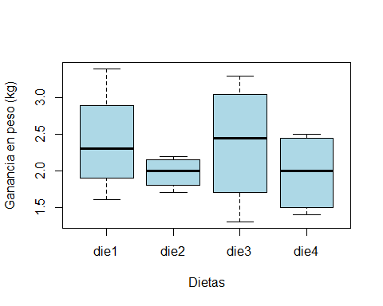

tapply(Dietas$GP, Dietas$Trat, var)

## die1 die2 die3 die4   
## 0.56000000 0.04916667 0.75583333 0.30916667

fligner.test(Dietas$GP, Dietas$Trat)

##   
## Fligner-Killeen test of homogeneity of variances  
##   
## data: Dietas$GP and Dietas$Trat  
## Fligner-Killeen:med chi-squared = 4.6369, df = 3, p-value = 0.2004

bartlett.test(Dietas$GP, Dietas$Trat)

##   
## Bartlett test of homogeneity of variances  
##   
## data: Dietas$GP and Dietas$Trat  
## Bartlett's K-squared = 4.1152, df = 3, p-value = 0.2493

diet.aov <- aov(Dietas$GP ~ Dietas$Bloq)  
summary(diet.aov)

## Df Sum Sq Mean Sq F value Pr(>F)  
## Dietas$Bloq 3 0.682 0.2273 0.543 0.662  
## Residuals 12 5.022 0.4185

boxplot(Dietas$GP ~ Dietas$Bloq, col = "red", xlab = "dietas", ylab = "bloques")

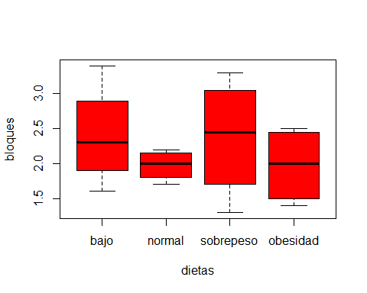

di2.aov <- aov(Dietas$GP ~ Dietas$Trat + Dietas$Bloq)  
summary(di2.aov)

## Df Sum Sq Mean Sq F value Pr(>F)  
## Dietas$Trat 3 0.682 0.2273 0.543 0.662  
## Residuals 12 5.022 0.4185