Lab2.2.R

USUARIO 1

2024-05-13

#Cynthia Amely Plata Suarez   
#2071394  
#08/05/2024  
  
#Tarea 2  
  
  
  
# Ingresar datos directo en la consola -----------------------------------  
  
dbh <- c(16.5, 25.3, 22.1, 17.2, 16.1, 8.1, 34.3, 5.4, 11.2, 24.1, 14.5, 7.7, 15.6, 15.9, 10, 17.5, 20.5, 7.8, 27.3, 9.7, 6.5, 23.4, 8.2, 28.5, 10.4, 11.5, 14.3, 17.2, 16.8)  
  
  
# Datos de URL seguras: Dropbox y Github ----------------------------------  
  
library(repmis)  
conjunto <- source_data("https://www.dropbox.com/s/hmsf07bbayxv6m3/cuadro1.csv?dl=1")

## Downloading data from: https://www.dropbox.com/s/hmsf07bbayxv6m3/cuadro1.csv?dl=1

## SHA-1 hash of the downloaded data file is:  
## 2bdde4663f51aa4198b04a248715d0d93498e7ba

head(conjunto)

## Arbol Fecha Especie Clase Vecinos Diametro Altura  
## 1 1 12 F C 4 15.3 14.78  
## 2 2 12 F D 3 17.8 17.07  
## 3 3 9 C D 5 18.2 18.28  
## 4 4 9 H S 4 9.7 8.79  
## 5 5 7 H I 6 10.8 10.18  
## 6 6 10 C I 3 14.1 14.90

library(readr)  
file <- paste0("https://raw.githubusercontent.com/mgtagle/",   
 "202_Analisis_Estadistico_2020/master/cuadro1.csv")  
  
inventario <- read.csv(file)  
head(inventario)

## Arbol Fecha Especie Clase Vecinos Diametro Altura  
## 1 1 12 F C 4 15.3 14.78  
## 2 2 12 F D 3 17.8 17.07  
## 3 3 9 C D 5 18.2 18.28  
## 4 4 9 H S 4 9.7 8.79  
## 5 5 7 H I 6 10.8 10.18  
## 6 6 10 C I 3 14.1 14.90

# Operaciones con la base de datos ----------------------------------------  
  
mean(trees$dbh)

## Warning in mean.default(trees$dbh): argument is not numeric or logical:  
## returning NA

## [1] NA

sd(trees$dbh)

## [1] NA

sum(trees$dbh < 10)

## [1] 0

which(trees$dbh < 10)

## integer(0)

trees.13 <- trees[! (trees$parcela == "2"), ]  
trees.13

## [1] Girth Height Volume  
## <0 rows> (or 0-length row.names)

trees.1 <- subset(trees, dbh <= 10)  
head(trees.1)

## Girth Height Volume  
## 6 10.8 83 19.7  
## 8 11.0 75 18.2  
## 12 11.4 76 21.0  
## 15 12.0 75 19.1  
## 18 13.3 86 27.4  
## 20 13.8 64 24.9

mean(trees$dbh)

## Warning in mean.default(trees$dbh): argument is not numeric or logical:  
## returning NA

## [1] NA

mean(trees.1$dbh)

## Warning in mean.default(trees.1$dbh): argument is not numeric or logical:  
## returning NA

## [1] NA

# Representacion grafica --------------------------------------------------  
  
# Histogramas  
  
mamiferos <- read.csv("https://www.openintro.org/data/csv/mammals.csv")  
hist(mamiferos$total_sleep)

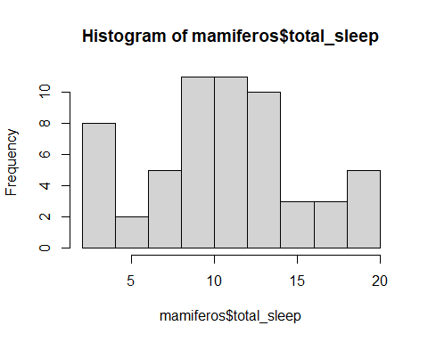

hist(mamiferos$total_sleep, xlim = c(0, 20), ylim = c(0,14),  
 main = "Total de horas sueño de las 39 especies",   
 xlab = "Horas sueño", ylab = "Frecuencia", las = 1, col = "#996600")

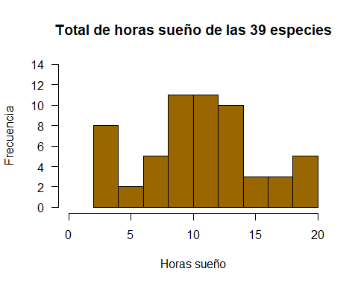

# Datos  
hist(mamiferos$total_sleep,  
 xlim = c(0,20), ylim = c(0,14), # Cambiar los limites de x & y,  
 main = "Total de horas de sueño de 39 especies ", # Cambiar el titulo,  
 xlab = "Horas de sueño", # Cambiar eje de las x,  
 ylab = "Frecuencia", # Cambiar eje de las y,  
 las = 1, # Cambiar orientacion de y,  
 col = "#996600") # Cambiar color de las barras

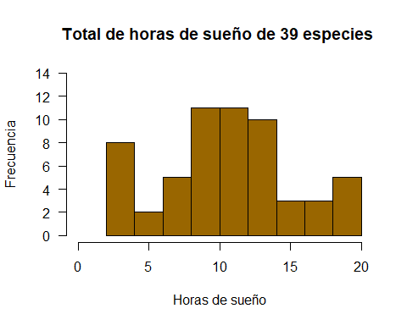

# Barplots  
  
data("chickwts")  
head(chickwts[c(1:2, 42:43, 62:64),])

## weight feed  
## 1 179 horsebean  
## 2 160 horsebean  
## 42 226 sunflower  
## 43 320 sunflower  
## 62 379 casein  
## 63 260 casein

feeds <- table(chickwts$feed)  
feeds

##   
## casein horsebean linseed meatmeal soybean sunflower   
## 12 10 12 11 14 12

barplot(feeds)

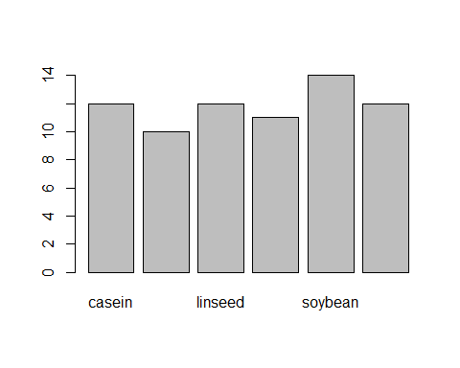

barplot(feeds[order(feeds, decreasing = FALSE)])

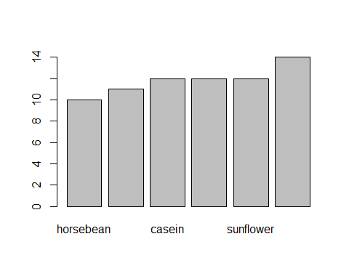

# Personalizar histograma  
  
barplot(sort(feeds), horiz = TRUE,  
 main = "Frecuencia de alimentacion",  
 las = 1, xlab = "Numeros de pollos",  
 col = c("red", "orange", "yellow", "lightgreen", "lightblue", "purple"))

