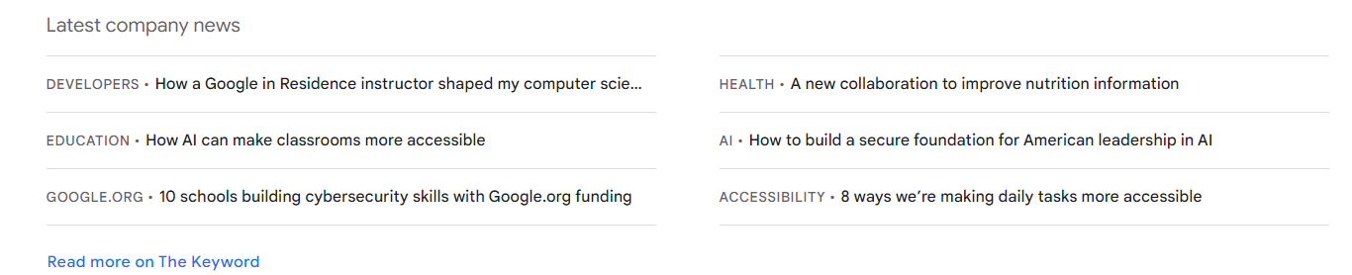

Skills (If the skills can be put left and right similar to the picture above format)

Python: Is a high-level, versatile programming language known for its simplicity and readability, often used for web development, data analysis, and more.

Spark: Apache Spark is an open-source, distributed data processing framework designed for big data analytics and machine learning.

AWS: Amazon Web Services (AWS) is a comprehensive cloud computing platform that provides a wide range of cloud-based services for businesses and developers.

Excel: Microsoft Excel is a spreadsheet application used for data analysis, calculation, and visualization, with a wide range of business and personal applications.

SQL: Structured Query Language (SQL) is a domain-specific language used for managing and querying relational databases.

SAS: SAS (Statistical Analysis System) is a software suite used for advanced analytics, business intelligence, and data management.

Keras: This is an open-source deep learning framework that provides an easy and high-level interface for designing and training neural networks.

PyTorch: This is an open-source deep learning framework known for its flexibility and dynamic computation graph, widely used in research and machine learning applications.

Scikit-learn: This is a popular machine-learning library in Python that provides tools for data mining and data analysis.

TensorFlow: TensorFlow is an open-source machine learning framework developed by Google, widely used for building and training deep learning models.

Hadoop: This is an open-source framework used for distributed storage and processing of large datasets, especially in big data applications.

Tableau: This is a data visualization tool that allows users to create interactive and shareable dashboards and reports from various data sources.

Business Intelligence (BI): This refers to technologies, processes, and tools for collecting, analyzing, and presenting data to support decision-making in business.

Apache Flink: This is an open-source stream processing framework designed for real-time data processing and analytics.

MongoDB: This is a NoSQL database management system that stores data in flexible, JSON-like documents and is widely used for scalable and high-performance applications.

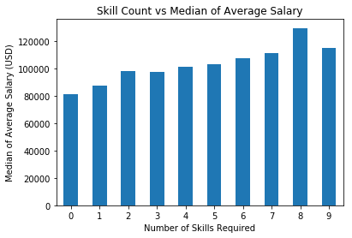

This view shows as the number of skills required increases, the median average data scientist salary increases as well.

The analysis of median average salaries for various skill combinations based on degree level provides valuable insights into the job market's demand for specific expertise. Overall, the choice of skills and the corresponding degree level can significantly influence salary expectations in the dynamic job market, and a keen understanding of these dynamics can help individuals make informed career decisions and achieve their salary goals.

