netEval

Yehonatan and Carmel

**Software Requirements Specification**

**Document**

**Version: 0 Date: 19.01.2020**

Table of Contents

**1. Introduction** 3

1.1 Purpose 3

1.2 Scope 4

1.3 Definitions, Acronyms, and Abbreviations. 4

1.4 References 5

1.5 Overview 5

**2. The Overall Description** 5

2.1 Product Perspective 5

**2.1.1 System Interfaces** 5

**2.1.2 Interfaces** 5

**2.1.3 Hardware Interfaces** 6

**2.1.4 Software Interfaces** 7

**2.1.5 Communications Interfaces** 7

**2.1.6 Memory Constraints** 7

**2.1.7 Operations** 7

**2.1.8 Site Adaptation Requirements** 7

2.2 Product Functions 7

2.3 User Characteristics 7

2.4 Constraints 8

2.5 Assumptions and Dependencies 8

2.6 Apportioning of Requirements. 8

**3. Specific Requirements** 8

3.2 Functions 8

**3.2.1 Display properties of the network** 8

**3.2.2 Estimation of the network** 8

**3.2.3 Graph visualization** 8

**3.2.3 Filter results** 8

**3.2.4 Exporting results** 9

**3.2.5 Import File Requirement** 9

**3.2.6 Color Requirement** 9

**3.2.7 Provide Help Requirement** 9

**3.2.8 Display Selected Node’s Statistics Requirement** 9

**3.2.9 Log in Requirement** 9

3.4 Logical Database Requirements 9

3.5 Design Constraints 9

3.6 Software System Attributes 10

**3.6.3 Security** 10

**4. Document Approvals** 10

# **1. Introduction**

## 1.1 Purpose

This Software Requirements Specification provides a complete description of all the functions and specifications of the software network evaluation.

The expected audiences of this document are the advertisers, the network’s owner and the developers.

## 1.2 Scope

The goal of the project is to develop a program that will give a social network evaluation. The program name will be netVal.

The user will be able to load a database and the program algorithm will calculate how much the network is worth based on the information in the database.

This evaluation will help determine the value of the network on the stock exchange as well as help the network owners know when to sell the network.

Another important goal of the project is to help advertisers know whether they should advertise according to their requirements. Advertisers can get features on the network such as: number of network members, average network traffic, average network stay, etc.

Another thing advertisers can see is the distribution of the network according to their advertising goals, for example, the advertiser wants to see how many members of the network are under 18 or how many playing computer games, giving the advertiser an indication of the number of users relevant to the product they want to advertise.

The program is to give a consistent and stable assessment and all this data can be viewed graphically and user-friendly by users.

## 1.3 Definitions, Acronyms, and Abbreviations.

|  |  |
| --- | --- |
| **Term** | **Definition** |
| netEval | Network Evaluation |
| member | A customer that uses the network |
| owner | The person who owns the network |
| advertiser | Advertisers who seek to sell their product |
| producer | These are the people who make products and turn to advertisers who advertise the products |
| consumer | The people who show interest in the advertisement |

**Social Network Analysis**

A Social Network is the social structure which facilitates communication between a group of actors (individuals or organizations) that are related somehow (i.e. by common interests, shared values, financial exchanges, friendship, dislike, etc).

Nodes represent the individual actors within the networks, while edges visualize the relationships between those actors. The result is graph-based structures which are often very complex.

## 1.4 References

*Recommended Practice for Software Requirements Specifications.*

## 1.5 Overview

This document has three main parts. The first part providing a full description of the project. The second part shows system environment and functional requirements. In the last part, there is more detailed explanation of requirements and non-functional requirements.

# **2. The Overall Description**

We seek to build a flexible and user-friendly tool for the analysis and visualization of a social network in the Java language.

This project targets primarily the owner of the network and advertisers who want to invest in the network.

This project (netEval) lets the user to construct a visualization of a network and it lets the user to load a network of various kinds with the option to modify it. The program will evaluate how much the network is worth and will present it to the user.

The program can compute all the basic network properties, such as graph diameter, radius, distance between two vertices, shortest path, eccentricity of a vertex, the total number of members, groups, traffic in the network, and how long each user spends in the network every day.

Furthermore, the program lets the user to present the network graphically. The user can filter data as he would like.

## 2.1 Product Perspective

There are no popular related products of netEval.

### **2.1.1 System Interfaces**

There are no system interfaces requirements.

### **2.1.2 Interfaces**

The user interface is divided into two parts, in the first part the user can see the network data in general in the interface and the second part is the graphical display of the network.

**Data view:**

The user will then be able to upload a file from a database, which will then show on the screen general characteristics of the network such as: the number of members on the network, the average number of responses per day, the average amount of time spent on the network, the number of advertisers, etc.

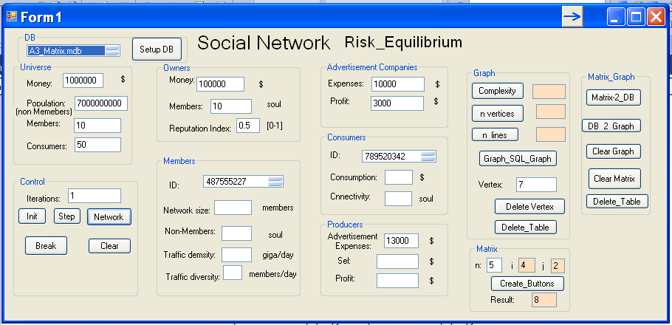

**Graphic display:**

The user will be able to click on a button that will move it to the screen with the graphical display of the grid on this screen the user will see the grid in the form of a graph, ie with vertices and edges linking the vertices. The user will be able to filter the graph according to their advertising goals.

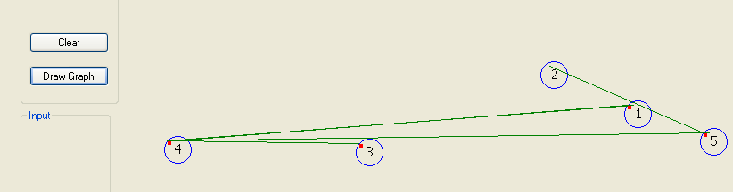

### **2.1.3 Hardware Interfaces**

This program will run on Windows.

### **2.1.4 Software Interfaces**

There are no external software interfaces requirements.

### **2.1.5 Communications Interfaces**

There are no external communications interface requirements.

### **2.1.6 Memory Constraints**

.

### **2.1.7 Operations**

.

### **2.1.8 Site Adaptation Requirements**

No Adaptation Requirements are needed.

## 2.2 Product Functions

**Network creation**

To start working with netEval you need network data, i.e. a graph of nodes (vertices) and links (edges). netEval enables the creation of such networks or loads them from files.

**Calculate the value of the network**

After you load data into the program, you can calculate the value of the network.

To do this, you will need to click on a button on the display and the system will print a financial estimate of the value of the network based on all network properties.

**properties of the network**

Apart from calculating the network value, an important function that netEval provides is the calculation of the network characteristics, detailed explanation of requirement 3.2.1

**Visual display of the network**

netEval will allow the user to switch from the information view to the graphical display of the network.

When are nodes represent the individual actors within the networks, while edges visualize the relationships between those actors.

## 2.3 User Characteristics

Any user familiar with network analysis and basic concepts of using a personal computer is normally able to use the program. As a result, no specific requirements are affected by the user’s characteristics.

## 2.4 Constraints

The most important limitation for using this program is the amount of RAM and CPU speed rates. In addition, the number of nodes and the complexity of the graph that will be displayed is also limited by the resolution of the screen.

## 2.5 Assumptions and Dependencies

.

## 2.6 Apportioning of Requirements.

Color requirement and exporting results requirement may be delayed.

# **3. Specific Requirements**

## 3.2 Functions

**3.2.1 Display properties of the network**

The program will display some properties of the network such as:

1. Number of members on the network.
2. Number of advertisers on the network.
3. The number of consumers that have bought products.
4. Number of likes/shares/groups/pages.
5. Profit of advertisers.
6. Average of time that members spend on the network.

**3.2.2 Estimation of the network**

The program must return the value of the network in dollars. This requirement is the most important aspect of the execution of this program.

**3.2.3 Graph visualization**

The program must be able to display a visualization of the network.

**3.2.3 Filter results**

The program must allow the user to filter the grid view to see only the vertices and connections they want to see.

**3.2.4 Exporting results**

The program shall export the evaluation calculations into a file on the system.

**3.2.5 Import File Requirement**

The program shall allow the user to import a file that contains social network data.

**3.2.6 Color Requirement**

The program shall allow the user to set a color for every connection type in the graph.  
This requirement is important for giving the user a better view and understanding of the network’s visual appearance as well as providing a better and more user-friendly work environment.

**3.2.7 Provide Help Requirement**

The program shall provide an assistant section to the user. This requirement is important for giving the user some FAQs as well as an “about” section.

**3.2.8 Display Selected Node’s Statistics Requirement**

The program must be able to display a specific node’s statistics to the user. This requirement is important for giving the user an overview of each node that the network is consisted of.

Node’s statistics like:

* Node number
* Node In-degree
* Node Out-degree

**3.2.9 Log in Requirement**

The program shall provide access to only authorized users.

## 3.4 Logical Database Requirements

The following are to be placed into the data base:

Names of members of the network, the city they live in, their friends, amount of time that they spend on the network, profit of the advertisers, traffic, name of owners, their share.

## 3.5 Design Constraints

Not relevant

## 3.6 Software System Attributes

**3.6.3 Security**

To be able to use the program, the user must enter his/her e-mail and password in order to use the program. This will help to increase privacy.

# **4. Document Approvals**

המנחה צריך למלא