MBAI 5310G-001: AI Programming
Assignment 5: K-Means Clustering
TalentWorks: Employee Segmentation
Field | Detail
Student | Clement Yorke
Course | MBAI 5310G-001: AI Programming
Institution | Ontario Tech University
Lecturer | Zahra Atf
Date | June 2026

1. Business Overview
TalentWorks People Analytics is a fictional HR analytics consulting unit that supports mid-sized service and retail organizations. The business helps managers understand workforce patterns, reduce avoidable employee turnover, and improve employee experience using data-driven decision support.
The organization has observed that employee turnover is increasing in several departments. Replacing employees is costly because the company must spend time and money on hiring, onboarding, training, and temporary staffing. High turnover can also reduce service quality and lower team morale.
This assignment applies K-Means clustering to segment employees into natural groups based on their workplace experience, satisfaction, performance, and commute patterns. These segments help HR managers identify which groups of employees need targeted support and which are at highest risk of leaving.
Attribute | Detail
Business | TalentWorks People Analytics
Objective | Segment employees into groups to support targeted HR retention strategies
Method | K-Means Clustering (unsupervised learning)
Dataset Size | 286 employee records (280 after cleaning)
Features Used | 12 numerical features
Number of Clusters | k=3 (selected via Elbow Method)
Algorithm | KMeans (sklearn, random_state=42, n_init=10)
2. Data Preparation
2.1 Dataset Overview
The dataset contains 286 records representing individual TalentWorks employees. Each record has 23 columns spanning six feature groups:
- Employee profile: Age, Education_Level, Marital_Status
- Work arrangement: Employment_Type, Remote_Work_Available, Commute_Time_Minutes, Distance_From_Home_km
- Job experience: Tenure_Months, Department, Job_Role
- Workplace experience: Job_Satisfaction, Work_Life_Balance, Manager_Feedback_Score, Engagement_Score
- Performance and workload: Performance_Rating, Workload_Level, Overtime, Absences_Last_Quarter
- Development: Training_Hours_Last_Year, Promotion_Last_2_Years
2.2 Preprocessing Steps
The following preprocessing steps were applied before clustering:
- Dropped Employee_ID, an identifier with no analytical value
- Removed 6 duplicate rows (286 reduced to 280)
- Filled missing values in numerical columns with column medians (Monthly_Income: 2, Work_Life_Balance: 3, Training_Hours_Last_Year: 6, Manager_Feedback_Score: 5, Engagement_Score: 5)
- Selected 12 numerical features for clustering: Age, Monthly_Income, Tenure_Months, Distance_From_Home_km, Commute_Time_Minutes, Job_Satisfaction, Work_Life_Balance, Training_Hours_Last_Year, Absences_Last_Quarter, Performance_Rating, Manager_Feedback_Score, Engagement_Score
- Scaled all features using StandardScaler to ensure no single feature dominates due to differences in scale
3. K-Means Clustering Model
3.1 How K-Means Clustering Works
K-Means is an unsupervised machine learning algorithm that groups data points into a fixed number of clusters based on similarity. Unlike supervised learning, K-Means does not use a target variable; it discovers natural patterns in the data on its own.
The algorithm follows five steps: (1) choose k, the number of clusters; (2) randomly initialize k cluster centres; (3) assign each data point to the nearest centre using Euclidean distance; (4) recalculate each centre as the mean of its assigned points; (5) repeat until centres no longer move. The result is a set of clusters where points within each cluster are as similar as possible to each other and as different as possible from other clusters.
3.2 Elbow Method
To choose the right value of k, the Elbow Method was applied. K-Means was trained for k=1 through k=10. For each value of k, the inertia (total within-cluster sum of squared distances) was recorded. The optimal k is the point where reducing k further yields rapidly diminishing returns, marking the bend or elbow in the curve.
k | Inertia | k | Inertia
1 | 3360.00 | 6 | 2411.97
2 | 2962.33 | 7 | 2324.62
3 | 2739.05 | 8 | 2271.60
4 | 2616.49 | 9 | 2204.99
5 | 2498.76 | 10 | 2152.28
Table 1: Inertia values for k=1 to k=10
The curve drops steeply from k=1 to k=3, then begins to flatten. The elbow at k=3 represents the best balance between cluster compactness and model simplicity. Beyond k=3, additional clusters produce diminishing reductions in inertia without meaningful new insights.
4. Cluster Analysis and Interpretation
4.1 Cluster Summary Statistics
After training the K-Means model with k=3, cluster labels were added back to the dataset. The table below shows the mean value of each feature per cluster.
Feature | Cluster 0 (108) | Cluster 1 (51) | Cluster 2 (121)
Age | 35.98 | 34.82 | 36.25
Monthly_Income ($) | 4,905.69 | 6,594.67 | 4,682.18
Tenure_Months | 23.43 | 81.33 | 22.59
Distance_From_Home_km | 26.76 | 14.73 | 8.50
Commute_Time_Minutes | 70.69 | 42.47 | 26.74
Job_Satisfaction | 3.06 | 3.39 | 3.54
Work_Life_Balance | 3.24 | 3.53 | 2.95
Training_Hours_Last_Year | 18.85 | 16.98 | 25.00
Absences_Last_Quarter | 2.22 | 3.37 | 2.89
Performance_Rating | 3.19 | 3.69 | 3.70
Manager_Feedback_Score | 3.18 | 3.13 | 3.54
Engagement_Score | 65.92 | 65.75 | 67.09
Cluster Size | 108 employees | 51 employees | 121 employees
Table 2: Cluster average feature values
4.2 Cluster Interpretation
Cluster 0: Strained Commuters (108 employees)
These employees have the longest average commute (70.69 minutes) and live furthest from the workplace (26.76 km). They report the lowest job satisfaction (3.06) and have the lowest performance ratings (3.19) in the dataset. Monthly income is moderate ($4,906) and tenure is short (23 months), suggesting early-career employees who may be struggling with the daily burden of a long commute. This group carries the highest attrition risk and should be the primary focus of HR intervention.
Cluster 1: Experienced High Earners (51 employees)
These are the most tenured employees in the organization, with an average tenure of 81.33 months (nearly 7 years). They earn the highest average income ($6,595) and have the strongest work-life balance scores (3.53). Commute times are moderate (42.47 minutes). Performance ratings are strong (3.69). This is the most stable and organizationally valuable segment; these employees represent deep institutional knowledge and leadership capacity.
Cluster 2: High-Performing Locals (121 employees)
These employees live closest to the workplace (8.50 km) with the shortest commute (26.74 minutes). They have the highest performance ratings (3.70), highest training hours (25.00 per year), and strongest manager feedback scores (3.54). Despite this strong output profile, they have the lowest work-life balance scores (2.95) and the lowest average income ($4,682) in the dataset. This suggests they may be overworked and undercompensated relative to their contribution, raising the risk of disengagement or burnout if not addressed.
5. Cluster Visualizations
5.1 Elbow Method Plot
The Elbow Method plot shows inertia decreasing as the number of clusters increases. The steepest drop occurs between k=1 and k=3. After k=3, the reduction in inertia becomes gradual, indicating that additional clusters provide diminishing analytical value. The red dashed line marks the selected value of k=3.

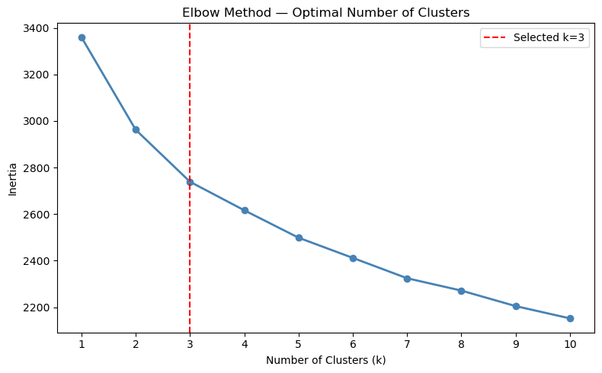
Figure 1: Elbow Method plot with selected k=3 marked
5.2 Scatter Plot: Monthly Income vs Tenure Months
The scatter plot shows each employee as a point, coloured by cluster assignment. Cluster 1 (Experienced High Earners, orange) is clearly separated along both axes, concentrated at high tenure and relatively higher income. Clusters 0 and 2 overlap significantly on the tenure axis (both are short-tenured) but differ in commute and satisfaction patterns that are not visible in this two-dimensional view.
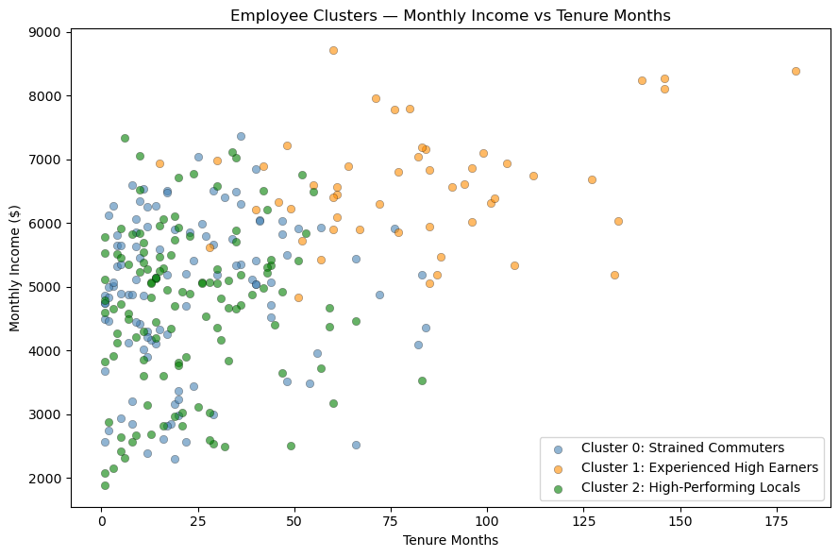
Figure 2: Scatter plot of Monthly Income vs Tenure Months by cluster
5.3 Bar Chart: Key Workplace Experience Features
The bar chart compares the average scores of Job_Satisfaction, Work_Life_Balance, Performance_Rating, and Manager_Feedback_Score across all three clusters. Cluster 0 (steelblue) is represented by the first bar in each group, Cluster 1 (orange) by the second, and Cluster 2 (green) by the third. Cluster 2 records the highest scores for Job_Satisfaction, Performance_Rating, and Manager_Feedback_Score. Cluster 1 has the highest Work_Life_Balance score. Cluster 0 scores lowest in Job_Satisfaction, Work_Life_Balance, and Performance_Rating, while Cluster 1 records the lowest Manager_Feedback_Score, reflecting differences in management support across segments.
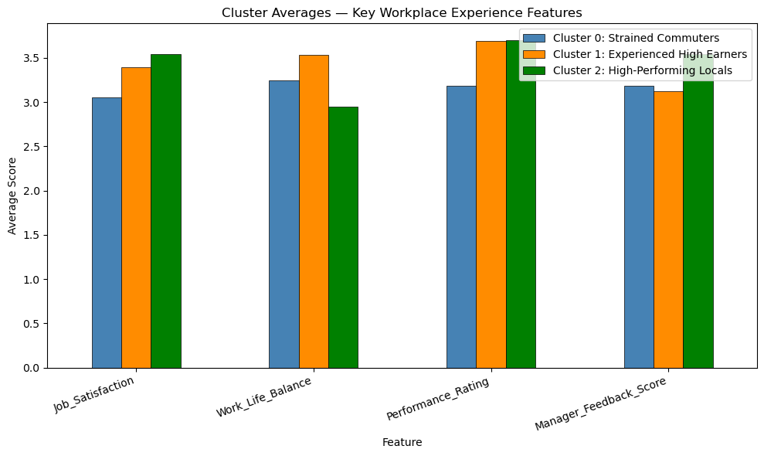
Figure 3: Bar chart comparing cluster averages across key workplace experience features
5.4 Box Plot: Commute Time by Cluster
The box plot shows the distribution of commute times within each cluster. The x-axis displays three groups from left to right: Cluster 0 (Strained Commuters, steelblue), Cluster 1 (Experienced High Earners, orange), and Cluster 2 (High-Performing Locals, green). Cluster 0 has the highest median commute time (approximately 68 minutes) and the widest interquartile range, confirming that long and variable commutes are a defining characteristic of this group. Cluster 1 sits in the middle range with a median of approximately 40 minutes. Cluster 2 has the lowest and most tightly distributed commute times, consistent with their proximity to the workplace.
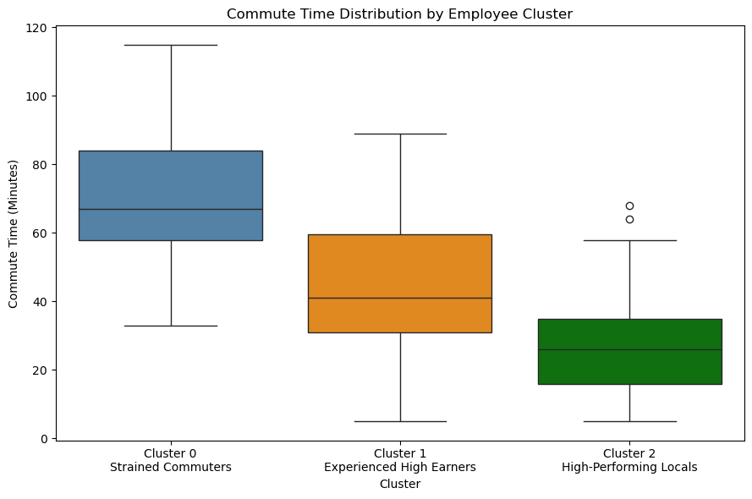
Figure 4: Box plot of commute time distribution by employee cluster

6. Business Actions and Recommendations
Based on the clustering results, the following HR strategies are recommended for each employee segment:
Cluster Insight | Recommended HR Action
Cluster 0: Long commutes and low satisfaction | Offer remote work options or flexible scheduling to reduce commute burden. Conduct manager check-ins to identify individual pain points. Provide early career development support and clear promotion pathways to improve engagement.
Cluster 1: High tenure and high income | Focus on recognition programs, succession planning, and mentoring initiatives. These employees carry deep organizational knowledge; prioritize retention through career challenge and leadership roles. Conduct stay interviews to understand what keeps them engaged.
Cluster 2: High performance but low work-life balance | Conduct an immediate workload review to address burnout risk. Consider compensation adjustments, as this group delivers the highest performance and training investment but earns the least. Make promotion criteria transparent to prevent disengagement.
All clusters: Replace informal HR judgment | Use cluster membership as a data-driven early warning signal. Review cluster assignments quarterly as new employee data becomes available. Pair model outputs with manager review before taking action on any individual employee.
7. Limitations
The following limitations should be considered before applying these results in a real HR environment:
- Small dataset: The 280-record dataset after cleaning is relatively small for clustering. Results may not fully represent the diversity of a larger workforce, and minor changes in the data could shift cluster assignments.
- Missing contextual factors: Important variables such as team dynamics, manager quality, personal circumstances, and organizational culture are not captured in the dataset. These factors often drive attrition and cannot be inferred from the available features alone.
- K-Means assumptions: K-Means assumes clusters are roughly spherical and equal in size, which may not reflect how employee profiles naturally group. The algorithm is also sensitive to the initial random placement of cluster centres, meaning different runs can produce slightly different results.
- Synthetic data: The dataset was synthetically generated for educational purposes. Real employee data would likely produce different patterns and require additional validation before acting on results.
- No causal inference: Clustering reveals correlation patterns, not causal relationships. The fact that Cluster 0 has lower satisfaction and longer commutes does not prove that commutes cause lower satisfaction; other factors may be at play.
8. Responsible AI Considerations
HR analytics applications directly affect employees' working conditions and livelihoods. The following responsible AI principles apply to this analysis:
- Fairness: Cluster membership should never be used to make blanket decisions about individuals. Employees in Cluster 0 could be unfairly disadvantaged if cluster labels are treated as permanent categories rather than as signals for support. Geography and commute distance (which are outside employees' control) are significant drivers of cluster assignment.
- Human oversight: Clustering results should always be reviewed by HR professionals and managers before any action is taken. The model surfaces patterns; human judgment must determine the appropriate response for each individual employee.
- Transparency: Employees whose data is used in HR analytics should be informed that their information is being used to support workforce planning. Organizations have a responsibility to be transparent about how data-driven tools influence HR decisions.
- Privacy: All employee data used in this analysis must be stored and processed in accordance with applicable privacy legislation, including PIPEDA in Canada. Personal data should not be shared beyond the HR teams responsible for retention planning.
- Avoiding harm: Cluster labels such as 'Strained Commuters' or 'High-Performing Locals' are analytical descriptors, not judgments. HR teams must ensure that these labels are never communicated to employees or used to justify adverse employment decisions.

9. Final Conclusion

This assignment applied K-Means clustering to the TalentWorks employee dataset to discover natural workforce segments. After cleaning the data (removing 6 duplicate rows, filling 21 missing values, and dropping the Employee_ID column), 12 numerical features were selected and scaled using StandardScaler. The Elbow Method identified k=3 as the optimal number of clusters.
Three distinct employee segments were identified. Cluster 0 (Strained Commuters, 108 employees) are early-tenure employees with long commutes, low satisfaction, and low performance and represent the group most at risk of leaving. Cluster 1 (Experienced High Earners, 51 employees) are long-tenured, well-compensated, and organizationally stable, making them the most valuable segment to retain. Cluster 2 (High-Performing Locals, 121 employees) are nearby, high-performing employees who receive strong manager feedback but face work-life balance pressures and earn the least despite strong output.
These findings allow TalentWorks to move from reactive to proactive HR management. Rather than applying the same retention strategy to all employees, the business can now direct targeted interventions: remote work options and career support for Cluster 0, recognition and mentoring for Cluster 1, and compensation review and workload relief for Cluster 2.
Used responsibly alongside human judgment and regular re-evaluation, K-Means clustering provides TalentWorks with a practical, data-driven foundation for reducing avoidable employee turnover and improving workforce wellbeing.

