MBAI 5310G-001: AI Programming
Assignment 6: Model Evaluation, Explainability, and Fairness Reflection
Event Registration & Attendance: Predicting Event Turnout
Clement Kwesi Yorke
Ontario Tech University
Instructor: Zahra Atf
Spring 2026

1. Business Overview
Event management organisations invest significant resources in planning for each event: catering portions, seating arrangements, staffing levels, and materials printing. All of these depend heavily on the number of people who will actually attend. When organisations rely on raw registration counts, they consistently over-allocate or under-prepare — either wasting money or disappointing attendees.
This assignment applies a Decision Tree classification model to a dataset of 380 event registrations. The goal is to predict, at the time of registration, whether a specific individual is likely to attend or not. By identifying likely no-shows in advance, event teams can adjust logistics, focus re-engagement efforts on at-risk registrants, and plan more confidently.
The analysis goes beyond simple accuracy reporting. It evaluates the model using multiple classification metrics, explains predictions using SHAP and LIME, and assesses whether the model performs equitably across demographic and geographic subgroups. The report concludes with a business-oriented recommendation on model readiness.

2. Data Preparation

2.1 Dataset Overview
The dataset contains 380 records representing individual event registrants. Each record has 17 columns spanning four categories:
- Registration behaviour: days_before_event_registered, group_registration, calendar_invite_accepted
- Engagement signals: email_reminders_opened, social_media_clicks
- Logistics: age, ticket_type, ticket_price, registration_channel, event_category, distance_to_venue_km
- Previous history: previous_events_attended
The target variable is attended_event (1 = attended, 0 = did not attend). The class distribution is mildly imbalanced: 233 records attended (61.3%) and 147 did not (38.7%).
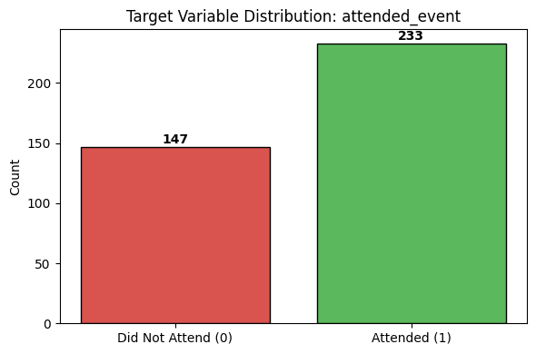
Figure 1: Target variable distribution — 233 attended (61.3%), 147 did not (38.7%)

2.2 Feature Design
Three columns were excluded from model input and retained only for fairness analysis: gender, age_group, and region. These are protected or group-sensitive attributes that should not drive predictions but must be monitored to assess model equity.
The remaining 12 columns formed the model input features, split into:
- Numerical: age, days_before_event_registered, ticket_price, previous_events_attended, email_reminders_opened, social_media_clicks, distance_to_venue_km
- Categorical: ticket_type, registration_channel, event_category, group_registration, calendar_invite_accepted

2.3 Preprocessing Steps
All preprocessing was applied using a scikit-learn Pipeline and ColumnTransformer to prevent data leakage:
- Numerical features: missing values imputed using the column median (SimpleImputer). Two columns had missing values: ticket_price (7 missing) and distance_to_venue_km (5 missing).
- Categorical features: missing values imputed with the most frequent value, then one-hot encoded (OneHotEncoder).
- The full preprocessing pipeline was fitted only on training data and applied to the test set, ensuring no information from the test set influenced preprocessing decisions.
The final processed feature matrix contained 24 columns after one-hot encoding expanded the categorical variables.

3. Train/Test Split
The dataset was split 80/20 into training and testing sets using stratified sampling to preserve the class ratio in both sets.
- Training set: 304 records (80%)
- Testing set: 76 records (20%)
- Stratified split: maintains the 61%/39% class ratio in both sets
- random_state=42 used for reproducibility
The training set is used to teach the model the relationship between features and the target label. The testing set is held out completely and used only after training to evaluate how the model performs on data it has never seen. This separation is essential to obtain an honest estimate of real-world performance.

4. Decision Tree Model

4.1 How Decision Trees Make Predictions
A Decision Tree is a supervised machine learning algorithm that learns a series of yes/no decision rules from the training data. At each node in the tree, the algorithm selects the feature and threshold that best separates the training records by their target label. This process repeats recursively until a stopping condition is reached — in this case, a maximum depth limit.
The primary advantage of Decision Trees is interpretability: a prediction can be traced step by step through the tree to understand exactly which conditions led to a particular output. This is especially valuable in business contexts where stakeholders need to explain and validate model decisions.

4.2 Model Training
Two models were trained:
- Unconstrained tree: no depth limit, trained for comparison only. Reached depth 8, achieving near-perfect training accuracy through overfitting.
- Controlled tree (max_depth=4): selected as the final model. Restricts splits to 4 levels, preventing overfitting and improving generalisation to unseen data.
All evaluations, metrics, feature importances, SHAP values, and LIME explanations in this report use the controlled model (max_depth=4). The table below shows the first 15 test records with their actual labels, predicted labels, and whether the prediction was correct.
Record | Actual | Predicted | Correct | Interpretation
1 | 1 | 1 | Yes | Correctly predicted attendance
2 | 0 | 0 | Yes | Correctly predicted no-show
3 | 1 | 1 | Yes | Correctly predicted attendance
4 | 0 | 1 | No | False Positive — predicted attend, did not
5 | 0 | 1 | No | False Positive — predicted attend, did not
6 | 0 | 0 | Yes | Correctly predicted no-show
7 | 1 | 0 | No | False Negative — predicted no-show, attended
8 | 1 | 1 | Yes | Correctly predicted attendance
9 | 0 | 1 | No | False Positive — predicted attend, did not
10 | 1 | 1 | Yes | Correctly predicted attendance
11 | 0 | 0 | Yes | Correctly predicted no-show
12 | 0 | 1 | No | False Positive — predicted attend, did not
13 | 0 | 1 | No | False Positive — predicted attend, did not
14 | 1 | 1 | Yes | Correctly predicted attendance
15 | 1 | 1 | Yes | Correctly predicted attendance
Table 1: Actual vs. predicted labels for first 15 test records (0 = Did Not Attend, 1 = Attended)

5. Model Evaluation

5.1 Classification Metrics
The controlled model (max_depth=4) was evaluated on the 76-record test set using four classification metrics:
Metric | Score | What It Means
Accuracy | 81.58% | 81.6% of all predictions (attended and not attended) were correct
Precision | 0.8235 | Of all predicted attendees, 82.4% actually attended
Recall | 0.8936 | Of all actual attendees, 89.4% were correctly identified
F1-Score | 0.8571 | Harmonic mean of precision and recall — balanced performance measure
Table 2: Classification metrics for the controlled model (max_depth=4)
The F1-score is the most important metric for this problem. Because the target classes are mildly imbalanced and both types of errors carry real operational costs, the F1-score provides the most balanced view of model performance.
Metric trade-off: Prioritising recall (currently 0.894) ensures fewer actual attendees are missed, reducing the risk of under-preparing for real demand. However, if precision drops significantly, the model may trigger unnecessary resource allocations for registrants who will not attend. In this context, under-preparation (low recall) is more harmful than over-preparation (low precision), so recall should be treated as the floor constraint in any production deployment.
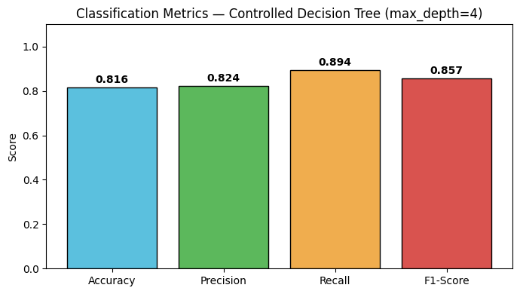
Figure 2: Classification metrics bar chart — Accuracy, Precision, Recall, F1-Score for the controlled model

5.2 Confusion Matrix
The confusion matrix below shows the breakdown of all 76 test predictions:
 | Predicted: Did Not Attend | Predicted: Attended
Actual: Did Not Attend | True Negative (TN): 20 | False Positive (FP): 9
Actual: Attended | False Negative (FN): 5 | True Positive (TP): 42
Table 3: Confusion matrix — 76 test records
- True Negatives (20): Model correctly predicted no-show — resources not allocated, correctly.
- False Positives (9): Model predicted attendance, but person did not come — 9 wasted resource allocations.
- False Negatives (5): Model predicted no-show, but person actually attended — 5 under-prepared instances, causing attendee dissatisfaction.
- True Positives (42): Model correctly predicted attendance — core value delivered.
False Negatives are the more serious error in an event context. An attendee who shows up without a prepared seat or catering allocation represents a failure of service delivery. False Positives, while wasteful, are operationally easier to absorb — slight over-preparation creates less harm than under-preparation.
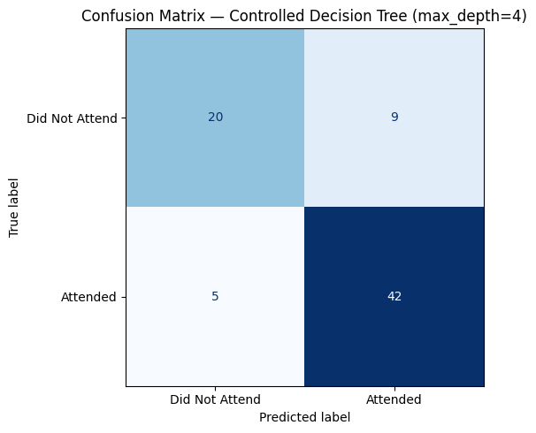
Figure 3: Confusion matrix heatmap — True Negative (20), False Positive (9), False Negative (5), True Positive (42)

6. Error Analysis
Of 76 test records, the model made 14 wrong predictions: 9 False Positives and 5 False Negatives. False Positives are the most common error — the model more frequently predicts attendance when the person does not show up than the reverse.
The model systematically over-predicts attendance more than it under-predicts it. This means the primary operational risk is over-preparation: allocating more catering, seating, or staffing than needed. While costly, this is the less harmful direction of error compared to leaving actual attendees without resources.
The error analysis also reveals the model leans in the operationally safer direction: over-preparing is less harmful than under-preparing in an event context. The 5 False Negatives (missed actual attendees) represent the riskiest predictions and should be the focus of further model improvement.
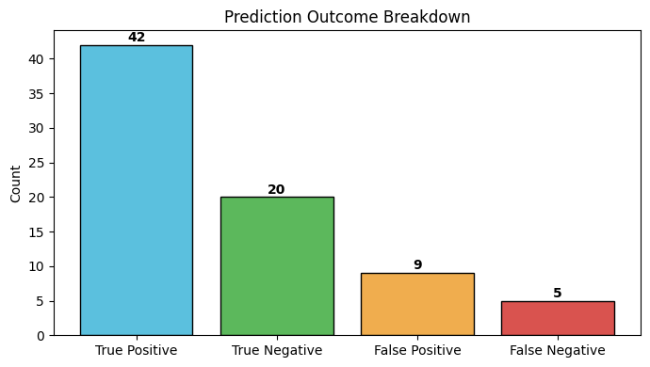
Figure 4: Error type counts — True Positive (42), True Negative (20), False Positive (9), False Negative (5)
Record | Actual | Predicted | Error Type
1 | Did Not Attend | Attended | False Positive
2 | Did Not Attend | Attended | False Positive
3 | Attended | Did Not Attend | False Negative
4 | Did Not Attend | Attended | False Positive
5 | Did Not Attend | Attended | False Positive
6 | Did Not Attend | Attended | False Positive
7 | Attended | Did Not Attend | False Negative
8 | Attended | Did Not Attend | False Negative
9 | Attended | Did Not Attend | False Negative
10 | Attended | Did Not Attend | False Negative
11 | Did Not Attend | Attended | False Positive
12 | Did Not Attend | Attended | False Positive
13 | Did Not Attend | Attended | False Positive
14 | Did Not Attend | Attended | False Positive
Table 4: All 14 wrong predictions — 9 False Positives and 5 False Negatives

7. Cross-Validation
5-fold cross-validation was applied to the training set (304 records) to obtain a more reliable performance estimate than a single train/test split. In each fold, 80% of training data trains the model and 20% is used to validate it — rotating through all five folds.
Fold 1 | Fold 2 | Fold 3 | Fold 4 | Fold 5 | Mean Accuracy
63.93% | 65.57% | 63.93% | 68.85% | 65.00% | 65.46% (Std: 0.018)
Table 5: 5-fold cross-validation results
The low standard deviation (0.018) confirms the model performs consistently across different subsets of the data — it is not sensitive to which particular records fall in the training vs. validation set.
However, the mean CV accuracy of 65.46% is significantly lower than the single-split test accuracy of 81.58%. This is a major concern. The 16-percentage-point gap suggests the single-split test result was optimistic — the 76-record test set may have happened to be easier than average. The CV mean of 65.46% is the more conservative and reliable estimate of how the model would perform on genuinely new data. At 65.46%, the model is barely above the 61.3% baseline (always predicting the majority class), and must be treated as a starting point rather than a production-ready tool.
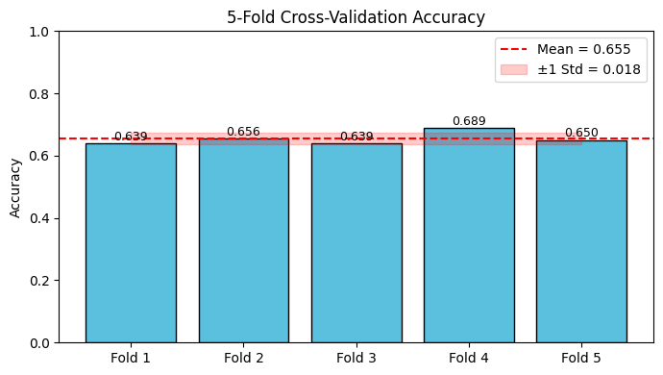
Figure 5: Cross-validation fold accuracy chart — all five folds near the 65% mean, standard deviation 0.018

8. Overfitting and Underfitting Analysis
The model was retrained across tree depths 1 through 15 to identify the optimal complexity level:
- Depths 1–2: Both training and testing accuracy are low — the model underfits, too simple to capture meaningful patterns.
- Depths 3–4: Both accuracies rise — the model learns genuine patterns.
- Depths 5+: Training accuracy continues to climb while test accuracy plateaus or falls — classic overfitting. The unconstrained tree (depth 8) achieves near-perfect training accuracy but lower test accuracy.
The controlled model at max_depth=4 achieves the best balance:
- Training accuracy: 83.88%
- Testing accuracy: 81.58%
- Gap: 2.30 percentage points — minimal, confirming good generalisation on the held-out test set
All subsequent evaluations use the max_depth=4 model. Note that the cross-validation mean accuracy (65.46%) is a more conservative estimate of true generalisation performance than the single-split test accuracy (81.58%).
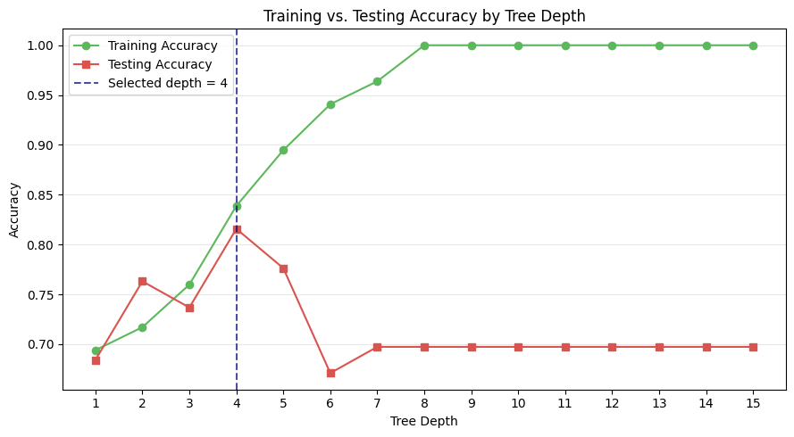
Figure 6: Training vs. testing accuracy by tree depth — overfitting visible at depth 5+; max_depth=4 selected as the optimal balance

9. Feature Importance
Feature importances were extracted from the controlled tree (max_depth=4). The top features are:
Feature | Importance Score | Rank
previous_events_attended | 0.256 | 1
email_reminders_opened | 0.228 | 2
calendar_invite_accepted_Yes | 0.208 | 3
distance_to_venue_km | 0.176 | 4
ticket_price | 0.075 | 5
age | 0.038 | 6
ticket_type_Student | 0.019 | 7
Table 6: Top feature importance scores from the controlled tree (max_depth=4)
Business interpretation of top features:
- previous_events_attended (0.256): The strongest predictor. Returning attendees are significantly more likely to attend again — past behaviour is the best predictor of future behaviour.
- email_reminders_opened (0.228): Registrants who open email reminders are actively keeping the event in mind. Well-timed, targeted reminders measurably increase the probability of attendance.
- calendar_invite_accepted_Yes (0.208): Formal calendar commitment is a powerful attendance signal. Registrants who accept a calendar invite have made an explicit scheduling commitment.
- distance_to_venue_km (0.176): Physical distance is a natural attendance barrier. Distant registrants represent higher no-show risk and may benefit from hybrid or livestream alternatives.
- ticket_price (0.075): Paid tickets — especially premium tiers — correlate with stronger attendance commitment.
Important caveat: feature importance scores show which features the Decision Tree used most, but they do not prove cause and effect. High importance for a feature means the model relied on it heavily — not that changing it will directly change behaviour.
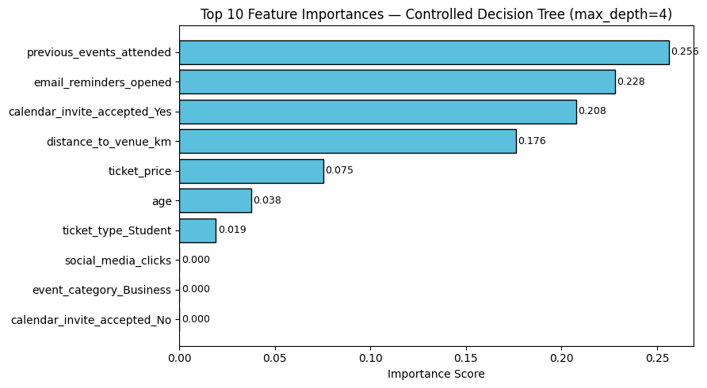
Figure 7: Top 10 feature importance chart — previous_events_attended (0.256) is the dominant predictor

10. SHAP Explanation
SHAP (SHapley Additive exPlanations) was used to explain the model beyond basic feature importance. Unlike global feature importances, SHAP provides both global patterns and individual-level explanations, and crucially, it shows the direction of each feature's influence (increases or decreases the probability of attendance).
The SHAP summary plot below shows that previous_events_attended and email_reminders_opened are the most consistently influential features across the entire test set. High values of these features (shown in red) push predictions strongly toward attendance, while low values (blue) push toward no-show.
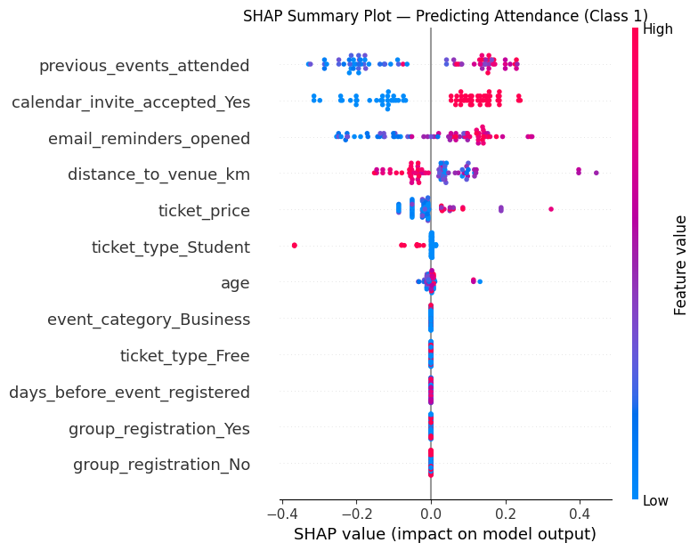
Figure 8: SHAP summary plot (class 1 — Attended) — each row is a feature, each dot is a test record; red = high feature value, blue = low
For the individual record explained (Record 1), SHAP reveals the specific features that pushed the prediction toward or away from attendance. The waterfall plot below decomposes the prediction for this specific registrant:
Feature | SHAP Value (push toward attendance)
previous_events_attended | -0.180 (pushes away from attendance)
calendar_invite_accepted_Yes | +0.132 (pushes toward attendance)
distance_to_venue_km | +0.089 (pushes toward attendance)
ticket_price | -0.051 (pushes away from attendance)
email_reminders_opened | +0.016 (pushes toward attendance)
age | +0.009 (pushes toward attendance)
Table 7: SHAP values for Record 1 — positive values increase predicted probability of attendance
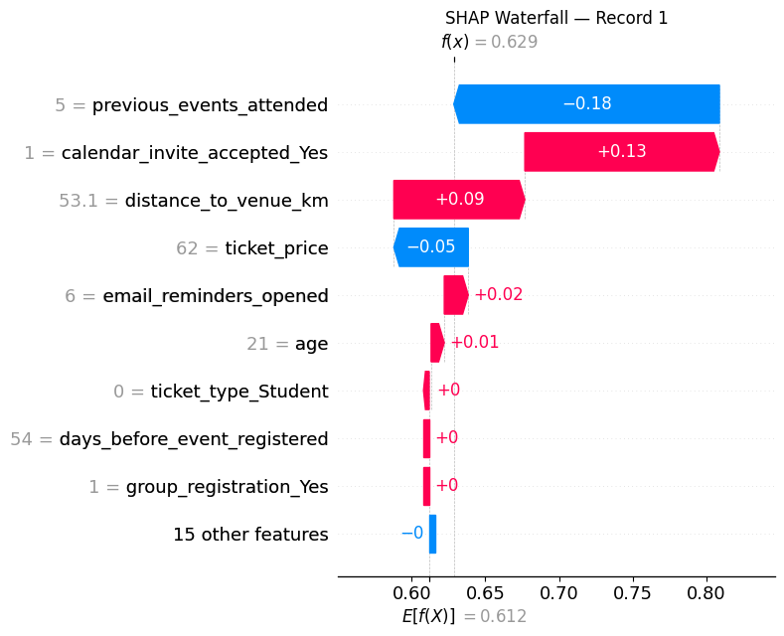
Figure 9: SHAP waterfall plot for Record 1 — decomposition of individual prediction into per-feature contributions
SHAP goes beyond basic feature importance in two key ways:
- Local explanations: SHAP explains any individual prediction, not just the global model behaviour.
- Direction of influence: Feature importance gives magnitude only. SHAP shows whether each feature increased or decreased the predicted probability — essential for actionable business decisions.

11. LIME Explanation
LIME (Local Interpretable Model-agnostic Explanations) was used to explain one individual prediction in plain language. For Record 1, LIME predicts a 62.9% probability of attendance (37.1% probability of no-show), resulting in a predicted class of Attended.
LIME works by creating a simplified local model around the specific record, testing small perturbations of the features, and identifying which features have the largest influence on the prediction in that local neighbourhood. The table below shows the feature weights for Record 1:
Feature Condition | Weight | Direction
calendar_invite_accepted_Yes > 0 | +0.269 | Supports Attendance
email_reminders_opened > 5 | +0.150 | Supports Attendance
3 < previous_events_attended <= 8 | -0.098 | Against Attendance
ticket_type_Student <= 0 | +0.085 | Supports Attendance
56 < ticket_price <= 140.25 | -0.044 | Against Attendance
registration_channel_Website <= 0 | -0.020 | Against Attendance
53 < distance_to_venue_km <= 70.5 | -0.018 | Against Attendance
Table 8: LIME feature weights for Record 1 — positive weights support attendance, negative weights work against it
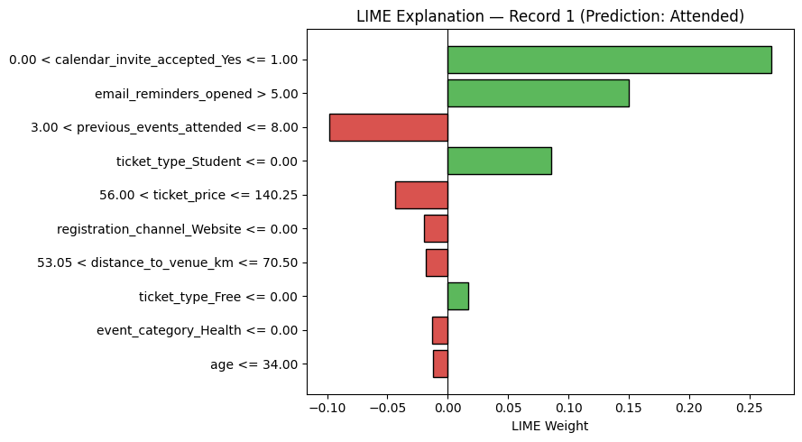
Figure 10: LIME feature weight chart for Record 1 — green bars support attendance, red bars work against it
Features supporting the prediction of attendance include calendar invite acceptance (the strongest positive driver) and high email reminder engagement. Features working against attendance include a moderate level of previous event attendance (suggesting diminishing returns at mid-range history) and a relatively high-ticket price.
For business users: a customer success manager reviewing a low-confidence prediction for a specific registrant can use the LIME explanation to identify exactly which conditions are reducing the likelihood of attendance — and take targeted action (e.g., a personalised reminder or an incentive offer) before the event.

12. Fairness and Bias Reflection
Model performance was evaluated across three group-related columns: gender, region, and age group. These columns were excluded from model training but retained specifically for this analysis.

12.1 Gender
Group | N | Actual Positive Rate | Accuracy
Female | 38 | 60.5% | 81.6%
Male | 38 | 63.2% | 81.6%
Table 9: Fairness metrics by gender
Accuracy is identical for Male and Female groups (81.6% each). Predicted positive rates differ only marginally (68.4% female vs. 65.8% male). Gender appears to be the most equitable dimension in this model.

12.2 Region (Most Significant Disparity)
Region | N | Actual Positive Rate | Predicted Positive Rate | Accuracy
East | 19 | 73.7% | 78.9% | 94.7%
North | 14 | 64.3% | 64.3% | 85.7%
South | 26 | 53.8% | 57.7% | 80.8%
West | 17 | 58.8% | 70.6% | 64.7%
Table 10: Fairness metrics by region
The West region has the lowest accuracy at 64.7% — the model is wrong for nearly one in three West region registrants. The model also significantly over-predicts attendance for West region registrants (predicted 70.6% vs. actual 58.8%), meaning event planners relying on this model for West region events will systematically over-allocate resources. This disparity warrants investigation into whether the training data underrepresents West region attendance patterns.

12.3 Age Group
Age Group | N | Actual Positive Rate | Predicted Positive Rate | Accuracy
18–25 | 10 | 70.0% | 60.0% | 70.0%
26–35 | 9 | 55.6% | 55.6% | 77.8%
36–50 | 18 | 72.2% | 66.7% | 83.3%
51+ | 39 | 56.4% | 71.8% | 84.6%
Table 11: Fairness metrics by age group
The 18–25 group has the lowest accuracy (70.0%) — though this group also has the smallest test sample (10 records), which limits statistical confidence. The 51+ group shows the largest predicted vs. actual gap: the model over-predicts attendance for this group by 15.4 percentage points (71.8% predicted vs. 56.4% actual). If used to allocate resources for events targeting older audiences, this model would systematically over-prepare.

12.4 Overall Fairness Assessment
The model does not perform equally across geographic and age groups. The West region and 18–25 age group show the weakest performance — both in absolute accuracy and in prediction bias direction. These groups should not be subject to automated model decisions without human review.
The model must be used strictly as a decision-support tool. Event managers must retain final decision authority, especially for at-risk groups. Model predictions must never be used to penalise or exclude individual registrants. The specific fairness risk here is geographic and demographic over-prediction, which can lead to misallocation of catering, seating, and staffing in ways that correlate with group membership.
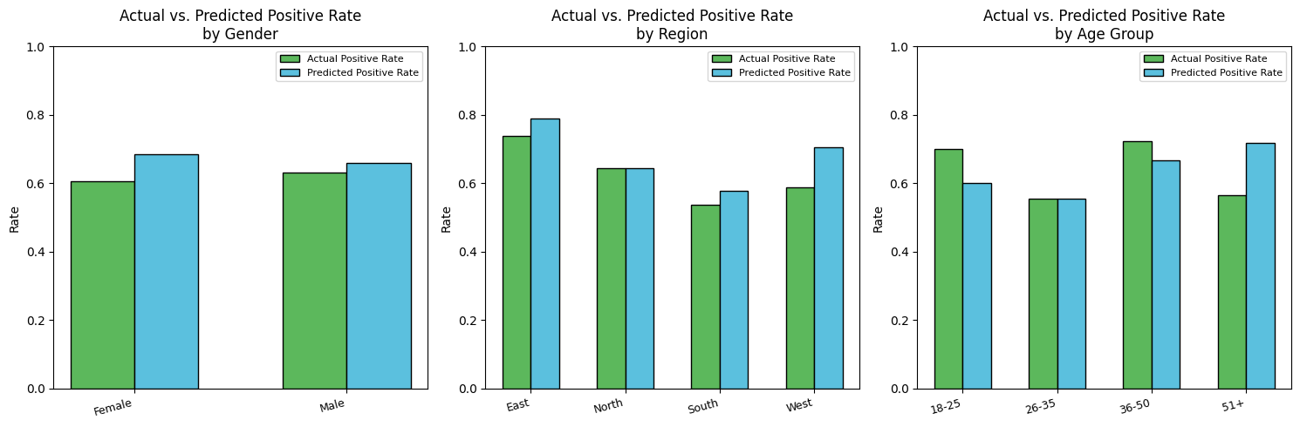
Figure 11: Actual vs. predicted positive rates by group (gender, region, age group) — West region and 51+ show the largest over-prediction gaps
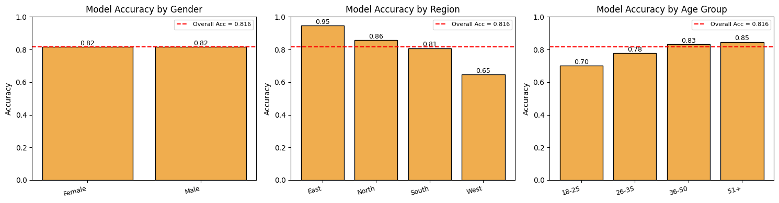
Figure 12: Model accuracy by group — West region (64.7%) and 18–25 age group (70.0%) show the weakest accuracy

13. Business Actions and Recommendations
Based on the model's findings, the following actions are recommended for event management teams:
- Target re-engagement outreach at registrants who have not accepted a calendar invite, opened fewer than 2 reminders, or have no prior event history. These are the highest-risk no-shows according to the model's feature importances.
- Offer remote or livestream access to registrants with high distance_to_venue_km values. This converts a likely no-show into a confirmed remote attendee, reducing the prediction gap for distant registrants.
- Use the model to generate a risk-tiered attendance forecast (high confidence / medium confidence / low confidence) rather than a binary yes/no prediction. This gives event planners more actionable planning outputs.
- Monitor model performance across the West region and 18–25 age group separately. If errors persist, retrain with more representative data from those subgroups.
- Do not use model predictions as the sole basis for any individual-facing decision (e.g., cancelling a registrant's booking or withholding event access). All model outputs should inform human decisions, not replace them.

14. Limitations
The following limitations should be considered before applying these results in a real event management environment:
- Small dataset: 380 records is insufficient for a robust production model. Results — especially fairness metrics for sub-groups of 9–19 records — may not generalise.
- CV vs. test gap: The 5-fold CV mean accuracy of 65.46% is substantially lower than the single-split test accuracy of 81.58%. The CV estimate is more reliable and reveals the model is barely above the naive baseline.
- Decision Tree limitations: Decision Trees are prone to instability — small changes in training data can produce structurally different trees. Ensemble methods (Random Forest, Gradient Boosting) would likely produce more stable predictions.
- Static model: Attendance behaviour changes over time as event formats, audience expectations, and communication channels evolve. The model requires periodic retraining.
- Synthetic-style data: The dataset was created for educational purposes. Real-world event data would include more complex patterns, missing data, and distribution shifts.
- Binary target only: The model predicts only attend/not attend. It does not predict the probability of attendance (which would enable more nuanced risk scoring) or partial attendance (e.g., attending only part of a multi-day event).

15. Responsible AI Considerations
Event management AI applications that affect attendee experience and resource allocation carry a responsibility to operate fairly and transparently. The following principles should govern any deployment of this or similar models:
- Fairness: The model should never be used to disadvantage registrants from any geographic or demographic group. Model predictions must not trigger automatic exclusions, cancellations, or reduced service quality for any subgroup.
- Human oversight: All predictions must be reviewed by event management professionals before any resource or outreach decision is made. The model serves as a risk-scoring tool, not a decision-maker.
- Explainability: SHAP and LIME explanations allow event teams to understand why a specific registrant was flagged as a likely no-show. This supports accountability and helps staff identify when a prediction may be unreliable.
- Transparency to registrants: Organisations using attendance prediction models should inform registrants that their registration data is used in automated planning processes, in accordance with applicable privacy regulations.
- No punitive use: Model outputs should never be used to penalise individual registrants — for example, by cancelling their booking or denying access based on a low predicted attendance score.
- Model monitoring: If deployed, the model's fairness metrics should be re-evaluated after each event cohort, particularly for the West region and 18–25 age group, which showed the largest disparities in this analysis.

16. Final Conclusion
This assignment applied a Decision Tree classifier to the Event Registration & Attendance dataset to predict whether registrants would attend their booked event. The full machine learning pipeline — including preprocessing, model training, evaluation, explainability, and fairness analysis — was implemented using scikit-learn with a Pipeline and ColumnTransformer to prevent data leakage.
The controlled model (max_depth=4) achieved a single-split test accuracy of 81.58% and an F1-score of 0.857, which appears strong. However, the 5-fold cross-validation mean accuracy of 65.46% — only 4 percentage points above the naive majority-class baseline — reveals that the single-split result was optimistic. The CV score is the more honest and reliable estimate of generalisation performance, and it indicates that the model has limited predictive power on genuinely new data.
The most important predictive features are prior event attendance history (previous_events_attended), email engagement (email_reminders_opened), calendar commitment (calendar_invite_accepted_Yes), and physical distance to the venue (distance_to_venue_km). These findings are consistent and actionable for event management teams.
SHAP analysis confirms these features as the dominant positive drivers across the test set, while LIME enables individual-level explanations that allow staff to understand and act on specific at-risk predictions. Together, these tools transform the model from a black box into an interpretable decision-support instrument.
The fairness analysis identified material disparities: the West region (64.7% accuracy) and the 18–25 age group (70.0% accuracy) are systematically under-served by the current model. The West region in particular shows a 15.4 percentage-point over-prediction bias that would lead to chronic resource misallocation if the model were deployed without human oversight.
The recommended path forward is to treat this model as an early baseline prototype: use it to identify the most relevant engagement signals and to build intuition about attendance patterns, but do not deploy it autonomously. Retraining on a larger, more representative dataset — particularly with more West region and younger-age-group records — would be the highest-priority next step before any production use.

