**Part I - Fashion MNIST Classification with RNNs**

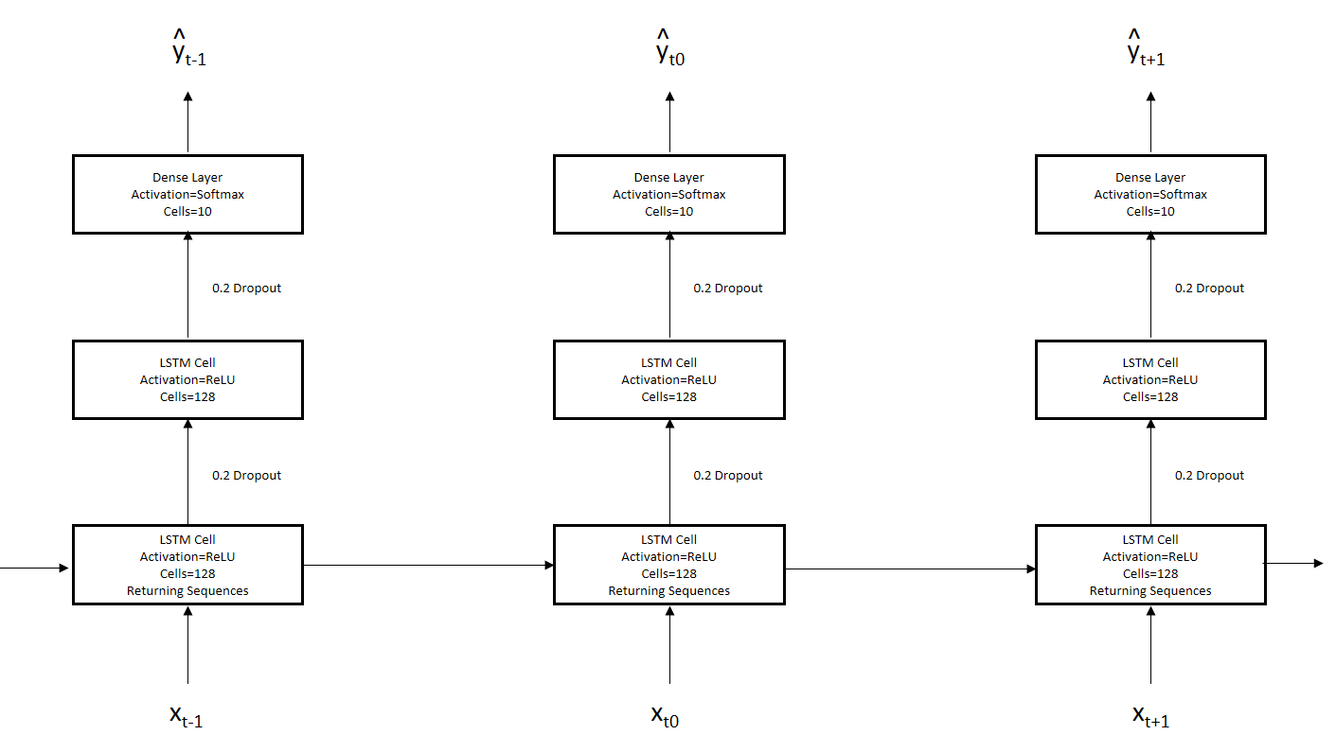

In the above architecture I’ve chosen to classify the Fashion MNIST dataset using a 3 layer network with a single hidden layer. xt is a 28 x 28 pixel image The input layer is an LSTM layer comprised of 128 cells, the second/hidden layer is an also an LSTM layer made up of another 128 cells, however this layer is not returning sequences. Both the input and hidden LSTM layers use the ReLU activation. The final output layer is a dense layer a dense layer made up of 10 cells, one cell for each output, and uses softmax as the activation. Each LSTM layer uses a 0.2 dropout value to avoid vanishing/exploding gradients.

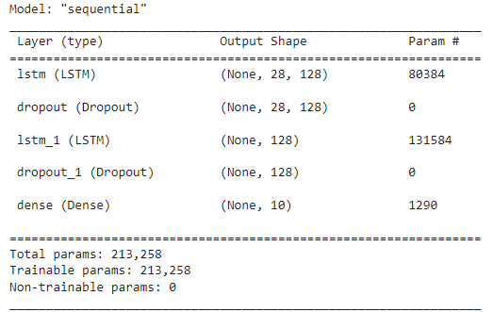

**Part II – RNN Implementation See notebook**

**Part III – Performance Comparison**

After 15 epochs the RNN achieved 90% accuracy with a .276 loss. The CNN achieved 87.75% accuracy and a .34 loss. The training time per epoch of the RNN is ~30x higher than the CNN with an average time per epoch 156s compared to the average of 5 sec for the CNN.

The RNN is also showing evidence of overfitting illustrated by the difference in training and validation loss.

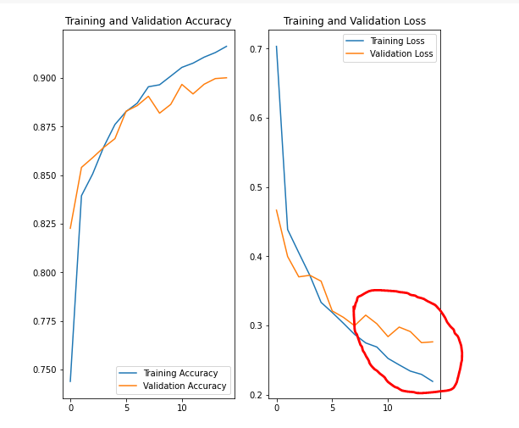

**Part IV – CNN + RNN**

CNNs have proven to be very effective in the case of single label image classification. But in the case where we have images that contain multiple objects and can be defined by multiple labels the CNN needs to be augmented in order to learn the relationship between certain objects and labels featured in images. In the approach outlined by the paper the CNN iterates over the training data set in order to model fit images to labels while the RNN models the correlation between all labels for a given image and stores them in the LSLM. I believe that the performance benefit from this approach comes from modeling the relationship between multiple labels. Traditionally we’d need to train models to label learn each label individually. By modeling the relationship of multiple labels in a recurrent manner we can reduce training time and increase the accuracy of highly dependent objects.