Aligning Molecular and Microscopy Methods for Early Detection of Biofouling of Farmed Seaweed (Alaria esculenta and Saccharina latissima)
Calum Young, Konstantin Chekanov, Brendan Robertson, Eleni Christoforou, Martin Llewellyn, Maria Alguero-Muniz, Victoria Delannoy, Kayla Orr, Sofie Spatharis
Abstract
Seaweed biofouling by epibiont taxa, including bryozoans, hydrozoans, amphipods, bivalves, and gastropods is a key constraint to improving the yield and quality of cultivated kelp in the North-East Atlantic. The meroplanktonic larval stages of these groups can appear in the water column and precede visible settlement on seaweed blades by weeks to months. This creates an opportunity for early intervention if detected promptly. Samples were collected from a site on the Isle of Skye, Scotland, which integrated eDNA metabarcoding with plankton and blade microscopy. Targeted COI gene metabarcoding was applied to validate microscopic identifications and enable direct comparison of monitoring techniques with focus on detection efficiencies and taxonomic resolution.
Molecular and microscopy results did show agreement in the detection of key epibiont taxa with eDNA and microscopy consistently detecting epibionts in the meroplankton earlier in the season, relative to direct observations upon blades. Molecular techniques were successful in improving observations by providing greater taxonomic resolution of key groups and revealed several cryptic and early-stage species that could only be broadly classified through microscopy. eDNA signals for several key fouling taxa often appeared weeks before plankton microscopy detections and up to two months before blade colonisation, illustrating distinct seasonal lags between methods. Notably, hydrozoan eDNA peaks in March/April preceded plankton abundance maxima recorded in May/June and peak blade coverage (>85%) later in July. Depth-stratified blade surveys showed that tip segments harboured the highest fouling loads, highlighting potentially depth-related settlement preferences.
The results indicate that the combination of molecular diagnostics and conventional light microscopy improves the sensitivity and specificity of biofouling detection, facilitating earlier and more informed farm management decisions. This approach supports the development of a predictive biofouling risk framework with targeted mitigation strategies that has strong applicability within the expanding North-East Atlantic kelp aquaculture sector.
Keywords: biofouling, environmental DNA, kelp aquaculture, early warning, epibionts

Introduction
Kelp cultivation offers significant potential as a sustainable marine bioresource, capable of advancing global food security while mitigating climate change and delivering high-value products across medical, agricultural and industrial sectors (Jagtap and Meena, 2022, Duarte et al., 2023, Sultana et al., 2023). Although Asian producers have long dominated global seaweed markets, emerging expansion within regions like the North-East Atlantic demonstrates the rising international interest for macroalgae production (Veenhof et al., 2024, Zhang et al., 2022). With plants to increase production to 8 million tonnes by 2030, seaweed farming is critical to the EU’s sustainable blue economy that aims to create 85,000 jobs and generate an estimated 9 billion Euros of revenue (Jueterbock et al., 2025). There are however significant barriers to commercial viability for Europe’s seaweed industry which is predominantly made up of small-scale startups (Addamo et al., 2022). A major limitation to consistent quality and biomass yield within kelp aquaculture is the biofouling of fronds by epibionts that typically expand coverage during the latter stages of the growing season (Visch et al., 2020). This late-season colonisation can lead to increased blade fragility and reduced growth that impacts the commercial value of the harvested product (Walls et al., 2017, Bannister et al., 2019).
Biofouling by proliferating epibionts remains a major constraint on the commercial viability of seaweed aquaculture (Bannister et al., 2019). The cold, mesotrophic waters of the North-East Atlantic which are ideal for macroalgal cultivation also provide optimal conditions for seasonally proliferating epibionts (Forbord et al., 2020). Main biofouling taxa which colonize both wild and farmed seaweed blades include bryozoans, hydrozoans, gastropods, amphipods, bivalves, tunicates and epiphytic algae (Matsson et al., 2019). Fouling organisms compromise host seaweeds in three major ways: through physical damage, physiological disruption, and competition for vital resources (Bannister et al., 2019). Encrusting species such as bryozoans reduce light penetration, hinder nutrient and gas exchange, and block reproductive spore release which can collectively lead to tissue necrosis (Walls et al., 2017). Biofouling also reduces frond flexibility which increases hydrodynamic drag leading to breakage and detachment in higher wave-exposed environments leading to losses of harvestable biomass (Krumhansl et al., 2011). As infestation severity increases, the quality, taste, and market value of the crop declines. This leads to rising processing costs and allergen risks for consumers (Walls et al., 2017, Bannister et al., 2019). To avoid peak biofouling, many farmers are forced to harvest early which sacrifices yield volume and profitability (Visch et al., 2020).
The structure of epibiont communities differs significantly depending on location and host species culminating to site-specific impacts upon cultivated seaweeds. For example, Saccharina latissima and Alaria esculenta show similar successional patterns from biofouling that coincide with well-established model for epibiosis (Forbord et al., 2020). The process begins with deposition of a thin organic film, followed by bacterial colonization and subsequent diatom biofilm establishment; these early processes are mainly dictated by the physicochemical properties of the host surface (Pansch et al., 2009). As succession progresses, algal spores and invertebrate larvae settle and dominate the epibiotic community, particularly hydrozoans and bryozoans (Ronowicz et al., 2008, Rolin et al., 2017). For example, bryozoans form calcified mat-like colonies that can significantly alter the ecological structure of the host surface (Førde et al., 2015). In contrast, hydrozoan colonies may themselves act as substrate for other fouling taxa by creating a complex, multi-layered biofilm (Tendal and Dinesen, 2005)
The meroplanktonic component of the biofouling process is vital because it allows epibionts to disperse throughout the water column before ultimately settling on a suitable substrate, which could be macroalgae, rocks, or aquaculture infrastructure (Agostini and Ozorio, 2022). In the Northern Hemisphere, fouling activity peaks during spring and autumn as seasonal variations in temperature, light availability, and water movement influence activity (Visch et al., 2020).
The larval dispersal stages of adult organisms are meroplanktonic and play a crucial role in shaping seasonal biofouling dynamics on kelp. Bryozoan species such as Membranipora membranacea release larvae called cyphonautes from already established overwintering colonies, acting as an early-season dispersal source. These larvae can remain in the water column for months before finally settling and establishing themselves (Ryland, 1962). Year-round presence of M. membranacea larvae has been recorded in the North Atlantic region, with peak abundances occurring from late June onwards, likely driven by rising temperatures that enhance plankton production (Førde et al., 2015). In contrast, hydrozoan dispersal occurs via release of medusae or planula larvae from either benthic polyp or pelagic stages of surrounding fouling communities (Martell et al., 2018). Hydrozoa are found to be more prevalent on farmed kelp compared to wild populations due to reduced hydrodynamic forces among the dense cultivation lines, which favour larval settlement and decrease benthic predation by suspending farm structures (Delannoy et al., 2025). Bivalves such as Mytilus sp. and Hiatella arctica produce planktonic veliger larvae during synchronous spawning events that drift from nearby rocky shores, shellfish beds or aquaculture structures themselves (Garcia et al., 2003, Delannoy et al., 2025).
To understand and reduce the biofouling risk caused by epibionts, it is important to precisely identify when each biofouling meroplanktonic taxon enters the planktonic phase. Accurate monitoring of their seasonal patterns is essential for predicting settlement events and enabling informed farm management strategies. Achieving this demands a quick, sensitive, and taxonomically detailed method.
Metabarcoding of environmental DNA (eDNA) from seawater samples enables early detection of epibiont communities by identifying genetic material shed into the surrounding environment by organisms, often before they become detectable through microscopy (Zaiko et al., 2016, Djurhuus et al., 2017). Amplification of targeted barcode regions from eDNA can reveal epibiont presence weeks before colonisation may become visible on blades(Keck et al., 2022, Rishan et al., 2023). A commonly used marker in marine metazoan metabarcoding is the mitochondrial cytochrome c oxidase subunit I (CO1) gene, which provides species-level resolution for many invertebrates (Borrell et al., 2017). However, with metabarcoding, challenges remain with taxonomic gaps and detection inconsistencies, particularly in low abundance species due to amplification biases caused by primer selectivity (Algueró‐Muñiz et al., 2024).
Quantitative microscopy of water samples allows for identification and enumeration of problem epibionts during the larval stages (Agostini and Ozorio, 2022). As such, plankton surveys serve as a valuable detection method of biofouling risk prior to the visual appearance on seaweed crops. Detection of seasonal peaks in larva abundance may allow farmers to anticipate infestation severity of subsequent blade colonisation and enable adaptation of time management strategies. However, microscopy is labour-intensive and requires strong taxonomic expertise that could still miss cryptic or rare taxa (Chen et al., 2023).
Integrated analysis of molecular data alongside physical observations enables investigation into the temporal lags between meroplanktonic larvae within the water column and their subsequent physical settlement upon the seaweed substrate. While metabarcoding has proven effective in community composition studies, its potential as a tool for early detection is increasingly evident as it offers broad taxonomic resolution and ability to detect often overlooked or cryptic species. By aligning molecular reads with visual observations such as planktonic counts and blade colony assessments, it becomes possible to generate a more holistic understanding of biofouling dynamics. Collectively, this can improve the accuracy and reliability in using molecular read data within biofouling monitoring frameworks.
The aim of this study was to assess a combination of molecular methods (plankton eDNA and epibiont barcoding) and microscopy methods (kelp epibiont and plankton counts) in better understanding the timing and community composition of biofouling. To achieve this aim, we sampled a kelp farm which crop Saccharina latissima and Alaria esculenta for plankton and seaweed during a whole production cycle. Our first objective was to obtain a detailed ID of the epibionts on the kelp blades using both microscopy and barcoding. The second objective was to assess the sensitivity of eDNA metabarcoding in detecting the planktonic stages of epibionts compared to the traditional plankton microscopy counts and identification. Our third objective was to check for lags between the timing that kelp epibiont species are detected in the plankton (by both eDNA and microscopy) and when these appear as adult stages on the kelp. Finally, we checked for potential effects of depth on the distribution of epibionts on kelp blades.

Methods
Methods overview
We combined eDNA metabarcoding, plankton‐net microscopy counts, and visual surveys of blade‐attached epibionts to undertake both descriptive and comparative analyses addressing three core objectives: 1) Method comparison: Quantify and contrast the sensitivity and taxonomic resolution of molecular (eDNA) versus microscopy‐based approaches in detecting epibionts both in the water column and on kelp blades. 2) Temporal dynamics: Characterize time‐lags among eDNA signal emergence, planktonic epibiont detections, and their subsequent settlement on seaweed fronds. 3) Depth distribution: Evaluate how epibiont colonization intensity varies along blade depth gradients. Fig. 1 represents the combined methodological framework utilized within this study.
Figure 1. Methodological Framework: Overview of the study approach and objectives.

Site and Sampling: Farm layout, coordinates
Between September 2021 and July 2022, with an additional sampling day in June 2021, the Scalpay site within the ®KelpCrofters seaweed farm (NW Scotland) was sampled. This allowed for an end-to-end comparison of kelp production cycles for two different kelp species (S. latissima and A. esculenta), spanning a total of 18 sampling days. Samples were collected from 3 GPS points () as replicates across the whole sampling period. At each GPS point (acting as replicates), phytoplankton, zooplankton, eDNA and epibionts were monitored.
Zooplankton and Microscopy
The zooplankton community was sampled using vertical net hauls at three GPS points, employing an Apstein net (40cm diameter, 55µm mesh size) equipped with a closed cod end, which collected a total volume of 491 L. One net haul was taken per GPS sampling point, sinking the net up to 10m depth, mimicking the maximum depth the kelp would grow during the harvesting cycle. Samples were rinsed on site with pre-filtered seawater, collected in containers, and fixed with buffered 40% formaldehyde solution for preservation.
During analysis, organisms were sorted using a stereomicroscope (Leica S9i) and classified to the lowest possible level, to a minimum of class level. Every sample was sieved through 50 μm mesh, rinsed with tap water and poured into a calibrated beaker, where organisms were well mixed before subsampling three aliquots with a Hensen Stempel pipette [1] representing a minimum of 12 % volume of the sample. Counting was restricted to the 12 % of volume for the most abundant taxa, whereas the remaining sample volume was monitored for the taxa not recorded in the aliquots to record diversity.
Analyses were focused on meroplanktonic species, specifically those that accounted for planktonic early life stages, which will ultimately adopt a benthic lifestyle, potentially becoming members of the seaweeds fouling community (REFS). Based on the proximity of this seaweed farm to a salmon farm —where hydromedusae are related to salmon gill disease [2]— and the relevance of hydrozoans as a seaweed fouling community [3], special interest and effort were placed in this group.
Epibionts: morphological and molecular identification
Morphological and molecular approaches were combined to identify epibionts to compare the resolution of methods and to achieve the lowest possible taxonomic level. Sampling took place between June 2021 and July 2022 to coincide with the period when kelp fronds were sufficiently developed to host epibionts. Fronds were collected at the Kelpcrofters Seaweed Farm (Isle of Skye), preserved in 95–100% ethanol, and stored at –20 °C until analysis.
Before processing, samples were acclimatised to room temperature and handled under sterile conditions. Unattached organisms were recovered by sieving, and fronds were rinsed with ethanol. Each frond was photographed to estimate fouling cover, and attached specimens were removed with sterile forceps. Specimens were identified morphologically under a stereomicroscope (Leica S9i), photographed, and preserved for molecular analysis. Abundance of each taxon per frond was estimated under the stereomicroscope. To confirm and refine identifications, selected individuals were subjected to DNA barcoding.
DNA extraction was performed using Qiagen DNeasy® Blood & Tissue Kit protocol with minor adjustments. Individual specimens were placed in 2 mL centrifuge tubes, treated with Buffer ATL, and gently pressed with a sterile ball-point tool before the addition of Proteinase K. Samples were incubated at 56 °C for 1 h, and the remaining steps of the Quick-Start Protocol were followed with elution in 150 µL Buffer AE. DNA yields were quantified by NanoDrop or Qubit™ Fluorometer; samples exceeding 20 ng/µL were diluted to ~1.3 ng/µL and used for PCR amplification. PCR products were checked by gel electrophoresis, purified with the Invitrogen PureLink® PCR Purification Kit and then submitted to Sanger sequencing (University of Dundee).
Sequences were trimmed and aligned using BioEdit Sequence Alignment Editor and taxonomically assigned using BLAST searches against the NCBI GenBank database. A threshold of ≥97% sequence similarity, amplicon length >80 bp, and the lowest E-value was applied for species designation. Sequences not meeting these criteria were omitted.
Planktonic Environmental DNA (eDNA)
Environmental DNA was extracted from seawater samples collected at the seaweed cultivation sites. A Niskin bottle was used to collect 5 L of seawater at 5 m depth. The water was transferred into a handheld sprayer pump adapted to hold two output tubings fitted with 0.2 µm Sterivex filters (Merck), allowing filtration of 500 mL seawater per filter. Filters were then air-dried and stored individually in 50 mL sterile centrifuge tubes at 4 °C until extraction.
DNA extraction was carried out using the Qiagen DNeasy® Blood and Tissue Kit following the manufacturer’s Quick-Start Protocol with minor modifications. 500 µL of lysis buffer and 50µL of Proteinase K was added to each filter before being sealed on both sides and incubated overnight at 56 °C on a rotary wheel (~150 rpm). The lysate was then transferred to 2 mL centrifuge tubes and mixed with 500 µL AL buffer and 500 µL absolute ethanol. Solution was transferred in parts to a spin-column and centrifuged at 15,000 xg (1min) until all was used. 500 µL of AW1 wash buffer was added, and spun again at 15,000g (1min). 500 µL of AW2 wash buffer was then added, and spun again at 15,000g (2min). Wash buffers were discarded after each spin. Spin-columns were then spun with no buffer (15,000 xg for 1 min) to remove remaining trace ethanol. Finally, 55 µL of AE elution buffer was added to the spin-column, this was left for 5 minutes to incubate at room temperature before a final centrifuge into a collection Eppendorf (10,000 xg for 2 min). Sample purity and concentrations were tracked via Nanodrop and Qubit analysis, respectively.
Extracted DNA was amplified using a two-step PCR protocol that targeted mitochondrial cytochrome c oxidase subunit I (COI) gene. The first PCR used 10 µL polymerase master mix, 1 µL each of forward and reverse primers, 0.16 µL bovine serum albumin, 5.84 µL molecular-grade water, and 2 µL DNA extract. Thermocycling conditions were: 95 °C for 5 min; 35 cycles of 95 °C for 1 min, 55 °C for 1 min, 72 °C for 1 min; and a final extension at 72 °C for 5 min.
The second PCR used internal barcoding primers, and a reaction mix of 2.5 µL barcode (red plate), 8.7 µL H₂O, 12.5 µL Q5 polymerase, and 1.3 µL first-round PCR product per sample. Amplification products were checked by gel electrophoresis, purified using the Invitrogen PureLink® PCR Purification Kit, and submitted for Sanger sequencing.
Data analysis
Data analysis was performed in R (v4) using the tidyverse framework for data wrangling and transformation. Plankton abundances, blade coverage, and eDNA read counts were standardised and log-transformed when deemed necessary. Heatmaps of seasonal dynamics temporal patterns of plankton abundances were produced using ggplot2 package. Statistical analyses, including generalised linear models (GLMs) and ANOVA tests, were conducted with significance determined at p < 0.05.

Results
Barcoding analysis for the detection of kelp epibionts
DNA barcoding greatly improved the resolution and accuracy of epibiont identifications, relative to traditional microscopy. Table 1 shows several taxa which were not confidently identified above the taxonomic level of order during visual surveys but were successfully identified to species level using barcode sequencing. For example, Caprella mutica and Jassa herdmani were both confidently identified with 100% sequence identity, while microscopy was unable to distinguish them beyond the broader taxonomic group. Similarly, hydrozoan taxa such as Ectopleura larynx, Bougainvillia muscus, and Clytia hemisphaerica were all allocated to species level by barcoding despite being recorded only as “Hydroid” or left unclassified in plankton and blade microscopy.
Several barcoded taxa including Caprella mutica, Jassa herdmani, Hiatella arctica, Ectopleura larynx, and Bougainvillia muscus were also recorded from rope scrubs, indicating that these species may establish on farm infrastructure prior to kelp blade development. Notably, Hiatella arctica, a bivalve only identified via its juvenile form in microscopy, was confirmed through barcoding at 97.7% identity and detected on ropes, supporting the interpretation of rope colonisation as a precursor to blade settlement.
Assessing the efficiency of eDNA vs microscopy in detecting the planktonic stages of kelp epibionts
Comparisons between eDNA and microscopy datasets revealed both overlaps and discrepancies in detection of epibiont taxa. Across all five target groups, detections were generally more consistent and taxonomically specific in eDNA data. Although several species were successfully identified by both methods, they often varied in taxonomic depth.
Bryozoa
Microscopy detected bryozoan larvae (cyphonautes) in plankton tows, assigning them only to class level. The first major peak in bryozoan abundance occurred between October and November 2021, followed by a marked decline through January and February 2022. A second distinct increase was observed in March, indicating a spring emergence. These patterns aligned closely with eDNA detection trends, particularly for Electra pilosa and Membranipora membranacea, both of which peaked during the autumn window—though M. membranacea exhibited a weaker signal. In March, eDNA data showed a concurrent spike in Celleporella hyalina, a key biofouler confirmed via blade barcoding (Table 1), which was not detected in microscopy samples. Notably, bryozoans were undetected in both datasets during May, but re-emerged in June, culminating in a strong summer peak in plankton counts in July. This preceded visible and severe (~60%) colonisation of Saccharina blades in late July (Fig. 2), whereas Alaria blades remained unaffected throughout the study period.
Hydrozoa
Plankton microscopy recorded low levels of hydrozoan abundance in September and October 2021, followed by a period of no detection throughout winter and early spring. Abundances began to gradually increase in May 2022, culminating in a distinct peak between late May and June, when cell concentrations reached their highest levels (Fig. 3). This seasonal pulse coincided with sharp increases in blade colonisation on Saccharina, where mean coverage rose steeply in June and reached its maximum in mid-July (~30%). Alaria exhibited substantially lower levels of colonisation, with the average only peaking at ~3% coverage in early July.
Microscopic analysis was only able to identify hydrozoans to the class level, reflecting the limited taxonomic resolution of traditional plankton surveys. In contrast, the molecular dataset identified 25 distinct hydrozoan taxa at the genus or species level. Among the most prominent were Bougainvillia muscus and Clytia spp., both of which were also confirmed from blade samples via CO1 barcoding (Table 1). Notably, Clytia sp. 2 exhibited the broadest temporal range of detection, with eDNA signals present from November 2021 through July 2022 with brief dropouts in December and late February. This taxon also exhibited the single highest peak in eDNA abundance among hydrozoans in early February.
Both Bougainvillia muscus and Clytia sp. 2 showed pronounced eDNA signals in March and April, preceding a sharp rise in hydrozoan plankton abundance and later followed by peak blade colonisation on Saccharina in June and July. In addition to these dominant taxa, several other hydrozoans including Ectopleura larynx and Obelia dichotoma were also detected at lower and more sporadic levels between early March and late May. Despite generally low detection levels during the winter months, faint eDNA signals from hydrozoans such as Aglaophenia tubulifera and Obelia bidentata were recorded sporadically in December and early February. However, these detections were not reflected in blade colonisation or microscopy counts, suggesting either early-stage presence or low-density overwintering cohorts that remained undetectable by visual methods.
Bivalvia
Bivalve larvae were consistently detected by microscopy, with abundances gradually increasing from January 2022 and peaking sharply in mid-July, reaching mean values exceeding 2,000 cells/L, the highest recorded for any taxonomic group in the study (Fig. 4). In contrast, eDNA metabarcoding revealed more intermittent but taxonomically resolved patterns. Early-season detections included Montacutona signalinoidicola and Mytilus edulis in October and November 2021, which were not detectted by microscopy. A second, more pronounced eDNA signal was observed between May and June, dominated by Kurtiella bidentata and Dosinia sp. This molecular peak closely coincided with rising plankton abundance and preceded the onset of visible bivalve colonisation on kelp blades, particularly on Saccharina.
Blade colonisation was substantially higher on Saccharina, where total bivalve densities exceeded 3 individuals/cm² by late July. This fouling was primarily attributed to Mytilus sp., Pecten sp., and several other bivalves that remained unresolved beyond class level in microscopy. In contrast, Alaria supported minimal colonisation, with peak densities remaining below 0.004 ind/cm². However, bivalve settlement on Alaria was detectable from March through May, prior to the cessation of sampling for this species.
Amphipoda
Amphipod larvae were detected at low and sporadic levels by microscopy between January and March, followed by a sharp increase in abundance peaking in May at over 125 cells/L (Fig. 5). Microscopy could only assign blade specimens to higher taxonomic levels (e.g. Gammaridae, Caprellidae), without species-level resolution. In contrast, eDNA metabarcoding resolved three distinct amphipod taxa in the water column: Jassa herdmani, Aora gracilis, and Niphargus arbiter. Notably, J. herdmani was first detected in eDNA in March, peaked in April, and preceded the rise in plankton abundance observed microscopically in May. This early molecular signal suggests eDNA detected the species before larvae reached densities visible under microscopy. Meanwhile, A. gracilis peaked in eDNA concurrently with the May microscopy maximum, supporting method agreement in both timing and presence. N. arbiter appeared briefly in April but was not mirrored in microscopy or blade data.
Gastropoda
Gastropod larvae were consistently detected by microscopy throughout the study period (Fig. 6), with a prominent peak in September 2021 reaching over 800 cells/L, the highest recorded for these taxa. Despite sustained presence in the plankton, microscopy was limited to class-level identification and could not resolve taxa further. In contrast, eDNA metabarcoding provided species-level resolution, detecting 22 unique gastropod taxa. Steromphala cineraria exhibited a strong early eDNA signal in September 2021, coinciding with the peak in plankton abundance. Additional taxa such as Burnupia sp., Doto coronata, and Placida dendritica were detected in March and April, preceding the secondary increase in planktonic gastropods recorded in May.
Lacuna sp. was identified on both Saccharina and Alaria blades (Fig. 6). Initial blade detections occurred in January on Alaria, followed by a clearer peak in May. On Saccharina, colonisation was observed later, peaking in July. These blade settlement patterns came after a strong eDNA signal for Lacuna vincta detected in March, suggesting a lag between larval presence in the water column and physical colonisation. Alaria supported earlier but lower-density settlement, peaking below 0.016 ind/cm² in May, while Saccharina showed later colonisation by Lacuna and Rissoa spp. in late June and July. These later settlement events on Saccharina were preceded by eDNA detections in April–May.

Epibiont ID | Plankton ID | Barcode ID | Rope Scrub Presence | Photo
Amphipoda (Caprellidae) | NA | Caprella mutica (100%) | Y | 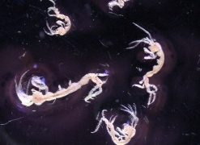
Amphipoda (Caprellidae) | NA | Jassa herdmani (100%) | Y | 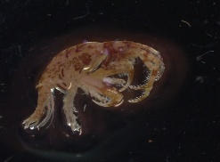
Amphipoda (Jassa) | NA | Jassa herdmani (100%) | Y | 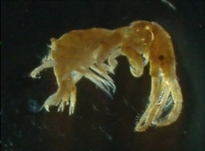
Bryozoans (cf Celleporella hyalina) | Cyphonaute | Celleporella hyalina (98.79%) | N | 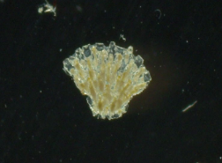
Clam juvenile | Bivalvia | Hiatella arctica (97.7%) | Y | 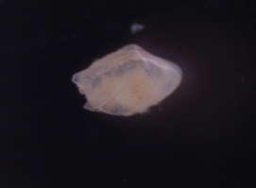
Dendronotid sea slug (Doto) | Gastropod | Doto coronata (99.62%) | Y | 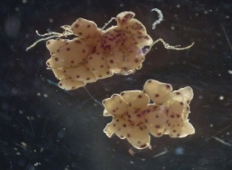
Electra pilosa | Cyphonaute | Electra pilosa (97.3%) | Y | 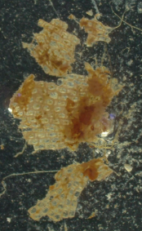
Hydroid (Tubulariidae) | NA | Ectopleura larynx (100%) | Y | 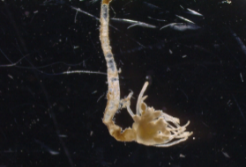
Table 1. Summary of epibiont taxa identified and the highest taxonomic resolution achieved by each method: visual identification from blades, planktonic microscopy surveys, and DNA barcoding of individuals sampled from blades. Percentage value (%) denotes the percentage identity match of the sequence with with GenBank database. Rope scrub presence (Y/N) denotes taxa identification from scrubbing of farm ropes prior to seaweed seeding.

Epibiont ID | Plankton ID | Barcode ID | Rope Scrub Presence | Photo
Hydroid (with Licmophora attached) | Clytia sp. | Clytia hemisphaerica (99.59%) | Y | 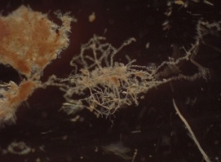
Hydroid (with Licmophora attached) | NA | Bougainvillia muscus (99.41%) | Y | 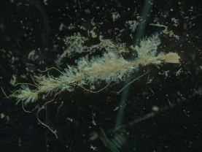
Membranipora membranacea | Cyphonaute | Membranipora membranacea (99.60%) | N | 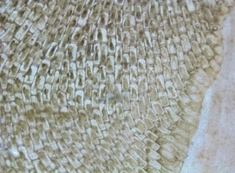
NA | Balanoid nauplii | Amphibalanus improvisus (100%) | N | 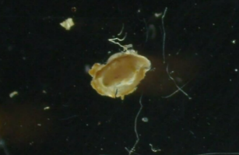
Obelia sp. | Obelia sp. | Obelia dichotoma (99.67%) | N | 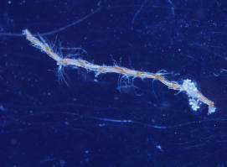
Rhodophyta (Pterosiphonia spinifera) | NA | Pterothamnion plumula (98.86%) | Y | 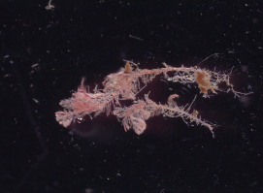
Unidentified | NA | Laminaria digitata (99.6%) | Y | 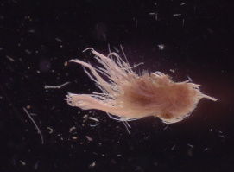
Unidentified algae (with Licmophora attached) | Hydroid | Bougainvillia muscus (99.41%) | Y | 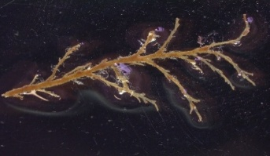

Assessment of time lags between eDNA, plankton and blade settlement of epibiont taxa
Bryozoa
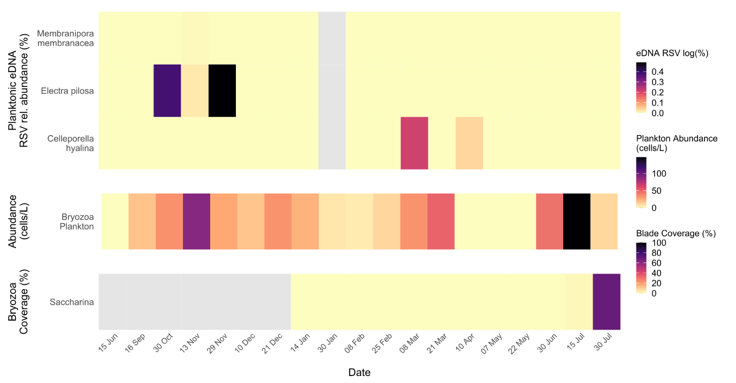
Figure 2. Temporal dynamics of Bryozoa epibionts. Heatmaps showing the seasonal patterns of bryozoan detection by eDNA metabarcoding, plankton microscopy, and blade settlement on cultivated kelp. Colours indicate log-transformed relative sequence variant (RSV) abundances (%), plankton cell counts (cells/ L); and percent coverage (%) of bryozoan colonies on Saccharina blades. No blade dectection of bryozoan species were recorded on Alaria. Sampling dates span 15 Jun 2021 to 30 Jul 2022. All values are monthly averages calculated from three independent replicate samples per date.Grey shading marks data unavailable.

Hydrozoa
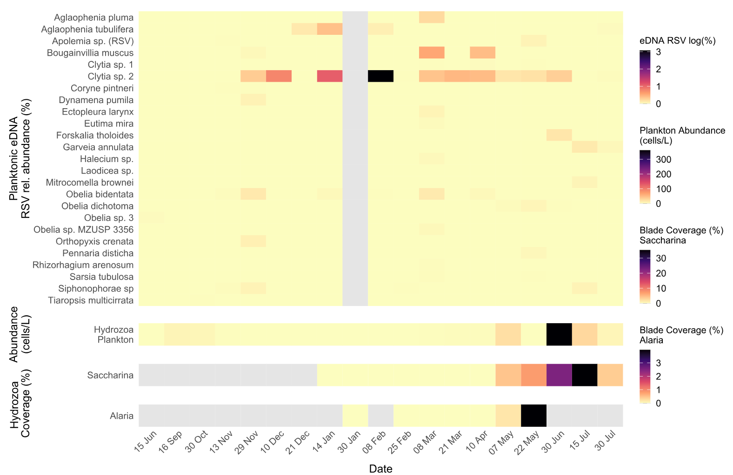
Figure 3. Heatmaps showing the emergence and settlement of Hydrozoa detected by eDNA metabarcoding, plankton microscopy, and blade fouling on two kelp hosts. Colour intensity represents relative abundance of log RSV (%) from eDNA read samples, plankton abundances (cells/ L); and percent blade coverage (%) measured separately on Saccharina and Alaria. Sampling dates span 15 Jun 2021 to 30 Jul 2022. All values are monthly averages calculated from three independent replicate samples per date. Grey shading marks data unavailable
Bivalvia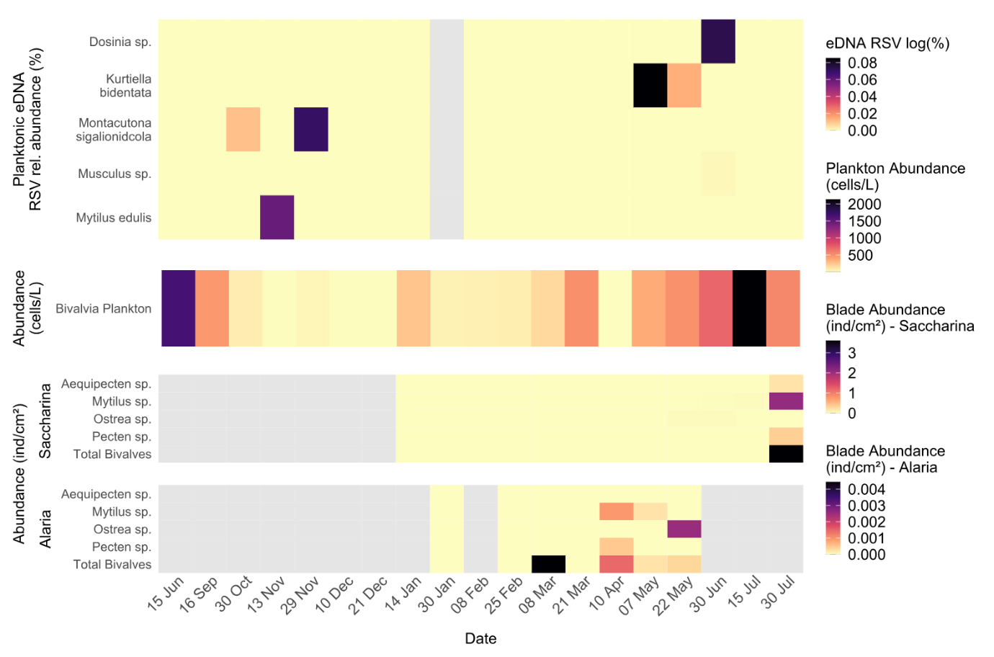
Figure 4. Heatmaps illustrating bivalve detection and colonization over time by relative abundance of eDNA RSV log (%) in the water column, plankton microscopy counts (cells/ L), individual density (ind/cm²) on Saccharina blades, and individual density on Alaria blades. All values are monthly averages calculated from three independent replicate samples per date. As before, sampling dates run from mid-June 2021 to end-July 2022, and grey bars indicate periods without data.

Amphipoda
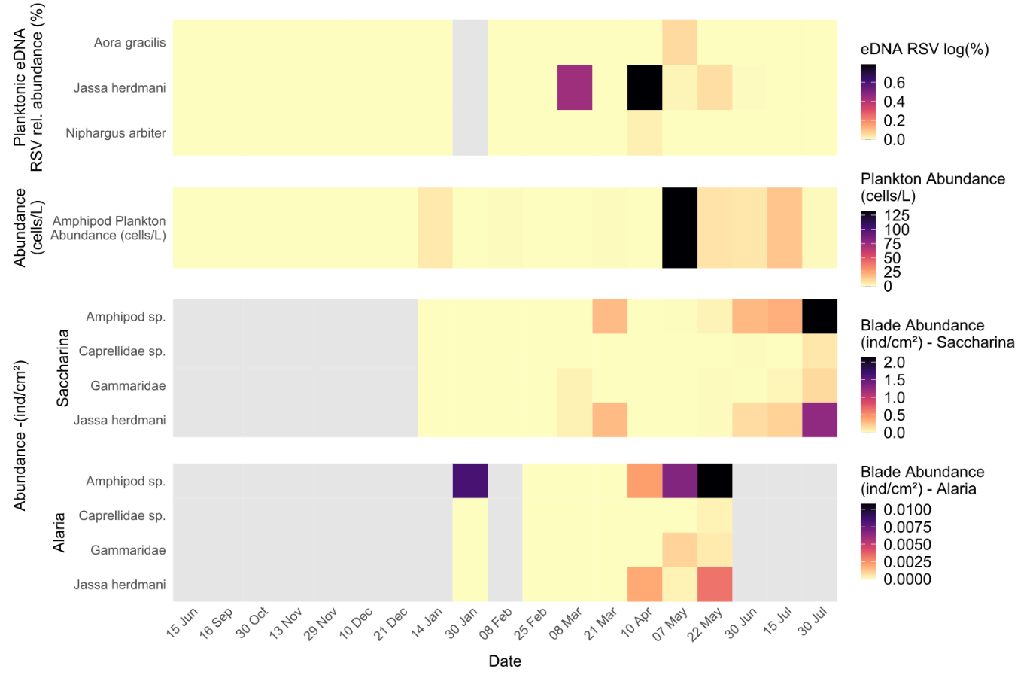
Figure 5. Heatmaps representing seasonal patterns of amphipod detection and settlement by eDNA metabarcoding (log RSV %), plankton‐net microscopy counts (cells/L), and blade colonization abundance (individuals/cm²) on Saccharina and Alaria fronds. All values are monthly averages calculated from three independent replicate samples per date. Sampling dates span mid-June 2021 to late-July 2022, and the grey-shaded areas mark indicate periods without data.

Gastropoda
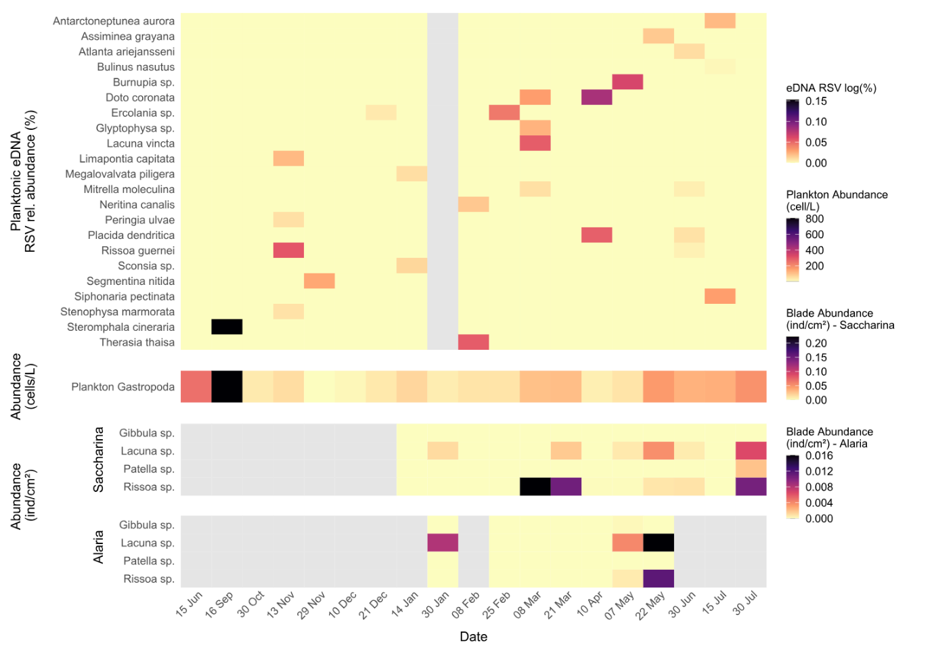
Figure 6 Heatmaps illustrating seasonal emergence and settlement of gastropods detected by eDNA metabarcoding (RA log RSV %), planktonic abundance (cells/L), and blade settlement abundance (individuals cm⁻²) on Saccharina blades. All values are monthly averages calculated from three independent replicate samples per date. Sampling dates run from mid-June 2021 through late-July 2022, and grey shading denotes periods without data.

Temporal Composition of dominant zooplankton taxa
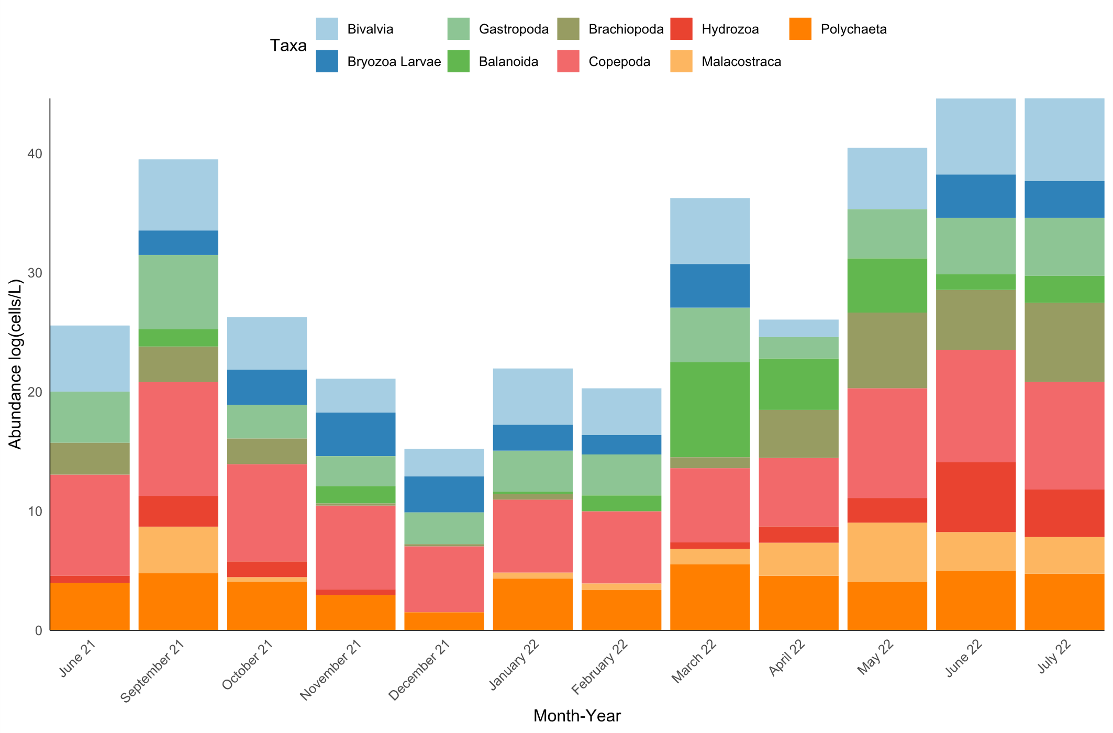
Figure 7. Stacked bar chart showing the mean monthly log-transformed abundances (cells/ L) of the principal planktonic groups collected by plankton net from June 2021 through July 2022 from Pabay, Isle of Skye.
Figure 7 depicts pronounced seasonal variation in both abundance and composition of dominant zooplankton groups in monthly seawater samples from Pabay, Isle of Skye, between June 2021 and July 2022. Community structure shifted markedly over the sampling period with fluctuations in total abundance (log-cells L⁻¹) driven by successive dominance of different taxonomic groups.
In summer 2021 (June - September), overall zooplankton abundance was high and dominated by copepods, bivalve larvae, and gastropods, with notable contributions from polychaetes and brachiopods. Autumn (October–November) saw a decline in total abundance, driven largely by reductions in copepods and hydrozoans, although bryozoan larvae and malacostracans became more prominent.
Winter months (December - February) were characterised by the lowest overall abundances, with a more even distribution among taxa and smaller contributions from polychaetes and brachiopods. From March 2022 onward, a marked spring/summer increase was evident, with sequential peaks in copepods, bivalves, and gastropods, accompanied by rising hydrozoan abundance in late spring.
By June/July 2022, bivalve larvae reached their highest recorded levels, coinciding with elevated hydrozoan and bryozoan counts.

Biofouling blade coverage of Alaria and Saccharina
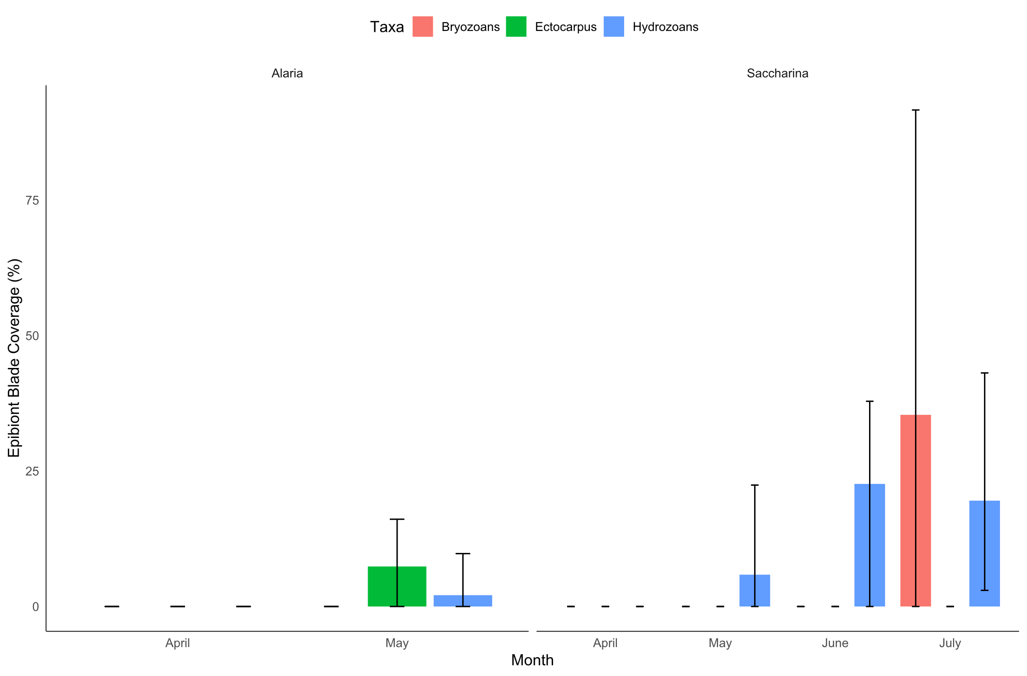
Figure 8. Bar charts showing mean percent blade surface covered by three epibiont groups—Bryozoans (red), Ectocarpus (green), and Hydrozoans (blue)—from April through July 2022. Error bars extend from the minimum to maximum observed coverage across replicate blades. Alaria fouling only recorded in May (no June or July data available), whereas Saccharina exhibited negligible coverage in April–May followed by substantial hydrozoan and bryozoan colonization in June–July.
In Alaria, measurable fouling was detected only in May, when hydrozoan coverage reached approximately 5% and Ectocarpus covered up to ~10% of the blade surface. No bryozoan colonisation was observed on Alaria during the study period although sampling for this species was only possible between January and May.
In contrast, Saccharina blades exhibited a clear fouling pulse later in the season. Coverage remained negligible through April, but by June hydrozoans reached mean coverage of ~20%, closely followed by a sharp July peak in bryozoan coverage exceeding 35% on average, with some blades approaching complete encrustation (>80%). Hydrozoan coverage remained high in July (~20%), while Ectocarpus was absent from Saccharina throughout the sampling window.

Biofouling blade colonisation of Alaria and Saccharina
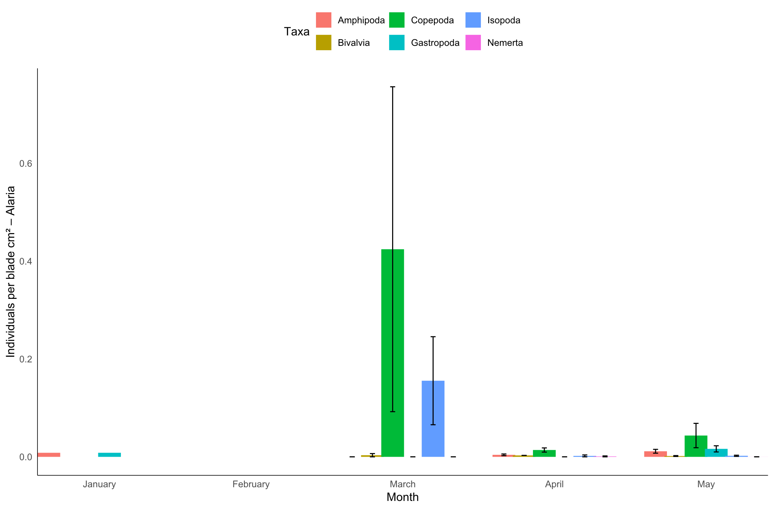
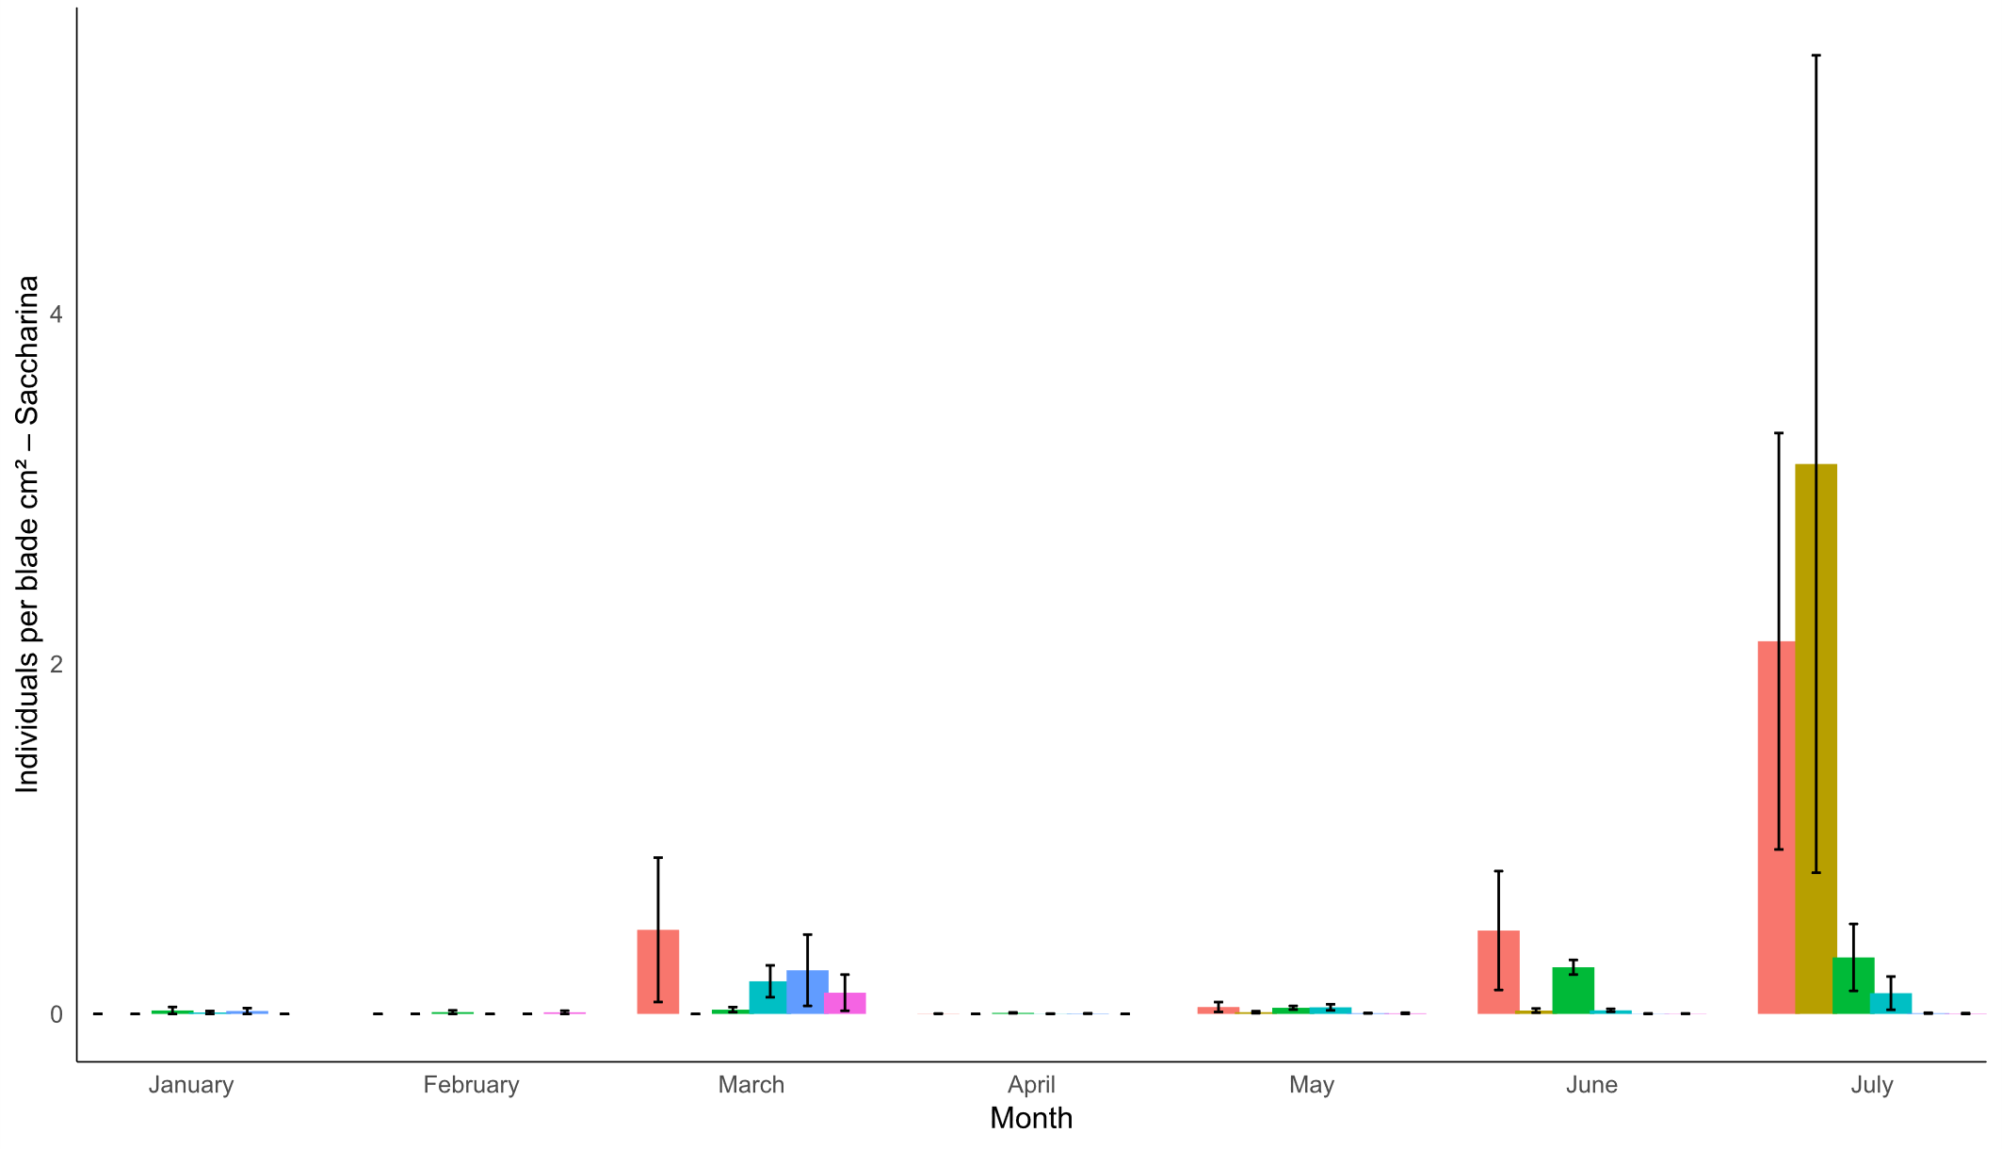
Figure 9. Bar charts showing mean colonization density (individuals /cm²) of six major taxa—Amphipoda (red), Copepoda (green), Isopoda (blue), Bivalvia (gold), Gastropoda (teal), and Nemertea (magenta)—on Alaria (top) and Saccharina (bottom) blades from January to July 2022. Error bars span the minimum to maximum values among replicate blades. On Alaria, peak copepod and isopod settlement occurs in March, with negligible densities before and after; on Saccharina, low-level settlement from January–June is followed by more pronounced amphipod and bivalve colonization in July.
In Alaria, colonisation densities were generally low throughout the sampling period, with a distinct peak in March driven by elevated copepod (~0.42 ind./cm²) and isopod (~0.18 ind./cm²) settlement. All other taxa occurred at negligible densities (<0.02 ind./cm²) across the season, and no further increases were observed after March.
In Saccharina, colonisation was initially low from January through June, with densities for most taxa remaining below 0.2 ind./cm². From late June into July, settlement intensity increased sharply, dominated by amphipods (~3.5 ind./cm²) and bivalves (~2.8 ind./cm²), alongside smaller contributions from gastropods, copepods, and isopods. Nemerteans were detected sporadically at very low densities (<0.05 ind./cm²) throughout the sampling window.
Depth effect on epibiont distribution on seaweed blades
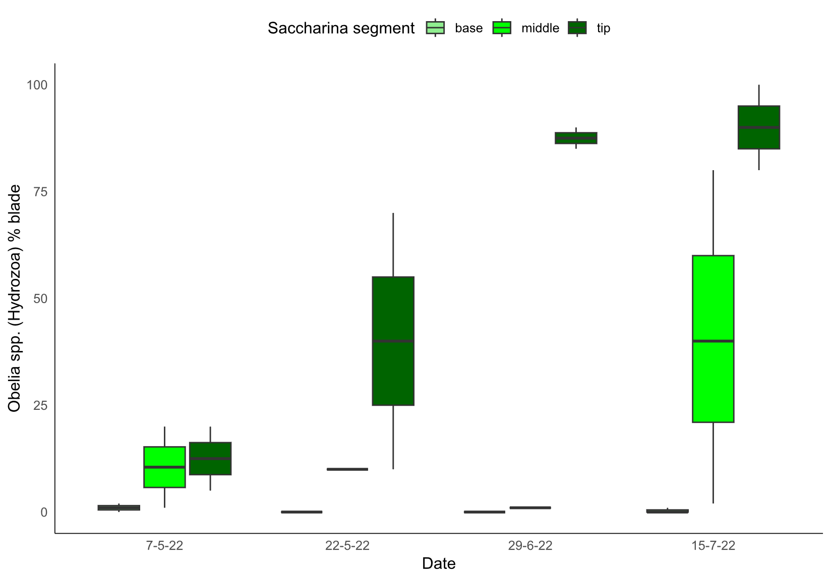
Figure 10. Boxplots of the percentage of blade area covered by Obelia spp. (Hydrozoa) on three blade segments—base (light green), middle (green), and tip (dark green)—sampled on 7 May, 22 May, 29 June and 15 July 2022. Colonization was essentially zero on the basal segment throughout the season, appeared first and most moderately on the mid‐blade by late May (median ~12 %), and quickly surged on the tip segment, rising from ~30 % coverage in late May to >85 % by late June and nearly complete (>90 %) by mid‐July. This pattern highlights both the rapid seasonal increase in hydrozoan fouling and the strong depth‐related gradient of epibiont settlement along the kelp blade.
Two-way ANOVA showed that hydrozoan coverage was significantly influenced by blade segment depth (F₂,₁₉ = 12.93, p < 0.001) and varied significantly across sampling dates (F₃,₁₉ = 3.44, p < 0.05). Across all sampling dates, hydrozoan coverage on the basal blade segment remained negligible (<2%), indicating minimal settlement in this zone. The mid-blade segment showed low but detectable colonisation in early May (~10–15%), which increased steadily to median values around 40% by mid-July. In contrast, the tip segment displayed both earlier and more intense fouling. By late May, coverage already exceeded 30%, rising sharply to >85% by late June and reaching near-complete encrustation (>90%) by mid-July. This consistently higher colonisation at the blade tip compared to mid and basal segments reflects a strong depth‐related gradient in settlement intensity. Overall, these data show that hydrozoan colonisation of Saccharina blades follows a distinct vertical pattern, with the oldest, most distal tissue supporting the earliest and densest settlement, and younger basal tissue remaining largely unafflicted throughout the season.
Discussion
As the first of its kind study, we aligned eDNA metabarcoding, DNA barcoding, plankton microscopy and blade surveys across a full kelp production cycle to directly compare detection capacities and temporal resolutions. eDNA was demonstrated to be a powerful early-warning tool in detecting key epibionts weeks before observation by plankton microscopy, and up to two months before colonisation on kelp blades. This pattern was most evident in Hydrozoans, where eDNA signals peaked in March and April, followed by elevated plankton counts in May and June and subsequent blade coverage maximums in July (Fig. 3). These detection lags indicate a predictable seasonal window of infestation risk, with Saccharina latissima proving greater susceptibility to blade colonisation relative to Alaria esculenta (Fig. 8 and 9). Relative to light microscopy surveys, DNA barcoding (COI) and eDNA metabarcoding provided far higher taxonomic resolution of cryptic and early-stage species, notably Bougainvillia muscus, Clytia hemisphaerica, Jassa herdmani and Hiatella arctica (Table. 1). Overall, plankton microscopy was only able to allocate taxa to the level of class or order while molecular tools identified to the species level (Table. 1). Rope scrubs confirmed presence of epibionts on farm infrastructure suggesting potential reservoirs/vectors for fouling activity (Table. 1). Comparisons of depth-related settlement patterns showed hydrozoan (Obelia spp.) fouling intensity to be significantly greater on blade tips which is positioned deepest in the water column, while basal regions remained largely free from fouling (Fig. 10).
Enhanced taxonomic resolution via barcoding
Barcoding provided improved accuracy in epibiont identification relative to conventional morphological microscopy, generating species-level resolution for groups that were otherwise indistinguishable. For example, several specimens were microscopically identified simply as “hydroids,” which would have grouped them collectively. However, COI barcoding confidently resolved them into distinct species including Ectopleura larynx, Bougainvillia muscus, and Clytia hemisphaerica (Table 1). Conversely, there were cases where microscopy classified multiple specimens as separate taxa, but barcoding revealed them to be the same species, e.g. B. muscus (Table 1). These findings highlight the inherent challenges of morphology-based identification that DNA barcoding overcomes. In particular, hydroids and bryozoan stages are often small, cryptic or morphologically similar making them notoriously difficult to identify to species level microscopically (Lee et al., 2011, Schuchert, 2020).
The barcode identification of epibionts on rope infrastructure followed by their observed colonisation on kelp blades is significant, as it indicates that ropes may serve as reservoirs until blades reach a suitable size for settlement. As ropes often remain submerged year-round, they may serve as persistent sources of larvae, facilitating colonisation once blade surfaces reach surface suitability. This vector role of infrastructure in biofouling dynamics is previously reported in shellfish and salmon operations and suggests that farms could benefit from proactive rope management, such as cleaning, air exposure or chemical/heat treatment prior to seeding to mitigate latter infestation (Sievers et al., 2019, Hopkins et al., 2021) .
Temporal lags between eDNA, plankton, and blade settlement
Temporal lag strucutres between sampling methods did emerge with eDNA signals being detected first, followed by plankton counts and finally blade settlement survey. Of the taxa examined, hydrozoans showed the most pronounced eDNA peaks between March and April largely attributed to Clytia sp. 2 and Bougainvillia muscus (Fig. 3). This was followed by microscopy maxima in May/June, followed by extensive colonisation Saccharina blades in July, with some blades exceeding 85% coverage (Fig. 3). Bryozoans showed a similar though slightly less pronounced lag, with eDNA signals of Celleporella hyalina appearing concurrently with elevated cyphonautes counts, which then rose sharply only a few weeks before blade coverage reached its peak. Temporal offsets were most evident in hydrozoans and bryozoans which are known to exhbit strong seasonal recruitment pulses within temperate climates suggested to be driven by seasonal temperature and photoperiodic cues (Saunders and Metaxas, 2009, Forbord et al., 2020). This illustrates the applicability of molecular tools for early-warning of infestation onset. In this case, providing a window of opportunity lasting several weeks to months where intervention management strategies such as selective harveting could be implemented to fully avoid fouling onset (Bannister et al., 2019).
The strength of seasonal lags between methods differed among taxonomic groups. Overall, gastropods and bivalves showed weaker or less consistent temporal lags between method types and instead showed synchrony between eDNA, plankton and blade signals, particulalry for Alaria samples (Figs. 4 and 6). This may be result of the more prolonged or opportunistic recruitement dynamics that these taxa employ as opposed to defined seasonal pulses. Settlement studies have shown that bivalves such as Mytilus edulis can spawn repeatedly over extended periods, with settlement occurring continuously throughout the year (Garcia et al., 2003). Consistent with this study, plankton microscopy indicated that bivalve larvae were present during much of the study period, although this was not reflected in the eDNA dataset (Fig. 4). This life-history traits help explain the lack of clear sequential phases across methods for bivla\ves, in contrast to the more seasonally pulsed recruitment observed in hydrozoans and bryozoans.
Overall, this suggests that the strength of eDNA as an early-warning tool is greatest for taxa with distinct, seasonally synchronised recruitment events relative to groups with extended or continuous reproduction. Metabarcoding does provides a valuable complementary perspective but does not necessarily extend the temporal resolution offered by microscopy and blade monitoring for all biofouling taxa problematic to seaweed aquaculture.
Among amphipods, Jassa herdmani provided one of the clearest examples of a temporal lag structure across methods. eDNA first detected the species in March, followed by a pronounced peak in April. This preceded a distinct rise in planktonic amphipod abundance recorded in microscopy samples in May, and ultimately culminated in substantial blade colonisation on Saccharina in late July which was confirmed cia COI barcoding (Table 1). This stepwise progression highlights the capacity of molecular approaches to identify J. herdmani several months before visible fouling occurs on blades. Furthermore, Alaria blades exhibited earlier but lower-intensity colonisation in May, whereas Saccharina supported a later yet considerably denser infestation, suggesting differences in host-specific susceptibility and timing of amphipod settlement. Other amphipod detections, including Caprellidae and Gammaridae, were observed on blades but not identified through eDNA which suggests either low eDNA shedding or database limitations.
Although not distinctly identified by plankton microscopy, the eDNA dataset revealed presence of larvae or free-floating DNA from the gastropod nudibranch Doto coronata, a known predator of hydroids, including those of the genus Clytia (Martinsson et al., 2021). Here, D. coronata, was detected in in March eDNA samples concurrent with Clytia sp. signals (Fig. 3 and 5). This co-occurrence implies that predator-prey interactions may already be shaping early-stage biofouling communities. Trophic dynamics such as these are difficult to capture though visual techniques but can be inferred from molecular approaches, highlighting their potential in not only revealing fouling taxa diversity but also their ecological relationships.
Overall, the integration of methods revealed both clear alignment and important mismatches, underscoring the strengths of eDNA for early detection and taxonomic specificity as well as highlight the complementary value of microscopy and blade surveys in confirming physical presence and quantifying settlement intensity.
eDNA vs microscopy – detection efficiency and mismatches
This mirrors findings from a comparable study of fouling communities on settlement plates in a Portuguese port where metabarcoding consistently outperformed morphological identification, providing a far greater diversity of taxa and highlighting cryptic species that microscopy overlooked (Azevedo et al., 2020). Although the degree of improvement varied across groups, metabarcoding consistently provided substantially higher taxonomic resolution than microscopy. For hydrozoans, eDNA resolved 25 distinct taxa, whereas microscopy identified only the broad class “Hydrozoa”. (Fig. 3). A similar contrast was seen for gastropods, with microscopy limited to class-level larvae while eDNA detected 22 individual species (Fig. 6). In comparison, bryozoans, bivalves, and amphipods yielded more modest results, with eDNA detecting only 3–4 species per group beyond the broader microscopic findings (Figs. 2,4 and 5). These differences may reflect the true diversity of the sampled communities however more likely illustrate the relative completeness of available barcode reference databases utilised for COI which appear more comprehensive for hydrozoans and gastropods than for the other taxa. This underscores the urgent need for a more taxonomically comprehensive COI reference database for global zooplankton, which would greatly enhance the accuracy of eDNA and barcoding approaches and strengthen their value across fisheries management, climate change monitoring, and broader ecological research (Bucklin et al., 2021, Keck et al., 2022).
A recurring feature within the molecular dataset was the presence of dropouts, instances where a species produced a strong eDNA signal in one sampling month but then failed to be detected in subsequent months despite its continued observation via microscopy. For example, bryozoan cyphonautes were consistently recorded microscopically between September and March and again from midsummer onwards (Fig. 2). In contrast, eDNA signals for key bryozoans such as Electra pilosa and Membranipora membranacea peaked in autumn and spring but were intermittently absent at other times, including periods when plankton counts remained high and blade coverage reached its maximum in late July (Fig.2). At the point when colonies reached their highest coverage, it would be expected that processes such as shedding, tissue decay, and DNA release from sloughing would generate abundant genetic material in the surrounding water, making these taxa readily detectable by eDNA. The absence of a molecular signal during this period, despite high levels of visible fouling underscores the problem of dropouts and infers methodological limitations. For example, the lack of and effective universal primer across a diverse phyla range can cause amplification biases leading to these detection inconsistencies (Borrell et al., 2017). A recent study on planktonic threats in salmon aquaculture reported comparable discrepancies between microscopic and molecular approaches, with metabarcoding showing limited predictive capacity for organismal abundance and considerable variation in detection sensitivity (Algueró‐Muñiz et al., 2024). The authors also reported that each method identified species that the other failed to detect, underscoring the limitations and complementarity of both visual and molecular diagnostics (Algueró‐Muñiz et al., 2024). Robustness of molecular data can be improved by employing multiple genetic markers simultaneously which has proven effective in minimising primer-driven taxonomic bias and improving detection sensitivity of small or cryptic organisms, a recognised limitation in metabarcoding studies (Azevedo et al., 2020, Algueró‐Muñiz et al., 2024).
Host-specific susceptibility
It is well established that the bryozoans cause major issues for the northeast Atlantic seaweed industry with encrusting colonies causing tissue necrosis and reducing harvestable biomass (Forbord et al., 2020, Førde et al., 2015). Saccharina latissima infestation showed an explosive increase in coverage, rising from negligible levels in June to approximately 90% coverage on some blades by July (Fig.8). The rapid increase in coverage highlights a clear tipping point in colonisation dynamics between initial observable settlement and severe infestation. Known environmental drivers of bryozoan growth include rising summer temperature and hydrodynamic conditions (Saunders and Metaxas, 2007). Although environmental data were beyond the scope of this study, it is likely that seasonal temperature increases contributed to the observed fouling maxima. These results are consistent within findings from Norwegian cultivation sites, where Saccharina also exhibited sharp increases in bryozoan cover in late June and July. The authors reported colony densities varying between sites with different farm stocking density, with higher seaweed densities likely driving local spawning and recruitment from pre-existing colonies (Yoshioka, 1982, Førde et al., 2015). At the Skye study site, peak seaweed biomass in July may similarly have facilitated rapid bryozoan settlement. While microscopy did not resolve species identity on blades, the detection of Membranipora membranacea, Electra pilosa, and Celleporella hyalina through eDNA and COI barcoding aligns with expectations, as these are well-established biofouling taxa for the region (Hermansen et al., 2001, Rouse et al., 2013).
Interestingly, between the two cultivated kelp species examined, only Saccharina latissima showed signs of bryozoan colonisation (Fig. 2). This may suggest a degree of host-specific susceptibility, with Saccharina providing a more favourable substrate than Alaria esculenta. This pattern is consistent with earlier observations by (Ryland, 1962) who reported M. membranacea exhibiting preference for laminarian hosts (e.g. S. latissima), whereas E. pilosa is less selective and frequently colonises hard substrates such as rocks and shells. However, in this study Alaria was only sampled until May, before bryozoan colonies typically appear on blades and any apparent resistance may therefore be likely an artefact of sampling constraints.
Depth effect on epibiont distribution on seaweed blades
This suggests that sugar kelp biofouling activity by Obelia sp. is driven by depth and time. This may be due to colonisation being favoured by a more stable water column microenvironment. For example, reduced light penetration, turbulence and potentially higher nutrient availability may contribute to hydrozoan proliferation. Segments deeper in the water column would have less mechanical disturbance from wave action further enabling sustained polyp growth.
Furthermore, seaweed growth occurs as the base/meristem while older tissue at the tips continually sheds (Mann, 1973). The distal blade segment represents the oldest, most established surface. The increased colonisation at the tip may be resultant from the tissue being more withered or structurally compromised due to longer exposure to environmental stressors thus heightening susceptibility to infestation. More simply, the tip section of the frond has existed the longest and therefore has had the greatest exposure time, providing more opportunities for settlement events and colony expansion. These combined physical and biological factors offer a plausible explanation for the consistently higher levels of biofouling observed at the blade tips. However, further targeted investigation is needed to disentangle the relative contribution of each factor and determine whether a single dominant driver or a synergistic combination is primarily responsible for hydrozoan colonisation patterns.
Biofouling represents a major bottleneck within kelp aquaculture; limiting yields, compromising sustainability and ultimately limiting long-term viability of farms operations (Bannister et al., 2019, Walls et al., 2017). Advancing methods of early detection of problem epibionts within farm-management strategies will provide farmers with an opportunity to incorporate pro-active measures to improve sustainability and mitigate infestation before infestation reaches economically damaging levels. This work demonstrates aligning complementary molecular and microscopy methods not only strengthens understanding of biofouling dynamics but also provides powerful risk awareness to safeguard farm productivity.

References
ADDAMO, A. M., CALVO SANTOS, A., GUILLÉN, J., NEEHUS, S., PERALTA BAPTISTA, A., QUATRINI, S., TELSNIG, T. & PETRUCCO, G. 2022. The EU blue economy report 2022, Publications Office of the European Union.
AGOSTINI, V. O. & OZORIO, C. P. 2022. Biofouling initial succession on offshore artificial substrate under subtropical conditions. An Acad Bras Cienc, 94, e20201357.
ALGUERÓ‐MUÑIZ, M., SPATHARIS, S., DWYER, T., DE NOIA, M., CHEAIB, B., LIU, YEE W., ROBERTSON, BRENDAN A., JOHNSTONE, C., WELSH, J., MACPHEE, A., MAZURKIEWICZ, M., BICKERDIKE, R., MIGAUD, H., MCGHEE, C., PRÆBEL, K. & LLEWELLYN, M. 2024. High‐Resolution Longitudinal eDNA Metabarcoding and Morphological Tracking of Planktonic Threats to Salmon Aquaculture. Environmental DNA, 6.
AZEVEDO, J., ANTUNES, J. T., MACHADO, A. M., VASCONCELOS, V., LEAO, P. N. & FROUFE, E. 2020. Monitoring of biofouling communities in a Portuguese port using a combined morphological and metabarcoding approach. Sci Rep, 10, 13461.
BANNISTER, J., SIEVERS, M., BUSH, F. & BLOECHER, N. 2019. Biofouling in marine aquaculture: a review of recent research and developments. Biofouling, 35, 631-648.
BORRELL, Y. J., MIRALLES, L., DO HUU, H., MOHAMMED-GEBA, K. & GARCIA-VAZQUEZ, E. 2017. DNA in a bottle-Rapid metabarcoding survey for early alerts of invasive species in ports. PLoS One, 12, e0183347.
BUCKLIN, A., PEIJNENBURG, K. T. C. A., KOSOBOKOVA, K. N., O’BRIEN, T. D., BLANCO-BERCIAL, L., CORNILS, A., FALKENHAUG, T., HOPCROFT, R. R., HOSIA, A., LAAKMANN, S., LI, C., MARTELL, L., QUESTEL, J. M., WALL-PALMER, D., WANG, M., WIEBE, P. H. & WEYDMANN-ZWOLICKA, A. 2021. Toward a global reference database of COI barcodes for marine zooplankton. Marine Biology, 168.
CHEN, Y., WANG, H., GONG, Y., ZHANG, P., ZHANG, H., WANG, T., XIE, J., XU, J., WANG, H. & KONG, X. 2023. Benefits of combined environmental DNA and microscopy for diversity monitoring in rotifer community: A mesocosm experiment. Ecological Indicators, 155.
DELANNOY, V., ALGUERÓ‐MUÑIZ, M., CHRISTOFOROU, E., HADDOU, Y., MACPHEE, A., MCEACHNIE, K., ORR, K. & SPATHARIS, S. 2025. Large‐Scale Environmental Drivers of Kelp Biofouling Based on Literature Data. Reviews in Aquaculture, 17.
DJURHUUS, A., PORT, J., CLOSEK, C. J., YAMAHARA, K. M., ROMERO-MARACCINI, O., WALZ, K. R., GOLDSMITH, D. B., MICHISAKI, R., BREITBART, M., BOEHM, A. B. & CHAVEZ, F. P. 2017. Evaluation of Filtration and DNA Extraction Methods for Environmental DNA Biodiversity Assessments across Multiple Trophic Levels. Frontiers in Marine Science, 4.
DUARTE, S., SIMOES, L. & COSTA, F. O. 2023. Current status and topical issues on the use of eDNA-based targeted detection of rare animal species. Sci Total Environ, 904, 166675.
FORBORD, S., MATSSON, S., BRODAHL, G. E., BLUHM, B. A., BROCH, O. J., HANDÅ, A., METAXAS, A., SKJERMO, J., STEINHOVDEN, K. B. & OLSEN, Y. 2020. Latitudinal, seasonal and depth-dependent variation in growth, chemical composition and biofouling of cultivated Saccharina latissima (Phaeophyceae) along the Norwegian coast. Journal of Applied Phycology, 32, 2215-2232.
FØRDE, H., FORBORD, S., HANDÅ, A., FOSSBERG, J., ARFF, J., JOHNSEN, G. & REITAN, K. I. 2015. Development of bryozoan fouling on cultivated kelp (Saccharina latissima) in Norway. Journal of Applied Phycology, 28, 1225-1234.
GARCIA, E. G., THORARINSDOTTIR, G. G. & RAGNARSSON, S. A. 2003. Settlement of bivalve spat on artificial collectors in Eyjafjordur, North Iceland. Hydrobiologia, 503, 131-141.
HERMANSEN, P., LARSEN, P. S. & RIISGÅRD, H. U. 2001. Colony growth rate of encrusting marine bryozoans (Electra pilosa and Celleporella hyalina). Journal of Experimental Marine Biology and Ecology, 263, 1-23.
HOPKINS, G., DAVIDSON, I., GEORGIADES, E., FLOERL, O., MORRISEY, D. & CAHILL, P. 2021. Managing Biofouling on Submerged Static Artificial Structures in the Marine Environment – Assessment of Current and Emerging Approaches. Frontiers in Marine Science, 8.
JAGTAP, A. S. & MEENA, S. N. 2022. Seaweed farming: A perspective of sustainable agriculture and socio-economic development. Natural Resources Conservation and Advances for Sustainability.
JUETERBOCK, A., HOARAU-HEEMSTRA, H., WIGGER, K., DUARTE, B., BRUCKNER, C., CHAPMAN, A., DUAN, D., ENGELEN, A., GAUCI, C., HILL, G., HU, Z.-M., KHANAL, P., KHATEI, A., MACKINTOSH, A., MELAND, H., MELO, R., NILSEN, A. M. L., OLSEN, L., RAUTENBERGER, R., REISS, H. & ZHANG, J. 2025. Roadmap to sustainably develop the European seaweed industry. npj Ocean Sustainability, 4.
KECK, F., BLACKMAN, R. C., BOSSART, R., BRANTSCHEN, J., COUTON, M., HURLEMANN, S., KIRSCHNER, D., LOCHER, N., ZHANG, H. & ALTERMATT, F. 2022. Meta-analysis shows both congruence and complementarity of DNA and eDNA metabarcoding to traditional methods for biological community assessment. Mol Ecol, 31, 1820-1835.
KRUMHANSL, K. A., LEE, J. M. & SCHEIBLING, R. E. 2011. Grazing damage and encrustation by an invasive bryozoan reduce the ability of kelps to withstand breakage by waves. Journal of Experimental Marine Biology and Ecology, 407, 12-18.
LEE, H.-J., KWAN, Y.-S., KONG, S.-R., MIN, B.-S., SEO, J.-E. & WON, Y.-J. 2011. DNA Barcode Examination of Bryozoa (Class: Gymnolaemata) in Korean Seawater. Animal Systematics, Evolution and Diversity, 27, 159-163.
MANN, K. 1973. Seaweeds: Their Productivity and Strategy for Growth: The role of large marine algae in coastal productivity is far more important than has been suspected. Science, 182, 975-981.
MARTELL, L., BRACALE, R., CARRION, S. A., GIANGRANDE, A., PURCELL, J. E., LEZZI, M., GRAVILI, C., PIRAINO, S. & BOERO, F. 2018. Successional dynamics of marine fouling hydroids (Cnidaria: Hydrozoa) at a finfish aquaculture facility in the Mediterranean Sea. PLoS One, 13, e0195352.
MARTINSSON, S., MALMBERG, K., BAKKEN, T., KORSHUNOVA, T., MARTYNOV, A. & LUNDIN, K. 2021. Species delimitation and phylogeny of
Doto (Nudibranchia: Dotidae) from the Northeast Atlantic, with a discussion on food specialization. Journal of Zoological Systematics and Evolutionary Research, 59, 1754-1774.
MATSSON, S., CHRISTIE, H. & FIELER, R. 2019. Variation in biomass and biofouling of kelp, Saccharina latissima, cultivated in the Arctic, Norway. Aquaculture, 506, 445-452.
PANSCH, C., CERDA, O., LENZ, M., WAHL, M. & THIEL, M. 2009. Consequences of light reduction for anti-herbivore defense and bioactivity against mussels in four seaweed species from northern-central Chile. Marine Ecology Progress Series, 381, 83-97.
RISHAN, S. T., KLINE, R. J. & RAHMAN, M. S. 2023. Applications of environmental DNA (eDNA) to detect subterranean and aquatic invasive species: A critical review on the challenges and limitations of eDNA metabarcoding. Environmental Advances, 12.
ROLIN, C., INKSTER, R., LAING, J. & MCEVOY, L. 2017. Regrowth and biofouling in two species of cultivated kelp in the Shetland Islands, UK. Journal of Applied Phycology, 29, 2351-2361.
RONOWICZ, M., WLODARSKA-KOWALCZUK, M. & KUKLINSKI, P. 2008. Factors influencing hydroids (Cnidaria: Hydrozoa) biodiversity and distribution in Arctic kelp forest. Journal of the Marine Biological Association of the United Kingdom, 88, 1567-1575.
ROUSE, S., SPENCER JONES, M. E. & PORTER, J. S. 2013. Spatial and temporal patterns of bryozoan distribution and diversity in the Scottish sea regions. Marine Ecology, 35, 85-102.
RYLAND, J. S. 1962. The Association Between Polyzoa and Algal Substrata. Journal of Animal Ecology, 31, 331-338.
SAUNDERS, M. & METAXAS, A. 2007. Temperature explains settlement patterns of the introduced bryozoan Membranipora membranacea in Nova Scotia, Canada. Marine Ecology Progress Series, 344, 95-106.
SAUNDERS, M. I. & METAXAS, A. 2009. Population dynamics of a nonindigenous epiphytic bryozoan Membranipora membranacea in the western North Atlantic: effects of kelp substrate. Aquatic Biology, 8, 83-94.
SCHUCHERT, P. 2020. DNA barcoding of some Pandeidae species (Cnidaria, Hydrozoa, Anthoathecata). Revue suisse de Zoologie, 125, 101-127, 27.
SIEVERS, M., DEMPSTER, T., KEOUGH, M. J. & FITRIDGE, I. 2019. Methods to prevent and treat biofouling in shellfish aquaculture. Aquaculture, 505, 263-270.
SULTANA, F., WAHAB, M. A., NAHIDUZZAMAN, M., MOHIUDDIN, M., IQBAL, M. Z., SHAKIL, A., MAMUN, A.-A., KHAN, M. S. R., WONG, L. & ASADUZZAMAN, M. 2023. Seaweed farming for food and nutritional security, climate change mitigation and adaptation, and women empowerment: A review. Aquaculture and Fisheries, 8, 463-480.
TENDAL, O. S. & DINESEN, G. E. 2005. Biogenic sediments, substrates and habitats of the Faroese shelf and slope. BIOFAR Proceedings, 2005, 224-242.
VEENHOF, R. J., BURROWS, M. T., HUGHES, A. D., MICHALEK, K., ROSS, M. E., THOMSON, A. I., FEDENKO, J. & STANLEY, M. S. 2024. Sustainable seaweed aquaculture and climate change in the North Atlantic: challenges and opportunities. Frontiers in Marine Science, 11.
VISCH, W., NYLUND, G. M. & PAVIA, H. 2020. Growth and biofouling in kelp aquaculture (Saccharina latissima): the effect of location and wave exposure. Journal of Applied Phycology, 32, 3199-3209.
WALLS, A. M., EDWARDS, M. D., FIRTH, L. B. & JOHNSON, M. P. 2017. Successional changes of epibiont fouling communities of the cultivated kelp Alaria esculenta: predictability and influences. Aquaculture Environment Interactions, 9, 57-71.
YOSHIOKA, P. M. 1982. Predator-induced polymorphism in the bryozoan Membranipora membranacea (L.). Journal of Experimental Marine Biology and Ecology, 61, 233-242.
ZAIKO, A., SCHIMANSKI, K., POCHON, X., HOPKINS, G. A., GOLDSTIEN, S., FLOERL, O. & WOOD, S. A. 2016. Metabarcoding improves detection of eukaryotes from early biofouling communities: implications for pest monitoring and pathway management. Biofouling, 32, 671-84.
ZHANG, L., LIAO, W., HUANG, Y., WEN, Y., CHU, Y. & ZHAO, C. 2022. Global seaweed farming and processing in the past 20 years. Food Production, Processing and Nutrition, 4.

