eDNA Kit preparation for sampling
Book chemical safety cabinet (fume hood) in 208: : lab 208 booking.xlsx

Consumables and equipment:
50ml falcon tubes
Silica beads
Filter barrels
Small Ziplock bags

Method:
- Turn on UV light in chemical safety cabinet in 208 for 15mins
- Open the door, turn on by pressing CABINET, ALARM MUTE, LIGHT
- Spray and clean with ethanol
- Open the 50ml falcon tubes under the hood an pour in silica up to about the 5ml mark
- Close the falcon tube
- Place 2 falcon tubes per small ziplock bag
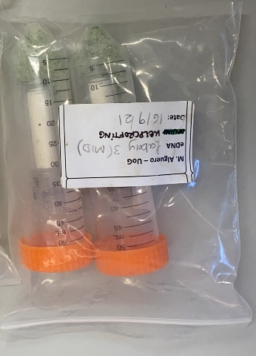
- Turn off the cabinet by pressing CABINET and close the lid
- Turn on UV light for 15mins

eDNA extraction protocol

The following protocol describes the procedure per sample.

Materials:

DNEasy Blood and Tissue kit:
- ATL Buffer
- AL Buffer
- AW1 Buffer
- AW2 Buffer
- AE Buffer
- Proteinase K
- Spin columns and collection tubes
2 ml eppendorfs
Centrifuge
Bunsen or lighter (naked flame)
P1000 Gilson pipette and tips
P100 Gilson pipette and tips
Tip waste jar
100% Ethanol (from -20ºC freezer)
Rotating incubator (preheat to 56ºC)
Plastic containers suitable to house sample tubes in incubator overnight
Heat shrink tubing – 2 sizes that fit neatly over the inlet and outlet parts. If they are too wide, they will not shrink enough.
Parafilm
Tweezers or Pliers (to squeeze ends of tubing closed). Pliers work best but harder to flame with ethanol.

Important: If frozen samples - all eDNA filter samples should be removed from -20ºC and placed into fridge (4ºC) 2-4 hours before carrying out the following procedure.

Important: Remember to change pipette tips between each sample and buffer and don’t put lids etc. face down on the work top – any contamination at all will completely destroy your results. And use filtered pipette tips only.

Important: Flame tweezers or ends of pliers in 100% EtOH between each use. DO NOT PUT THEM BACK INTO ETHANOL IMMEDIATELY AFTER FLAMING!

Very Important: DO NOT AT ANY TIME HAVE ETHANOL CLOSE TO THE NAKED BUNSEN FLAME OR USE THE EtOH SPRAY BOTTLE TO CLEAN THE IMMEDIATE AREA – SPRAY ON TO BLUE ROLL AWAY FROM FLAME THEN SANITISE SURFACES – IF YOU BLOW YOURSELF UP, IT WOULD BE VERY INCONVENIENT FOR ALL PARTIES.

Procedure:

DAY1
- Wipe all surfaces 100% Ethanol
- Preheat rotating incubator to 56ºC
- Keep Bunsen burning on lab workstation to ensure sterile conditions whilst extracting DNA
- Label the centrifuge tubes containing the barrel filters (can do max 24 samples at a time)
- Use sterile scissors to cut, 1 3cm long narrow shrinking tube per samples and 1 3cm wide shrinking tube per samples
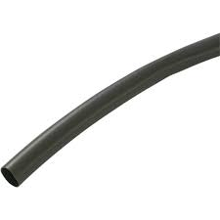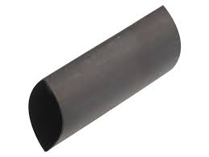
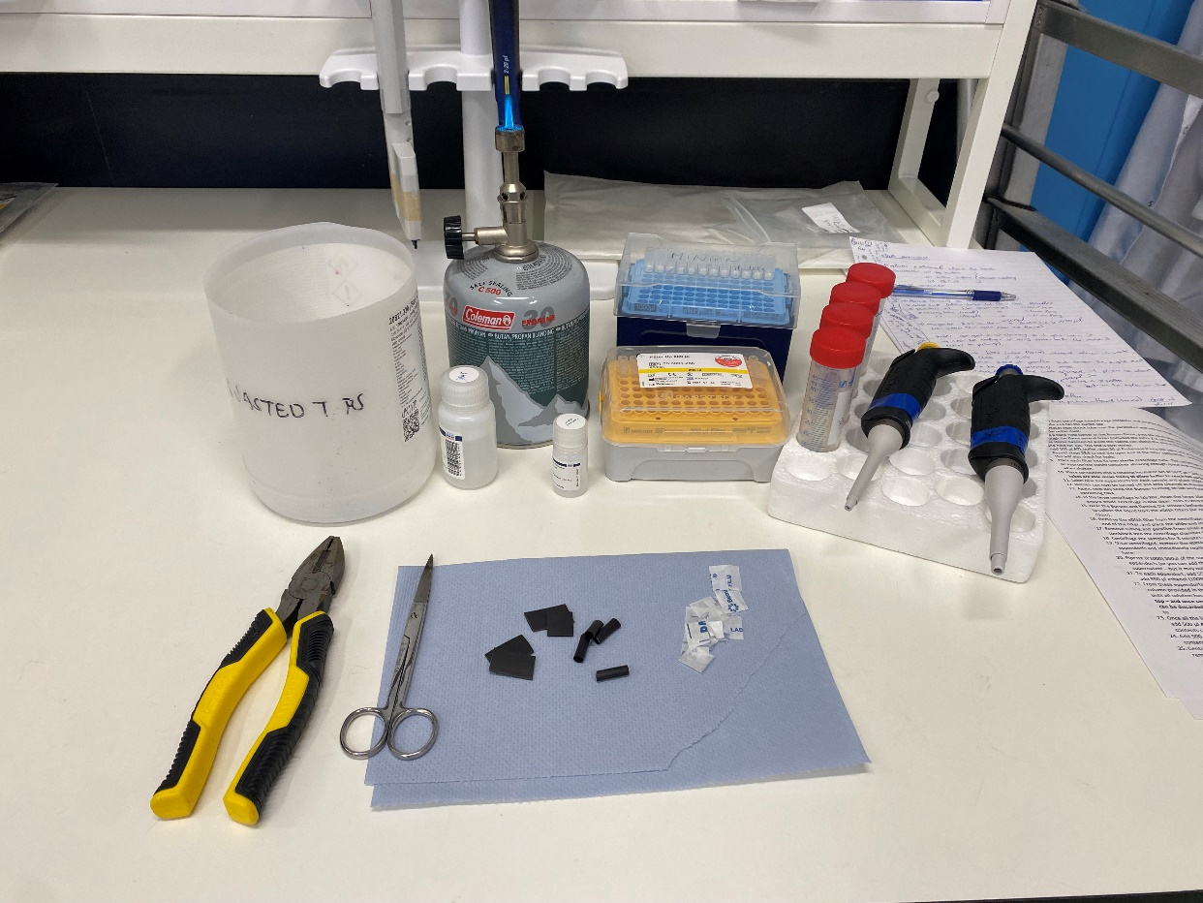
- Take filter from centrifuge tube/storage container and remove the silica in a waste container
- Parafilm the narrower outlet. This can be fiddly if the end has the purple cap.
- Place narrow heat shrink tube over the end
- Using a hand-held lighter or the Bunsen flame, pass the heat tube (still over the outlet pipe) through the flame several times (included the extra 2-3 cm) until it has tightened around the pipe. Use sterile tweezers to pinch the tubing just above the end of the outlet pipe whilst it’s still warm and hold for 10s. This end is now sealed.
- Add 500 µl ATL buffer, then 50 µl Proteinase K into the open end of the filter.
*Buffer can get a bit cloudy, if it does, hold close to the fire (or in an water bath) to liquify again
- Repeat steps 7-9 to seal the open end of the filter completely with the wide tube– and invert several times to mix – this will also check for leaks.
- Place each filter into its own sterile centrifuge tube, with the small/purple side at the bottom. The centrifuge tubes can then be placed into an appropriate stable container allowing enough space and movement so the tubes move freely when shaken (allow to roll).
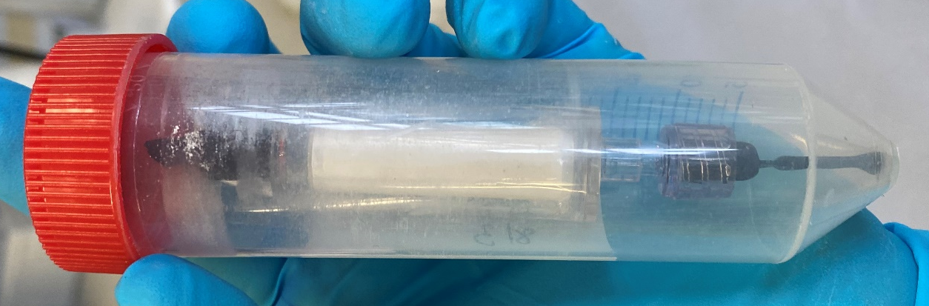
- Place containers into a rotating incubator set at 56ºC at ~150 rpm overnight. It is essential that the tubes are able move freely to allow buffer to reach full surface area of filters.
- Label new 2ml eppendorfs for each sample and place 100% ethanol in the freezer for the next day.
- Bunsen can now be turned off and area cleaned as mentioned in step 1.

DAY 2
- Again, next day keep the Bunsen burning on lab workstation to ensure sterile conditions whilst extracting DNA.
- In the large centrifuge in lab 202, clean the large 15ml fitting with 100% EtOH before use – and ensure inside centrifuge is also clean. THIS IS WHERE CONTAMINATION MOST LIKELY TO HAPPEN.
- Near the Bunsen and flaming the scissors beforehand, open the eppendorfs intended to collect the liquid from the eDNA filters (be careful as they have a tendency to fly across the room).
- Remove the eDNA filter from the centrifuge tubes, by the use of sterile forceps remove the tubing and parafilm from the wide end of the filter, and place the wide end inside the lidless Eppendorf.
- Remove tubing and parafilm from small end then immediately place the Eppendorf and filter combined back into the centrifuge tube (should fit neatly inside).
- Centrifuge the samples for 3 minutes at 1700xg. (make sure the centrifuge is balanced)
- Once centrifuged, remove the eDNA filters first and then use sterile tweezers to remove the eppendorfs (pick the Eppendorf at the connection between the lid and the tube) and immediately replace the lids. (It’s handy to have the Bunsen next to the centrifuge here).
*keep the falcon tubes and eppendorfs in order in case the labelling comes off revenge
*if there is a leakage in the falcon tube, flame the forceps to prevent contamination of other samples and pure any liquid from the tube to the Eppendorf
- To each eppendorf, add 550 µl (or same volume as supernatant) of AL buffer.
- Then add 550 µl ethanol (100% from freezer). Frozen ethanol precipitates DNA better.
- Rotate the base x10 for the samples to mix
- Open and label extraction columns for each samples.
- From the eppendorfs (now containing 1650 µl), take 750 µl at a time and add it to the spin column provided in the extraction kit and centrifuge for 1 minute at 15,000 xg each time – repeat until all solution has been used up. Note that the spin column collection tube separates from the top – and once centrifuged through the spin column filter, the liquid that collects at the bottom can be discarded each time. Always retain the spin column filter as this is what the DNA will bind to.
- Once all the liquid has been centrifuged through the spin column for each sample, add 500 µl AW1 buffer to spin column and centrifuge for 1 minutes at 15,000 xg – collection tube contents can be discarded after centrifugation
- Add 500 µl AW2 buffer to spin column and centrifuge for 2 minutes at 15,000 xg – collection tube contents can be discarded after centrifugation
- Centrifuge the column and collection tube alone with no added buffer for 1 minute at 15,000 to remove all traces of ethanol – note that both the bottom collection tube AND its contents can now be discarded after centrifugation.
- Replace the collection tube with 1.5 ml eppendorf before adding the next buffer (remember to label).
- Add 55 µl AE (elution) buffer
- Leave at room temperature for 5 minutes
- Centrifuge for 2 minutes at 10,000 xg into the 2 ml eppendorfs – note that the 2 ml eppendorf lids will snap if placed in a downwards position in the centrifuge. Keep spaces between each of the tubes in the centrifuge with the lids in to the bottom left (will spin clockwise), and ensure centrifuge is balanced overall.
- You should now have ~55 µl containing all your extracted DNA in the eppendof
- Use Nanodrop to check for DNA presence and quality in each sample – keep a record of values.

Important: If using samples within 5 days, store in fridge (4ºC). Otherwise, store at -20ºC.

