KV Cache Tiering Demo — Manual Deployment
Every component installed, configured, and verified by hand on a vast.ai A100
July 2026 · ~45–60 minutes hands-on · what deploy.sh automates, unpacked step by step

1. The system you are building
Six cooperating pieces on one GPU node, plus a tunnel from your workstation:
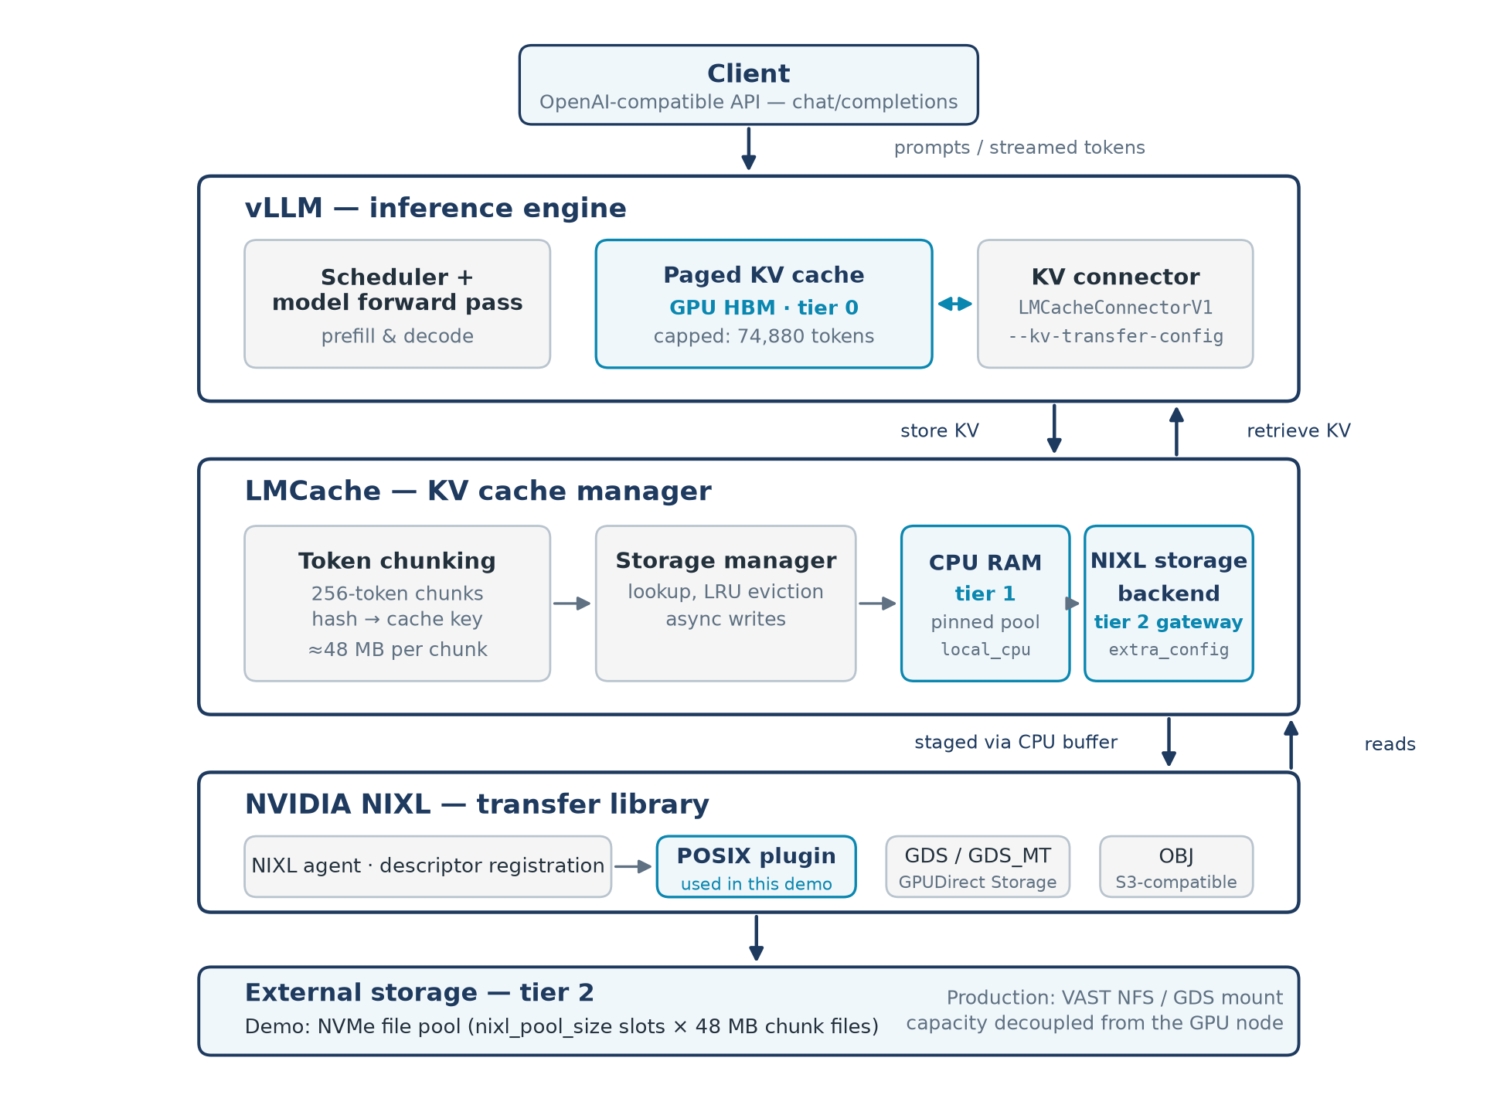
vLLM + LMCache + NIXL and the three KV tiers (demo runs the full hierarchy: all tiers at once)
- vLLM — serves Qwen2.5-14B on :8000; owns Tier 0 (GPU paged KV, ~47 GB).
- LMCache — in-process KV manager: 256-token chunks, content-hash keys, write-through to every enabled tier, per-tier LRU.
- CPU tier — Tier 1: 60 GB pinned host RAM (LocalCPUBackend).
- NIXL tier — Tier 2: NVIDIA NIXL agent + POSIX plugin → 1,700 × 48 MiB slot files = 85.6 GB on NVMe.
- LMCache controller — admin service on :9050 — pure per-tier eviction (/clear) and index audits (/lookup).
- Demo tooling — dashboard server on :7811 + probes (TTFT measurement, evidence, crash-proof mode switching).

2. Rent and reach the instance
vastai search offers 'gpu_name in [A100_SXM4,A100_PCIE] num_gpus=1 gpu_ram>=75 \
disk_space>=150 reliability>0.98 inet_down>=500 rentable=true verified=true \
cuda_vers>=12.4' -o 'dph'
vastai create instance <OFFER_ID> --image lmcache/vllm-openai:latest --disk 150 --ssh --direct
# note new_contract = your INSTANCE_ID; poll until running, then:
vastai show instance <ID> --raw | grep -E '"ssh_host"|"ssh_port"|actual_status'
ssh -p <PORT> root@<HOST> # type yes at the fingerprint prompt; nvidia-smi must show the A100
HOST QUIRK #1 Fresh instances sometimes boot to 'exited' after the image pull. Fix: vastai start instance <ID>, wait for running again.

3. Install the components

3.1 vLLM + LMCache
The lmcache/vllm-openai:latest image ships both, version-matched, in /opt/venv (validated pair: vLLM 0.24.0 + LMCache 0.5.1). Nothing to install. On a bare CUDA machine instead:
uv venv /opt/venv --python 3.12
uv pip install --python /opt/venv/bin/python3 vllm==0.24.0 lmcache==0.5.1 nixl
PIN THE PAIR LMCache compiles against a specific vLLM connector API. Install both in one command with pinned versions — independent resolution produces installs that break at runtime, not install time.

3.2 NVIDIA NIXL (on the docker image)
# the image's venv has no pip module — use uv, which is preinstalled:
uv pip install --python /opt/venv/bin/python3 nixl
python3 -c 'import nixl; print("nixl OK")'
ls /opt/venv/lib/python3.12/site-packages/.nixl*/plugins/ # POSIX, GDS, GDS_MT, OBJ, UCX…

3.3 Model and corpus
python3 -c "from huggingface_hub import snapshot_download; snapshot_download('Qwen/Qwen2.5-14B-Instruct')"
# demo files: clone the repo on your workstation and push them up
git clone https://github.com/cypanized/kvcache-demo.git ~/kvcache && cd ~/kvcache
scp -P <PORT> remote/run_server.sh remote/gen_docs.py demo/switch.sh demo/ask.py \
demo/spill_test.py demo/evidence_lookup.py demo/onbox_server.py demo/index.html root@<HOST>:/root/
ssh -p <PORT> root@<HOST> 'chmod +x /root/*.sh && cd /root && python3 gen_docs.py 40 9000'
The 40 synthetic docs are ~65 KB of deterministic text each (2.6 MB total) but cost ~2 GB of KV each when read — 192 KiB per token × ~10,500 tokens. That 30,000× inflation is the entire reason tiering exists.

4. Patch LMCache 0.5.1 (required for per-tier clears)
Upstream's NIXL backend implements no clear() — the controller's per-tier eviction silently reports 0 tokens. Add one (idempotent; bootstrap.sh does exactly this):
python3 - <<'EOF'
path = "/opt/venv/lib/python3.12/site-packages/lmcache/v1/storage_backend/nixl_storage_backend.py"
src = open(path).read()
if "def clear(self) -> int:" not in src:
anchor = " async def mem_to_storage("
patch = ''' def clear(self) -> int:
with self.key_lock:
num_chunks = len(self.key_dict)
for meta in self.key_dict.values():
try: self.pool.push(meta.index)
except Exception: pass
self.key_dict.clear()
return num_chunks * 256

'''
open(path, "w").write(src.replace(anchor, patch + anchor, 1))
EOF

5. Configure and launch the stack

5.1 The full-hierarchy configuration, line by line
# /root/lmcache_full.yaml (run_server.sh writes this; shown for understanding)
chunk_size: 256 # tokens per cache chunk (= 48 MiB of KV each)
local_cpu: true # enable Tier 1
max_local_cpu_size: 60 # GB of pinned host RAM
nixl_buffer_device: "cpu" # POSIX plugin requires CPU staging (cuda → assert fail)
enable_controller: true # register with the admin controller
lmcache_instance_id: "demo"
controller_pull_url: "localhost:8300"
controller_reply_url: "localhost:8400"
lmcache_worker_ports: [8500]
extra_config:
enable_nixl_storage: true # Tier 2 via NIXL
nixl_backend: "POSIX" # GDS/GDS_MT on GDS-capable hardware
nixl_pool_size: 1700 # slot COUNT (× 48 MiB = 85.6 GB) — NEVER bytes
nixl_path: "/root/lmcache_nixl/"
THREE LANDMINES IN THIS CONFIG (1) nixl_pool_size in bytes makes LMCache build a multi-hundred-GB index and the engine is OOM-killed with no traceback. (2) The pool keeps one open fd per slot — launch with ulimit -n 65536. (3) Do NOT add use_direct_io: true — it deadlocks 0.5.1 at startup (futex wait, no error).

5.2 Environment the launcher must set (run_server.sh does all three)
export VLLM_SERVER_DEV_MODE=1 # exposes /reset_prefix_cache (pure GPU-tier eviction)
export PYTHONHASHSEED=0 # chunk keys use Python's randomized hash — every LMCache
# process needs the same seed or controller lookups match nothing
ulimit -n 65536 # NIXL pool fds

5.3 The controller service
cat > /root/start_controller.sh <<'EOF'
#!/bin/bash
export PYTHONHASHSEED=0
pkill -f 'lmcache.v1.api_serve[r]' 2>/dev/null; sleep 1
cd /root && exec python3 -m lmcache.v1.api_server --host 127.0.0.1 --port 9050 \
--monitor-ports '{"pull": 8300, "reply": 8400}' > /root/controller.log 2>&1
EOF
chmod +x /root/start_controller.sh
setsid nohup bash /root/start_controller.sh >/dev/null 2>&1 </dev/null &

5.4 The dashboard server
cat > /root/restart_ui.sh <<'EOF'
#!/bin/bash
pkill -f 'onbox_serve[r].py' 2>/dev/null; sleep 2
cd /root && exec python3 onbox_server.py > /root/onbox_server.log 2>&1
EOF
chmod +x /root/restart_ui.sh
setsid nohup bash /root/restart_ui.sh >/dev/null 2>&1 </dev/null &

5.5 Launch vLLM in full-hierarchy mode
setsid nohup /root/switch.sh full >/dev/null 2>&1 </dev/null &
# switch.sh: kills any prior server INCLUDING orphaned 'VLLM::EngineCore' processes
# (they rename themselves; a naive pkill leaves them holding ~45 GB of GPU memory),
# wipes stale tier files, then launches run_server.sh full — detached, so an SSH
# drop mid-switch cannot kill the restart. Load takes ~3 minutes.

5.6 Tunnel from your workstation
nohup bash -c 'while true; do ssh -o ServerAliveInterval=30 -o ExitOnForwardFailure=yes \
-N -L 7811:127.0.0.1:7811 -p <PORT> root@<HOST>; sleep 3; done' >/dev/null 2>&1 &
# then open http://127.0.0.1:7811

6. Verify every layer (do not skip)
# 1. engine + backends healthy, nothing degraded:
grep -cE 'init failed|degraded' /root/server_full.log # MUST print 0
grep -o 'Created backend: [A-Za-z]*' /root/server_full.log | sort -u
# → LocalCPUBackend + NixlStorageBackend
# 2. the tier ladder — each rung via pure evictions (expected TTFTs):
# cold ~1.9s → GPU hit ~0.07s → clear GPU → CPU hit ~0.17s
# → clear GPU+CPU → NIXL hit ~0.35s → clear all → ~1.8s recompute
# 3. which tier served? read the engine's own log — throughput fingerprints the medium:
grep -a 'Retrieved' /root/server_full.log | tail -3
# ≈24 GB/s = pinned RAM (Tier 1) · ≈5 GB/s = NVMe pool (Tier 2)
# 4. controller audit matches reality:
python3 /root/evidence_lookup.py # per-doc /lookup vs the dashboard gauges
KNOWN 0.5.1 BLIND SPOT The NIXL backend never reports its contents to the controller registry, so /lookup cannot name NixlStorageBackend as a location — after clearing the CPU tier the audit reads empty while the pool still serves (prove it: clear GPU+CPU, ask a doc, ~0.35s + a 'Retrieved 10496 of 10496' log line). LMCache issue #3387 tracks the same failure class for P2P.

7. Troubleshooting quick table
engine dies at start, exit 137, no traceback → nixl_pool_size was bytes; use a slot count
'Too many open files' during pool creation → ulimit -n 65536 before launch
'Invalid NIXL backend & device combination' → POSIX needs nixl_buffer_device: cpu
warm TTFT equals baseline in a tiered mode → LMCache degraded; grep 'init failed'
startup hangs forever (futex wait) → remove use_direct_io from extra_config
next launch fails; GPU busy with no server → pkill -9 -f 'VLLM::' (orphaned engine cores)
controller /lookup or /clear returns 0 → PYTHONHASHSEED not pinned in ALL processes,
or tokens lack the chat template
host resource stats error on some hosts → cgroup v1 vs v2 paths (onbox_server handles both)

8. Tear down
vastai destroy instance <ID> # irreversible; billing stops; storage is NOT free on stopped instances

