vTask Manager for Windows VMs

Kannan Balasubramanian, Rashmi Biswal
Central Engineering, Bangalore

Abstract

Next Generation Task Manager for Windows VMs that can go above and beyond what the conventional windows Task Manager offers in terms of monitoring and managing the processes running on the Guest Windows VMs. Departing from the conventional task manager, vTask Manager provides much granular insights into applications, processes, device drivers/DLLs, System Modules, Memory utilization, Threads, Heap and Performance way deeper than the conventional counterpart. Also provides the dependency information between applications, processes, modules and threads giving a holistic view of the system, taking task management to the next level. Using advanced Win32 APIs such as THAPI, PSAPI and WinAPI, the tool brings out unique perspectives of the system catering to administrative and development and trouble-shooting needs of the users that can be leveraged by the entire VMware Ecosystem involving VMware Developers, Customers and Partners. Can easily be integrated into VMware tools for wider adoption across different families of Guest OS and can really come handy for debugging complex problems.

Problem Statement
Task Management is an important function on windows with which one can best utilize the system resources and optimize how your application behaves on the Windows Operating System. Any modern day windows operating system comes with Task Manager Tool but this tool is far from reality with regard to how it brings a developers perspective. This tool is mostly used by windows users only when there is a problem with some running application and is often used to kill or restart the application. If there is a hang of some kind or a deadlock which causes the application to be non-responsive, users open the task manager to either kill or restart the respective process. That’s not the problem with the user but traditionally that’s how the tool has been projected and the features provided by the tool also cater only to such needs.
But what people are not aware of is the developer perspective that we can bring-in with the task manager tool and one can use it to debug/trouble-shoot problems further or optimize the application that he/she is developing for the windows platform. The underlying win32 APIs are actually capable of bringing out the necessary perspective that is needed for an administrator or a developer and the goal of this paper is to talk about the new Task Manager from VMware that can potentially re-define how the users look at task management on windows VMs and what kind of use cases one can address using the new vTask Manager.
Note: The tool has already been developed as a POC and you will see the screenshots of the tool in the subsequent sections. The task manager tool demonstrated here is far more advanced that the currently available Task Manager shipped with Windows OS and there is lot of potential to integrate this tool into VMware Tools for Windows VMs.

Description
In this section we will see more about what the vTask Manager offers in addition to what you see on the traditional task manager. vTaskManager is composed of multiple tabs where each tab brings a different kind of perspective on the system and In this section, let us see each of those tabs in detail and the respective information that is presented.

Applications Tab

In the traditional task manager (here after, referred to as TM for convenience), what you would see under this tab is just the application name and the status which always shows it is running. However, in this task manager you will see the following information as shown in Figure-1.

- Application Name or Window Title
- Process ID
- Class Name
- Process Priority

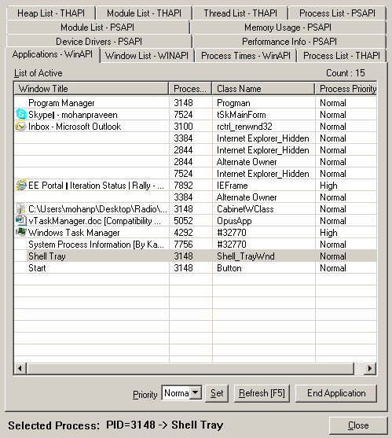
Figure-1 – Applications Tab

Class Name shows the win32 class name corresponding to the application shown and one can associate the process ID and process priority with the running application in the same screen. In a traditional TM, you need to visit multiple tabs to be able to this and you never get the win32 class name.

In the same tab, it allows you to alter the process priority at application level instead of process level in the traditional TM. In addition to this, it also shows the count of applications that are live currently on the top right corner. In addition to this, you can also end the application just like the way you do on the normal task manager. The association between class name/PID/Priority to that of the application is important debugging information for trouble-shooting a spurious application.

Windows List

Showing a list of active windows associated with each of the live processes is often a useful information to understand what kind of visual elements are associated with the live app. It could be a minimized window on the taskbar or could be a try icon in the system tray which is not apparent to the user. One may have closed the application from the taskbar but that does not mean the app has exited, if it is being added to the system tray. Also there could be a lot more active windows in the background that is associated with the process which the user cannot see in the traditional TM as shown in Figure-2.

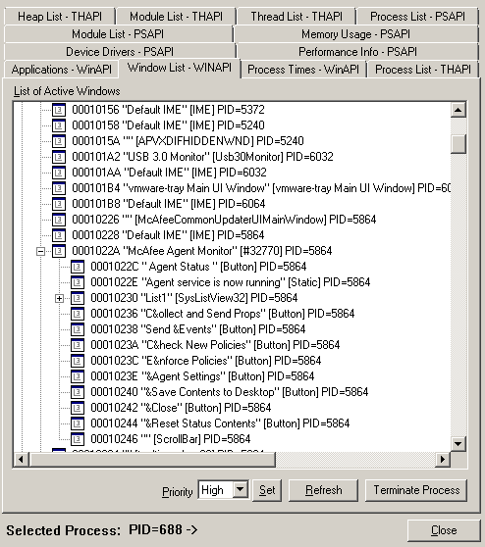
Figure-2 – List of active Windows

It is also possible that there could be multiple levels of hierarchical active windows for the given process as shown in Figure-2. This perspective is not all available in the conventional TM.

Process Times

Process times is another tab in vTask Manager that shows more information about each process in terms of chronology as to when those processes were created and how much of user time goes into each of the processes. Typically the following information is shown, as you see in Figure-3.
- Process Name
- Process ID
- Process Version
- Creation Time
- Kernel Time
- User Time

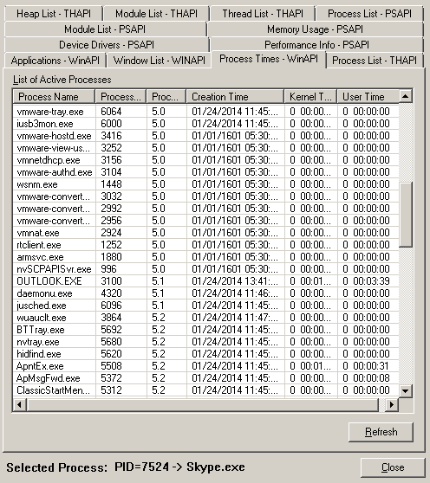
Figure-3 – Process Times

As you see, this information gives you an unique perspective as to how long a process has been running and how much of time user is spending on this process and where does it stand with regard to the usage in comparison to other processes. It also shows the current version of the process if multiple versions co-exist. One can derive more conclusions from the creation and user time with regard to how important the given process is.

Process List

This is another important tab on the list of processes and this tab gives a completely different perspective on the active processes compared to the previous one. The goal of this tab is to give you more details on how many threads are associated with each process and what are the priorities of those threads. It also gives the ID of the module and ID of the parent process which establishes a hierarchical relationship between the processes as shown in Figure-4.

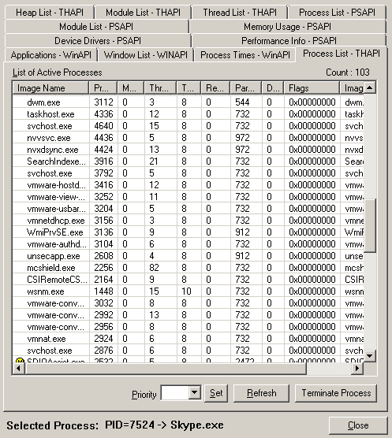
Figure-4 – Process List

This view also brings out reference count and Heap ID to further drill down from the thread information and also gives the complete path to the processes. On the top right corner, it shows the count of no. of processes that are currently active.

Device Drivers

Another important aspect of the system is the device drivers that are currently active and most of the issues on the windows system could be attributed to the incorrect or malfunctioning device drivers.

This tab gives you complete information about the currently active device drivers, the unique driver address associated with the each device driver and the physical file name that represents the driver. It also shows how many device drivers are currently active, on the top right corner as shown in Figure-5.

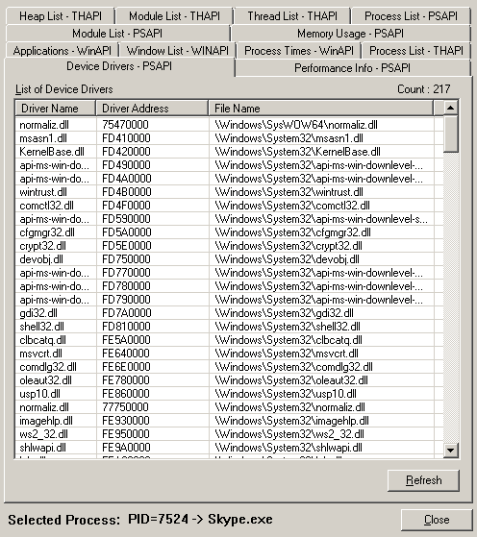
Figure-5 – Device Driver Information

This is an important piece of information that assists the users/administrators in debugging an issue with one of the currently loaded drivers that is seemingly malfunctioning. This information is obtained using PSAPI.

Performance Info

This tab gives you information about the performance of the system in terms of no. of handles/Threads/Processes, how much of physical and kernel memory available to the applications and how much of them is used by the system cache and information about the commit charge. It also shows which version of windows is currently running and what build of the respective windows operating system as shown in Figure-6.
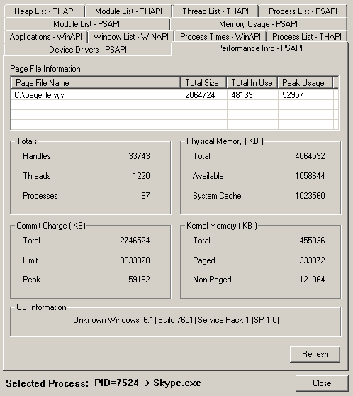
Figure-6 – Performance Info

There is scope to add more information to this tab and potentially a live performance graph of various system parameters that can show the load on the system and load triggered by each of the active processes. This information is obtained using PSAPI.

Module List - PSAPI

This is another unique perspective that is not shown by the conventional task manager and typically the following pieces of information are represented under the module list tab, as shown in Figure-7.

- Process ID
- Module Handle
- Module Name
- Full Path to the module
- Process Name
- Process Full Path
- Base Address
- Module Size
- Entry Point
- No of Modules - Count

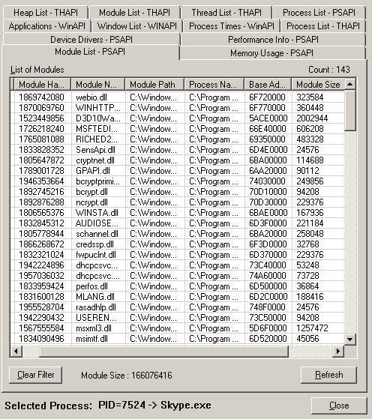
Figure-7 – Module list information

Establishing the relationship between modules and process/application is an important aspect of win32 debugging and this tab will help the developer easily narrow down the problematic module that has been loaded by the process that is currently being debugged. In some cases, it could be possible that there is a memory leak in the module which bloats up the module size exponentially, causing the respective process to become un-responsive. This information is obtained using PSAPI.

In any case, this is an important perspective that a trouble-shooter will need when working with win32 applications.

Memory Usage

Many of the windows issues can be attributed to memory leaks, Page Faults and sometimes, insufficient memory because of some other application using up the memory unintentionally.

Memory Usage tab is a drill-down version of the high level performance info shown as part of section 2.6 where it brings up lot of other useful information on memory such as the following using win32 PSAPI –
- Process Name
- Process ID
- Page Fault Count
- Peak Working Set Size
- Working Set Size
- Quota Peak Paged Pool Usage
- Quota Peak Non-Paged Pool Usage
- Quota Non-Paged Pool Usage
- Page File Usage
- Peak Page File Usage
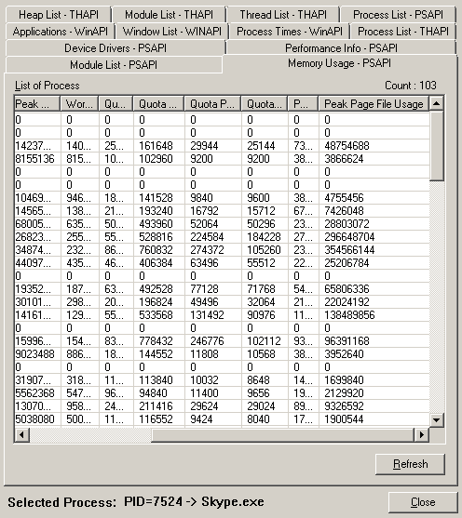
Figure-8 – Memory Usage View

The information shown in this tab (Figure-8) are critical for analysis of any memory related issue of a win32 application and the conventional task manager never brings out a memory view that is as detailed as this one for assisting the system administrator/developer in trouble-shooting an existing application or profiling a new application.

Heap List
Heap List tab brings down a detailed view on the heaps used by various processes and provides information such as the following
- Process ID
- Flags
- Heap ID
  - Handle
  - Start Address
  - Size
  - Lock Count
  - Flags

For each heap used by the process, one gets to know more information on the size, location of the heap and its handle as shown in Figure – 9.
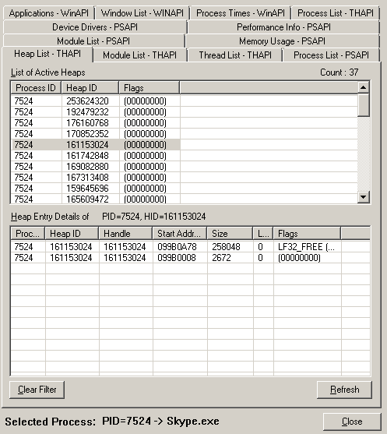
Figure-9- Heap View

Heap View is implemented using THAPI.

Module List – THAPI
The module list shown by THAPI version is little different from the one shown by PSAPI earlier as described in section-2.7.
THAPI adds more information to the modules such as global usage count, local usage count, Base Address and Module Size. This gives a new perspective on the process-module association and on the usage of the modules loaded as shown in Figure-10.

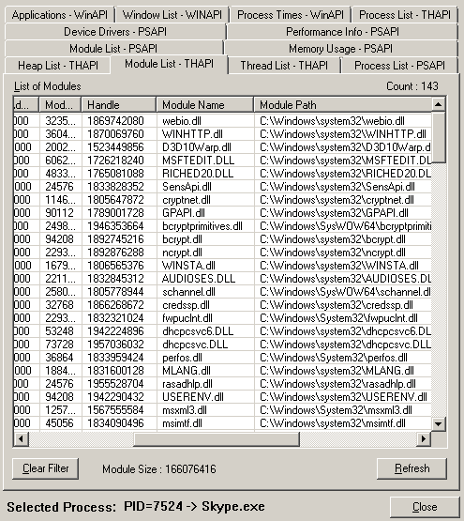
Figure-10 – Module List - THAPI

Thread View

Thread view tab gives you good insight into the currently active threads, their association with the process, their base priority, their delta priority and the process name with which they are associated. This view is again brought up by THAPI and gives the developer a better ammunition to analyze the system and the processes, as shown in Figure-11.

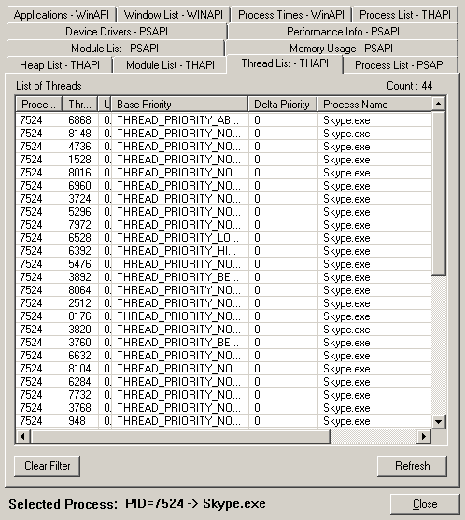
Figure-11 – Thread list from THAPI

Value Preposition
vTask Manager brings in different perspectives of the windows system that are not available in the conventional task manager from Windows such as the following
- Process-Thread mapping
- Process-Module mapping
- Process-Heap mapping
- Drill-down view of the memory usage
- Process-Window Handle mapping
- Application – Class Name mapping
- Chronological and User Based process time classification
- Module-Thread mapping
- Process-Device Driver mapping
- Drill-down view of processes/threads/heap/modules

These are very useful information to any user of VMware Windows Guest VMs be it an admin or a developer or an end user. The information provided by vTaskManager are very valuable in terms of optimizing the new application for Windows VMs and can help the developers to a great extent in trouble-shooting spurious win32 applications.

VMware Developers and Partners can use this tool to best optimize the applications for Windows based VMs, offering world-class solutions to the larger VMware Customer Base and Community.

Next Level
The tool can further be enhanced in terms of user experience and more real time performance monitoring can be added to the tool by plotting real time graphics against CPU/Memory usage and the tool can easily be converted into a complete profiling, debugging and task management tool for Windows VMs created by VMware Developers, Customers and Partners.

Summary
Overall, providing a comprehensive view of the system information can largely help the developers and administrators in going extra miles with regarding to resolving customer and partner issues and can significantly improve the customer experience. Bundling such a tool with VMware Tools for Windows Guest VMs can benefit the complete VMware Ecosystems involving Developers, Customers and Partners in quickly trouble-shooting, debugging win32 applications and will help achieve utmost optimization for windows based solutions, making them world-class.

