**Human resource management with blockchain**

This is an simple example of Human resource management with blockchain.

hr.htm:

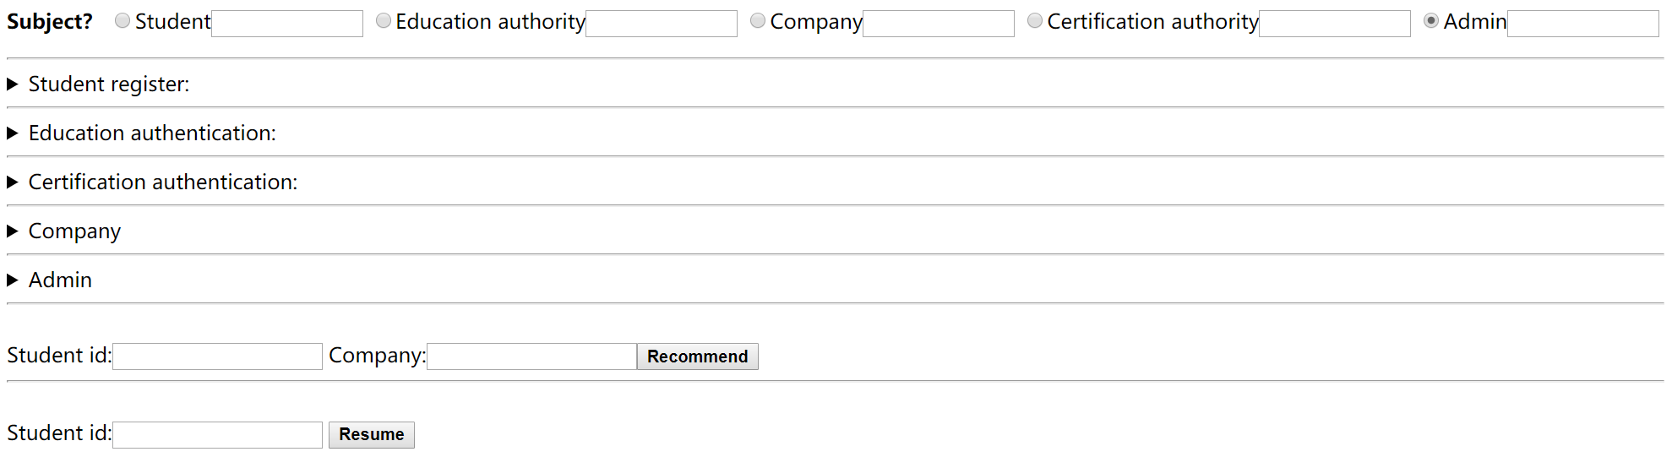

Displayed in hr.htm, there are 5 roles:

1.Student

2.Education authority

3.Company

4.Certification authority

5.Admin

Admin:

responsible for managing accounts of all roles

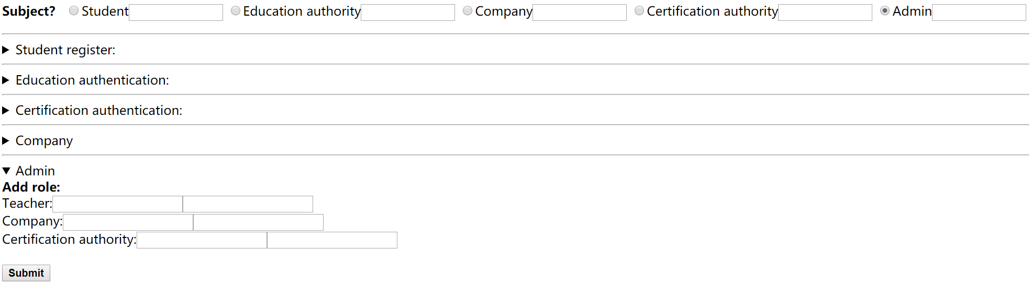

Student:

Register with the cypherium chain account,Just fill in the basic information

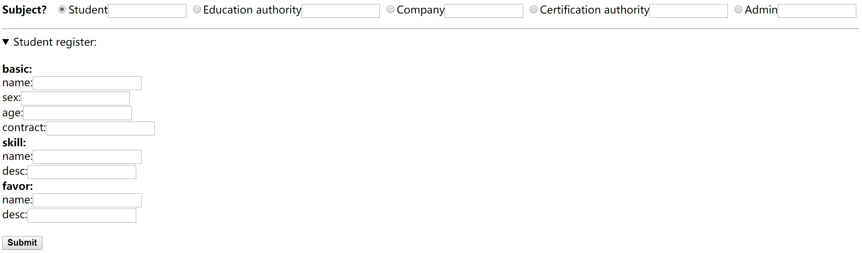

Education authority:

Use cypherium chain account to authenticate students' Education

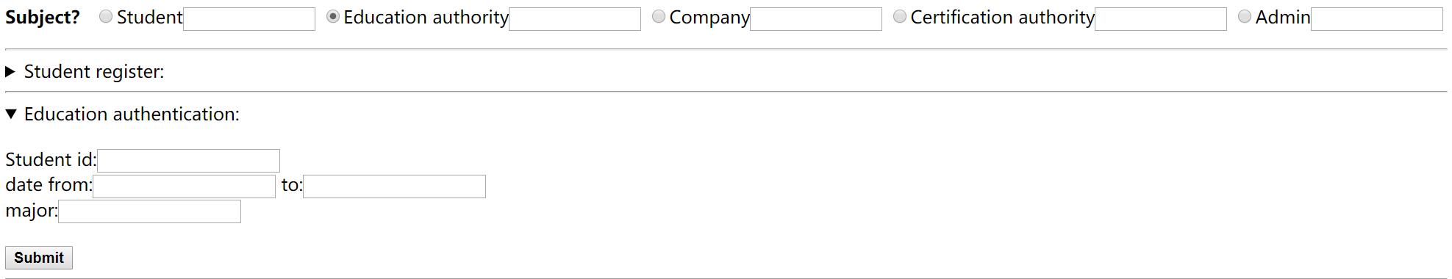

Company:

Using cypherium chain account to verify the work of employees(entry and leave)

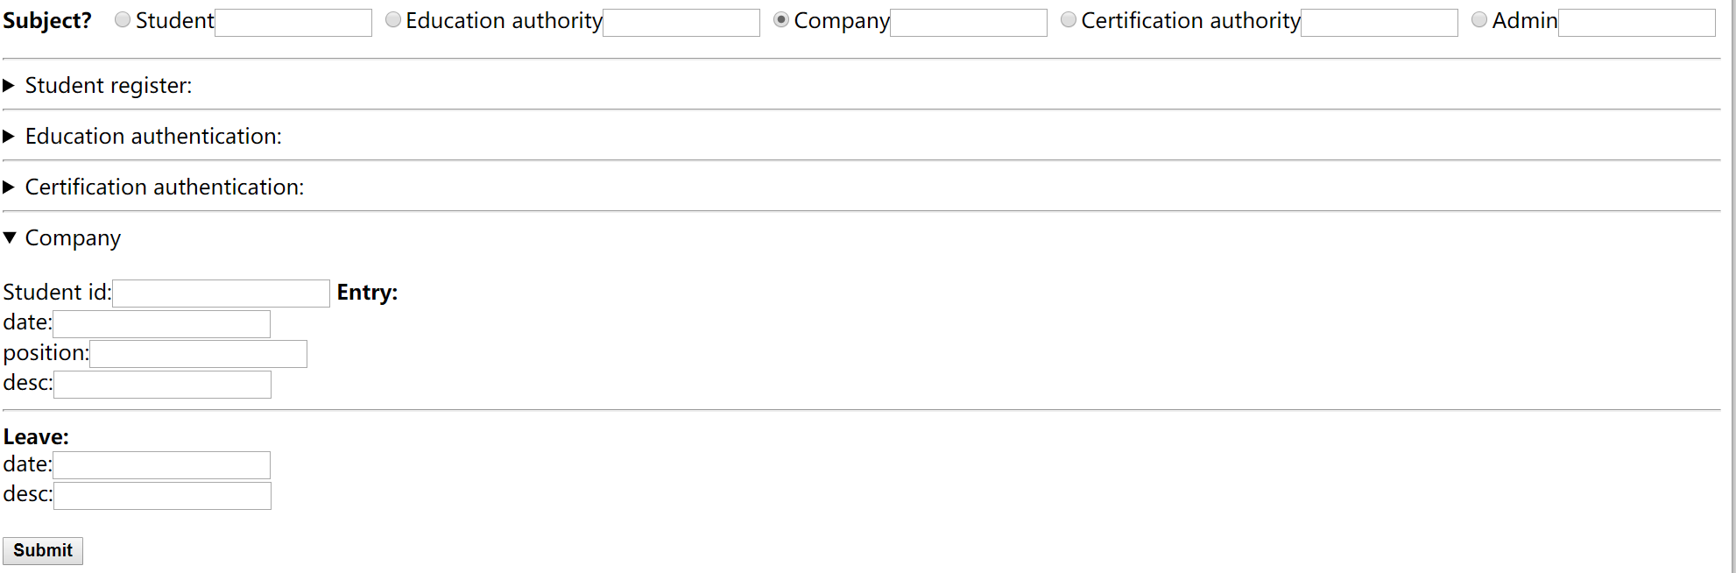

Certification authority:

Using cypherium chain account to authenticate the awards

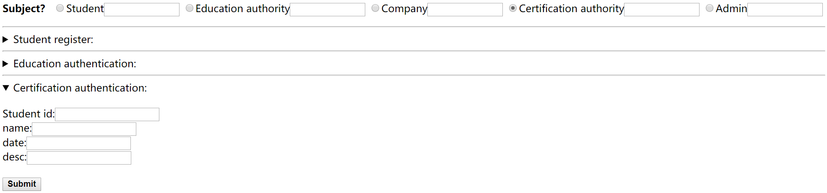

Recommend:

Recommend students to a company



Resume:

Show a student's complete resume

