CypherX AI
Multi-Tenant Agentic AI Platform

Contract-First · Microservices · AI Agent Orchestration

12 Production Services · 21 Immutable Contracts · 8 Database Schemas · 20+ Kafka Topics

Investor Pitch Documentation
Confidential · June 2026

parthasarathi.elumalai@l2m.ai

Table of Contents
1. Executive Summary & Platform Vision
2. Problem Statement & Market Opportunity
3. Platform Architecture
4. Core Services Deep-Dive
5. Security & Multi-Tenancy Model
6. Data Architecture & Persistence Strategy
7. Event-Driven Architecture & Kafka Topology
8. Developer & Operations Experience
9. API Design & Contract Governance
10. Observability & SLO Framework
11. Deployment Strategy (Local → Cloud)
12. Testing Strategy & Quality Gates
13. Roadmap & Phase Plan
14. Business Model & Key Metrics
15. Appendix: Architecture Decision Records

1. Executive Summary & Platform Vision
CypherX AI is a production-ready, multi-tenant, contract-first agentic AI platform that enables enterprises to build, deploy, and orchestrate intelligent agents at scale. Unlike point solutions, CypherX AI provides a complete infrastructure spine — from identity and safety to memory, retrieval-augmented generation, and tool use — as independently deployable microservices.

The Platform in One Sentence
"CypherX AI is the infrastructure layer that gives enterprises the ability to create, manage, and govern AI agents the same way they manage cloud microservices — with strong identity, audit trails, tenant isolation, and observable, contract-guaranteed behaviour."

Key Value Propositions
- Contract-First Design — 21 immutable JSON Schema / OpenAPI contracts govern every service boundary; contracts are versioned, never broken.
- Multi-Tenant Isolation — PostgreSQL Row-Level Security (RLS) makes cross-tenant data access architecturally impossible.
- Keyless-by-Default Local Dev — the entire platform runs offline with mock providers; a single env flag switches to live LLM keys.
- Observable by Default — every request carries a W3C traceparent; structured JSON logs, Prometheus metrics, and distributed tracing from day one.
- Language-Agnostic Runtime — agents are registered by JWT; any language or framework can talk the A2A protocol.
- First-Cycle Spine Proven — the complete path from agent registration → JWT → task → guardrails → LLM → response is live and smoke-tested.

Platform Architecture Overview
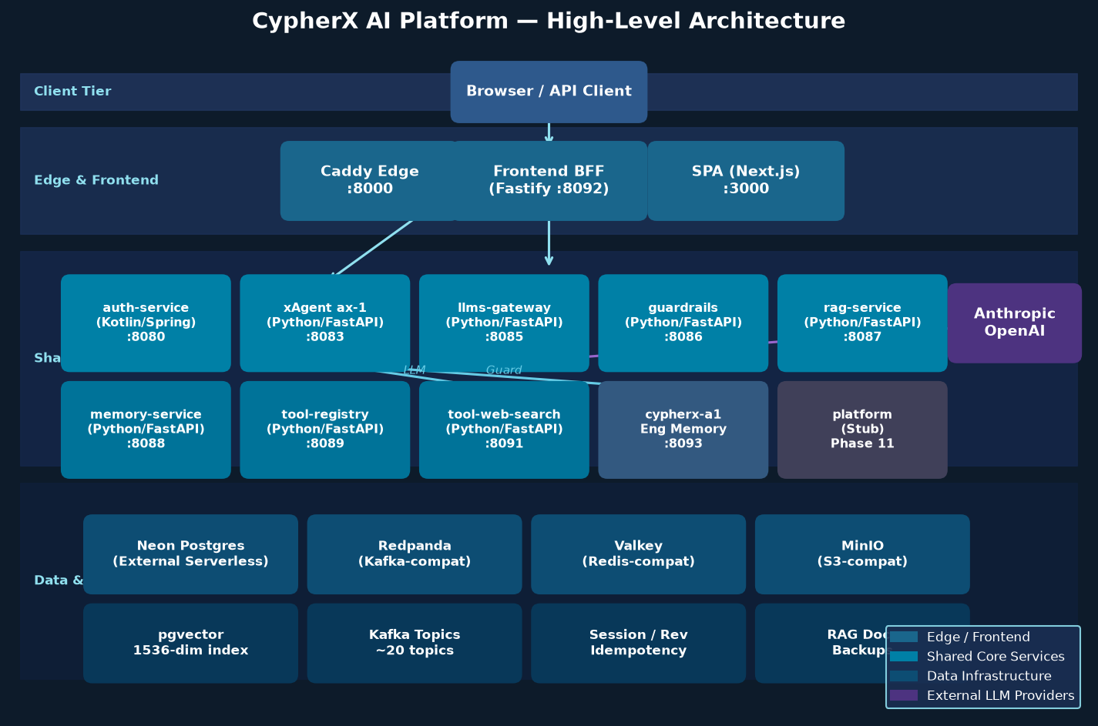
Figure 1.1 — CypherX AI Platform High-Level Architecture (4-tier)

Platform KPIs (Current Implementation)
Metric | Value
Production-ready services | 12 (auth, llms, guardrails, xagent, rag, memory, tool-registry, tool-web-search, frontend-bff, frontend-app, edge, cypherx-a1)
Cross-service contracts | 21 immutable contracts (Contracts 1–21)
Database schemas | 8 (auth, llms, guardrails, xagent, rag, memory, tools, cypherx_a1)
Kafka topics | ~20 (transactional outbox pattern, DLQ)
pgvector dimensions | 1 536 (OpenAI text-embedding-3-small)
JWT algorithm | RS256 with kid-based key rotation, revocation via Valkey mirror + Kafka broadcast
Tenant isolation | PostgreSQL RLS — SET LOCAL app.tenant_id per transaction
Local dev startup | docker compose up (Neon external, all services containerised)

2. Problem Statement & Market Opportunity

The Enterprise AI Infrastructure Gap
Enterprises trying to adopt AI agents face a fragmented landscape: LLM APIs are raw building blocks with no enterprise controls, open-source frameworks lack multi-tenancy and audit trails, and proprietary cloud AI platforms lock teams into a single vendor. The result is months of integration work before a single agent reaches production — with unknown security posture and no observable behaviour.

Problems CypherX AI Solves
Pain Point | CypherX AI Solution
No identity layer for AI agents | auth-service — agent registration, RS256 JWT, JWKS/OIDC, API key management
Uncontrolled LLM spend & vendor lock-in | llms-gateway — BYOK, multi-provider (Anthropic/OpenAI/OpenRouter), token metering, cost tracking
No safety guardrails before/after LLM | guardrails-service — cascading input/output filter, rule engine, PII redaction, violation audit log
No enterprise memory or knowledge | memory-service + rag-service — principal-scoped memory, pgvector semantic search, knowledge bases
No multi-tenant data isolation | PostgreSQL RLS — each tenant's rows are invisible to every other tenant at the DB layer
No tool ecosystem for agents | tool-registry + MCP protocol — discover tools, resolve name@version, stateless invoke
Poor observability / no audit trail | W3C traceparent end-to-end, Contract-6 JSON logs, Kafka audit events, Prometheus metrics + Grafana
Complex local dev setup | docker compose up — entire platform in one command; keyless mock mode; Neon external DB

Market Opportunity
The AI agent infrastructure market is nascent but growing rapidly as enterprises move from LLM experimentation to production deployment. CypherX AI targets the infrastructure layer — not the model layer — positioning it as a platform play with durable competitive advantages through network effects (contract ecosystem), data moats (tenant knowledge graphs), and switching costs (integrated identity and compliance audit trails).

Competitive Positioning
Competitor Category | Limitation | CypherX AI Advantage
Raw LLM APIs (Anthropic, OpenAI) | No identity, no guardrails, no multi-tenancy | Full enterprise infrastructure layer on top
LangChain / LlamaIndex | Framework, not platform; no multi-tenancy, no audit | Production platform with contractual guarantees
Cloud AI platforms (AWS Bedrock) | Single-cloud vendor lock-in, limited customisation | Cloud-agnostic, bring-your-own infra, open contracts
Custom in-house builds | Months of duplicated infrastructure work per company | Turn-key platform with proven first-cycle spine

3. Platform Architecture

Four-Tier Architecture
CypherX AI is structured in four logical tiers: Client (browser/API), Edge & Frontend (Caddy + BFF + SPA), Shared Core Services (12 microservices), and Data & Infrastructure (Postgres + Kafka + Valkey + MinIO). All tiers communicate via HTTP/REST using immutable versioned contracts. Event-driven coupling uses the Kafka transactional outbox pattern.

Figure 3.1 — Platform Architecture (all tiers, services, and infrastructure)

Request Flow (Browser → Response)
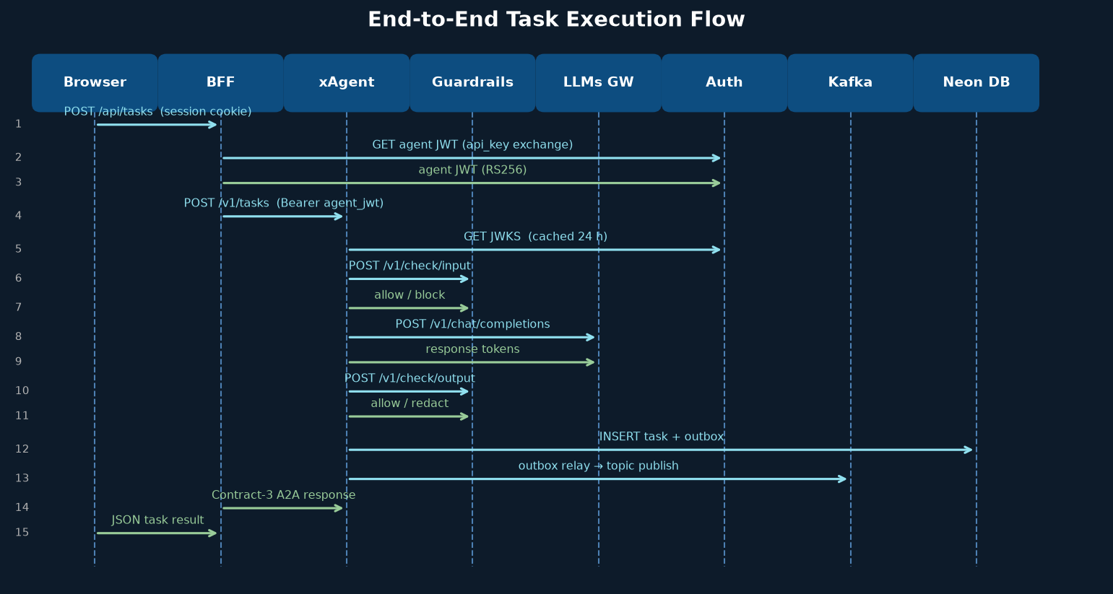
Figure 3.2 — End-to-End Task Execution Sequence

Design Principles
Contract-First: All 21 cross-service agreements are published as immutable JSON Schema / OpenAPI contracts BEFORE any service is built. Services adapt to contracts; contracts are never bent to services.
Dependency-Ordered Phases: Infrastructure (Phase 1) before auth (Phase 2) before LLMs (Phase 3) before guardrails (Phase 4) before xAgent (Phase 9A). Each phase only depends on previously proven contracts.
First-Cycle Spine First: The minimum viable path (agent registered → JWT → task → guardrails → LLM → response) is built and smoke-tested before any enterprise features. Phase 0–4 + 9A + frontend only.
Forward Compatibility: All contracts carry additionalProperties: true; verifiers ignore unknown fields. Breaking changes require a new /v2 endpoint alongside /v1. Old versions are deprecated, never deleted.
Zero Trust Identity: Every service re-verifies the agent JWT locally against Auth JWKS. No implicit trust between services. Service-to-service tokens follow Contract 12.
Keyless Local Dev: MOCK_PROVIDERS=true, MOCK_EMBEDDINGS=true, CLASSIFIER_MODE=stub, SEARCH_PROVIDER=mock. The entire platform runs offline without any API keys.

Service Inventory
Service | Technology | Role | Port
edge | Caddy 2 | Single local entrypoint, reverse proxy | 8000
auth-service | Kotlin 2 / Spring Boot 3.3 / JDK 21 | Agent identity, JWT, JWKS, API keys, audit | 8080
xagent/ax-1 | Python 3.12 / FastAPI | Single-agent runtime (stage pipeline) | 8083
llms-gateway | Python 3.12 / FastAPI | Unified LLM gateway, token metering, BYOK | 8085
guardrails-service | Python 3.12 / FastAPI | Input/output safety filter, rule engine | 8086
rag-service | Python 3.12 / FastAPI | Knowledge bases, chunking, pgvector retrieval | 8087
memory-service | Python 3.12 / FastAPI | Principal-scoped agent memory, semantic search | 8088
tool-registry | Python 3.12 / FastAPI | MCP tool catalogue, health polling | 8089
tool-web-search | Python 3.12 / FastAPI | MCP web_search tool (mock/SerpAPI/Brave) | 8091
frontend-bff | Node 22 / Fastify 4 | BFF: session, CSRF, JWT inject, proxy | 8092
frontend-app | Next.js 15 / React 19 | Admin SPA console | 3000
cypherx-a1 | Python 3.12 / FastAPI | Autonomous engineering memory (consuming app) | 8093

4. Core Services Deep-Dive

auth-service
Technology: Kotlin 2 / Spring Boot 3.3 / JDK 21 / Gradle KTS
Agent identity and access management. Issues RS256 JWT (Contract 1), manages API keys (Argon2id), JWKS/OIDC endpoint for verification, tenant and quota management, webhook delivery, append-only audit log, Valkey revocation mirror.

Key Endpoints
- POST /v1/agents — register agent
- POST /v1/agents/{id}/token — exchange api_key for JWT
- GET /.well-known/jwks.json — JWKS endpoint (cached 24h by consumers)
- POST /v1/agents/{id}/revoke — invalidate JWT (Valkey + Kafka broadcast)
- GET /v1/tenants/{id}/quota — quota status

xAgent / ax-1
Technology: Python 3.12 / FastAPI / psycopg3 / aiokafka
Single-agent runtime. Re-verifies agent JWT, runs the named stage pipeline LOAD → PRE_GUARDRAIL → PROMPT_BUILD → LLM → POST_GUARDRAIL → EVENT. Each stage records a task_step row. The EVENT stage atomically updates the task and writes to the Kafka outbox. WP12 stages (RAG_QUERY, MEM_RETRIEVE, TOOL_LOOP, MEM_WRITE) are coded but flag-disabled.

Key Endpoints
- POST /v1/tasks — submit a task (sync response, Contract-3 A2A)
- GET /v1/tasks/{id} — poll task status
- GET /v1/tasks/{id}/steps — stage-by-stage execution trace

llms-gateway
Technology: Python 3.12 / FastAPI / Anthropic + OpenAI SDKs
The only path to any LLM provider in the platform. Normalises a single OpenAI-superset schema to Anthropic or OpenAI. Resolves model aliases (fast → claude-3-5-sonnet). BYOK: tenant_provider_keys table (AES-encrypted). Records usage_records atomically. Idempotency via Valkey 24h cache. SSE passthrough for streaming.

Key Endpoints
- POST /v1/chat/completions — completion (sync or streaming SSE)
- POST /v1/embeddings — embedding vectors (used by rag + memory)
- GET /v1/models — available model aliases

guardrails-service
Technology: Python 3.12 / FastAPI / Neon Postgres
Guardrail-as-a-Service. Cascading policy evaluation: system → platform → tenant → agent. 11+ built-in rule types including PII detection (HMAC redaction), topic blocking, length limits, and custom patterns. Decisions: allow / warn / redact / block. Records violations to DB + Kafka outbox.

Key Endpoints
- POST /v1/check/input — evaluate agent input before LLM
- POST /v1/check/output — evaluate LLM response before delivery
- POST /v1/policies — create/update guardrail policy
- POST /v1/simulate — dry-run check (no side effects)

rag-service
Technology: Python 3.12 / FastAPI / psycopg3 + pgvector / MinIO
Universal RAG: knowledge bases, document ingestion (inline/presigned/Kafka worker), chunking, embedding via llms-gateway, pgvector cosine similarity retrieval. Documents progress through status: pending → processing → indexed. Raw files stored in MinIO/S3.

Key Endpoints
- POST /v1/kbs — create knowledge base
- POST /v1/kbs/{id}/documents — ingest document
- POST /v1/kbs/{id}/query — semantic retrieval (top-K chunks with scores)

memory-service
Technology: Python 3.12 / FastAPI / psycopg3 + pgvector / aiokafka
Principal-scoped agent memory: store/search/CRUD/sessions/GDPR-wipe. Embeds memories via llms-gateway (mock fallback). Semantic search uses pgvector cosine similarity over memory_vectors_1536. Importance-weighted retrieval. GDPR wipe emits Kafka event.

Key Endpoints
- POST /v1/memories — store memory (embeds asynchronously)
- POST /v1/memories/search — semantic search (top-K)
- DELETE /v1/principals/{id}/memories — GDPR wipe


Figure 4.1 — Service Interaction Overview

5. Security & Multi-Tenancy Model
Security is a first-class architectural concern, not a layer added after the fact. Every tenant's data is isolated at the database layer via PostgreSQL RLS; every service re-verifies JWTs; every sensitive action is appended to an immutable audit log; and all secrets live in Doppler — never in git.
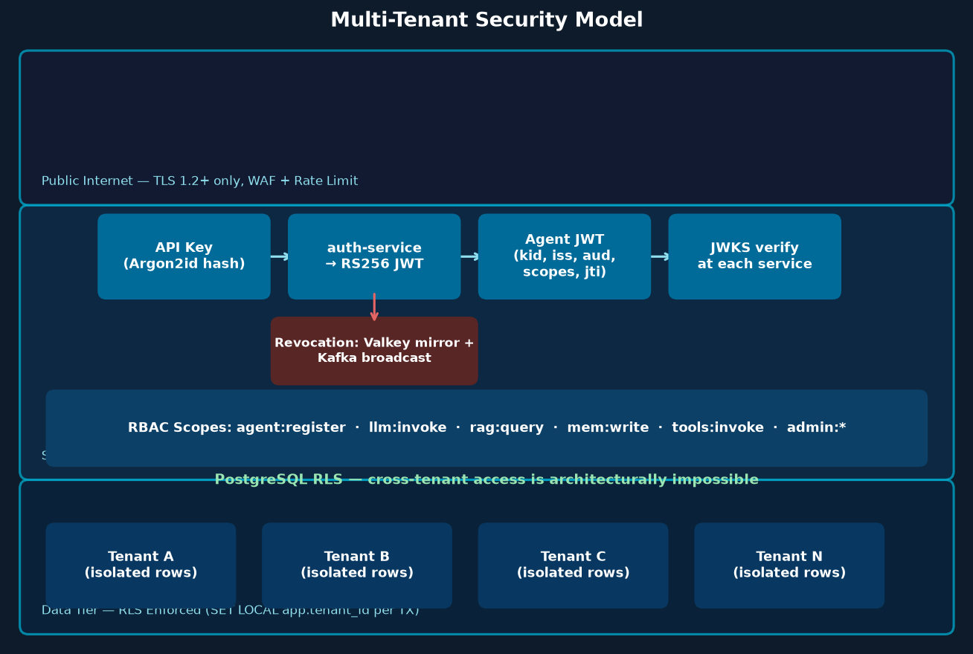
Figure 5.1 — Multi-Tenant Security Architecture

JWT Authentication Flow
Step 1: Client presents an API key (Argon2id hash stored in auth.api_keys table).
Step 2: auth-service validates the hash, checks scopes and quota, mints an RS256 JWT (kid, iss, aud, jti, scopes, tenant_id).
Step 3: JWT is returned to the client (BFF holds it in server-side Valkey session; never exposed to browser).
Step 4: Each downstream service re-verifies the JWT locally against the Auth JWKS endpoint (cached for 24h). No service trusts another service to have already verified.
Step 5: On revocation, auth-service writes jti to Valkey mirror (key: cypherx:rev:jti:<jti>) and broadcasts a Kafka event so all services flush their caches.

Multi-Tenancy (PostgreSQL RLS)
Every tenant-scoped table has RLS policies that check current_setting('app.tenant_id'). Services run as non-superuser roles (no BYPASSRLS). Each request sets SET LOCAL app.tenant_id = '{tenant_id}' at the start of the transaction. Cross-tenant access is architecturally impossible.

RBAC Scope Hierarchy
Scope | Service | Grants Access To
agent:register | auth-service | Register new agents, manage API keys
llm:invoke | llms-gateway | Submit chat completions, read usage records
rag:query / rag:admin | rag-service | Query knowledge bases (query) / full CRUD (admin)
mem:read / mem:write | memory-service | Read memories / store and delete memories
guardrails:check | guardrails-service | Check input/output (called by xAgent, not clients)
tools:invoke | tool-registry | Discover and invoke MCP tools
admin:* | All services | Full platform administration (console agents only)

Encryption & Secrets
What | How
LLM provider keys (BYOK) | AES-256-GCM envelope encryption; key in KMS/env; stored in tenant_provider_keys
JWT signing keys | RS256; private key stored AES-encrypted in auth.signing_keys; NEVER in env vars
API keys at rest | Argon2id hash; only the prefix is stored in plaintext (for display)
DB connections | sslmode=require on all DSNs; PgBouncer in cloud (transaction mode)
Service secrets | Doppler → K8s Secrets (cloud) / .env (local-only throwaway values)
Session cookies | httpOnly, SameSite=Strict; BFF holds Valkey session; browser never sees JWT
Transit | TLS 1.2+ externally; mTLS Istio mesh internally (cloud); plain HTTP within compose (local)

6. Data Architecture & Persistence Strategy
The platform uses a single Neon Serverless Postgres instance (database: cypherx_platform) with 8 separate schemas — one per service domain. Each service owns its schema and runs migrations through Atlas. Services connect via POOLED endpoint (PgBouncer transaction mode for RLS compatibility) and a separate DIRECT endpoint for migrations only.
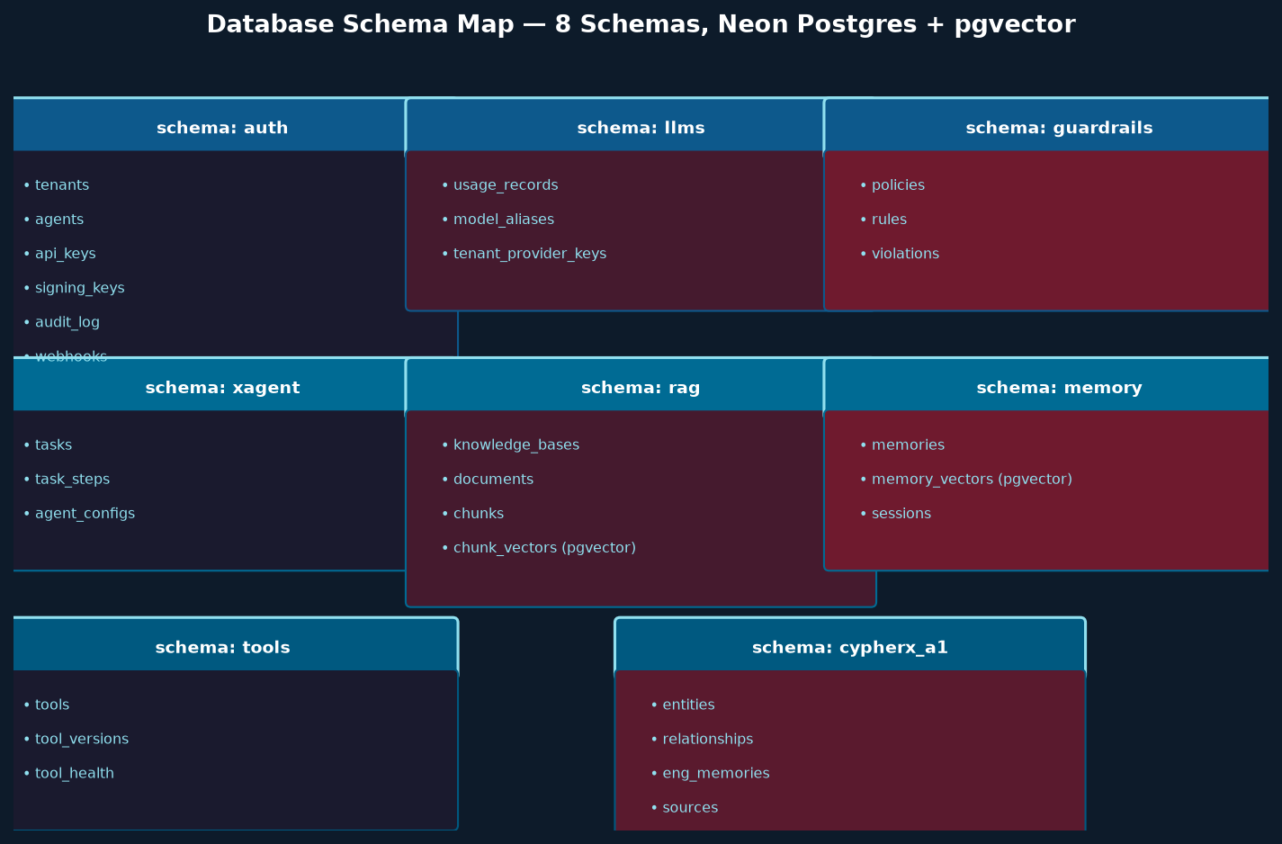
Figure 6.1 — Database Schema Map (8 Schemas, Neon + pgvector)

Schema Ownership
Schema | Owner Service | Key Tables | Special Features
auth | auth-service | tenants, agents, api_keys, signing_keys, audit_log, webhooks | Argon2id key hashes; AES-encrypted private keys; RLS on all tenant tables
llms | llms-gateway | usage_records, model_aliases, tenant_provider_keys | UNIQUE on (tenant_id, llm_call_id) — idempotent billing; AES-encrypted BYOK keys
guardrails | guardrails-service | policies, rules, violations | Cascading policy precedence; violation audit trail; RLS
xagent | xagent/ax-1 | tasks, task_steps, agent_configs | Idempotency key UNIQUE; outbox pattern; RLS; stage-level trace
rag | rag-service | knowledge_bases, documents, chunks, chunk_vectors | pgvector 1536-dim IVFFlat index for cosine similarity; MinIO storage_path; RLS
memory | memory-service | memories, memory_vectors, sessions | pgvector 1536-dim; importance-weighted retrieval; GDPR wipe support; RLS
tools | tool-registry | tools, tool_versions, tool_health | name@version resolution; periodic health polling
cypherx_a1 | cypherx-a1 | entities, relationships, eng_memories, sources | Knowledge graph + RAG corpus; separate Neon DB (engineering_knowledge_base)

Migration Strategy
- Atlas manages all schema migrations (Contract 14). Each service has a db/migrations/ directory.
- Migration DSN uses a *_ddl role (CREATEROLE mitigation); runtime DSN uses a *_user non-superuser role.
- Migrations run as a one-shot Docker Compose job (--profile migrate) against the DIRECT Neon endpoint.
- All init scripts are idempotent (CREATE TABLE IF NOT EXISTS, DO $$ BEGIN ... EXCEPTION WHEN duplicate_object) — safe to re-run.
- POOLED endpoint for app services (transaction mode, compatible with SET LOCAL RLS). DIRECT endpoint for migrations only (session mode for advisory locks).

pgvector — Vector Search at Scale
Both rag-service and memory-service use pgvector with 1536-dimensional embeddings (OpenAI text-embedding-3-small compatible). Vectors are stored in separate chunk_vectors and memory_vectors tables using IVFFlat indexes for approximate nearest-neighbour cosine similarity search. In local dev, embeddings fall back to a mock generator (MOCK_EMBEDDINGS=true).

7. Event-Driven Architecture & Kafka Topology
CypherX AI uses a transactional outbox pattern to guarantee at-least-once event delivery. Every service writes domain events to a local outbox table in the same database transaction as the state change. A relay process then publishes the outbox rows to Redpanda (Kafka-compatible). This eliminates the dual-write problem and ensures no events are lost even if Kafka is temporarily unavailable.
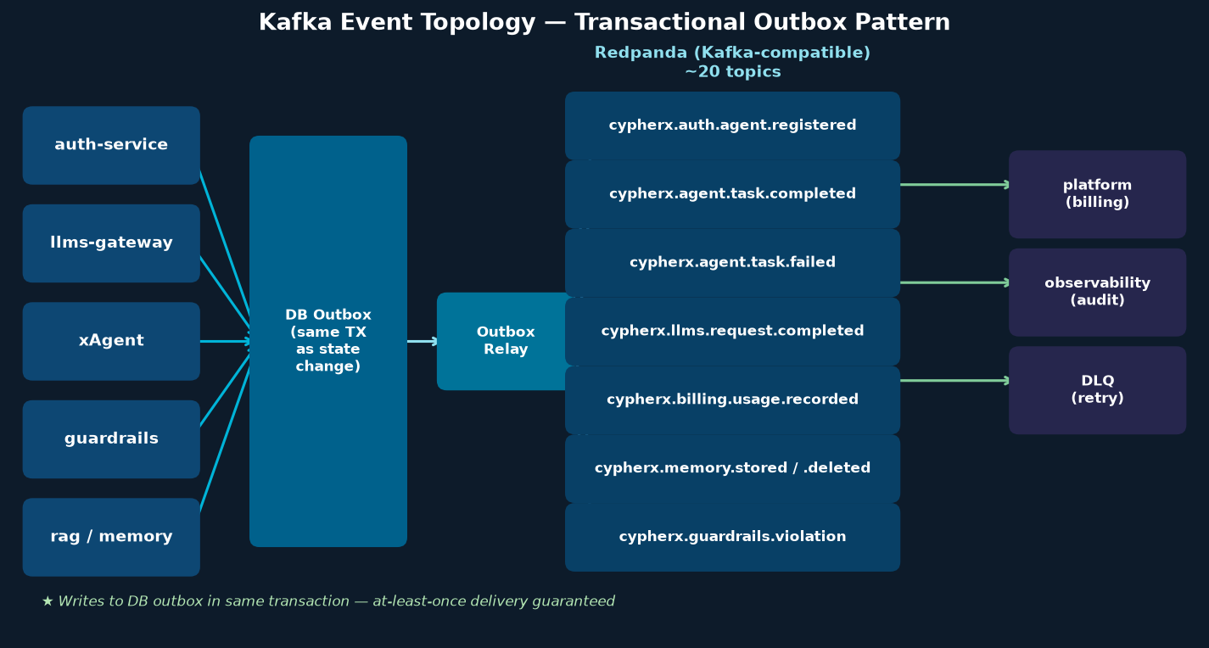
Figure 7.1 — Kafka Event Topology & Transactional Outbox Pattern

Topic Naming Convention
All topics follow the pattern: cypherx.<domain>.<entity>.<event-type>
Example: cypherx.agent.task.completed, cypherx.llms.request.completed, cypherx.billing.usage.recorded

Key Topics
Topic | Producer | Consumers | Partition Key
cypherx.auth.agent.registered | auth-service | platform (billing), audit log | tenant_id
cypherx.agent.task.completed | xagent | platform, observability, analytics | task_id
cypherx.agent.task.failed | xagent | platform, alerting, DLQ | task_id
cypherx.llms.request.completed | llms-gateway | billing, analytics | tenant_id
cypherx.billing.usage.recorded | llms-gateway | platform (cost roll-up) | tenant_id
cypherx.guardrails.violation | guardrails-service | audit, alerting | tenant_id
cypherx.memory.stored | memory-service | analytics, search index | principal_id
cypherx.memory.gdpr.wiped | memory-service | audit, compliance | principal_id
cypherx.tools.invocation.metered | xagent (outbox) | billing, analytics | tool_name
cypherx.rag.ingestion.requested | rag-service | rag async worker | kb_id

Outbox Relay Implementation
- Each service has a separate outbox table (e.g. auth.outbox, xagent.outbox) with columns: id, topic, partition_key, payload (JSONB), created_at, published_at.
- The relay process polls the outbox table for unpublished rows, publishes to Kafka, then sets published_at. Idempotent on re-publish (Kafka message key = outbox row id).
- Contract 5 defines the universal event envelope: { "specversion": "1.0", "type": "<topic>", "source": "<service>", "id": "<uuid>", "time": "<ISO8601>", "traceparent": "<W3C>", "data": {...} }.
- Dead-letter queue (DLQ) topics receive messages that fail all delivery retries. Kafka Streams / MSK Connect handles DLQ routing in cloud.

8. Developer & Operations Experience

Local Development (Zero to Running in Minutes)
Step | Command / Action
1. Neon setup | Create a Neon project with database cypherx_platform; note POOLED and DIRECT endpoint hosts.
2. Configure env | cp infra/compose/.env.example infra/compose/.env — fill in 7× DATABASE_URL (POOLED) + MIGRATE_DATABASE_URL (DIRECT).
3. Migrate once | docker compose --profile migrate up migrate — idempotent, creates all 8 schemas, tables, roles, and seed data.
4. Start stack | docker compose up -d --build — depends_on + healthchecks order startup automatically.
5. Smoke test | cd contracts && npm test — runs all 15 Contract-15 smoke-test cases against the live stack.

Keyless-by-Default Config Toggles
Env Var | Default (local) | Live value
MOCK_PROVIDERS | true | false (+ set ANTHROPIC_API_KEY or OPENAI_API_KEY)
MOCK_EMBEDDINGS | true | false (+ EMBEDDINGS_FALLBACK_TO_MOCK=false)
CLASSIFIER_MODE | stub | ml (deploys a classifier model)
SEARCH_PROVIDER | mock | serpapi or brave (+ SERPAPI_KEY / BRAVE_API_KEY)

Observability Profiles
The compose stack supports an --profile observability flag that adds: OpenTelemetry Collector (OTLP → Tempo + Loki), Grafana (host :3001), Tempo (distributed traces :3200), Loki (structured logs :3100), Prometheus (metrics scraping /metrics on every service). Span export is opt-in via OTEL_EXPORTER_OTLP_ENDPOINT; Prometheus scrapes unconditionally.

Coding Standards
Python services: uv for dependency management, pyproject.toml, ruff for linting/formatting, pytest + httpx for tests, async-first (asyncio + asyncpg/psycopg3).
Kotlin service (auth): Gradle KTS, ktlint, JUnit 5 + MockK, Spring Boot 3.3 conventions, coroutines for async.
TypeScript (frontend): ESLint + Prettier, Vitest for unit tests, Playwright for E2E, React 19 + Next.js 15 app router.
Contract changes: Edit contracts/ JSON Schema / OpenAPI, bump version if breaking, run npm test in contracts/ (gates every PR).
Migrations: Add Atlas migration file, run via --profile migrate, never touch existing migration files.

9. API Design & Contract Governance
CypherX AI is built contract-first. All 21 cross-service contracts are published and gated in CI before any service implements them. Contracts are immutable: additive, optional fields can be added without a version bump; breaking changes require a new /v2 endpoint alongside /v1. The contracts/ repository is the single source of truth.

The 21 Contracts
Contract | Name | Description
1 | Agent JWT | RS256 JWT claims: iss, aud, sub (agent_id), tenant_id, scopes, jti, exp
2 | Error Envelope | { "error": { "code", "message", "details" } } — universal error format
3 | A2A Task | Agent-to-Agent task request/response — input_text, metadata, response, status
4 | MCP Manifest | Tool manifest schema: name, version, description, inputSchema, outputSchema
5 | Kafka Envelope | CloudEvents 1.0 superset with traceparent field
6 | Log Format | Structured JSON log: timestamp, service, level, trace_id, tenant_id, message
7 | Health Probes | /livez (process-only), /readyz (downstream-aware), /metrics (Prometheus port 9090)
8 | Trace Context | W3C traceparent propagated through HTTP headers and Kafka events
9 | Idempotency | Idempotency-Key header; 24h Valkey cache; duplicate → 200 with cached response
10 | Guardrail Decision | Input/output check: decision (allow/warn/redact/block), violations array, redacted_text
11 | Skill Manifest | Declarative YAML skill definition (Phase 8, not yet built)
12 | Service Token | Service-to-service JWT: svc_id, scopes, exp — minted by auth-service
13 | Tenant RLS | SET LOCAL app.tenant_id per transaction; POOLED endpoint only
14 | Atlas Migration | Migration file naming and role conventions
15 | Smoke Tests | 15 test cases defining first-cycle sign-off criteria
16 | LLM Request | OpenAI-superset chat completion request normalised to any provider
17 | LLM Response | Normalised chat completion response with usage + cost fields
18 | Embedding Request/Response | POST /v1/embeddings — model, input → vectors, usage
19 | RAG Retrieval | POST /v1/kbs/{id}/query → chunks with scores, metadata
20 | Onboarding / Signup | Tenant self-registration: POST /v1/signup, POST /v1/verify
21 | Reserved Headers | Reserved HTTP header names + reserved metadata keys (anti-spoof guards)

API Standards
- REST/JSON over HTTPS; all endpoints versioned at /v1/ (or /v2/ for breaking changes).
- Every endpoint requires authentication (Bearer agent JWT or service JWT). No public unauthenticated endpoints except JWKS and health probes.
- Contract 2 error envelope on all 4xx/5xx responses.
- Contract 8 W3C traceparent header required on all inbound requests; propagated to all downstream calls.
- Contract 9 Idempotency-Key header supported on all mutating operations.
- Pagination: cursor-based (next_cursor, limit) on all list endpoints.
- additionalProperties: true on all request/response schemas — forward compatibility guaranteed.

10. Observability & SLO Framework
Every service in the platform emits structured JSON logs (Contract 6), Prometheus metrics (Contract 7), and W3C traceparent distributed traces (Contract 8). The observability stack (OTLP → Tempo → Grafana for traces; Loki for logs; Prometheus for metrics) is included in the compose stack under --profile observability.

The Three Pillars

Distributed Tracing
W3C traceparent propagated through every HTTP header and Kafka event envelope. OpenTelemetry auto-instrumentation. Tempo backend. A single trace_id follows a request from browser → BFF → xagent → guardrails → llms → response.

Structured Logging
Contract 6 mandates: timestamp (ISO 8601), service, level, trace_id, tenant_id, message, plus optional request_id, user_agent, duration_ms. Loki aggregates. Grafana queries. No free-text logs in production.

Metrics (Prometheus)
Every service exposes /metrics on port 9090 (fixed const in Helm chart schema). Standard metrics: http_requests_total, http_request_duration_seconds, db_pool_connections. Service-specific: llms_tokens_total{provider,model}, guardrails_violations_total{severity}, xagent_task_stage_duration_seconds{stage}.

Service-Level Objectives (SLOs)
Service | SLO | Target | Alert Threshold
xagent | Task completion rate | ≥ 99.5% | < 99.0% over 5 min
xagent | P95 task latency | ≤ 5 s | > 8 s over 5 min
llms-gateway | Provider error rate | < 1% | > 2% over 5 min
llms-gateway | P95 completion latency | ≤ 3 s | > 5 s over 5 min
auth-service | JWT mint error rate | < 0.1% | > 0.5% over 5 min
auth-service | P99 JWT mint latency | ≤ 200 ms | > 500 ms over 5 min
guardrails | P95 check latency | ≤ 100 ms | > 200 ms over 5 min
rag-service | Query P95 latency | ≤ 500 ms | > 1 s over 5 min

11. Deployment Strategy (Local → Cloud)
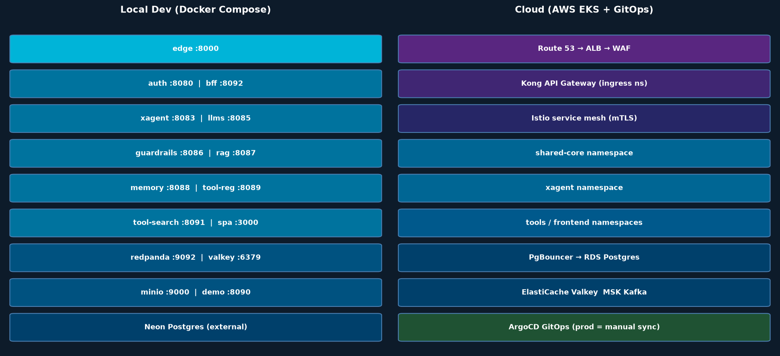
Figure 11.1 — Local Compose (left) vs Cloud EKS (right) Deployment

Local Development Stack
Docker Compose v2 (infra/compose/docker-compose.yml). Single entrypoint: Caddy edge on host :8000. Neon Postgres is external; all other infrastructure (Redpanda, Valkey, MinIO) runs as containers. Doppler CLI syncs secrets into .env (not committed). Full stack starts with docker compose up -d --build.

Cloud (AWS EKS) Topology
- Route 53 → ALB (TLS termination, WAF) → Kong API Gateway (JWT validation, rate limiting, routing) → Istio mTLS mesh → service pods.
- Namespaces: shared-core (auth, llms, guardrails, rag, memory), xagent, tools, frontend, observability.
- Node groups: c6i.xlarge for core services, c6i.2xlarge for xAgent, t3.large for tools/frontend, r6i.xlarge for observability.
- PgBouncer (connection pool, transaction mode) in front of RDS PostgreSQL Multi-AZ. Read replica in us-west-2 for DR.
- ElastiCache Valkey (cluster mode, 3 shards × 2 replicas). MSK Kafka (3 brokers, SASL_SSL). S3 with cross-region replication.
- VPC endpoints for S3 (Gateway), ECR, KMS, Secrets Manager — no internet egress for data plane.
- NAT Gateway for outbound HTTPS (LLM provider API calls only).

GitOps with ArgoCD
Environment | Sync Policy | Image Tags | Approval
dev | Automated (self-heal) | sha-<sha7> immutable | Automated on PR merge
staging | Automated (self-heal) | sha-<sha7> immutable | Automated on PR merge
prod | MANUAL SYNC ONLY | sha-<sha7> immutable | Human approval required

CRITICAL: prod-apps.yaml must NEVER have syncPolicy.automated. This is a deliberate safety gate — prod deploys require explicit human approval in the ArgoCD UI.

12. Testing Strategy & Quality Gates
CypherX AI uses a comprehensive test pyramid. The critical quality gate is Contract 15: 15 smoke-test cases that must all pass twice on a cold dev environment before any phase is considered complete.

Test Pyramid
Level | Tools | Scope | When
Unit | pytest (Python) / JUnit 5 + MockK (Kotlin) / Vitest (TS) | Individual functions and classes; mock all I/O | Every commit (CI)
Integration | pytest + real Neon DB + Redpanda | Service internals with real DB and Kafka | Every PR (CI)
Contract | AJV validator in contracts/ (npm test) | All 21 contract schemas validated against live service responses | Every PR (gates merge)
Smoke (Contract 15) | Custom test runner in contracts/smoke-tests/ | 15 end-to-end cases: register → JWT → task → guardrails → LLM → response | Phase sign-off (must pass twice cold)
Load | k6 (task throughput) + Locust (guardrail SLO) | Throughput and P95 latency under sustained load | Pre-release
Security | OWASP ZAP + custom JWT abuse tests | JWT forgery, tenant escape, scope elevation, injection | Pre-release

Contract-15 Smoke Tests (Phase Sign-Off)
Case | Description | Gates
1 | Register agent + receive 201 | Phase 2 (auth)
2 | Exchange api_key → JWT (200, valid RS256) | Phase 2
3 | Submit task → 200 A2A response | Phase 9A (xagent)
4 | Guardrail block → task returns blocked decision | Phase 4
5 | LLM completion via llms-gateway | Phase 3
6 | Token usage recorded in usage_records | Phase 3
7 | Task step trace recorded (all stages) | Phase 9A
8 | Revoke JWT → subsequent task → 401 | Phase 2
9 | Cross-tenant isolation: Tenant A cannot see Tenant B task | Phase 9A + RLS
10 | JWKS endpoint returns valid public key set | Phase 2
11 | RAG KB create + document ingest + query returns chunks | Phase 5
12 | Memory store + semantic search returns stored memory | Phase 6
13 | Tool registry discover + MCP invoke web_search | Phase 7
14 | Full WP12 pipeline: task → RAG → memory → tool → LLM → response | Phase 9A WP12
15 | Kafka topic receives task.completed event (outbox) | Phase 9A + Kafka

13. Roadmap & Phase Plan
The platform is built in dependency-ordered phases. The "first cycle" (Phases 0–4 + 9A + 12) proves the minimum spine end-to-end. The enterprise wave (Phases 5–8 + 9B + 9C + 10–11) adds knowledge, memory, tools, A2A orchestration, and control plane. All phases are already spec'd in archive/Manoj/phases/.

Phase Summary
Phase | Name | Status | Delivers
0 ⚡ | Contracts | DONE | 21 immutable cross-service contracts
1 ⚡ | Infrastructure | DONE | IaC, local compose, base Helm chart, GitOps skeleton
2 ⚡ | Auth | DONE | Agent identity, JWT, JWKS, API keys, audit, webhooks
3 ⚡ | LLMs Gateway | DONE | Unified LLM gateway, BYOK, multi-provider, token metering
4 ⚡ | Guardrails | DONE | Input/output safety filter, cascading policies, PII redaction
5 📋 | RAG | DONE | Knowledge bases, chunking, pgvector retrieval, MinIO
6 📋 | Memory | DONE | Agent memory, sessions, semantic search, GDPR wipe
7 📋 | Tools | DONE | Tool registry, MCP invoke, tool-web-search
8 📋 | Skills | PENDING | Declarative skill definitions indexed into RAG
9A ⚡ | xAgent (spine) | DONE | Stage pipeline, task execution, first-cycle smoke tests
9B/9C 📋 | xAgent (WP12) | CODED (flag-disabled) | RAG_QUERY, MEM_RETRIEVE, TOOL_LOOP, MEM_WRITE stages
10 📋 | A2A Orchestration | PENDING (ax-2 empty) | A2A router, orchestrator, multi-agent workflows
11 📋 | Platform Control Plane | STUB | Service registry, billing, config hot-reload, px0 bridge
12 📋 | Frontend | DONE | Admin console SPA, BFF, demo runner
13 📋 | Hardening | PENDING | External readiness, penetration testing, compliance
14 📋 | SDKs | PENDING | Python, TypeScript, Go SDKs for agent development

Immediate Next Steps
- Enable WP12 stages in production (flag STAGE_ENABLE_RAG_QUERY=true etc.) — code already written and tested.
- Build ax-2 (A2A router + Orchestrator) — phase-10-a2a-orchestration.md spec ready.
- Build platform control plane (Phase 11) — cost roll-up, service registry, config hot-reload.
- Build Skills repo (Phase 8) — declarative YAML skill definitions, Contract 11.
- Hardening (Phase 13) — penetration test, SOC2 evidence collection, WAF rule tuning.
- SDK release (Phase 14) — Python/TS/Go SDKs for partner and customer agent development.

14. Business Model & Key Metrics

Revenue Model
Revenue Stream | Description | Unit Economics
Platform Subscription | Monthly/annual SaaS fee per tenant tier (Starter / Pro / Enterprise) | Recurring ARR; high gross margin (~80%)
LLM Token Pass-Through | Margin on tokens routed through llms-gateway (cost + 10–20% markup) | Scales with usage; metered via usage_records
SharedCore SaaS | Each SharedCore service (auth, guardrails, rag, memory) sold as standalone SaaS product | Cross-sell to customers using only one component
Engineering Memory (cypherx-a1) | Autonomous engineering knowledge graph and copilot — per-seat or per-org pricing | Knowledge moat; high retention
Professional Services | Implementation, custom agent development, enterprise on-boarding | One-time; transitions to ARR

Key Platform Metrics
Metric | Why It Matters
Monthly Active Agents (MAA) | Primary growth metric — each registered, active agent represents an active customer workflow
Tasks per Day / LLM Tokens per Day | Usage-based revenue driver; scales with customer value delivery
Guardrail Block Rate | Safety health indicator; high block rate = policy misconfiguration; low = insufficient protection
RAG Query Volume | Knowledge base utilisation; higher = more tenant data moat and stickiness
P95 Task Latency | Platform reliability; SLO target ≤ 5 s end-to-end
Contract-15 Test Pass Rate | Engineering quality gate; must be 15/15 before any release
Tenant Churn Rate | Platform stickiness; identity + audit trail + memory create high switching cost

Competitive Moats
Contract Ecosystem: The 21 immutable contracts create a network effect — any tool, skill, or agent that speaks CypherX contracts works with every CypherX tenant.
Tenant Knowledge Graph: The cypherx-a1 engineering memory and per-tenant RAG corpora are unique data assets that grow over time and are hard to migrate.
Identity & Compliance Audit Trail: The append-only audit_log, immutable JWT jti revocation trail, and RLS isolation make CypherX AI a compliance-grade platform — a requirement for regulated industries.
Integrated Safety Layer: The guardrails-service is the only path LLM responses travel; every response is policy-checked before delivery — impossible to replicate as a bolted-on layer.

15. Architecture Decision Records (ADRs)
Architecture Decision Records document every significant technical decision, its context, the alternatives considered, and the consequences. These are living documents that provide institutional memory and rationale for future contributors and investors.

ADR-001: PostgreSQL + pgvector over MongoDB + dedicated vector DB
Status: Accepted
Single database engine simplifies operations, eliminates cross-DB consistency problems, enables RLS for multi-tenancy, and pgvector performance is sufficient for our workload. Dedicated vector DBs (Pinecone, Qdrant) would require separate auth, separate backups, and duplicate RLS enforcement.

ADR-002: Neon Serverless Postgres over self-managed RDS in compose
Status: Accepted
Eliminates the postgres container from compose (reducing local startup complexity), provides autoscaling and branching for dev environments, and the POOLED/DIRECT endpoint split maps cleanly to our transaction-mode RLS requirement.

ADR-003: Transactional Outbox Pattern for Kafka event delivery
Status: Accepted
Solves the dual-write problem: if we wrote to Kafka in the application layer separately from the DB write, a crash between the two would produce inconsistent state. The outbox ensures events are only published after the state change is committed.

ADR-004: RS256 (asymmetric) JWT over HS256 (symmetric)
Status: Accepted
Asymmetric keys allow any service to verify JWTs using the public JWKS without ever seeing the private key. HS256 would require sharing the secret with every service — a security anti-pattern at scale.

ADR-005: Contract-first development over code-first
Status: Accepted
Publishing immutable contracts before writing code prevents the most expensive category of bugs: service interface mismatches discovered in integration. It also enables parallel development across teams and provides a machine-verifiable specification.

ADR-006: Redpanda over Apache Kafka
Status: Accepted
Redpanda is Kafka-wire-compatible (all existing Kafka tooling works), eliminates ZooKeeper, has lower operational overhead in containers, and provides better single-machine performance for development. Full Kafka migration path exists if needed.

ADR-007: Python 3.12 / FastAPI / uv for Python services
Status: Accepted
FastAPI provides OpenAPI spec generation from type hints (critical for contract validation), async-first for I/O-bound workloads, excellent pydantic integration, and a large ecosystem. uv replaces pip for fast, reproducible builds.

ADR-008: Kotlin / Spring Boot for auth-service
Status: Accepted
Auth is the most security-critical service; Spring Security has a mature, battle-tested security ecosystem. Kotlin provides null safety and coroutine support. JVM warm-up is acceptable for a service that handles authentication (not hot-path latency-sensitive).

ADR-009: Doppler for secrets management over committed .env files
Status: Accepted
Committed secrets are a critical security vulnerability. Doppler provides audit logs for secret access, automatic rotation support, and environment-scoped secret sets. The Doppler operator syncs to K8s Secrets in cloud without service code changes.

ADR-010: ArgoCD GitOps with manual prod sync over CD pipeline direct deploys
Status: Accepted
GitOps provides a full audit trail of every deployment (git history + ArgoCD sync history), easy rollback (revert the git PR), and drift detection. Manual prod sync is a deliberate safety gate to prevent automated rollouts from reaching production without human review.

Appendix A: Full Technology Stack
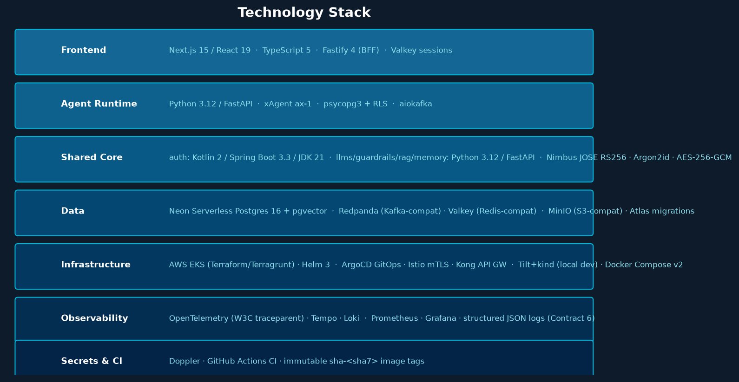
Figure A.1 — Full Technology Stack by Layer

