1. INTRODUCTION
Technology has advanced to the point where realism in virtual reality is very achievable. However, in our obsession to reproduce the world and human experience in virtual space, we overlook the most important aspects of what makes us who we are-our reality. Yet, it isn’t enough just to trick the eye or fool the body and mind. One must capture the imagination in order to create truly compelling experiences.
On the spectrum between virtual reality, which creates immersible, computer-generated environments, and the real world, augmented reality is closer to the real world. Augmented reality adds graphics, sounds, hap tics and smell to the natural world as it exists. You can expect video games to drive the development of augmented reality, but this technology will have countless applications. Everyone from tourists to military troops will benefit from the ability to place computer-generated graphics in their field of vision.

  - Scope
The report is a sincere attempt to study the upcoming technology of augmented reality and its application in the field of gaming.

  - Problem definition
Augmented reality (AR) is a field of computer research which deals with the combination of real world and computer generated data. Augmented reality (AR) refers to computer displays that add virtual information to a user's sensory perceptions. It is a method for visual improvement or enrichment of the surrounding environment by overlaying spatially aligned computer-generated information onto a human's view (eyes). It adds virtual computer-generated objects, audio and other sense enhancements to a real-world environment in real-time. These enhancements are added in a way that the viewer cannot tell the difference between the real and augmented world. It holds a major application in the field of gaming. Hence a game is to be implemented which uses the technology of augmented reality in major.
  - Motivation
Why is combining real and virtual objects in 3-D useful? Augmented Reality enhances a user's perception of and interaction with the real world. The virtual objects display information that the user cannot directly detect with his own senses. It can be otherwise termed as Intelligence Amplification. At least five classes of potential AR applications have been explored: medical visualization, maintenance and repair, annotation, entertainment and military aircraft navigation and targeting. The next section describes work that has been done in each area. While these do not cover every potential application area of this technology, they do cover the areas explored so far.

1.4 Properties
AR system to have the following properties:
- Combines real and virtual objects in a real environment;
- Runs interactively, and in real time; and
- Registers (aligns) real and virtual objects with each other.
Definition of AR to particular display technologies, such as a head mounted display (HMD). Nor do we limit it to our sense of sight. AR can potentially apply to all senses, including hearing, touch, and smell.

1.5 Augmented Reality vs. Virtual Reality
The term Virtual Reality was defined as "a computer generated, interactive, three-dimensional environment in which a person is immersed." There are three key points in this definition. First, this virtual environment is a computer generated three-dimensional scene which requires high performance computer graphics to provide an adequate level of realism. The second point is that the virtual world is interactive. A user requires real-time response from the system to be able to interact with it in an effective manner. The last point is that the user is immersed in this virtual environment
A very visible difference between these two types of systems is the immersiveness of the system. Virtual reality strives for a totally immersive environment. The visual, and in some systems aural and proprioceptive, senses are under control of the system.
In contrast, an augmented reality system is augmenting the real world scene necessitating that the user maintains a sense of presence in that world. The virtual images are merged with the real view to create the augmented display. There must be a mechanism to combine the real and virtual that is not present in other virtual reality work. Developing the technology for merging the real and virtual image streams is an active research topic.
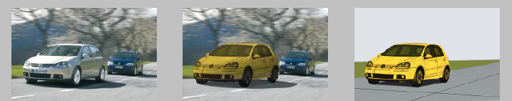

ACTUAL REALITY AUGMENTED REALITY VIRTUAL REALITY
Fig 1.1 Mixed Reality
The real world and a totally virtual environment are at the two ends of this continuum with the middle region called Mixed Reality. Augmented reality lies near the real world end of the line with the predominate perception being the real world augmented by computer generated data.
1.6 History
The beginnings of AR, as we define it, date back to Sutherland’s work in the 1960s, which used a see-through HMD to present 3D graphics. However, only over the past decade has there been enough work to refer to AR as a research field. In 1997, Azuma published a survey that defined the field, described many problems, and summarized the developments up to that point. Since then, AR’s growth and progress have been remarkable.
In the late 1990s, several conferences on AR began, including the international Workshop and Symposium on Augmented Reality, the International Symposium on Mixed Reality, and the Designing Augmented Reality Environments workshop. Some well-funded organizations formed that focused on AR, notably the Mixed Reality Systems Lab in Japan and the Arvika consortium in Germany.

2. APPLICATIONS
Only recently have the capabilities of real-time video image processing, computer graphic systems and new display technologies converged to make possible the display of a virtual graphical image correctly registered with a view of the 3D environment surrounding the user. Researchers working with augmented reality systems have proposed them as solutions in many domains. The areas that have been discussed range from entertainment to military training. Many of the domains, such as medical are also proposed for traditional virtual reality systems.
2.1 Medical

This domain is viewed as one of the more important for augmented reality systems. Most of the medical applications deal with image guided surgery. Pre-operative imaging studies, such as CT or MRI scans, of the patient provide the surgeon with the necessary view of the internal anatomy. From these images the surgery is planned. Visualization of the path through the anatomy to the affected area where, for example, a tumor must be removed is done by first creating a 3D model from the multiple views and slices in the preoperative study [2].
Fig 2.1 Simulated AR medical image of a brain

2.2 Entertainment
A simple form of augmented reality has been in use in the entertainment and news business for quite some time. Whenever we are watching the evening weather report the weather reporter is shown standing in front of changing weather maps. In the studio the reporter is actually standing in front of a blue or green screen. This real image is augmented with computer generated maps using a technique called chroma-keying. It is also possible to create a virtual studio environment so that the actors can appear to be positioned in a studio with computer generated decorating

Fig 2.2 Screenshot from the movie “Who Framed Roger Rabbit?” blending the real character and background with computer generated cartoon characters
In this the environments are carefully modeled ahead of time, and the cameras are calibrated and precisely tracked. For some applications, augmentations are added solely through real-time video tracking. Delaying the video broadcast by a few video frames eliminates the registration problems caused by system latency. Furthermore, the predictable environment (uniformed players on a green, white, and brown field) lets the system use custom chrome-keying techniques to draw the yellow line only on the field rather than over the players. With similar approaches, advertisers can embellish broadcast video with virtual ads and product placements.
2.3 Military Training
The military has been using displays in cockpits that present information to the pilot on the windshield of the cockpit or the visor of their flight helmet. This is a form of augmented reality display.
By equipping military personnel with helmet mounted visor displays or a special purpose rangefinder the activities of other units participating in the exercise can be imaged. In wartime, the display of the real battlefield scene could be augmented with annotation information or highlighting to emphasize hidden enemy units.
2.4 Engineering Design

Imagine that a group of designers are working on the model of a complex device for their clients. The designers and clients want to do a joint design review even though they are physically separated. If each of them had a conference room that was equipped with an augmented reality display this could be accomplished. The physical prototype that the designers have Fig 2.3 Virtual Design of a bridge to be built using Augmented Reality mocked up is imaged and displayed in the client's conference room in 3D. The clients can walk around the display looking at different aspects of it

2.5 Robotics and Tele robotics
In the domain of robotics and tele robotics an augmented display can assist the user of the system. A telerobotic operator uses a visual image of the remote workspace to guide the robot. Annotation of the view would still be useful just as it is when the scene is in front of the operator. There is an added potential benefit. The robot motion could then be executed directly which in a tele robotics application would eliminate any oscillations caused by long delays to the remote site.

2.6 Manufacturing, Maintenance and Repair
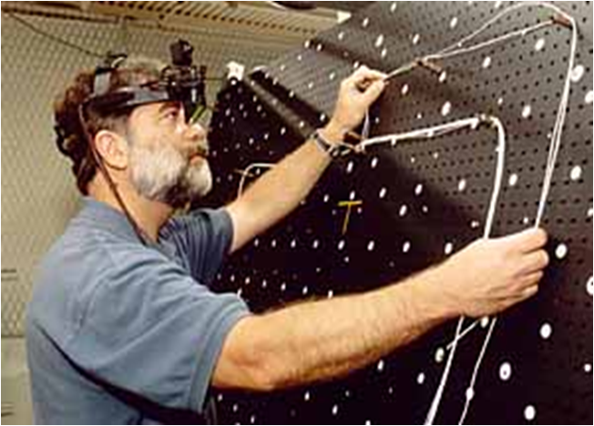
Recent advances in computer interface design, and the ever increasing power and miniaturization of computer hardware have combined to make the use of augmented reality possible in demonstration test beds for building construction, maintenance Fig 2.4 An engineer using a head mounted gear to measure for manufacturing and renovation. When the maintenance technician approaches a new or unfamiliar piece of equipment instead of opening several repair manuals they could put on an augmented reality display. In this display the image of the equipment would be augmented with annotations and information pertinent to the repair [2]. The military has developed a wireless vest worn by personnel that is attached to an optical see-through display. The wireless connection allows the soldier to access repair manuals and images of the equipment. Future versions might register those images on the live scene and provide animation to show the procedures that must be performed.
2.7 Gaming
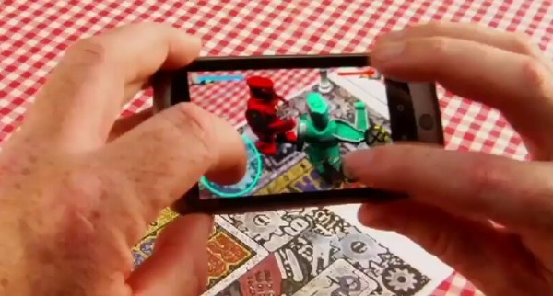
Reality in games is the most important aspect in itself. Augmented reality has its great contribution in the field of gaming. In recent times, games are not just animated they are combined with Fig 2.5 A combat game on a Smartphone using augmented reality the real world to get an ultimate realistic experience to the users. It feels like playing in the real environment using objects that actually do not exist. There are a quite a lot of games developed and many are in its seminal stage.
The table top role-playing game, Shadow run, introduced AR into its game world. Most of the characters in the game use viewing devices to interact with the AR world most of the time.
Cyber Generation, a table top role-playing game by R. Talsorian, includes "virtuality", an augmented reality created through v-trodes, cheap, widely available devices people wear at their temples [3].
In the video game Heavy Rain, Norman Jayden, an FBI profiler, possesses a set of experimental augmented reality glasses called an "Added Reality Interface", or ARI. It allows him to rapidly investigate crime scenes and analyze evidence [3].
In Dead Space the RIG worn by Isaac Clarke is thoroughly equipped with augmented reality technology, including a navigation system that projects a line along the best route to his destination, and a system that displays images, video and text in front of him [3].

3. GAMES USING AUGMENTED REALITY
Augmented reality seems like the perfect playground. In theory, it allows games of pretend where the imaginary characters act of their own accord, and new sports with complicated rules and elaborate scoring systems handled invisibly by computer. In practice, though, augmented reality alone is not enough to bring these games to life. The potential of AR gaming will be unlocked when it is integrated with other technology – most of which already exists – including RFID, GPS, and motion detection. As they are integrated, the potential for AR gaming will explode.

Types of AR Games

Stationary AR Games
Stationary AR games based on marker technology are the first and lowest hurdle we expect to be leaped. In fact, several developers are working on such games already, though none have yet made it to market. For the most part, these games are very similar to existing board and tabletop games.
Stationary Marker-Driven AR Games
These games may be very similar in feel and execution to existing games. One might wonder at whether it’s worthwhile to develop such a game; but consider the success of solitaire card games for the PC. Any implementation of a popular game that allows some of the game-management overhead to be controlled by the computer brings a value-add of low effort that could boost the adoption of AR versions of already familiar games.
- Arena duelling games
These games are similar to Magic: The Gathering, Pokémon, and Yu-Gi-Oh. The players (generally two) conduct a battle by gradually placing new markers (probably cards indicating creatures, abilities, or other concepts) into the field. The computer mediates the markers' interactions with one another and keeps track of score and other vital statistics [4].
- Battle chess
This is a popular game concept, from Star Wars to Harry Potter. It involves a traditional strategy game, such as chess, in which the pieces perform animations in AR that will vary depending on their relative position versus other pieces on the board.
- Tabletop strategy games
The non-AR analogue to this is War hammer 40K. In AR tabletop strategy games, markers are moved freely around on a table; the player inputs actions such as attacks or building fortifications, and the game computes damage and other statistics [4].

Mobile AR Games
The next step in the evolution of augmented reality gaming will come when the AR device is untethered. This requires a portable camera, display, computer, and some interface mechanism. While wearable computing devices and AR headsets would be ideal, a Smartphone should be sufficient.
- Mobile Marker-Driven Games
A mobile AR device relying on markers will still be extremely limited, but mobility does open up new genres of play.
- Mobile Marker less AR
While the games using AR markers will certainly be entertaining in their own right, it is only when the technology allows markerless AR that the games designed will start to become native to augmented reality, allowing completely new mechanisms of play rather than mere adaptations of existing ones. In these games, a player would view his or her surroundings through either a viewfinder on a mobile device or a camera/display headset. Software would detect objects and perspective and overlay AR information accordingly. First implementations are likely to include simple arcade and puzzle games.

Location Detection
Games using markerless AR and location detection – probably via a GPS-and-compass combination – should appear by 2012 at the outmost and likely quite a bit sooner. Note that two varieties of location detection are possible. In one, the system relies on static maps of an area to draw a playing field. These would likely be implemented outdoors first, as the interior of any given building would be highly unlikely to be mapped. In dynamic mapping, the computer would parse the environment for objects and continue mapping on the fly as the player moves and perspective and location both shift. Ultimately, an efficient system will likely rely on both techniques: Systems would access a Google Maps-style data store with size, perimeter and location information for large static objects, while dynamic mapping would account for the presence of mobile objects such as vehicles and people. It's unlikely that a completely integrated system will exist until sometime in 2013, and possibly not for quite some time afterward [4].

Motion Detection
Games relying on physical motion on the part of the player will open the avenue to entirely new categories of sport and exercise. To be sure, there are larger uses for motion detection in AR, including an interface based on a gesture vocabulary or the ability to interact with a virtual object in the same way as a physical one, but these games are not easily tackled by existing taxonomies.

Face and Image Recognition
Identity recognition -- of people or of objects -- is another technology that will significantly advance the gaming possibilities of AR. RFID chips embedded in everyday objects will allow the AR game to detect the existence, location and purpose of everyday items such as furniture, vehicles, or clothing. Facial recognition will allow the AR environment to paint individuals with clothing, accessories, or other personal attributes in keeping with a game. Together, these technologies would allow one of the most ambitious
goals of augmented reality gaming: the pervasive mobile MMORPG [4].

TECHNOLOGY

4.1 Hardware
The main hardware components for augmented reality are: display, tracking, input devices, sensors and processor. These elements, specifically CPU, camera, display, accelerometer, GPS and solid state compass are often present in modern smart phones, which make them prospective AR platforms.

4.1.1 Display
The three major display techniques for Augmented Reality are, head–mounted displays, handheld displays, and spatial displays.

Head–mounted
A Head Mounted Display (HMD) places images of both the physical world and registered virtual graphical objects over the user's view of the world. The HMD's are either optical see–through or video see–through. Optical see-through employs half-silver mirrors to pass images through the lens and overlay information to be reflected into the user's eyes. The HMD must be tracked with sensor that provides six degrees of freedom. This tracking allows the system to align virtual information to the physical world. The main advantage of HMD AR is the user's immersive experience. The graphical information is slaved to the view of the user [3].

Handheld
Handheld displays employ a small display that fits in a user's hand. All handheld AR solutions to date opt for video see-through. Initially handheld AR employed fiduciary markers, and later GPS units and MEMS sensors such as digital compasses and six degrees of freedom accelerometer–gyroscope. Today SLAM markerless trackers such as PTAM are starting to come into use. Handheld display AR promises to be the first commercial success for AR technologies. The two main advantages of handheld AR are the portable nature of handheld devices and ubiquitous nature of camera phones. The disadvantages are the physical constraints of the user having to hold the handheld device out in front of them at all times as well as distorting effect of classically wide-angled mobile phone cameras when compared to the real world as viewed through the eye [3].

Spatial
Instead of the user wearing or carrying the display such as with head mounted displays or handheld devices; Spatial Augmented Reality (SAR) makes use of digital projectors to display graphical information onto physical objects. The key difference in SAR is that the display is separated from the users of the system. Because the displays are not associated with each user, SAR scales naturally up to groups of users, thus allowing for collocated collaboration between users. SAR has several advantages over traditional head mounted displays and handheld devices. The user is not required to carry equipment or wear the display over their eyes. This makes spatial AR a good candidate for collaborative work, as the users can see each other’s faces. A system can be used by multiple people at the same time without each having to wear a head mounted display. Spatial AR does not suffer from the limited display resolution of current head mounted displays and portable devices. A projector based display system can simply incorporate more projectors to expand the display area. Where portable devices have a small window into the world for drawing, a SAR system can display on any number of surfaces of an indoor setting at once. The drawbacks, however, are that SAR systems of projectors do not work so well in sunlight and also require a surface on which to project the computer-generated graphics. Augmentations cannot simply hang in the air as they do with handheld and HMD-based AR.
The tangible nature of SAR, though, makes this an ideal technology to support design, as SAR supports both a graphical visualization and passive haptic sensation for the end users. People are able to touch physical objects, and it is this process that provides the passive hap tic sensation [3].

4.1.2 Tracking
Modern mobile augmented reality systems use one or more of the following tracking technologies: digitalcameras, other optical sensors, accelerometers, GPS, gyroscopes, solid state compasses, RFID and wireless sensors. These technologies offer varying levels of accuracy and precision. Most important is the position and orientation of the user's head. Tracking the user's hand(s) or a handheld input device can provide a 6DOF interaction technique.

4.1.3 Input devices
Techniques include the pinch glove, a wand with a button and a smart phone that signals its position and orientation from camera images.

4.1.4 Computer
The computer analyzes the sensed visual and other data to synthesize and position augmentations.

4.2 Software and algorithms
A key measure of AR systems is how realistically they integrate augmentations with the real world. The software must derive real world coordinates, independent from the camera, from camera images. That process is called image registration and is part of Azuma's definition of Augmented Reality.

Image registration uses different methods of computer vision, mostly related to video tracking. Many computer vision methods of augmented reality are inherited from visual odometers. Usually those methods consist of two parts. First detect interest points, or fiduciary markers, or optical flow in the camera images. First stage can use feature detection methods, edge detection or thresholding and/or other image processing methods.
The second stage restores a real world coordinate system from the data obtained in the first stage. Some methods assume objects with known geometry (or fiduciary markers) present in the scene. In some of those cases the scene 3D structure should be precalculated beforehand. If part of the scene is unknown simultaneous localization and mapping (SLAM) can map relative positions. If no information about scene geometry is available, structure from motion methods like bundle adjustment are used. Mathematical methods used in the second stage include projective(epipolar) geometry, geometric algebra with exponential map, kalman and particle filters, nonlinear optimization [3].

- IMPLEMENTATION
5.1 Description
In order to demonstrate an augmented reality game we attempt to implement a module of the game. We start with implementing a 3D model of earth and stars around it. We have managed to design a marker i.e. an AR tag which virtualizes a 3D view of the earth popping out of a box. The realism seen and experienced to view the earth as a real entity is extremely fascinating.

5.2 Components Used
- An AR marker tag
- A webcam
- FLAR Toolkit
- Adobe Flash Builder

  - Algorithm
- Download an image of the world map from the internet which is to be mapped into a sphere. The image we used is shown below in fig 5.1.

Fig 5.1 World Map

- Next we define a new sphere using the following code.
var Earth:Sphere = new Sphere(earth, 40);
Earth.z=200;
dispObj.addChild(Earth);

- Next we map the image of the world into the created sphere using the following line of code
var earth:BitmapFileMaterial = new BitmapFileMaterial("assets/map.jpg");

- We now add some stars around our earth by defining the stars and their positions. The following code explains the same.
var star1:Sphere = new Sphere(star, 4);
star1.z=65;
star1.x=84;
star1.y=164;
dispObj.addChild(star1);

- Next we trap the sphere and the stars in a box so that we can animate the sphere and the stars as if they are popped out of the box.
- We now import some libraries that help in animating the objects in flash. Some of the libraries that we have imported are GreenSock and AS3 TweenMax library.
- We now animate the earth using the following code snippet.
var Earth:Sphere = new Sphere(earth, 1);
Earth.z=-40;
TweenMax.to(Earth,4,{scaleX:40,scaleY:40,scaleZ:40,z:"200", delay:4});

- We now make the box lid using the following code
var top:Cube = new Cube( new MaterialsList( {all: Top} ) , 80 , 0 , 80 );
top.z=0;
top.y=40;
TweenMax.to(top, 2,{rotationX:-180, delay:2});
dispObj.addChild(top);

- Lastly we add some sound into it by importing some libraries such as SoundMixer and SoundChannel and play the sound as soon as the lid opens up.
dramaChnl = drama.play(0,1);

5.4 Results and Screenshots
The implementation resulted into a 3D model of the Earth and some stars surrounding it. The earth and the stars are animated to pop out from a trapped box as soon as the lid is opened.
The following are the screenshots of the 3D earth and the stars around it which is taken from a webcam.
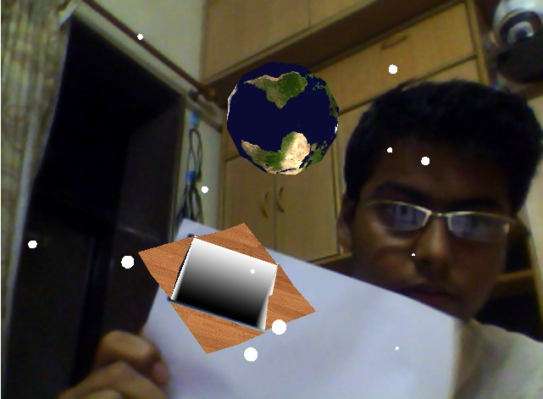
Fig 5.1 Screenshot of a 3D model of earth with stars Fig 5.2 AR marker Tag

6. CHALLENGES
6.1 Technological limitations
Although there is much progress in the basic enabling technologies, they still primarily prevent the deployment of many AR applications. Displays, trackers, and AR systems in general need to become more accurate, lighter, cheaper, and less power consuming. Since the user must wear the PC, sensors, display, batteries, and everything else required, the end result is a heavy backpack. Laptops today have only one CPU, limiting the amount of visual and hybrid tracking that we can do.
6.2 User interface limitation
We need a better understanding of how to display data to a user and how the user should interact with the data. AR introduces many high-level tasks, such as the need to identify what information should be provided, what’s the appropriate representation for that data, and how the user should make queries and reports. Recent work suggests that the creation and presentation of narrative performances and structures may lead to more realistic and richer AR experience.
6.3 Social acceptance
The final challenge is social acceptance. Given a system with ideal hardware and an intuitive interface, how AR can become an accepted part of a user’s everyday life, just like a mobile phone or a personal digital assistant. Through films and television, many people are familiar with images of simulated AR. However, persuading a user to wear a system means addressing a number of issues. These range from fashion to privacy concerns. To date, little attention has been placed on these fundamental issues. However, these must be addressed before AR becomes widely accepted.

7. CONCLUSION
The research topic "Augmented Reality" (AR) is receiving significant attention due to striking progress in many subfields triggered by the advances in computer miniaturization, speed, and capabilities and fascinating live demonstrations. AR, by its very nature, is a highly inter-disciplinary field, and AR researchers work in areas such as signal processing, computer vision, graphics, user interfaces, human factors, wearable computing, mobile computing, computer networks, distributed computing, information access, information visualization, and hardware design for new displays.
Augmented reality is a term created to identify systems which are mostly synthetic with some real world imagery added such as texture mapping video onto virtual objects. This is a distinction that will fade as the technology improves and the virtual elements in the scene become less distinguishable from the real ones.

8. REFERENCES
1. www.augmentedreality.com
2. www.active.tutsplus.com
3. www.wikipedia.org
4. www.ieeeexplore.org
5. www.citeseer.ist.psu.edu.
6. www.cs.columbia.edu
7. www.lsi.upc.es.
8. www.cs.ualberta.com

ACKNOWLEDGEMENTS
It is my proud privilege to epitomize my deepest sense of gratitude and indebtedness to Dr. Tanuja .K. Sarode Assistant Professor of Thadomal Shahani Engineering College Bandra for her valuable guidance, keen and sustained interest, intuitive ideas and persistent endeavor. Her inspiring assistance, laconic reciprocation and affectionate care enabled me to complete my work smoothly and successfully.
Last but not the least; I would like to thank my friends who have offered all sorts of help for the completion of this report.
Our Team includes the following members:
Vinay Narang C23-084115
Vishal Punjabi C23-084118
Yash Shah C23-084121
Ravi Teja Mulukutla C23-084135

