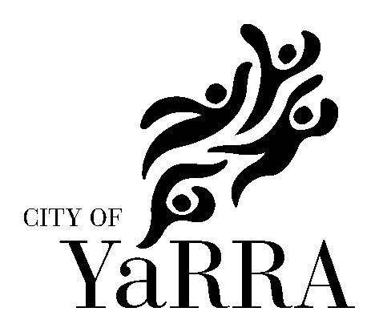

City of Yarra
Invitation List 2008

All invitations for the Mayor/Councillor to officially speak at any event (including those sponsored by Yarra City Council) should be extended in writing at least six weeks prior to the occasion.

All Councillor and staff invitations can be forwarded for distribution directly to:
Arts and Cultural Services
City of Yarra
PO Box 168
RICHMOND VIC 3121

Members of Parliament

A list of local representatives of Federal and State Members of Parliament can be found at:

Federal: http://www.yarracity.vic.gov.au/Council/Elections/Federal%20members.asp

State: http://www.yarracity.vic.gov.au/Council/Elections/State%20members.asp

Councillors
Cr Judy Morton (Mayor)  Cr Gurm Sekhon  Cr Kay Meadows  Cr Jenny Farrar  Cr Geoff Barbour  Cr Stephen Jolly  Cr Jackie Fristacky  Cr Paul D’Agostino  Cr Kathleen Maltzahn | Melba Ward  Melba Ward  Melba Ward (YAARTS Councillor representative)  Langridge Ward  Langridge Ward  Langridge Ward  Nicholls Ward  Nicholls Ward  Nicholls Ward

Council Officers
Dr Andi Diamond  Craig Kenny  Bruce Phillips  Tom Evans  Greg Anders  Jenny Ruffy  Siu Chan  Brona Keenan  Sandra Margulius  Fiona Hillary | Chief Executive Officer  Director Community Programs  Director City Development  Director Corporate and Financial Services  Director Infrastructure Services  Manager Cultural and Library Services  Coordinator Arts & Cultural Services  Arts & Cultural Development Officer  Arts & Cultural Development Officer  Arts & Cultural Development Officer

Yarra Arts Advisory Committee (YAARTS) 2007-2009

YAARTS is an advisory body which makes recommendations to Council on arts and cultural issues.

Maggie Maguire  Abbotsford Convent Foundation  Providence  1 St Heliers St  Abbotsford 3067 | Rosalie Hastwell  101 Clauscen Street  North FITZROY 3068 | Jeff Khan  Next Wave Festival  Office 4  5 Blackwood St  North Melbourne 3051 | Sandra Matlock  11 Charlotte Street  Richmond 3121
James Meldrum  81 Crown Street  Richmond 3121 | David Ryding  PO Box 1396  Fitzroy North 3068

