# City of Yarra

**Invitation List 2009**

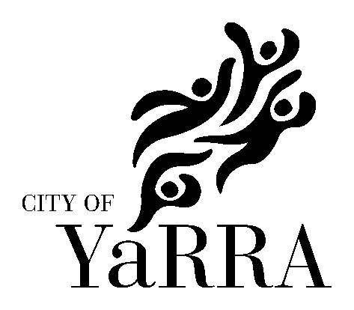

All invitations for the Mayor/Councillor to officially speak at any event (including those sponsored by Yarra City Council) should be extended in writing at least six weeks prior to the occasion.

All Councillor and staff invitations can be forwarded for distribution directly to:

Arts and Cultural Services

City of Yarra

PO Box 168

RICHMOND VIC 3121

Councillors

|  |  |  |
| --- | --- | --- |
| Cr Amanda Stone  Cr Geoff Barbour  Cr Stephen Jolly  Cr Alison Clarke  Cr Josh Funder  Cr Dale Smedley  Cr Jackie Fristacky  Cr Jane Garrett  Cr Sam Gaylard | Langridge Ward  Langridge Ward (YAARTS Councillor representative)  Langridge Ward  Melba Ward  Melba Ward  Melba Ward (YAARTS Councillor representative)  Nicholls Ward  Nicholls Ward (Mayor)  Nicholls Ward |  |

### Council Officers

|  |  |
| --- | --- |
| Dr Andi Diamond  Craig Kenny  Bruce Phillips  Jack Crawford  Vito Albicini  Frank Rog  Greg Axford  Ainslie Gowan  Jenny Ruffy  Siu Chan  Brona Keenan  Sandra Margulius  Fiona Hillary  Carol Campbell | Chief Executive Officer  Director Community Programs  Director City Development  Director Corporate and Financial Services  Director Infrastructure Services  Executive Manager Human Resources  Executive Manager Communications and Customer Service  Coordinator of Communications & Public Relations  Manager Cultural and Library Services  Coordinator Arts & Cultural Services  Arts & Cultural Development Officer  Arts & Cultural Development Officer  Arts & Cultural Development Officer  Collection Administrator |

Yarra Arts Advisory Committee (YAARTS)

YAARTS is an advisory body which makes recommendations to Council on arts and cultural issues.

|  |  |  |  |  |  |  |  |
| --- | --- | --- | --- | --- | --- | --- | --- |
| **Maggie Maguire**  Abbotsford Convent Foundation  1 St Heliers St  Abbotsford 3067  **Rosalie Hastwell**  101 Clauscen Street  North Fitzroy 3068 | | **Jeff Khan**  Next Wave Festival  Office 4  5 Blackwood St  North Melbourne 3051  **Crusader Hillis**  63 Johnston Street  Fitzroy 3065 | | **Xan Colman**  PO Box 133  Abbotsford 3067 | |  | |
|  |  | |  | |  | |

Members of Parliament

A list of local representatives of Federal and State Members of Parliament can be found at:

Federal: <http://www.yarracity.vic.gov.au/Council/Elections/Federal%20members.asp>

State: <http://www.yarracity.vic.gov.au/Council/Elections/State%20members.asp>