# City of Yarra

**Invitation List 2011**

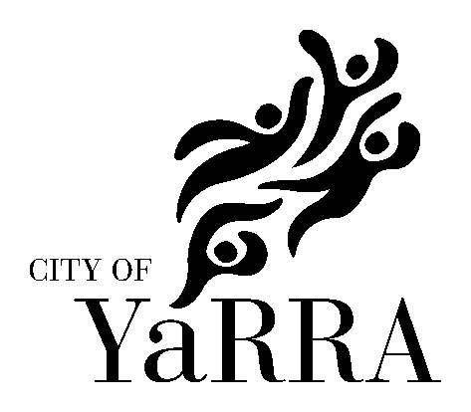

All invitations for the Mayor/Councillor to officially speak at any event (including those sponsored by Yarra City Council) should be extended in writing at least six weeks prior to the occasion.

All Councillor and staff invitations can be forwarded for distribution directly to:

Arts and Cultural Services

City of Yarra

PO Box 168

RICHMOND VIC 3121

Councillors

|  |  |  |
| --- | --- | --- |
| Cr Alison Clarke  Cr Josh Funder  Cr Dale Smedley  Cr Geoff Barbour  Cr Stephen Jolly  Cr Amanda Stone  Cr Jackie Fristacky  Cr Sam Gaylard  Cr Anthony Main | Melba Ward (Mayor)  Melba Ward  Melba Ward (YAARTS Councillor representative)  Langridge Ward (YAARTS Councillor representative)  Langridge Ward  Langridge Ward  Nicholls Ward  Nicholls Ward  Nicholls Ward |  |

### Council Officers

|  |  |
| --- | --- |
| Dr Andi Diamond  Craig Kenny  Bruce Phillips  Jack Crawford  Vito Albicini  Alex Messina  Jenny Ruffy  Siu Chan  Brona Keenan  Sandra Margulius  Kirsty Baird  Sally Hiller  Carol Campbell | Chief Executive Officer  Director Community Programs  Director City Development  Director Corporate and Financial Services  Director Infrastructure Services  Executive Manager Communications and Customer Service  Manager Cultural and Library Services  Coordinator Arts & Cultural Services  Arts & Cultural Development Officer  Arts & Cultural Development Officer  Arts & Cultural Development Officer  Arts & Cultural Development Officer  Collection Administrator |

Yarra Arts Advisory Committee (YAARTS) & CMAC

YAARTS is an advisory body which makes recommendations to Council on arts and cultural issues.

|  |  |  |  |  |  |  |  |
| --- | --- | --- | --- | --- | --- | --- | --- |
| **Maggie Maguire**  Abbotsford Convent Foundation  1 St Heliers St  Abbotsford 3067  **Rosalie Hastwell**  101 Clauscen Street  North Fitzroy 3068 | | **Crusader Hillis**  63 Johnston Street  Fitzroy 3065  **Lyndel Wischer**  276 Gillies Street  Fairfield 3078 | | **Xan Colman**  PO Box 133  Abbotsford 3067  **Jane Trengrove**  Arts Access  24 Eastern Road  South Melbourne 3205 | |  | |
|  |  | |  | |  | |

Members of Parliament

A list of local representatives of Federal and State Members of Parliament can be found at:

Federal: <http://www.yarracity.vic.gov.au/Council/Elections/Federal%20members.asp>

State: <http://www.yarracity.vic.gov.au/Council/Elections/State%20members.asp>