# City of Yarra

**Invitation List 2012**

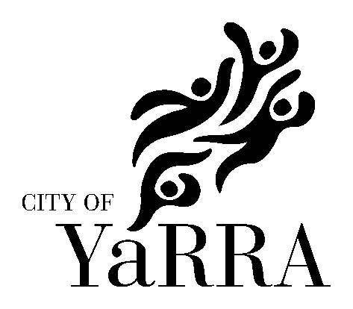

All invitations for the Mayor/Councillor to officially speak at any event (including those sponsored by Yarra City Council) should be extended in writing at least six weeks prior to the occasion.

All Councillor and staff invitations can be forwarded for distribution directly to:

Arts and Cultural Services

City of Yarra

PO Box 168

RICHMOND VIC 3121

Councillors

|  |  |  |
| --- | --- | --- |
| Cr Simon Huggins  Cr Misha Coleman  Cr Phillip Vlahogiannis  Cr Geoff Barbour  Cr Stephen Jolly  Cr Amanda Stone  Cr Jackie Fristacky  Cr Sam Gaylard  Cr Roberto Colanzi | Melba Ward (YAARTS Councillor representative)  Melba Ward  Melba Ward  Langridge Ward  Langridge Ward  Langridge Ward  Nicholls Ward (Mayor)  Nicholls Ward (YAARTS Councillor representative)  Nicholls Ward |  |

### Council Officers

|  |  |
| --- | --- |
| Vijaya Vaidyanath  Craig Kenny  Bruce Phillips  Jack Crawford  Guy Wilson-Browne  TBC  Siu Chan  Brona Keenan  Louisa Marks  Sandra Margulius  Kirsty Baird  Carol Campbell | Chief Executive Officer  Director Community Programs  Director City Development  Director Corporate and Financial Services  Director Infrastructure Services  Manager Cultural and Library Services  Coordinator Arts & Cultural Services  Arts & Cultural Development Officer  Arts & Cultural Development Officer  Arts & Cultural Development Officer  Arts & Cultural Development Officer  Collection Administrator |

Yarra Arts Advisory Committee (YAARTS) & CMAC

YAARTS is an advisory body which makes recommendations to Council on arts and cultural issues.

|  |  |  |  |
| --- | --- | --- | --- |
| **Maggie Maguire**  Abbotsford Convent Foundation  1 St Heliers St  Abbotsford 3067 | **Crusader Hillis**  63 Johnston Street  Fitzroy 3065 | **Neal Harvey**  Melbourne Fringe Festival  PO Box 21278  Lt. Lonsdale Street  VIC 8011 | **Clare Carmody**  11/15 South Tce, Clifton Hill 3068 |
| **Jenny Port**  PO Box 1420  Fitzroy North 3068 | **Michal Morris**  81 -85 Barry St  Carlton 3053 | **Lyndel Wischer**  c/- Arts & Cultural Services  City of Yarra  PO Box 168  Richmond 3121 |  |

Members of Parliament

A list of local representatives of Federal and State Members of Parliament can be found at:

Federal: <http://www.yarracity.vic.gov.au/Council/Elections/Federal%20members.asp>

State: <http://www.yarracity.vic.gov.au/Council/Elections/State%20members.asp>