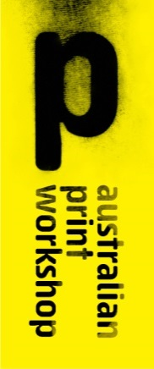

210 Gertrude Street, Fitzroy, Victoria 3065 Australia

PO Box 1236, Collingwood, Victoria 3066 Australia

Telephone 03 9419 5466

[auspw@bigpond.com](mailto:auspw@bigpond.com)

[www.australianprintworkshop.com](http://www.australianprintworkshop.com)

ANDREW BROWNE

Statement of Artwork and Resume

In 2013 Andrew Browne took part in the prestigious APW Collie Print Trust Printmaking Fellowship.

During his fellowship project Andrew produced six large-scale intaglio etchings. APW is submitting one of these works titled ‘A HOLLOW’ for the City of Yarra 2015 New Acquisition program.

The APW Collie Print Trust Printmaking Fellowship has become a significant annual printmaking award in Australia. The fellowship facilitates an extraordinary opportunity for a leading Australian Artist to work in collaboration with APW’s highly skilled printers to develop a major body of work in the print medium at APW’s professional studio base in the heart of Gertrude Street, Fitzroy.

Andrew Browne lives and works in the suburb of Fitzroy. His practice is predominantly in painting but also in photographic and printmaking mediums. Browne’s time spent in APW’s Custom Etching studio working in collaboration with APW printers during his Fellowship allowed him to employ a wide range of intaglio techniques. These processes included traditional etching techniques such as hard-ground, aquatint, spit-bite, drypoint and lift-ground.

Kirrily Hammond, (Curator – Collection, Monash University Museum of Modern Art) wrote in the exhibition catalogue essay, ‘Andrew Browne uses everyday urban detritus found in his neighbourhood (that of Fitzroy and surrounds) and in the midst of his travels; photos of random graffiti, branches washed up on the banks of inner city creeks, discarded wooden panels adorned with construction company logos and ripped pamphlets littering the streets. These images all find their way into Browne’s evolving collection of source material.’

Andrew Browne’s exhibition *Six Intaglios* was shown at Australian Print Workshop Gallery

from 18 May – 22 June 2013.

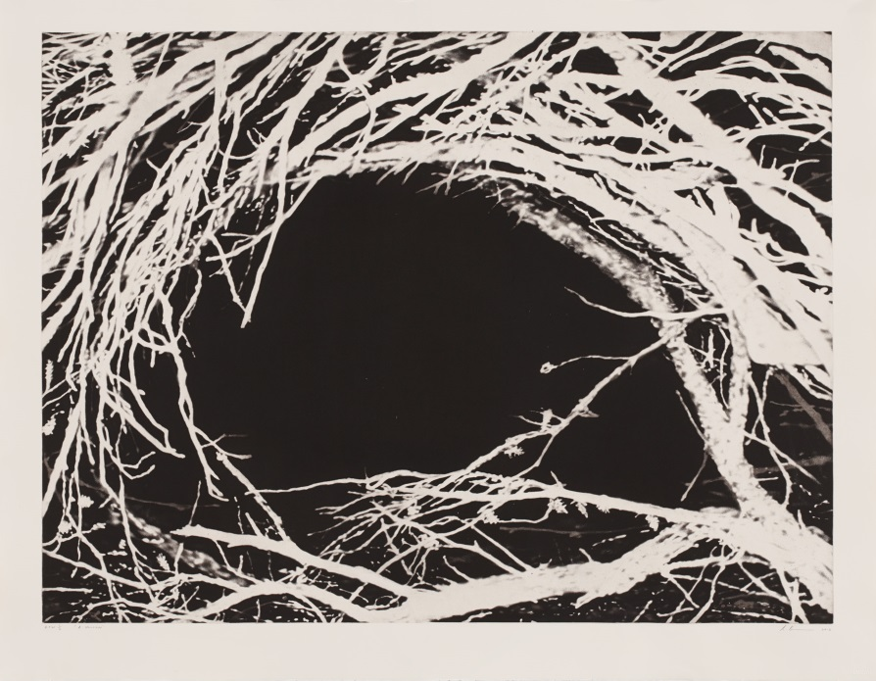

Details of Artwork:

Andrew Browne

*‘A HOLLOW’*

Aquatint

Drawn on the copper plate by the

Artist and printed in an edition of 15 plus proofs by APW Senior Printer Martin King at Australian Print Workshop, Melbourne 2013