* Cultural Diversity Week Concert Series – The Song Room (need location/cost/website info/100 word blurb/photos)

Every year the City of Yarra celebrates Cultural Diversity Week, this year we are bringing together

I am having a meeting about this next Wednesday. After this meeting I can supply a date, a blurb, a location and a photo.

* Koori Night Markets  (need confirmed dates & location/photos)

This project is currently up in the air. I can confirm that it is going ahead or being cancelled hopefully by tomorrow afternoon. We will be doing a launch of the Wurundjeri History Project (including a Walking Tour APP). This will be in March - April.

* Refugee Week Film Competition and Screening (need location/cost/100 word blurb/photos)

This project is going full steam ahead. The date is not confirmed. I can do a blurb and provide a photo today. Location is Fitzroy Town Hall. Sunday 16 - Saturday 22 JUNE. Event will be during the week, possibly a Wednesday. Cost is FREE.

* Performance Investigations (need confirmed title/date/cost/100 word blurb/photos)

Performance Investigations at the Richmond Theatrette

Performance Investigations will showcase 6 works in development by leading Melbourne theatre makers. Each work will be rehearsed and presented at the rejuvenated Richmond Theatrette. Audiences will have the rare opportunity to enjoy 3 pieces of theatre per night and to meet the artists after the show.

Season Friday 28th and Saturday 29th June tbc (next week)

Cost tbc (next week)

Richmond Theatrette, Level 2, 415 Church Street Richmond

MEL REF: 2H A9

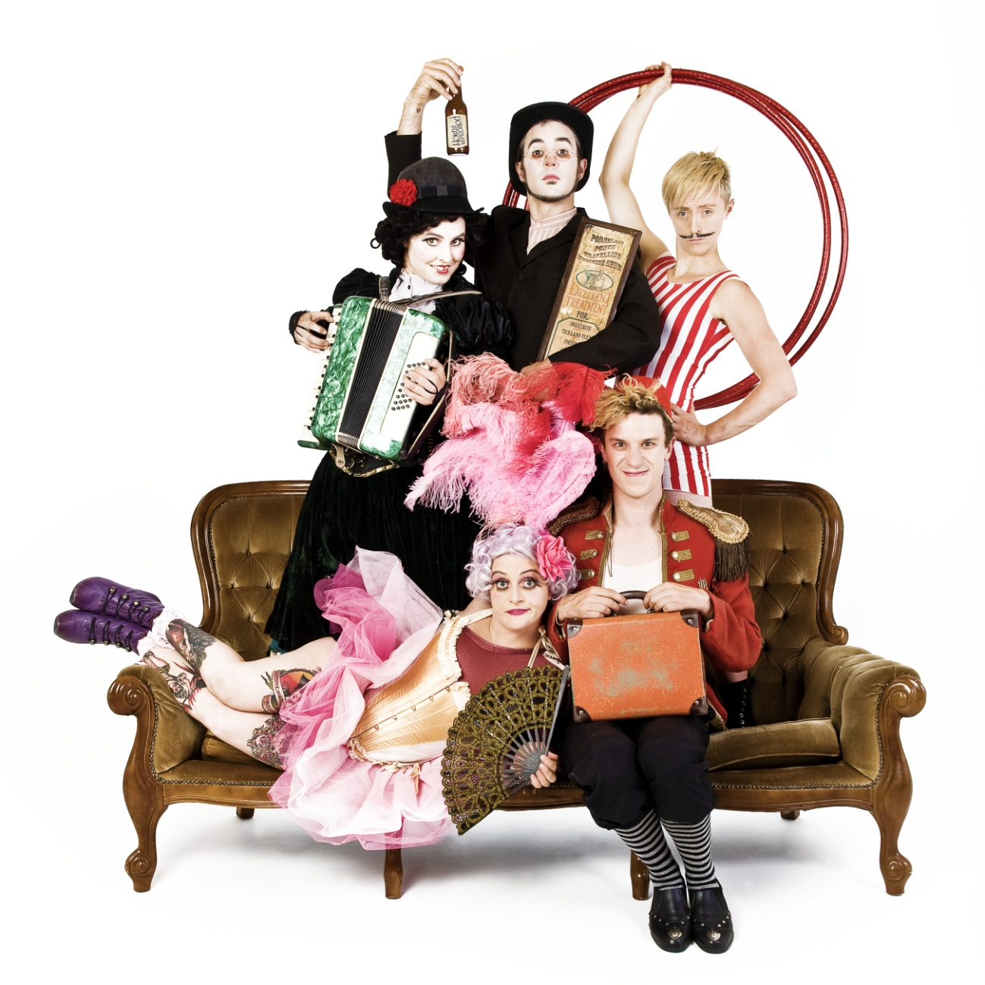

I am having a meeting asap about this. I can provide a blurb, photo by today or tomorrow. Date by next week. Last week of JUNE. Cost is FREE.

* Live Music Festival  - Aboriginal Music Component (need confirmed title/date/location/cost/website info/100 word blurb/photos)\

I am having a meeting about this on Friday. I can supply dates and possibly locations and photo once I have a draft of the program. JULY

* Zombies - The Trailer – sounds interesting! (need organisation/date/location of event/cost/website info/100 word blurb/photos)

The Zombies project has been funded by us and now by Arts Victoria to the tune of $40k. I am meeting with the organisers next Friday to nut out the details of the project. I am not sure yet if we will continue with the structure or change it.