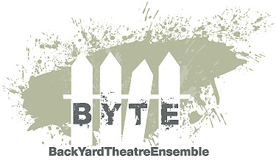Theatre Production

Masterclasses

Devising

Please find further info on:

[www.byteensemble.com](http://www.byteensemble.com)

[www.joachimmatschoss.com.au](http://www.joachimmatschoss.com.au)