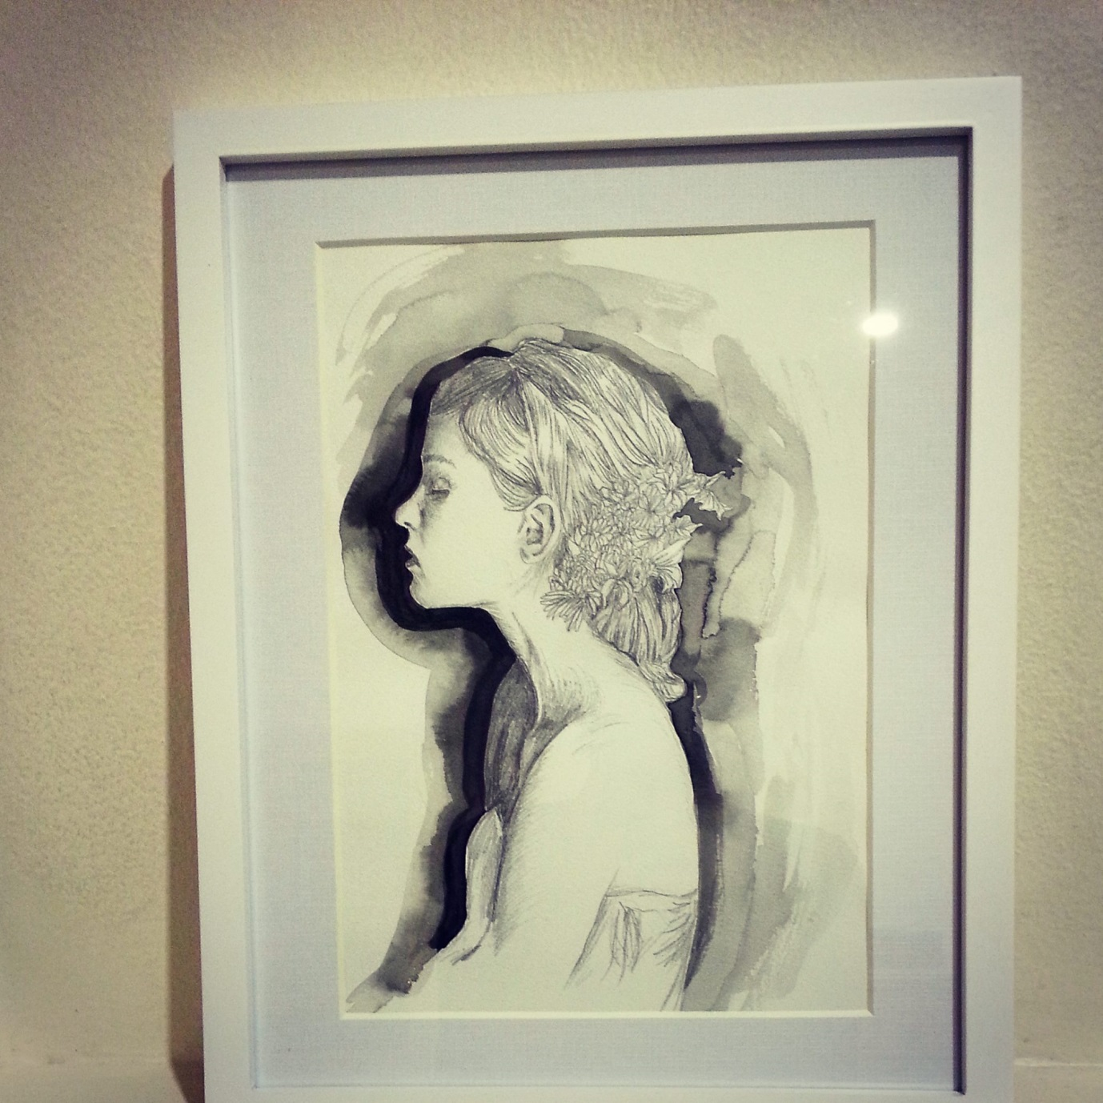

A piece from my Whimsical Wanderer Illustration Series

Original piece (no prints),

Pencil and ink

*About the Series:*

*8 Illustrations in total*

*Exhibited at RENDER at Brunswick Street Gallery 31 Oct 2014 to 13th Nov 2014*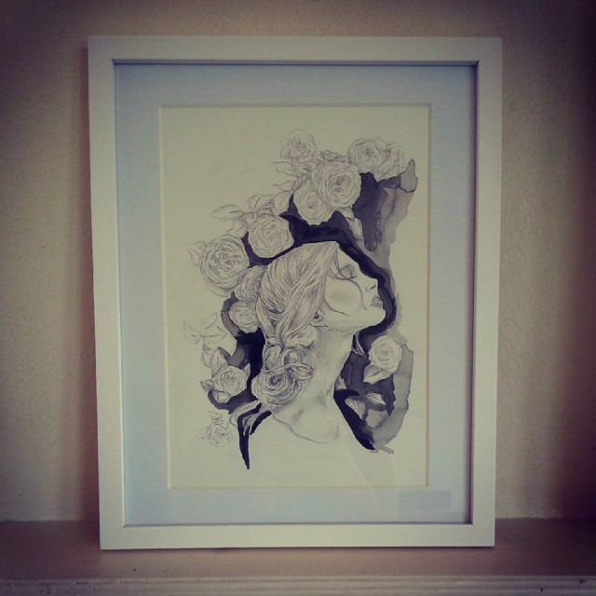

A piece from my Whimsical Wanderer Illustration Series

Original piece (no prints),

Pencil and ink

*About the Series:*

*8 Illustrations in total*

*Exhibited at RENDER at Brunswick Street Gallery 31 Oct 2014 to 13th Nov 2014*