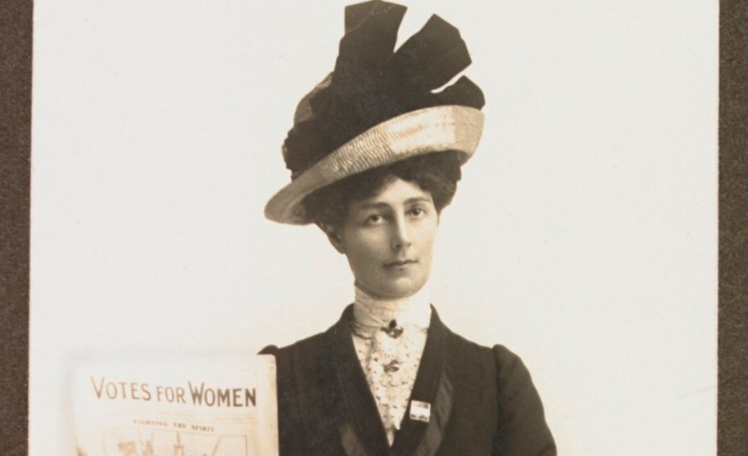

**FIRST WORLD WAR WOMEN**

**Working for peace in Melbourne 1914-1919**

**Free exhibition**

**←**