IMAGES

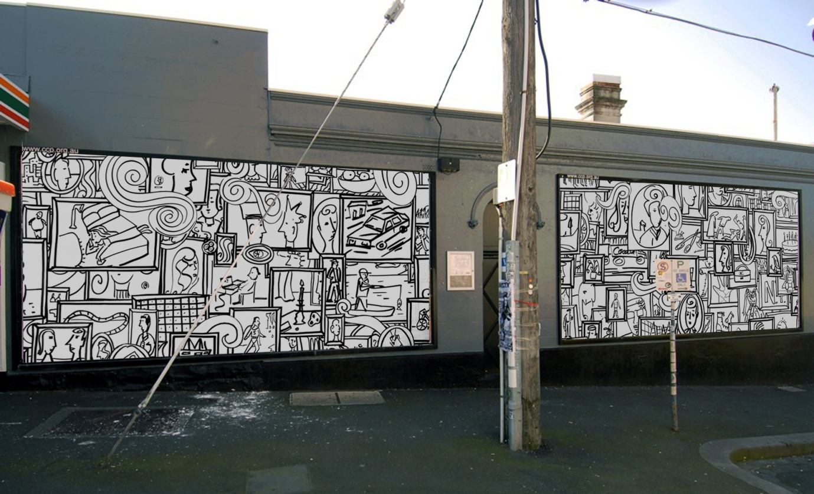

Sadie Chandler, Maquette for *Collingwood I*

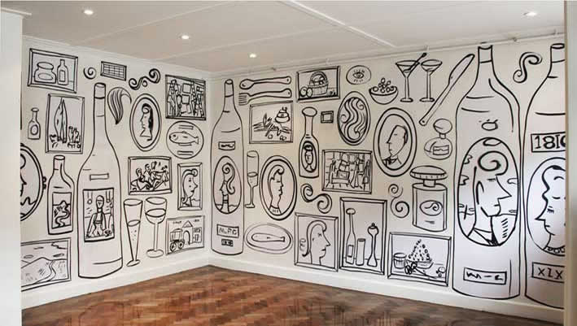

Sadie Chandler, *Lincoln Hotel*, Melbourne 2011 (installation view)

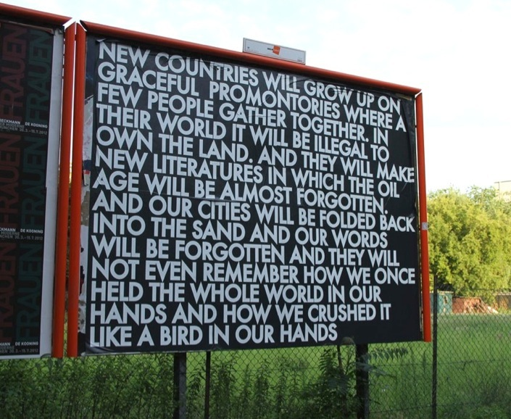

Robert Montgomery*, New countries will grow up*, 2012, Berlin, Germany

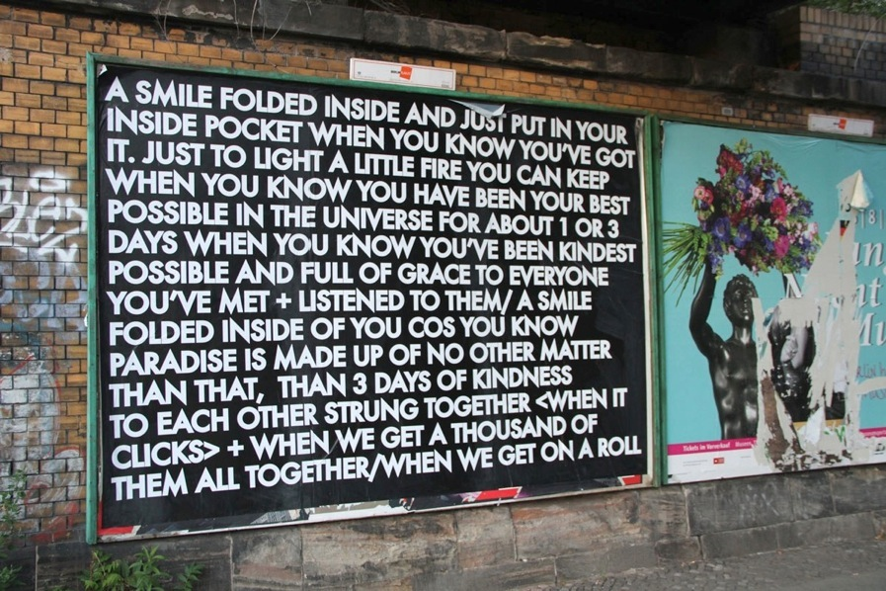

Robert Montgomery, *A smile folded*, 2010, Berlin, Germany

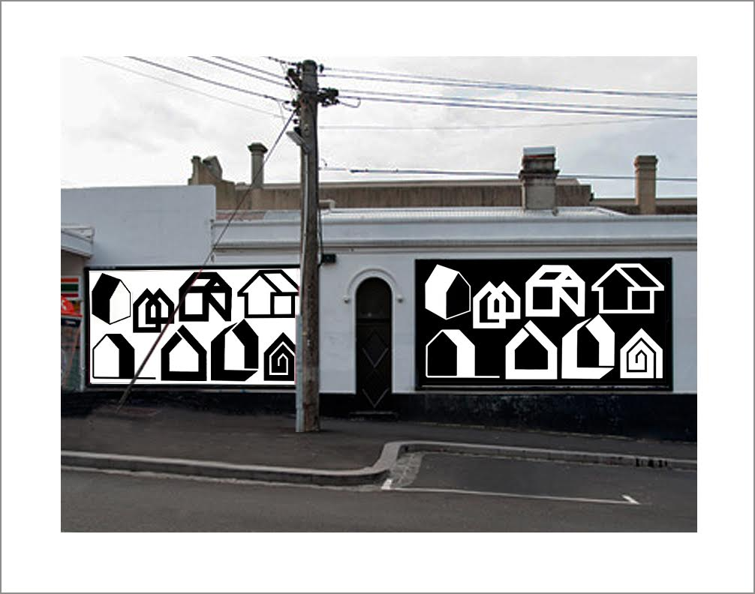Peter Atkins, *Obsolete Logo's c1970s – Houses I*, (study) 2014

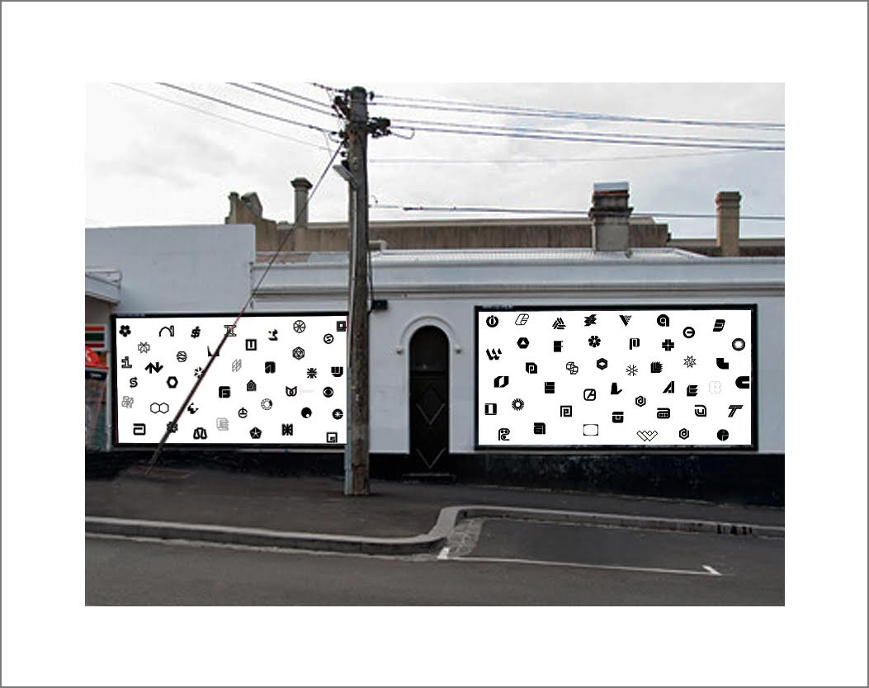

Peter Atkins, *Obsolete Logo's c1970s II* (nb. Please note that the artist can enlargen these logos if there is too much potential for graffiti)

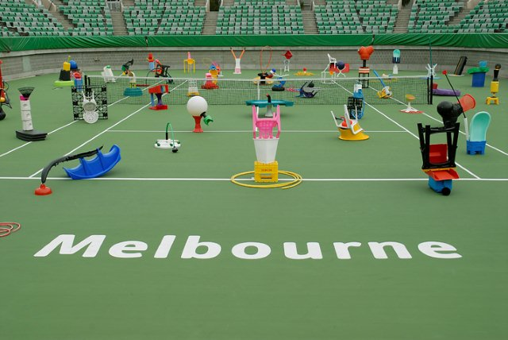

*Show Court 3*, 2007, installation of sculptures by Louise Paramor, Melbourne, curated by Jane O’Neill

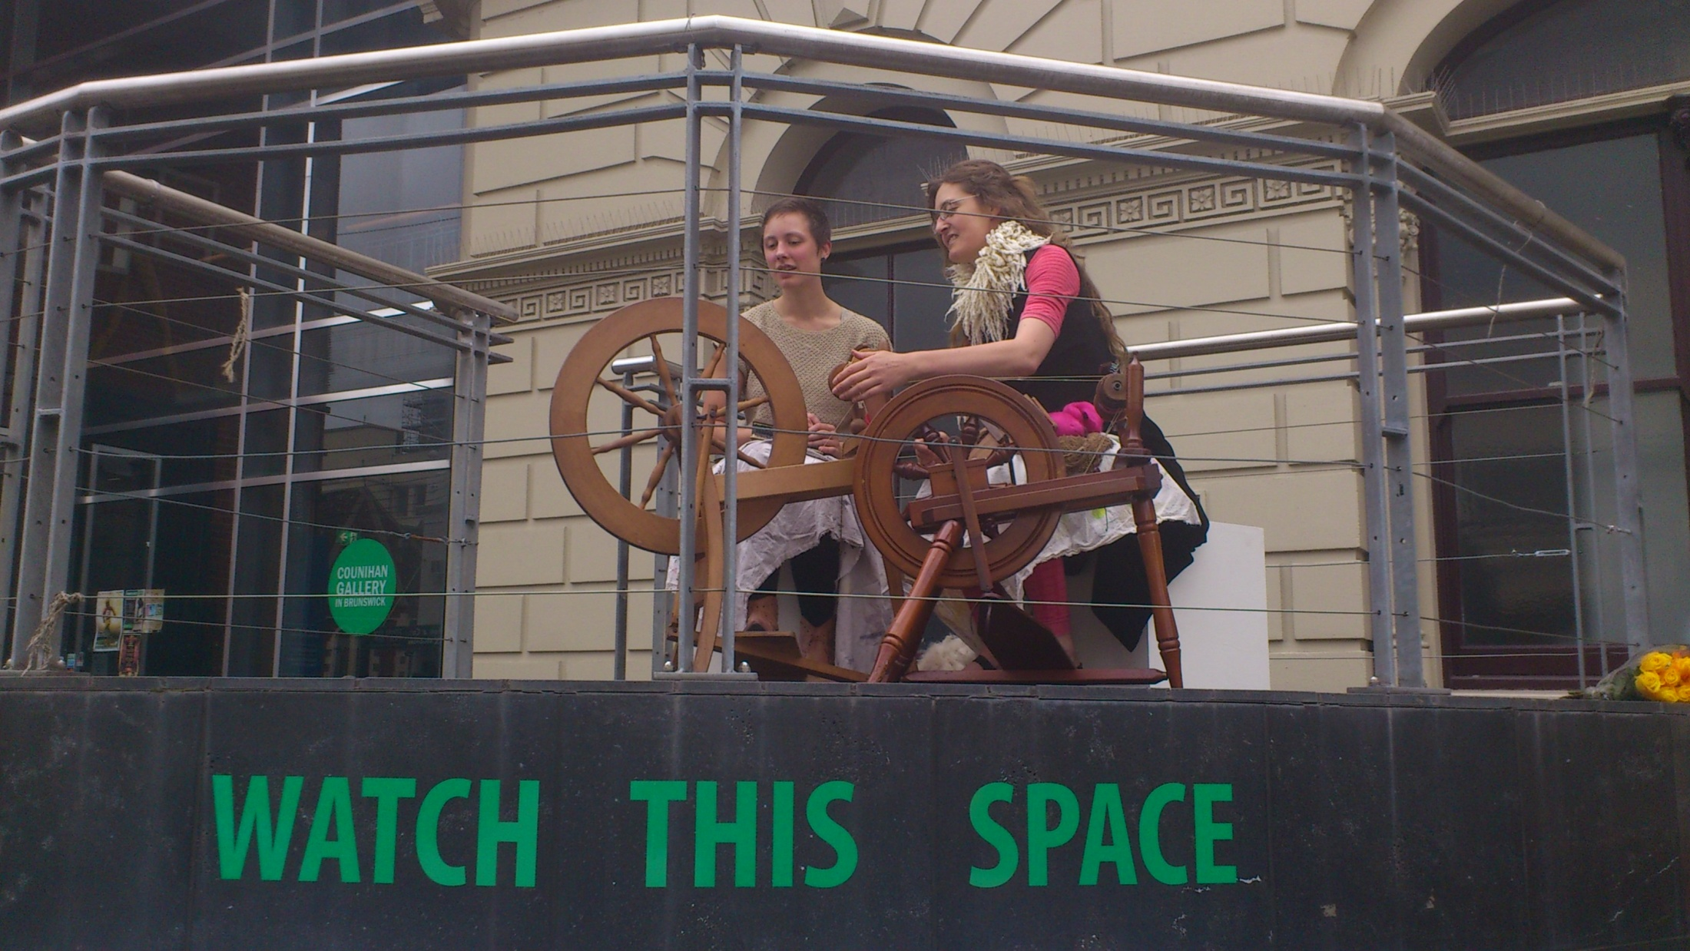

*Teaching/Learning Project*, Brunswick, 2012, curated by Jane O’Neill (picture illustrates two members of community teaching/learning to use a spinning wheel)