**Supporting images;**

URL link to hard cover publication Skypetrait Intercontinental Faces 2012 - 2013

<http://mams.rmit.edu.au/a70lhh19aunlz.pdf>

Link to Skypetrait movie shown at Fed Sq.

<https://vimeo.com/105465460>

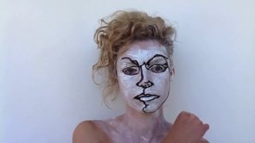

SkypeLab images for current Australian artists

<http://skypelab.wix.com/skypelab>