KEY DATES AND BUDGET

PRODUCTION AND INSTALLATION

So make the billboard skins for the below size for installation at 286 Smith Street, Collingwood.

The billboard frames are different sizes. The skins must be produced to fit the frames at the following dimensions:

5765mm (w) x 2785mm (h) x 2

5900mm (w) x 2895mm (h) x 2

The skins will have 6mm rope or kadar attached which slides into track and is fitted into the frames.

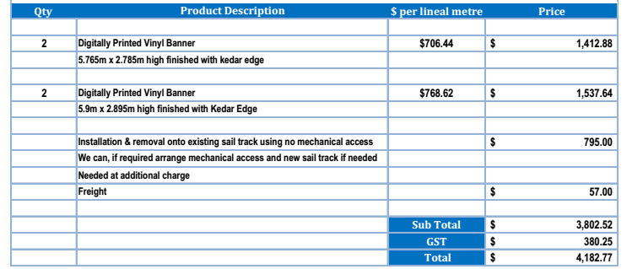

The above quote includes installation and printing of the canvas works. The deadline for the artwork to be printed is 10 days prior to installation. With installation taking less than one week.

I would ensure there is council approval six weeks prior to the artwork being sent to the printers and installed, on both installation occasions.